***DepEd Form 137-A***

Republic of the Philippines

**DEPARTMENT OF EDUCATION**



Cordillera Administrative Region

**___________________________________**



School

___________________________________

Municipality

**SECONDARY STUDENT’S PERMANENT RECORD**

***____________________________________________***Date of Birth: Year _____ Month_____________ Day____ Sex_______

*(Surname)* *(Given Name)*

Place of Birth: Province___________________ Town _______________________ Barrio ______________________

Parent of Guardian:_____________________________________________________________________________

*(Name)* *(Address)* *(Occupation)*

Elementary course completed _____________ School ________________________ Year __________ Gen. Ave.____________

**RECORD OF STANDARD INTELLIGENCE AND ACHIEVEMENT TEST**

Name and Form of Test

Score

Received

Percentile



Rank

Name & From of Test

Score

Received

Percentile

Rank

School ______________________________________________ Year _______________________ Section _________________

Total number of years in school to date __________________________________________ School Year 20 _____ - 20_______

**SUBJECT**

**PERIODICAL RATING**



**Averaging/Cumulative**

**1** **2** **3** **4**

**Final**

**Rating**

**Action**

**Taken**

**Units**

**Earned**

**Extra-**

**curricular Activities**

|  |  |
| --- | --- |
| June July Aug Sept Oct Nov Dec Jan Feb Mar April May | **TOTAL** |
| Days of School |  |
| Days Present |  |



Has Advance Units in _______________________________________________________________________________________

Lacks Units in _____________________________________________________________________________________________

To be Classified as ___________________________________ Total number of years in School to date _____________________

*(Cur. Year)*

School _____________________________________________ School Year 20____ - 20 _______ Section __________________

**SUBJECT**

**PERIODICAL RATING**



**Averaging/Cumulative**

**1** **2** **3** **4**

**Final**

**Rating**

**Action**

**Taken**

**Units**

**Earned**

**Extra-**

**curricular Activities**

|  |  |
| --- | --- |
| June July Aug Sept Oct Nov Dec Jan Feb Mar April May | **TOTAL** |
| Days of School |  |
| Days Present |  |



Has Advance Units in _______________________________________________________________________________________

Lacks Units in _____________________________________________________________________________________________

To be Classified as ___________________________________ Total number of years in School to date _____________________

*(Cur. Year)*

**NAME ___________________________________________________________________________________________________**

*(Surname)* *(First Name)*

School _____________________________________________ School Year 20____ - 20 _______ Section __________________

**SUBJECT**

**PERIODICAL RATING**



**Averaging/Cumulative**

**1** **2** **3** **4**

**Final**

**Rating**

**Action**

**Taken**

**Units**

**Earned**

**Extra-**

**curricular Activities**

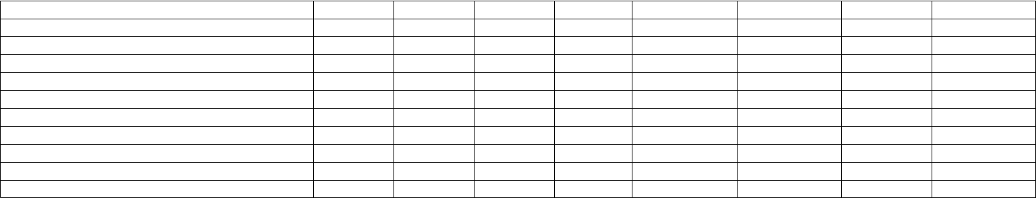

|  |  |
| --- | --- |
| June July Aug Sept Oct Nov Dec Jan Feb Mar April May | **TOTAL** |
| Days of School |  |
| Days Present |  |



Has Advance Units in _______________________________________________________________________________________

Lacks Units in _____________________________________________________________________________________________

To be Classified as ___________________________________ Total number of years in School to date _____________________

*(Cur. Year)*

School _____________________________________________ School Year 20____ - 20 _______ Section __________________

**SUBJECT**

**PERIODICAL RATING**



**Averaging/Cumulative**

**1** **2** **3** **4**

**Final**

**Rating**

**Action**

**Taken**

**Units**

**Earned**

**Extra-**

**curricular Activities**

|  |  |
| --- | --- |
| June July Aug Sept Oct Nov Dec Jan Feb Mar April May | **TOTAL** |
| Days of School |  |
| Days Present |  |



Has Advance Units in _______________________________________________________________________________________

Lacks Units in _____________________________________________________________________________________________

To be Classified as ___________________________________ Total number of years in School to date _____________________

*(Cur. Year)*

**CERTIFICATE OF TRANSFER**



**To Whom It May Concern:**

I certify that thus us a true record of ________________________________, this student is eligible, on this

__________ day of ______________________, 20_____, for admission to the _______________ year as a

regular/an Irregular and had no money or property responsibility in this school.

Remarks _____________________________________________________________________________________

_____________________________________________________________________________________________

_________________________

*(Principal)*

**

Copy of this record sent to principal of _______________________________________________________ school

on ________________________________________, 20____________.

_________________________

*(Principal)*