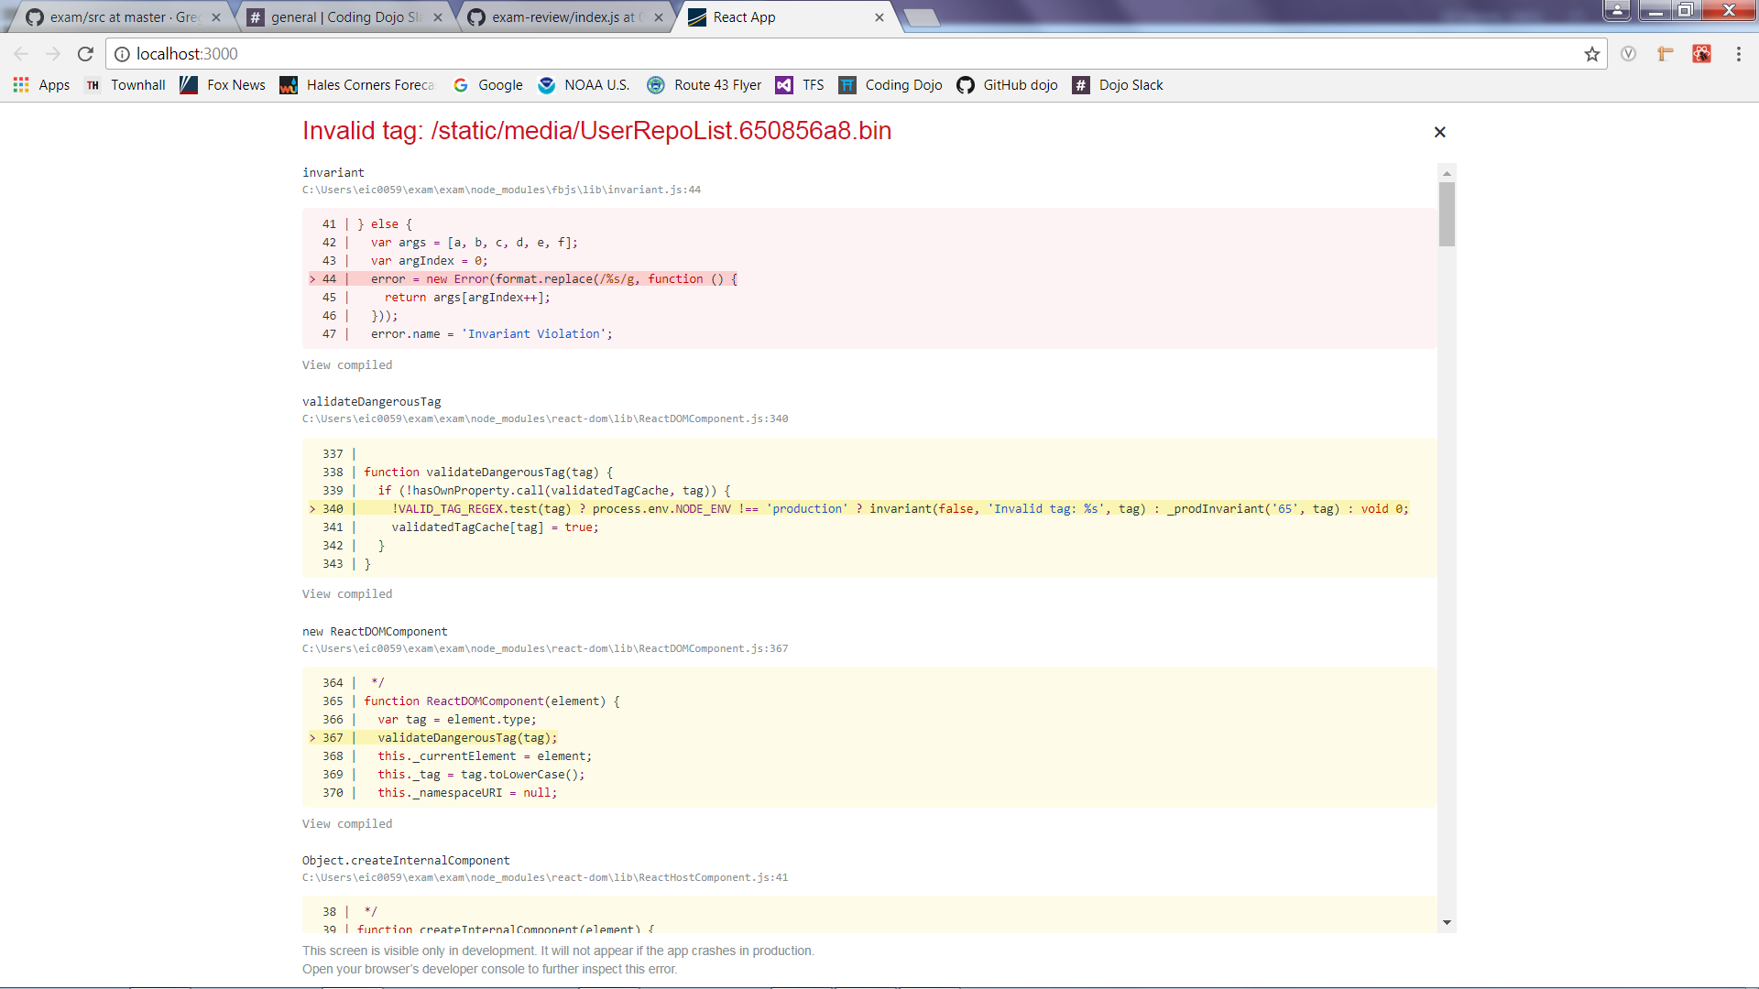

I used the example you showed us as a starting point. I can’t seem to get past this error even if I attempt to use a very basic component file. Therefore, I was unable to make any additional progress from this point. I attempted to look this up on the internet and found no solution.