From: RWWilliams, rwilliams@uthsc.edu, labwilliams@gmail

To: Many (and now about ready for a blog)

Date: 14Feb2021

Version: Extended cut of 15Feb2021 v2

Dear colleagues (particularly those interested in alcohol and drug addiction, brain proteomics, dopamine, causal modeling):

Xusheng Wang and colleagues Ling Li, Zhiping Wu, Ariana Mancieri, He Huangat the University of North Dakota have released a cool new rat HRDP brain proteomics data set. Other key collaborators include Junmin Peng (St. Jude Children's Research Hospital) and Michal Pravenec( Czech Academy of Science). New improved genotypes I will use below are courtesy of Hao Chen and Hakan Gunturun. And the new GEMMA mapping is courtesy of Pjotr Prins.  This is an open, **but not yet final**, quantitative proteomics data for the whole brain for 21 strains of rat (male and female isogenic littermates) from the HXB/BXH family—part of the Hybrid Rat Diversity Panel.

We will have data for more than 33 strains and eventually for four or more subregions of the brain. There is also a companion brain metabolomic data set—a first for rat.

For those of you on this list at NIH, first, thank you for all of your support over more than 20 years that has made this Valentine's primer possible—starting with the NIH Human Brain Project and continuing now with a NIDA P30. I hope you will be impressed not only by the data that Xusheng generated, but by the FAIR-ness and ease of analysis of highly valuable smart quadratic data.

What the heck is *smart quadratic data*? Please see an extended discussion on this topic (verging on a rant in sections) given at the University of Virginia in the Data Science program, 20Nov2020:  [***https://youtu.be/4ZhnXU8gV44***](https://youtu.be/4ZhnXU8gV44)

**Footnote on this presentation**: Do you wonder why translation fails from animal models to human clinical care? 1-N-der? NIH has funded *n = 1* biomedical experimental research for about 70 years without blinking. Anyone who read Roger J. Williams's *Biochemical Individuality* when it came out in 1956 should have known better (***https://en.wikipedia.org/wiki/Roger_J._Williams***). My excuse is that I was four years old, but James Shannon was 52 years old. Elias Zerhouni was 5 years old, Francis Collins was 6 years old, and Eric Lander was about –9 months old. But it is now 2021 and in this glorious "post-genomics" era of highly accurate personalized health care and prevention (not) we should grow up and embrace the diversity and complexity of living systems. *Necessary and sufficient*—only in your reductive dreams. Want more of this: see *Herding Cats—the Sociology of Data Integration*, 2009: PMID: 20228863 https://doi.org/10.3389/neuro.01.016.2009

Many of you have given talks with a hierarchy of traits. I remember a lovely talk that Nora Volkow gave to the Human Brain Project teams in about 2005—from gene variants at the bottom to variable outcome measures at the top—susceptible vs resistant, fast vs slow metabolizer, will relapse, won't replase. I would say we have made only modest progress at true holistic integration, and few biomedical researcher know much about causal quantitative modeling. We absolutely need the proteome tier to model addiction, and we need proteomes from dozen of brain regions and hundreds is not thousands of individuals to model risk and make reasonable predictions. Otherwise we are just flapping our hands and lips. The work by Xusheng and others shows that we are finally ready to come out of the proteomics "winter". The technolgy is mature; batch effect is well controlled; cost is about the same as Affymetrix arrays were in 2005. Several new proteomic data sets in GeneNetwork prove it, but only Xusheng's data is directly relevant to addiction.

End of context; on with the topic at hand:

One small molecule of great fame—dopamine—and its modulation, variation, and contribution to addiction

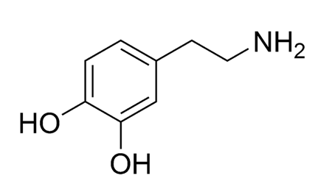

QUESTION:

**What proteins related to dopamine and its many roles in behavior are strongly modulated by DNA variants, and can we determine what gene variants are related both to dopamine function and substance use disorders.**

The Red Hot Chili Peppers ask this question in *This is the Place.*

"[Can I isolate your gene? Can I kiss your dopamine?](https://genius.com/Red-hot-chili-peppers-this-is-the-place-lyrics#note-1422525)

...

A master piece of DNA caught in a flashing ray"

(The lyrics areon the horror of drug addiction. The lead, Anthony Kiedis, has relapsed several times. The PG version of the song: [***https://www.youtube.com/watch?v=gqgm7ViA2Ag***](https://www.youtube.com/watch?v=gqgm7ViA2Ag)and the typical RHCP shirtless version for the cool kids:[***https://www.youtube.com/watch?v=8Dkvwu3aWkY***](https://www.youtube.com/watch?v=8Dkvwu3aWkY)

**Step 1.**To answer the BIG Question, we are going to review all genes/proteins in NCBI **Gene Reference into Function**—RIF for short—that are related in some way to *dopamine*.

There are two ways to do this:

1. Link to [***https://www.genenetwork.org***](https://www.genenetwork.org) and set up the **Select and search**screen to look as shown below:

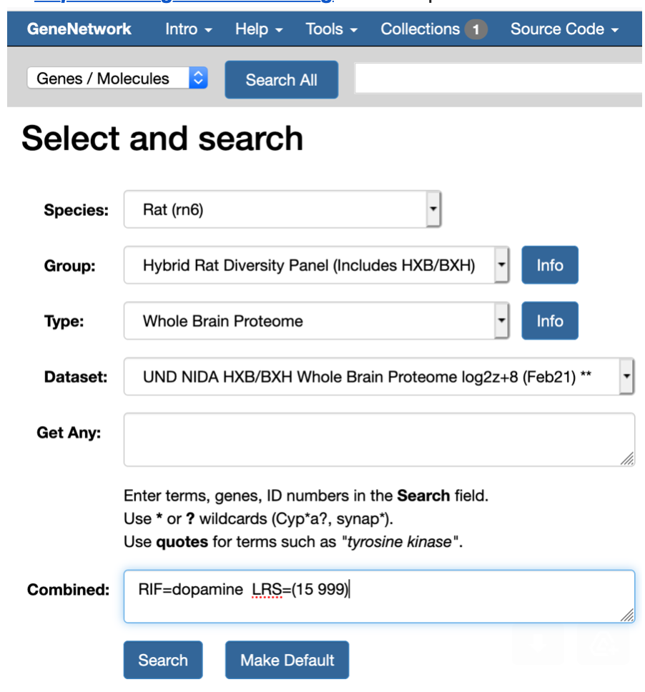

Note that in the **Combined** field above, I have entered the string

**RIF=dopamine   LRS=(15 999)**

This string will retrieve all proteins in the Hybrid Rat Diversity Panel (the HXB/BXD family in this specific case) that are expressed reasonably well (just over 8,000 proteins and over 200,000 peptide fragments) in the whole brain.

The second part of the search string (LRS...) finds all proteins that have strong linkage—a likelihood ratio statistic score of at least 15. This is equivalent to a LOD score of 3.3, and this is a value that is often close to the genome-wide significance level. The other value, 999, is just a high upper limit.

The second way to find these proteins is a bit easier—just paste this URL into your browser:

[***https://genenetwork.org/search?species=rat&group=HXBBXH&type=Whole+Brain+Proteome&dataset=UND_NIDA_HXB-BXH_WBPr_log2z8_0221&search_terms_or=&search_terms_and=RIF%3Ddopamine+LRS%3D%2815+999%29&FormID=searchResult***](https://genenetwork.org/search?species=rat&group=HXBBXH&type=Whole+Brain+Proteome&dataset=UND_NIDA_HXB-BXH_WBPr_log2z8_0221&search_terms_or=&search_terms_and=RIF%3Ddopamine+LRS%3D%2815+999%29&FormID=searchResult)

(This link can be shared, and will work *in perpetuity throughout the known universe;*a phrase I steal from the Walt Disney Company legal department with trepidation.)

**Step 2**. At this point, if you are following along, you should have a list of 115 proteins that are abundantly expressed in brain AND are linked to *dopamine* AND that have reasonable genetic linkage in the HXB family to a particular genome coordinate (usually a SNP). The **Search Results** table should look like the screenshot below.

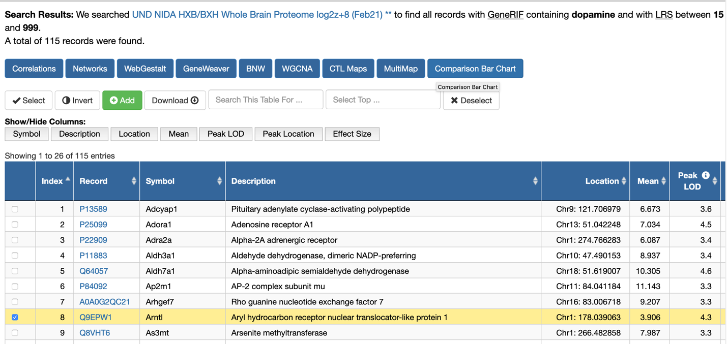

I have highlighted the row 8—the ARNTL protein—a major transcription factor involved in circadian rhythms that is upregulated by DRD2 signaling (PMID: 16606840 in PNAS, 2006)

**Step 3.** To begin to answer the second question—is there a major modulator of multiple dopamine-associated proteins—we need to re-sort this table using the column labeled **Peak Location**. In this screenshot below I have scrolled over to the right to display the **Peak Location** column after having performing the sort. All of these proteins map to Chr 1 at about 43.7 megabases (Mb).

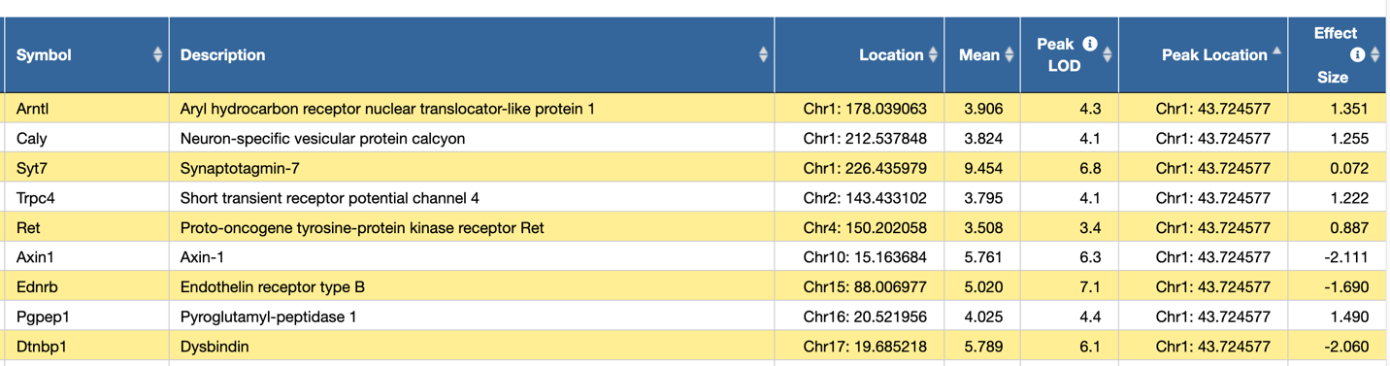

We see ARNTL again and eight other proteins that are genetically downstream of one or many DNA variants located on the proximal part of chromosome 1 (Chr 1). The **Peak LOD** scores range between 4.1 and 7.1.

If you scroll down this list (and you should), you will find another region of the rat genome that is highly linked with dopamine-associated proteins—Chr 19 at about 60 Mb. But before we head to Chr 19, let's continue to work with this proximal part of Chr 1 and try to figure out why the variation in expression of this band of nine proteins maps to this part of the rat genome. Step 3 below is a long step—my apology. Perhaps time for a coffee break.

**Step 3** involves mapping one or more of these nine proteins. I will pick SYT7 since it has the highest expression (9 log2 units of expression) and the second highest LOD score (6.8).

You can either click on the UNIPROT identifier—**Q62747**in the window, or you can just paste this URL command into a browser:

[***https://genenetwork.org/show_trait?trait_id=Q62747&dataset=UND_NIDA_HXB-BXH_WBPr_log2z8_0221***](https://genenetwork.org/show_trait?trait_id=Q62747&dataset=UND_NIDA_HXB-BXH_WBPr_log2z8_0221)

If all goes well, your browser will display this content (and much more too):

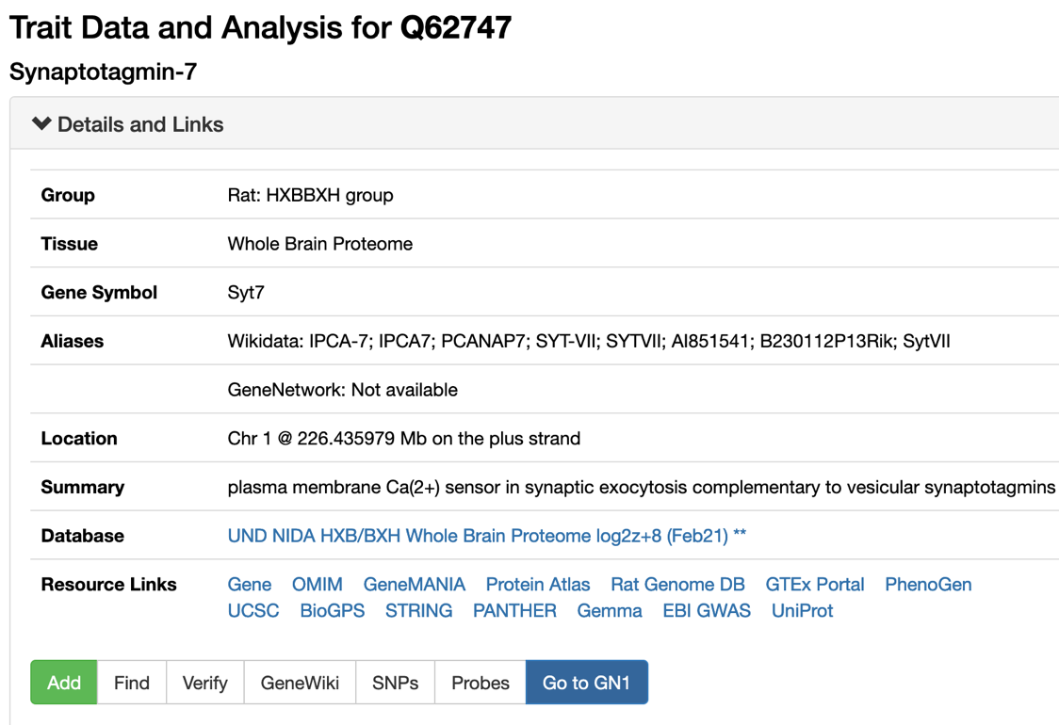

Before we map SYT7 protein expression, you may be curious to know how this protein has been linked to dopamine.

The answer is one click away. Tap on the **GeneWiki** button, highlighted below in grey.

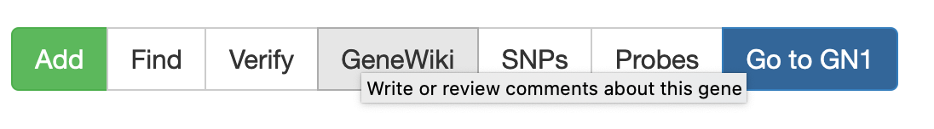

A **GeneWiki** window will open, and RIF number 18 explains the association with *dopamine* and also links to a 2011 paper (PMID 21576241) on somatodendritic dopamine release and the involvement of synaptotagmin 7 (SYT7).  
  
Again we pause briefly for "data due diligence". In the **Statistics** **histogram** window you will note that the distribution of SYT7 protein levels in 21 strains has a hint of bimodality—that is a good thing.

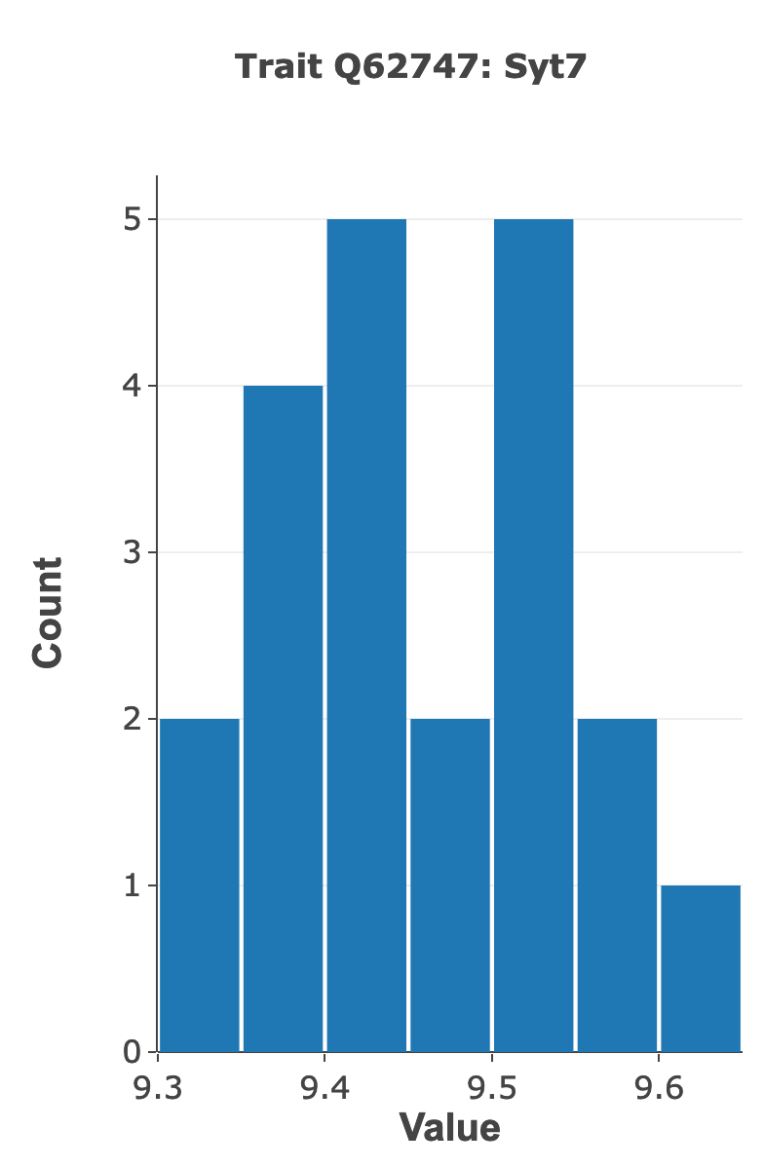

There are no outliers, so we can map these logged protein expression data "as given" without further normalization.

We can now finally proceed to the actual mapping of variation in protein expression—using for the first time "infinite marker maps" for all chromosome of all members of the HXB/BXH family, and using the updated GEMMA linear mixed model mapping function in GeneNetwork.

Open the **Mapping Tools** window

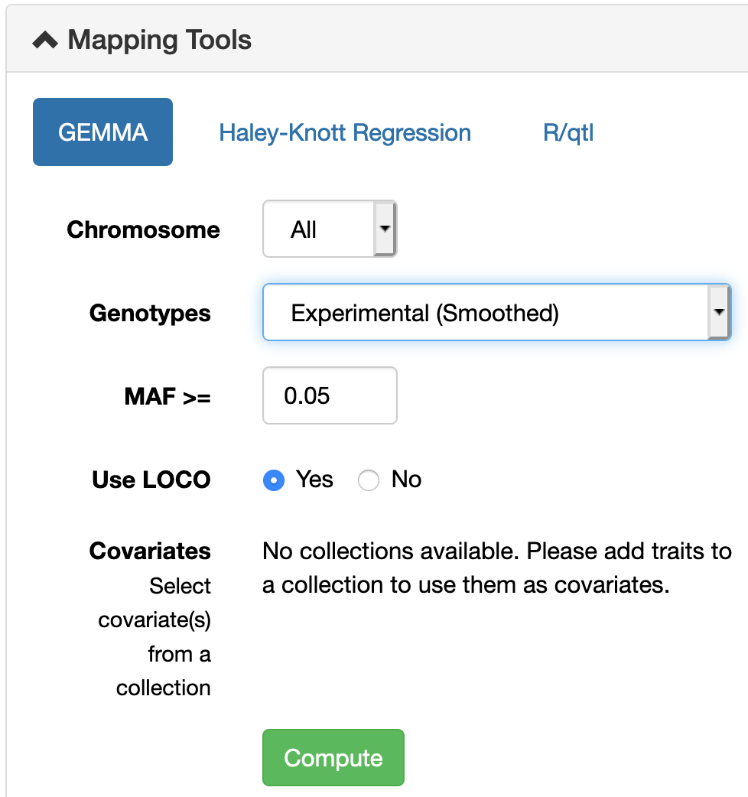

In the screenshot above I have mapped variation in SYT7 protein level using the new **Genotypes file: Experimental (smoothed)**

These are genotypes based on whole genome sequencing of the HXB/BXH family using linked-read 10X Chromium DNA libraries at a mean sequence coverage of just over 45X. Libraries were prepared at HudsonAlpha and sequenced on an Illumina Novaseq across the street from NIH at *The American Genome Center* (TAGC, thanks Michal, Melinda, Hao, Clifton, Jonathan, David, Hakan, Tristan, Victor, Jun, many others....).

The Manhattan plot of variation in SYT7 protein expression should look like this:

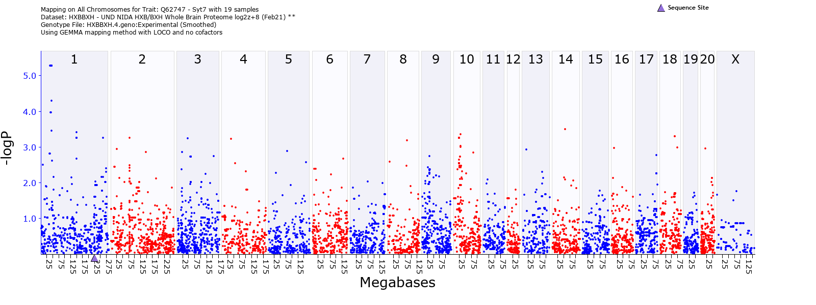

Beneath the Manhattan plot there is a **Mapping Statistics** table that provides estimates a SNP coordinates (Rnor6 assembly) calculated by GEMMA with –logP values and additive effects (log2 scale).

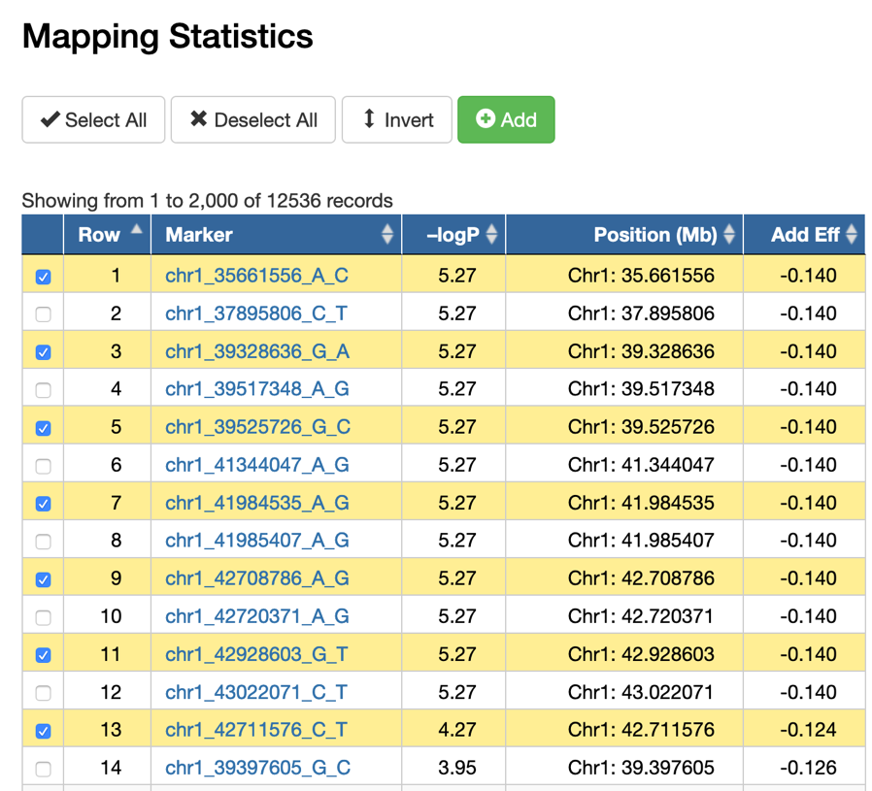

A –logP value of 5.27 is good—normally at or above genome-wide threshold of significance. (This assertion does need more support, and we are testing thresholds using using other mapping methods, including R/qtl's and WebQTL's standard interval mapping methods, and using permutation tests.)

**Step 4.** What is the approximate confidence interval of the SYT7 protein expression quantitative trait locus (QTL) on Chr 1? To answer this question we need to sort the **Mapping Statistics** by the **Position** column. Once sorted, we have to decide how wide a confidence interval is appropriate given the density of DNA variants, gene density, and –logP values. Karl Broman and others recommend a drop in the –logP linkage statistic of about 1.5 on either side of the peak, or plateau in this case. For the QTL map of SYT7 the confidence interval encompasses an stretch of DNA from about 35 megabases (Mb) to 43 Mb.

Normally, in an interval this large, we would just hit the pause button and spend more time increasing the sample size (in progress already by Xusheng Wang and colleagues). But for the sake of this GeneNetwork workflow, I am going to forge ahead and get to the box of chocolates—that essential dopamine kiss in nucleus accumbens.   
  
**Step 5**. What genes are located along this part of Chr 1?

To answer this question, click on the chromosome number, **1** in this case.

This will generate a chromosome-specific view; part shown below.

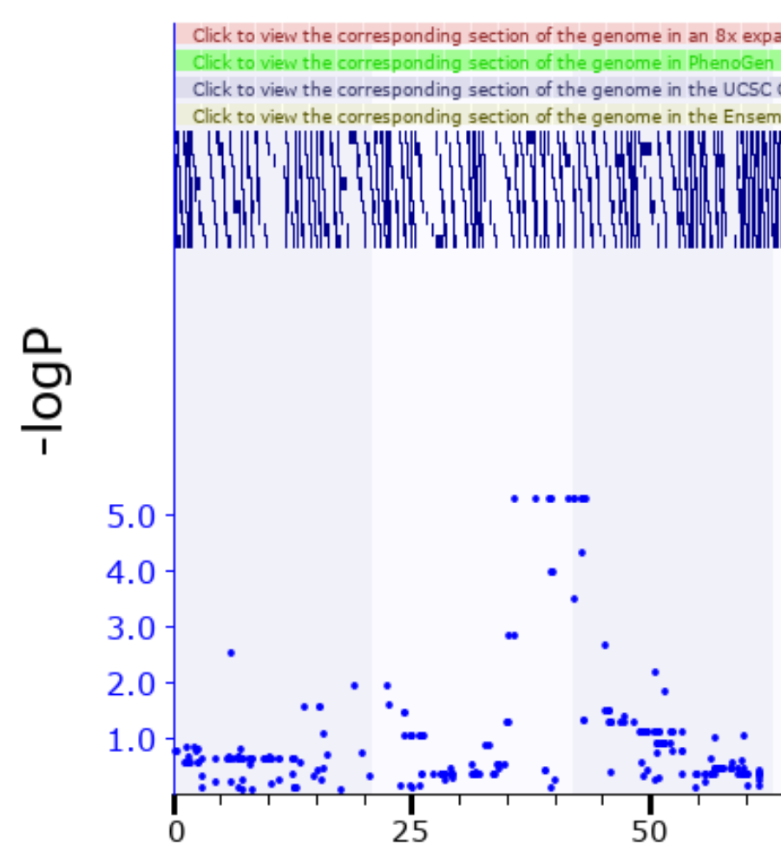

The QTL peak is a "non-recombinant" plateau that extends from 35 to 45 Mb—confirming visually what we had already determined from the –logP values. The blue blocks along the top are gene "models" and the lighter blue dots are the linkage values at different SNPs. You can zoom to a map with specific start- and end-coordinates.

You can keep zooming in on a specific region of a chromosome by clicking on the pink horizontal bar alonge the top. Here is the plateau region of the SYT7 protein expression QTL, or pQTL.

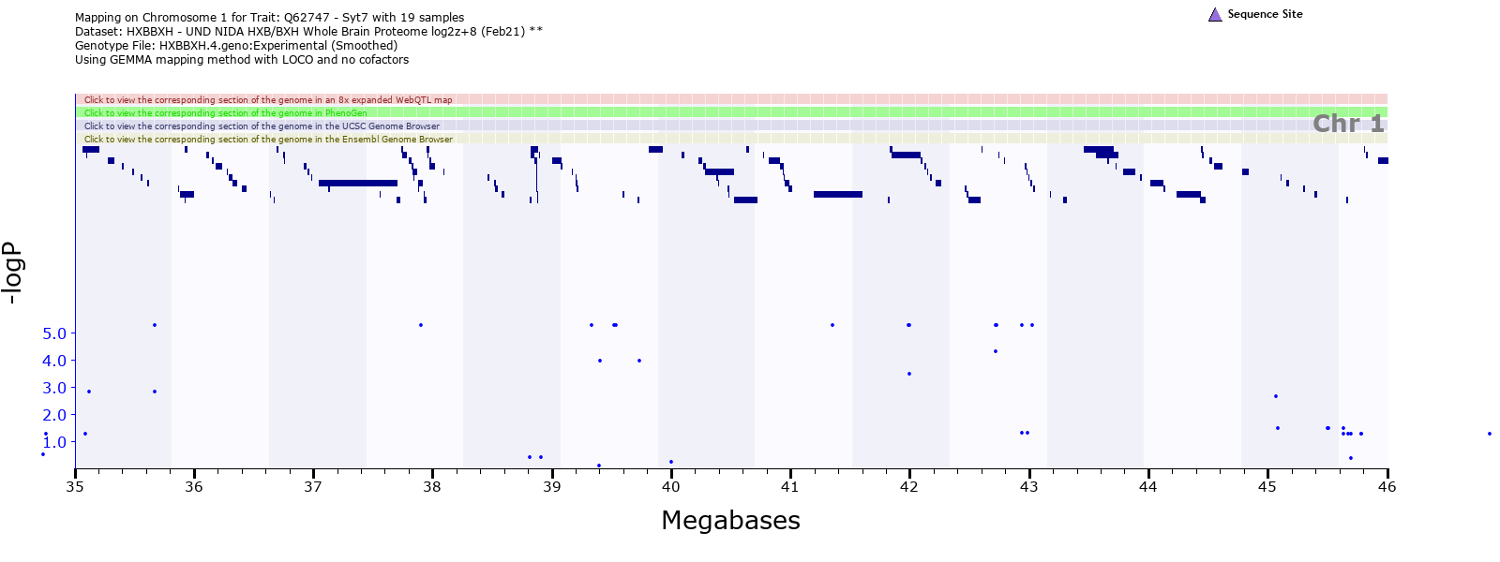

As you can tell from the screenshot, there are lots of genes—real and putative—that call this part of Chr 1 home.

Underneath each map there is an **Interval Analyst** table of all genes and pseudogenes in a specific interval. In this case, there are about 130 gene, of which 36 are protein-coding.

Let me list them out: from 35.2 to 44.6 Mb.

ADAMTS16

ICE1

MED10

UBE2QL1

NSUN2

SRD5A1

PAPD7

ADCY2

FASTKD3

MTRR

ZFP874B

ZFP748

PPP1R14C

IYD

PLEKHG1

MTHFD1L

AKAP12

ZBTB2

RMND1

ARNTL1

ESR1

SYNE1

MYCT1

VIP

CCDC170

FBXO5

MTRF1L

RGS17

OPRM1

IPCEF1

CNKSR3

SCAF8

TIAM2

TFB1M

CLDN20

NOX3

Anything catch your eye? Actually, lots of these genes may catch your eye—perhaps too many.

The gene/protein that most of you will highlight is ***OPRM1***—the mu opioid receptor.

Variants in this gene and locus are definitely controllers of morphine response—particularly so in the BXD mouse family (Paige Lemen, Hao Chen, Guy Mittleman, and Price Dickson have a paper in progress on this topic). And this is also true in *Homo sapiens* based on initial GWAS analysis.  
  
**Step 6**. How do we evaluate the strength of these candidates as controller of some subset of the nine proteins with variable expression that map to this region?

Simple—clip out all of those positional candidate genes and paste them into the search **Get Any** window of GeneNetwork. It should look like this:

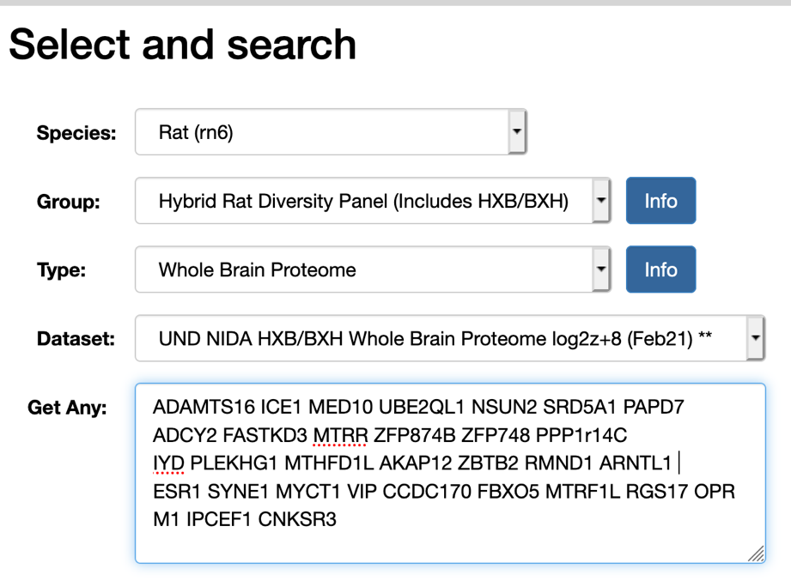

About 12 of these proteins have reasonably high expression in the rat brain, and three of these also are associated with reasonably strong cis-acting modulation—FASTKD3, PPP1R14C, and MTRR. That means that DNA variant in or around these genes modulate both mRNA expression but much more importantly, also the protein level.

You can review these three candidates at your leisure.

PPP1R14C (aka KEPI)—see PMID: 11812771

MTRR: not much related to CNS function—mainly cancer and development

FASKD3: not much CNS but key in mitochondrial function

Ok, time to go out and swim.

Any one that made it this far—bravo—you have persistence.

Any questions about the proteomics to Xusheng Wang.

Any questions about the genotypes and HXB sequence to Hao Chen.

Any questions about mapping to Pjotr Prins and me.

Any questions about GeneNetwork user interface to me.

[Can I isolate your gene? Can I kiss your dopamine?](https://genius.com/Red-hot-chili-peppers-this-is-the-place-lyrics#note-1422525)....

A perfect piece of DNA caught in a flashing ray

A master piece of DNA caught in a flashing ray

Thanks RHCP for thinking of us NIDA- and NIAAA-funded genetics researchers.

ps. You may want to know about OPRM1 as a great position and biological candidate gene—is it causal? Unfortunately expression is not consistently high in this proteomics analysis and we will have to look at bit harder to find peptide fragments for this protein. Coming soon to a webservice near you. But Hao Chen does know that there are high impact variants in OPRM1 in the HRDP, so one could test the hypothesis that the variant is causal by a CRISPR-Cas9 allele swap.