A few music related utilities I've written.

Greg Girardin
Auburn, ME
January 2020

chords.py - A python fretboard display utility. Uses tkinter. Click the instrument, key and chord/scale you want to display.
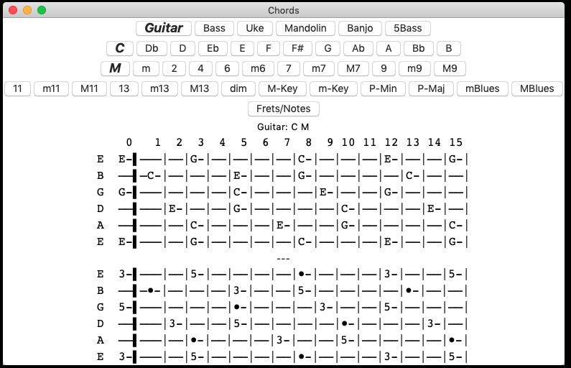
tab.py - A tablature creator for quickly getting down ideas. Runs in a terminal. Tab can be export as txt or html.

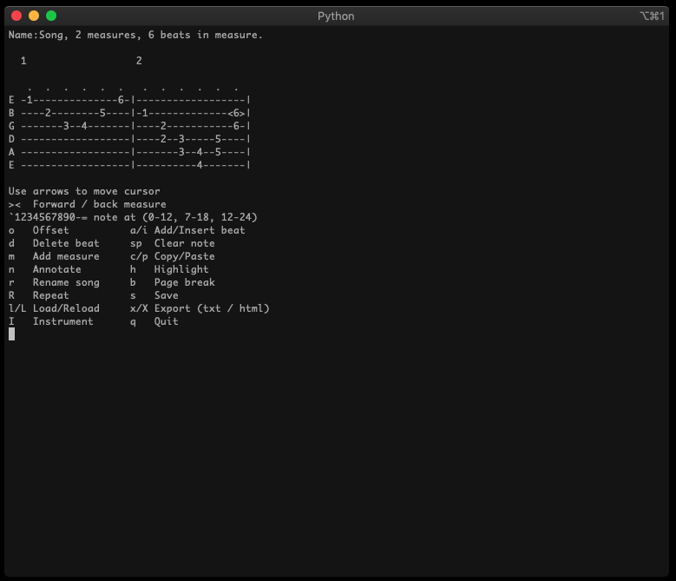
setlist.py - Allows you to generate an html setlist file from lyrics.

Put your lyrics as txt files in a directory.

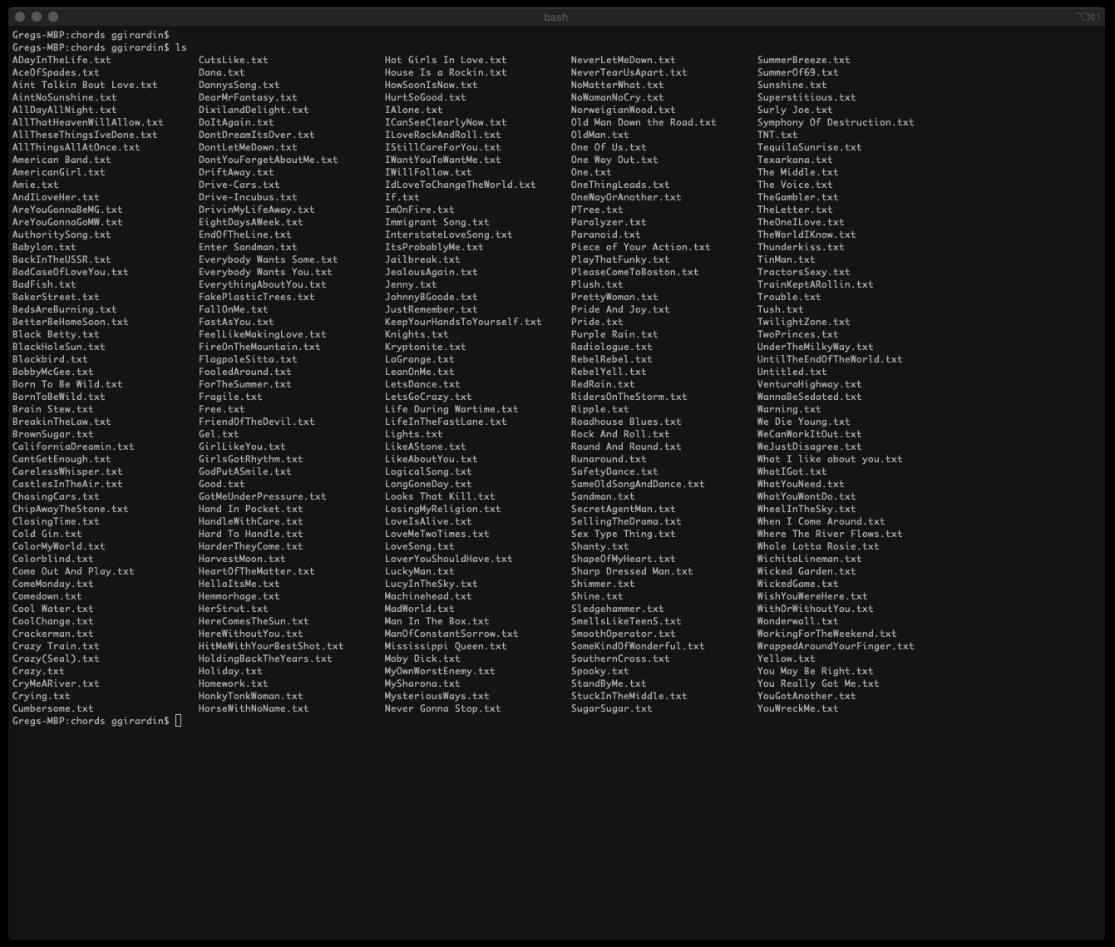

In a terminal window run setlist.py from your lyrics directory. It will scan the local directory for lyrics (.txt files) and these will show up in the Library.
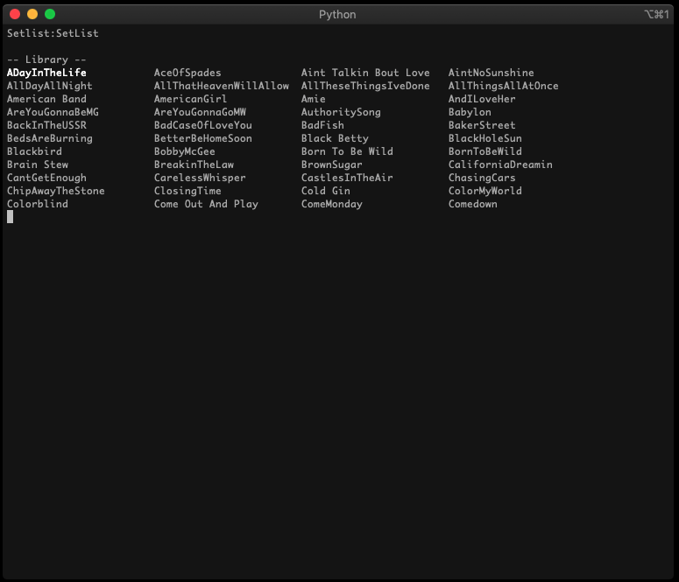
Press '?' to see the available commands.
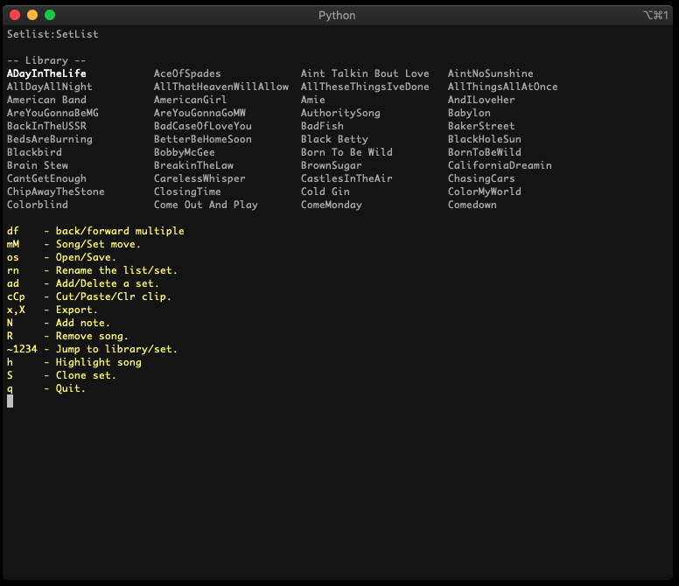
Name your setlist by pressing 'r'.

Add sets with "a". Navigate to the Library with the up/down/left/right/d/f

You can jump to a specific set by pressing '12345..'. You can jump to the library by pressing '`'

Name your sets by pressing 'n' while the cursor is in the particular set.
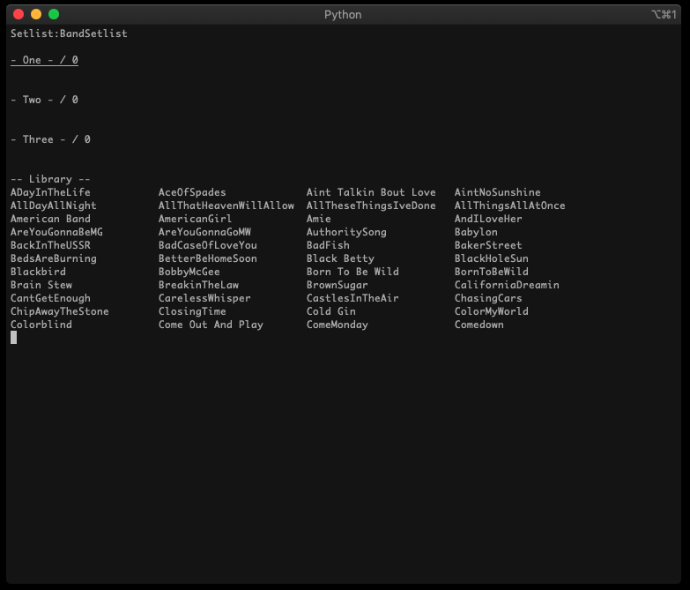

Navigate to the library. Add songs to the clipboard by pressing 'c' with the cursor over the desired song.

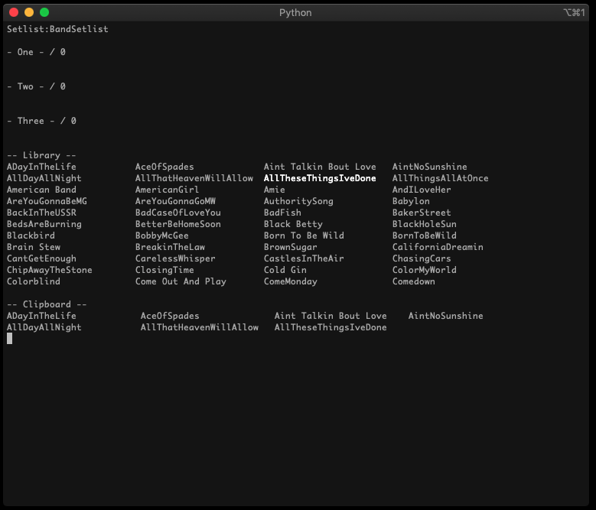

Paste the clipboard into the desired set by navigating to the desired set and pressing 'p'

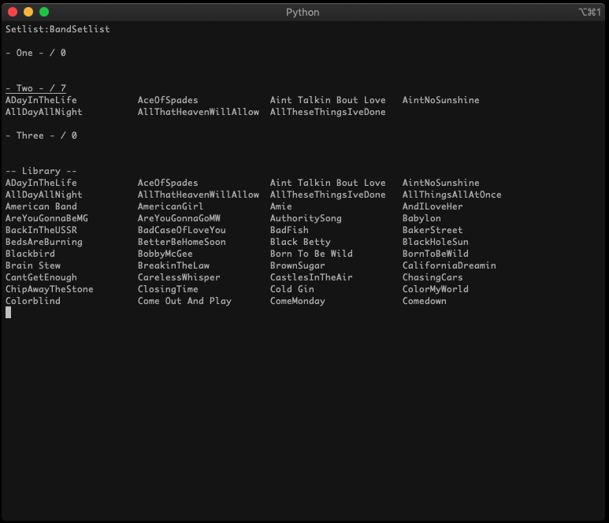

Songs can be rearraged in the set by moving the cursor over the song and pressing 'm'. Move the song to the desired location and press 'm' again to return to cursor to normal mode.

Once the setlist is complete, press 's' to save. A file called “setlist.set” will be generated. Press 'x' or 'X' to Export the list as an html file. "Setlist.html" will be in the current directory. This is your setlist. Click / tap the song title (the title is the first line of each lyric file) to show/hide the lyrics.
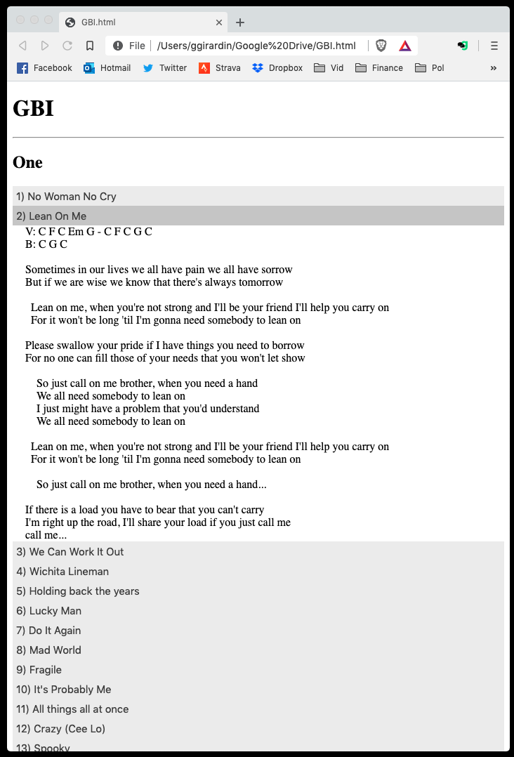
Lyrics files are text files with a .txt extension. The first line in the file should be the name of the song and will be used as the title of the song in the generated setlist.

There a few shortcuts that can be put in lyric files that setlist.py will recognize:
"c!" will be replaced with "Chorus"
"s!" will be replaced with "Solo"
"t!" will toggle usage of a fixed font (indended for tablature)

You can also put in html as that will be pasted into the output and the browser will simply interpret it.

If a song is in the setlist more than once it will be highlighted in blue.

If you wish to highlight specific songs. Press 'h' with the cursor over the song. These songs will show up as red in the exported setlist. This is useful for indicated which songs are homework, or what have you.

