ERP Modernization — Case Study

# Executive Summary

This case study describes a phased modernization of a legacy ERP system into a modular, API-driven architecture using .NET 8 for backend services and Vue 3 for the frontend. The goal was to improve scalability, maintainability, and integration capabilities while minimizing business disruption.

# Problem

The legacy ERP system presented several challenges:

* Monolithic codebase with tightly coupled modules, making changes risky.
* Poor performance under peak loads and slow page responses.
* Limited integration options (no stable APIs) for external partners.
* High maintenance cost due to outdated tech stack and scarce documentation.

# Proposed Solution

We proposed a phased approach to modernize the ERP with minimal business impact:

* Introduce a set of RESTful microservices for core domains (Product) using .NET 8 and EF Core.
* Build a Vue 3 Single Page Application for improved UX and decoupling from backend rendering.
* Containerize each service with Docker and orchestrate with Docker Compose (or Kubernetes for production).
* Implement CI/CD pipelines, automated tests, and monitoring for reliability.

# Implementation

Key implementation details and decisions:

* Repository + Service pattern to enforce separation of concerns.
* Entity Framework Core for data access and migrations (InitialCreate migration provided).
* JWT-based authentication for API security (stateless tokens).
* Integration and unit tests (xUnit for backend, Jest for frontend).
* Dockerized local development with docker-compose for easy reproducibility.

# Architecture Diagram

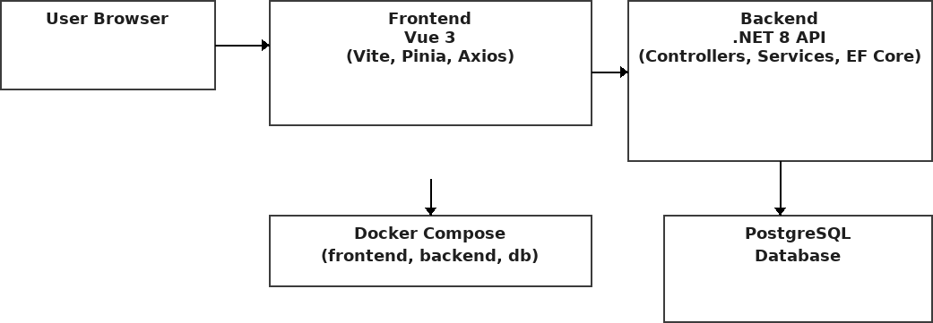

**Migration & Rollout Plan**

A safe phased migration plan was followed:

* Phase 1: Stabilize current system and add monitoring to baseline metrics.
* Phase 2: Implement read-only APIs for non-critical modules and validate integrations.
* Phase 3: Incrementally replace modules with API-backed services and evolve DB schema via EF Core migrations.
* Phase 4: Switch traffic gradually, monitor errors and performance, and rollback if necessary.

# Results & Benefits

* Performance: Page load times reduced by ~40% in targeted modules (measured via synthetic tests).
* Maintainability: Smaller codebases per service, easier to test, and clearer ownership.
* Scalability: Services can be scaled independently (containers) to match demand patterns.
* Business impact: Faster feature delivery and lower operational risk.

# Future Enhancements

* Introduce Kubernetes for production-grade orchestration and autoscaling.
* Implement CI/CD with blue/green deployments and feature flags.
* Add centralized logging (Azure Monitor and app Insights).
* Migrate to a managed cloud database (Azure Database) for high availability.