**Team Yellow: Load.In**

**Weekly Development Report # 11**

**Performance Period:** 3/29/2021 – 4/4/2021

1. **Group Accomplishments:** 
   1. **Meetings**
      1. Monday: Cancelled meeting with Lowell because of lack of significant demo progress on project
2. **Individual Contributions/Accomplishments:** 
   1. **Byron**
      1. Lab 3 discussion board post
      2. Modified sort algorithm of loading and unloading of truck so that boxes are correctly sorted for coming on or off the truck (bug fix)
      3. Worked with Jason to tie in his work with mine
      4. Planning for advanced load algorithm: met with Jason and we created stubs for work
   2. **Jason**
      1. Lab 2 Fixes
      2. Lab 3
      3. Load Plan Algorithm Improvements/Bug Fixing
      4. Planning for advanced load plan algorithm with Byron
      5. Took the exit exam
   3. **Greg**
      1. Worked on test cases.
      2. Worked on lab 2 corrections
      3. Worked on user feedback backend.
      4. **Exit Exam**
   4. **Chris**
      1. Studied for exit exam
      2. Researched potential Augmented Reality implementation into app
      3. Worked on updating requirements
      4. Worked on test cases
   5. **Lance**
      1. Worked on creating test cases.
      2. Worked on lab 2 corrections.
   6. **Paul**
      1. Worked on creating test cases for lab 3
      2. Worked on Lab 2 corrections
      3. Began design of move logistics UI
      4. Ordered 3 pounds of espresso to survive this last month of the semester
3. **Issues/Concerns/Memes:**

Memes:  
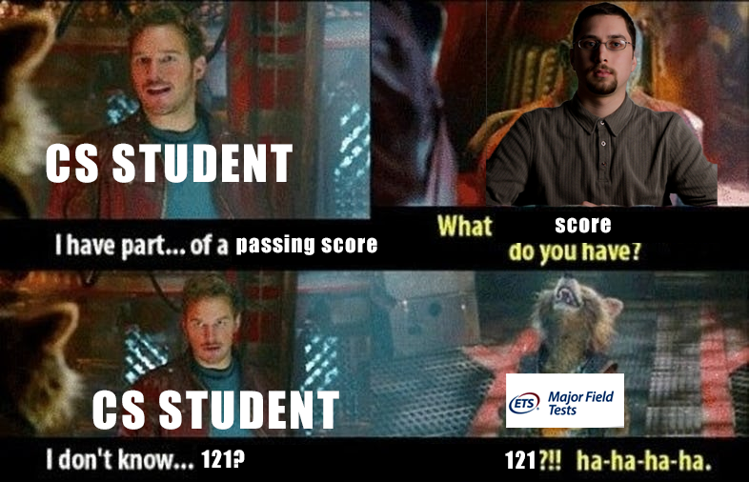

Concern: