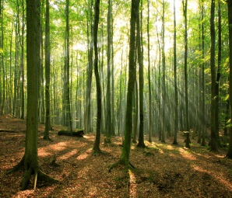 [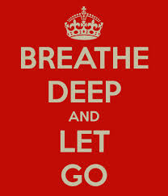](http://www.google.com/imgres?imgurl=http://sd.keepcalm-o-matic.co.uk/i/breathe-deep-and-let-go-2.png&imgrefurl=http://www.keepcalm-o-matic.co.uk/p/breathe-deep-and-let-go-2/&h=700&w=600&tbnid=LsHib8ExZKZoOM:&zoom=1&docid=xUWRbqqm8-UMaM&ei=qe1sVM7KNo6yyATy4oCgDQ&tbm=isch&ved=0CE0QMygZMBk&iact=rc&uact=3&dur=421&page=3&start=24&ndsp=17) 

[](http://www.google.com/url?sa=i&rct=j&q=&esrc=s&source=images&cd=&cad=rja&uact=8&ved=0CAcQjRw&url=http%3A%2F%2Frock.genius.com%2F1901746%2FPassion-pit-take-a-walk%2FI-took-a-walk&ei=s-5sVMjaL8OoyATEtYDQBQ&bvm=bv.80120444,d.aWw&psig=AFQjCNHLP4JLMGH7Kk4paBEd_eaT0BMP-A&ust=1416511406106066) [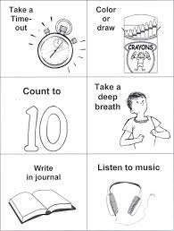](https://www.google.com/imgres?imgurl&imgrefurl=http://childhoodinterventions.blogspot.com/2012/08/coping-skills-flashcards.html&h=0&w=0&tbnid=BveuUW4V6I4vPM&zoom=1&tbnh=258&tbnw=195&docid=f2t3hUjRaTooBM&tbm=isch&ei=ovBsVNn0Ao-wogTwx4G4Bw&ved=0CA0QsCUoAw) 

[](http://www.google.com/imgres?imgurl=http://www.healthyplace.com/blogs/buildingselfesteem/files/2012/11/coping-skills.jpg&imgrefurl=http://www.healthyplace.com/blogs/buildingselfesteem/2012/11/the-power-of-coping-ahead/&h=280&w=554&tbnid=GkoVyT2ZkBijAM:&zoom=1&docid=bt39FL8xPY0QdM&ei=A_BsVOupFIeuyASzyYGwBA&tbm=isch&ved=0CAkQMygBMAE4ZA&iact=rc&uact=3&dur=1989&page=7&start=93&ndsp=16)

[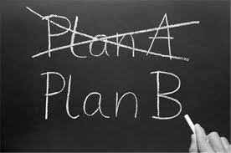](http://www.google.com/imgres?imgurl=http%3A%2F%2F1.bp.blogspot.com%2F-btpfApAvZCw%2FToxin_WeiyI%2FAAAAAAAAAS4%2FeROCWfTZXKY%2Fs1600%2Fcoping%252Badapting.jpg&imgrefurl=http%3A%2F%2Fwww.slideshare.net%2FKylePEdmondsMD%2Fcommunication-2-28499120&h=425&w=640&tbnid=Cz8mgmgBwjqGhM%3A&zoom=1&docid=9yHyMrpcQ939kM&ei=pu9sVKPsCMi3yATz-YKQAw&tbm=isch&ved=0CHEQMyg4MDg&iact=rc&uact=3&dur=826&page=4&start=44&ndsp=17) [](http://www.google.com/imgres?imgurl=https://beyondtheborderlinepersonality.files.wordpress.com/2011/09/coping_mechanism.jpg&imgrefurl=https://beyondtheborderlinepersonality.wordpress.com/category/coping/&h=400&w=287&tbnid=S3GQKG4x64Vf7M:&zoom=1&docid=r6tSsrPYhADLwM&ei=A_BsVOupFIeuyASzyYGwBA&tbm=isch&ved=0CBMQMygLMAs4ZA&iact=rc&uact=3&dur=364&page=8&start=109&ndsp=16)