Team Pluvali
Alexander Davis
Steven Kosovich
Timothy Leikam
Gregory Martini

Debra Parcheta
Katie Taliercio

Coping Skills Game: Detailed Testing Instructions
Steps:

1) Turn on and log in to a computer.

2)While connected to the Internet, open up Remote Desktop Connection*¹.
In Windows, search Remote Desktop, and it should come up. A screenshot is shown below.
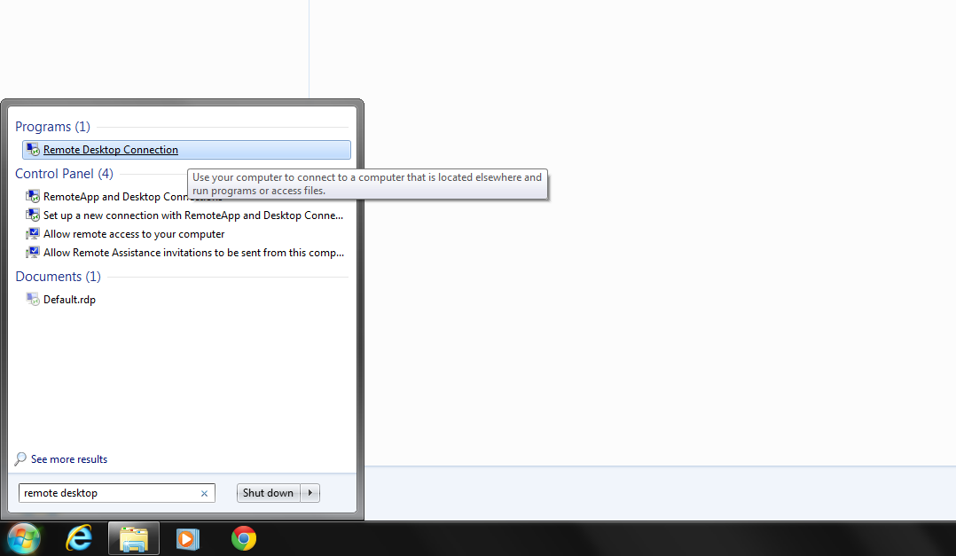

3) In Remote Desktop Connection, type in "64.197.9.116:6800" in the Computer field*².
Do not type in the quotation marks in the step above. Then click "Connect". A screenshot is shown below.
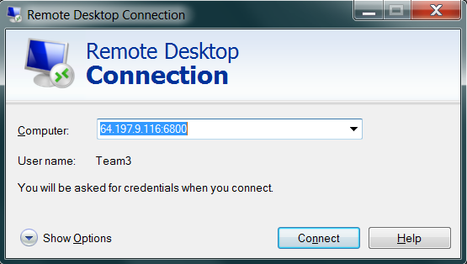

4) When prompted to enter your credentials, use "Team3" as your username and "Welcome2u" as your password.
Again, do not type in the quotation marks for these fields. This is an example of how to enter your credentials.
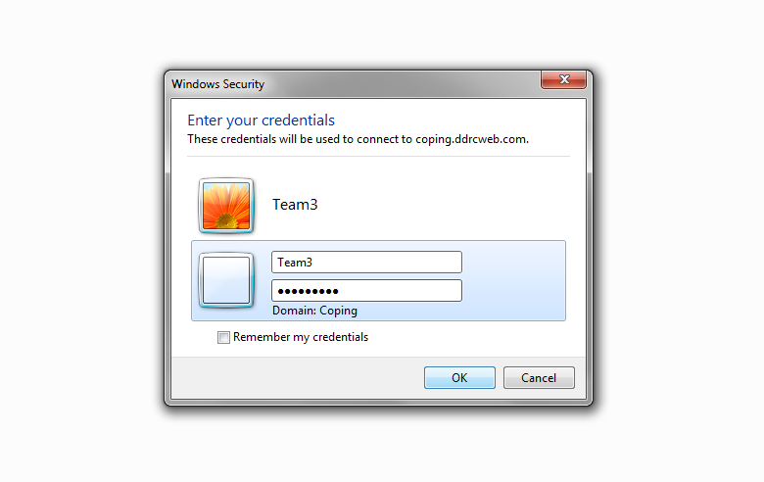
5) It will then probably give you a warning about verification, authentication, and certificates. Since we know it is safe and just a server at DDRC, just click "yes".
The warning is shown below.
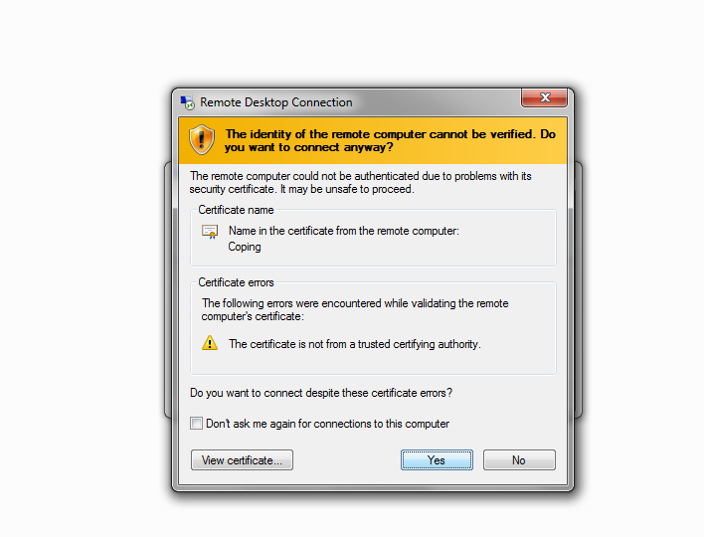

6) You should now be able to use the server, as if you were actually on the server. It is a Windows 7 Enterprise.
The screen should look something like the one below.
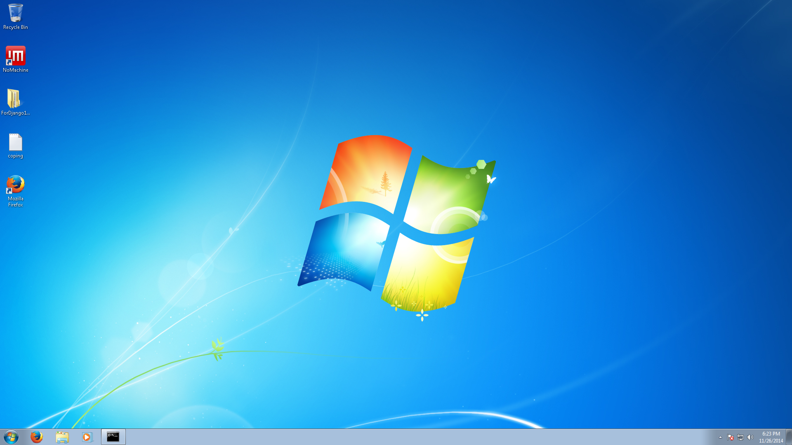

7) Now open up "Command Prompt" from the Start Menu, if it is not already running. A black box will be in the taskbar just to the right of Windows Media Player if it is running already (if it is not there, then continue with this step and on). If you are unsure if it is running already, skip to step 11. You might have to come back to this step if it is not running, but that's okay.
An easy way to get to Command Prompt is to click on the Windows button in the bottom-left corner, and type in "cmd" and hit Enter. Don't use the quotation marks. Shown below for reference.
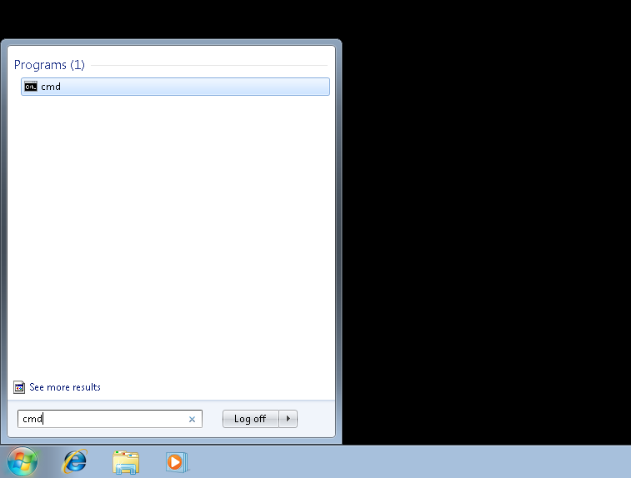

8) You are now looking at the command line. Type in "cd /." and hit the Enter key on your keyboard.
This is to get to the root (C:\) directory. Again, do not use the quotation marks. Remember to put a space between "cd" and "/.". The Command Prompt with the command is shown below.
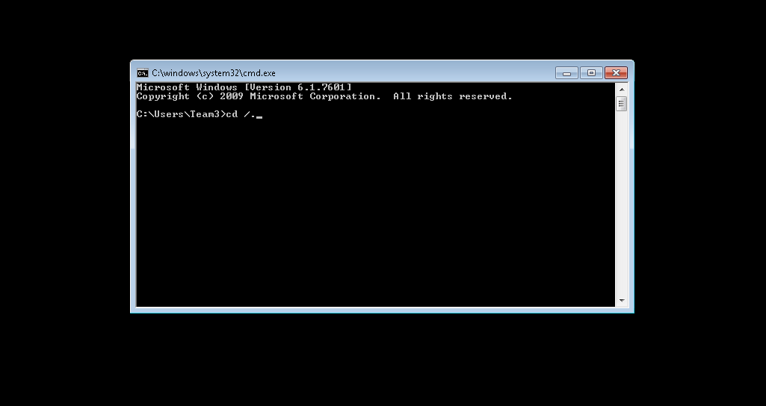

9) Now type "cd Django-1.7\pluvali" and then hit Enter.
This is to get to the game's folder. There is a space between "cd" and "Django-1.7\pluvali". There are no other spaces in this command, as seen below.
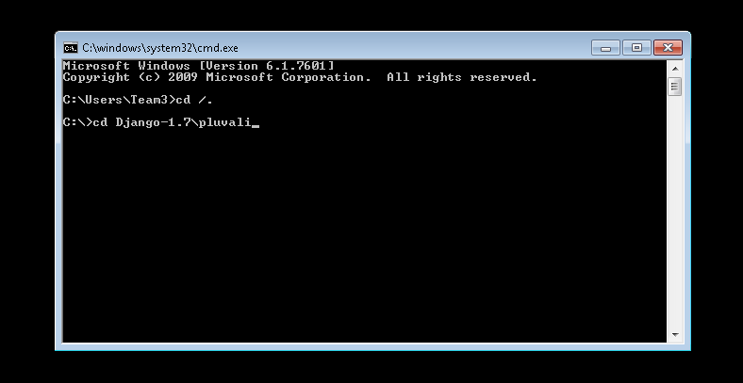

10) Now type "python manage.py runserver" and press Enter.
There are spaces between "python", "manage.py", and "runserver". A screenshot is shown below of what it should look like.
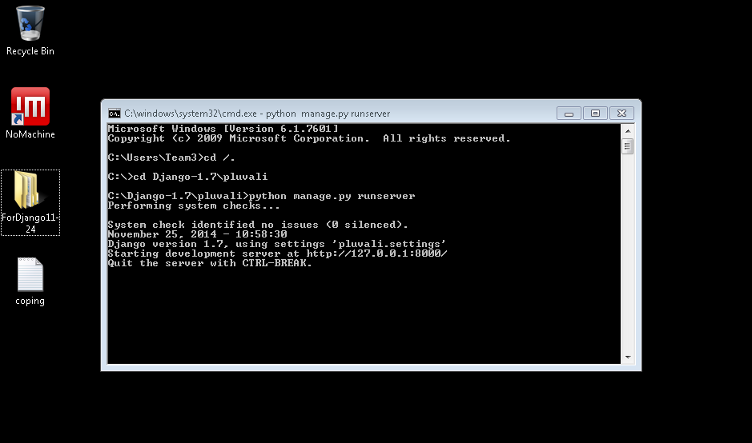

11) Do not close the Command Prompt window. With Command Prompt still open, open up the Firefox web browser.
Firefox is located just to the right of the Start Menu in the bottom-left corner of the screen. If Firefox isn't located there, simply double click on its icon on the desktop. What comes up will be somewhat similar to what is shown below.
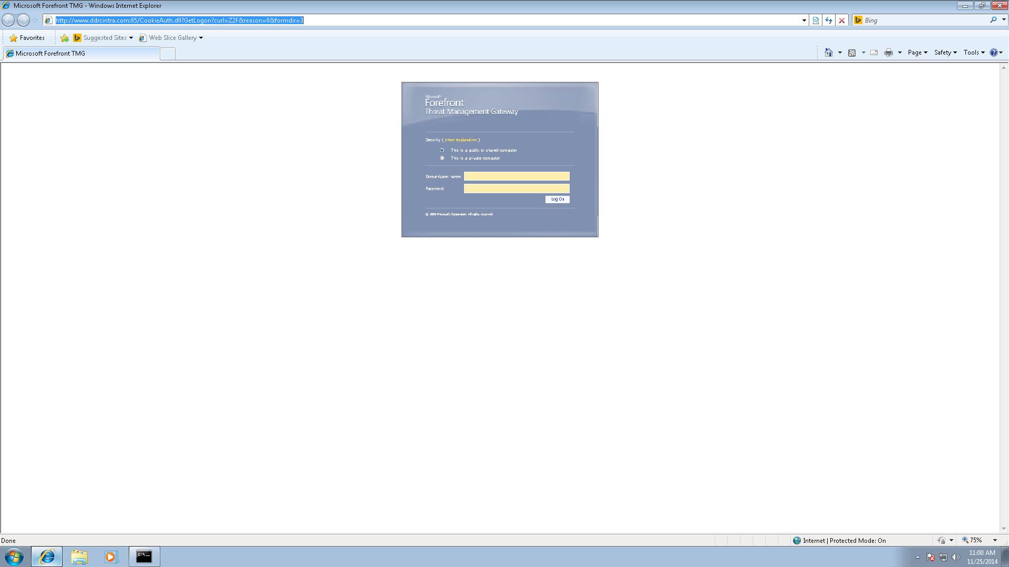

12) There should now be a page with either something about Microsoft Forefront Threat Management Gateway, or an error saying you can't connect to the internet. Just ignore it, and in the top address bar, type in "http://127.0.0.1:8000/CopingGame"
This should bring you into the Login screen of the game. Once again, do not type in the quotes for this field. Two screenshots are shown below. The first picture shows what and where to type it, and the second is what should come up once it is entered in.
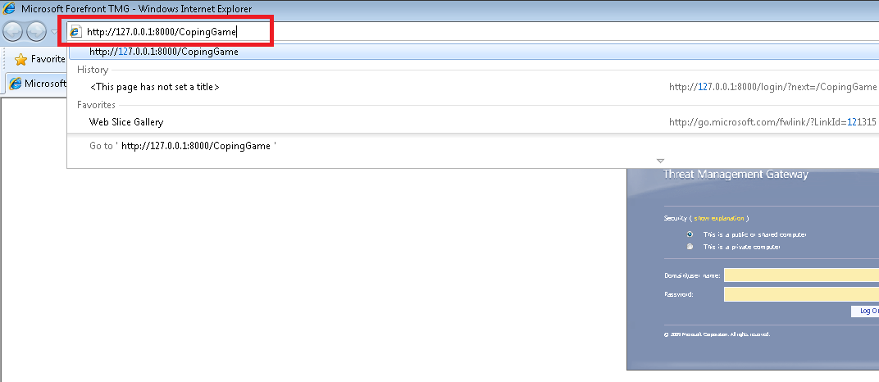

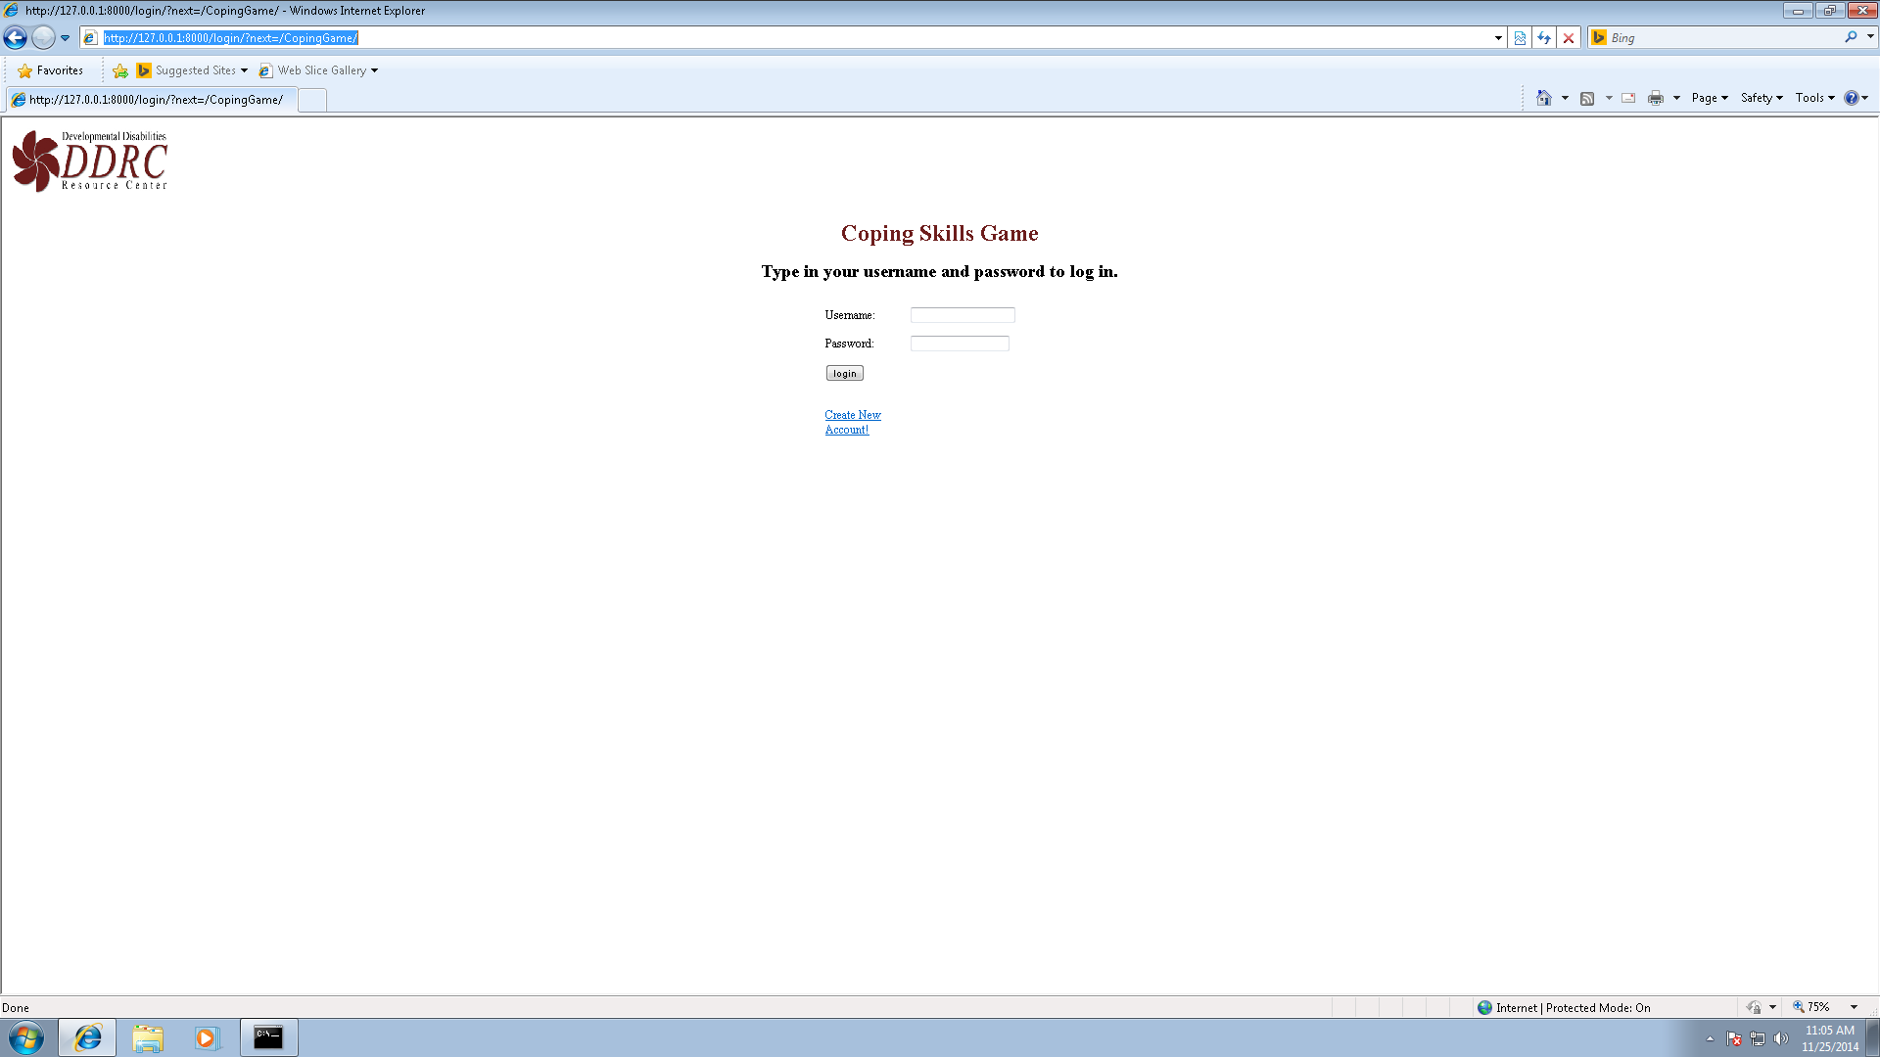

13) You are now ready to start testing the game! Click on "Create New Account!" to make your account, log in using your newly made credentials, then navigate and test the game! When finished, log off or close the remote desktop session.
If the Coping Skills Game page does not show up like the one show in the screenshot above, you probably need to go back to step 7 and follow the steps from there. This is to make the Python/Django server run, and to do so you need to run it from the command line like the instructions say. Then just got through steps 7 to 13, and it should work then.

*1 Note that these instructions are only tested for a Windows machine (tested on Windows 7, 8, and 8.1), and won't work on a Mac or Linux machine.

*2 If the server is turned off or offline, you will get an error message like the one shown below. If you get this error, there is no way to move past to the next steps in the instruction.

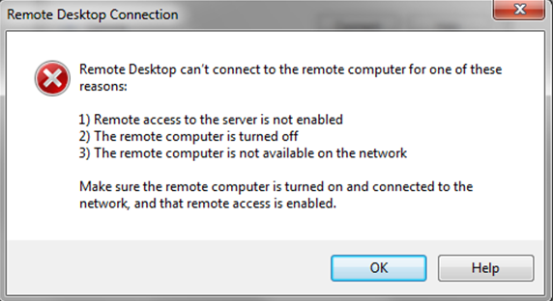

Be aware that this is a prototype for testing, and does not have all the functionality that it will have when it is completed. Note that there are only two scenarios, and they are both under Television Problems. Also, you do not need to get the amount of points to buy the Themes in the Store, as you would have to play the same scenarios over and over to get the required amount of points (User Pictures are not yet purchasable). There is also no Scenario Editor to make new scenarios yet.

