good start--note comments

J_REPORT_1

VLSI System Design Project

Team Members:
Sandeep Gone
Greg Mefford
Megan Schneider

April 6, 2009

SECTION 1: RESOURCES
a. List all personnel and skills of each.
Greg:
VHDL: Intermediate Skill
Verilog: No Experience
Altera: No Experience
Xilinx: Some Experience
Hardware Development: Basic experience based on VLSI Design courses
Software Development: Lots of professional and personal software development experience
Writing Skills: Some experience writing professional reports and proposals
Version Control: Extensive experience with SVN, some with CVS, and quickly learning to use git

Megan:
VHDL: Intermediate Skill
Verilog: Intermediate Skill
Altera: Experience from Embedded Systems class
Xilinx: No Experience
Hardware Development: Basic experience based on VLSI Design courses
Software Development: Basic programming experience
Writing Skills: Prior experience with project reports
Version Control: Learning to use git, but no prior experience

Sandeep:
VHDL: Intermediate Skill
Verilog: No Experience
Altera: No Experience
Xilinx: No Experience
Hardware Development: Basic experience based on VLSI Design courses
Software Development: Very good professional software development experience
Writing Skills: some experience writing project reports
Version Control: Learning to use git, but no prior experience

b. List the number of hours each team member has available to devote to the project over the quarter.
Greg: 8 hours per week
Megan: 8 hours per week
Sandeep: 8 hours per week

c. List all hardware and software resources that will be used for development.

Greg:
Primary: Apple Macbook Pro
2.5 GHz Core 2 Duo
4 GB 667 MHz DDR2 SDRAM
Operating System: Mac OS X 10.5.6

Secondary: Dell Dimension E521
2 GHz Athlon X2
4 GB 667 MHz DDR2 SDRAM
Operating System: Windows XP

Megan: HP Pavilion dv5 Notebook PC
AMD Turion(tm) X2 Dual-Core Mobile RM-70 2.00 GHz
3.00 GB RAM
Operating System: Windows Vista

Sandeep: Dell XPS M1330 Notebook PC
Intel(R) Core(TM) 2Duo CPU T5750 @2.00GHz
4GB RAM
Operating System: Windows Vista

Desktop PC in the lab 890 Rhodes:

Intel Pentium(c)
4 CPU 2.80 GHz
2.79 GHz, 504MB of RAM
Operating System: Windows XP version 2002 (SP 2)

Altera Board in the lab 890 Rhodes:

Cyclone*
EP1C6Q240C8

SECTION 2: PLANNING.
a. List who will be assigned to oversee each of the following:
Documentation - Megan
Testing - Sandeep
Version control and backups - Greg
Tracking and productivity - Greg

b. Describe how the team members will communicate and how they will coordinate their work.
Communication will be primarily through email in order to easily maintain a paper-trail of what was said.
Email Addresses:
Greg - gregory.mefford@gmail.com
Megan - mmswim22@gmail.com
Sandeep - gsandyreddy@gmail.com

Also, we will have some impromptu face-to-face time as needed before and after VLSI System Design class on Monday, Wednesday, and Friday 12-1.20pm.

In case other contact methods are impossible, our phone numbers are as follows:
Greg - 513-673-1912
Megan - 614-370-6368
Sandeep - 337-515-2357

c. Give the time and place of weekly team meetings.
Tentatively, we will plan on meeting Wednesdays after class in/outside the classroom until we can come up with a more permanent time and place.

d. Describe completely how you will handle version control and backups.
Version control: git
For version control of source code and assets associated with this project, the team will be using the git version control system (http://www.git-scm.com).
The primary reason for choosing this version control system is that is a distributed version control system by design.
What this means is that each team member will have a complete snapshot of the entire history of the project in their local repository, and that history will be automatically merged with the changes made by other team members as they are committed.
In order to make the collaboration process easier, we will be using github (http://www.github.com) as the official master repository through which we will sync each of our respective local repositories.

Backups: git + github + Dropbox
Because git was designed to be a distributed version control system, it inherently represents a backup system in itself, since each team member and also the github server, has a complete copy of the entire history of the project. So not only will we always have a copy of the most recent version of the project code, but we will also maintain every previously-committed state of the project code.
In addition to the protection inherently offered by the git version control system, Greg will be using Dropbox (Http://www.getdropbox.com) to sync code between his computers. Not only does Dropbox offer an additional server, on which the current state of the project assets will be stored, but it also allows for older versions of the files to be downloaded in the unlikely event that every other precaution fails and the whole git repository is lost on each computer and on github.

e. Describe your plan for testing. Altera does not support testbenches, only .vec files. add information about the csv tool in Synopsis, which does support testbenches How will you document your testing? This tool will allow you to generate testbench data which can be saved.
As Quartus II software includes simulation support, we can test that any new synthesis algorithms we develop in fact produce correct circuits by simulating the circuits with our algorithm on and off and checking that the output is the same.
The simulator allows the user to apply test vectors (.vec files) as inputs to the designed circuit and to observe the outputs generated in response.
However, using waveforms to simulate FPGA designs is not generally desirable. That is why we can write the code to run on Altera devices and use the Xilinx Modelsim simulator to test the design (this is also okay, or use the above Synopsis tool). We can later fit the same design to the Altera devices. I haven't tried this yet, but it’s a possibility that can be explored.
Note that physical information (timing, power usage, device usage) must be obtained from the altera simulator.
f. Provide both a Gantt chart and Tracking Document for your project.
Our Gantt chart will serve as both a planning and tracking document. It is an Excel file that we will update as often as necessary and provide in the weekly reports. Here is a screen shot of the Gantt chart.

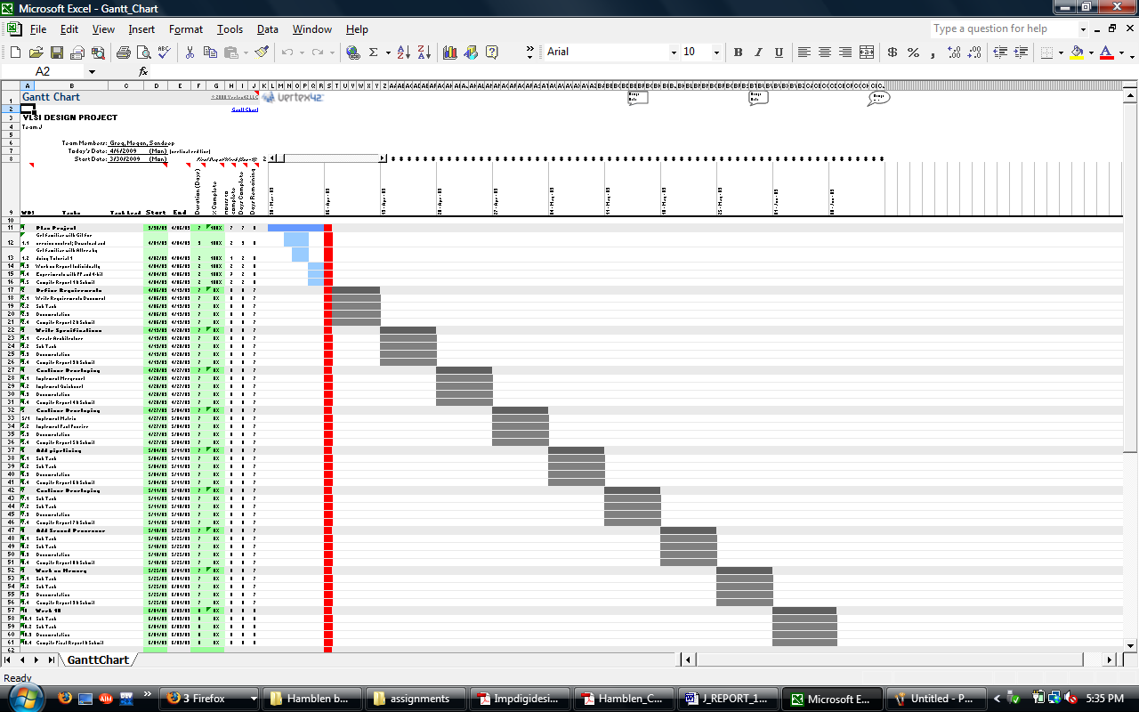

g. Describe the coding and documentation standards you will use.
We will be using the following Verilog coding standards: http://www.engr.sjsu.edu/cpham/VERILOG/VerilogCodingStyle.pdf

h. Describe how you will produce up-to-date documentation (content and form—online?) in parallel with the project. You will need to produce supporting documents, including a user manual, along with code documentation.
For the moment we will update our documentation manually (as a task in the Gantt chart), until we can find a way to do this automatically.

SECTION 3: HARDWARE BASICS
a. Describe the board you will be using:
this is the chip--what chip is it?
LEs: 5,980
M4K RAM Blocks (128 x 36 bits): 20
Total RAM Bits: 96,180
PLLs: 2
Maximum User I/O Pins: 185
Max Clock Speed: Approximately 200 MHz
board also has I/O capabilities….

b. Describe the capabilities of other chips which you can simulate using the design tools provided (in the event that the chip you have will not support dual-core processing)
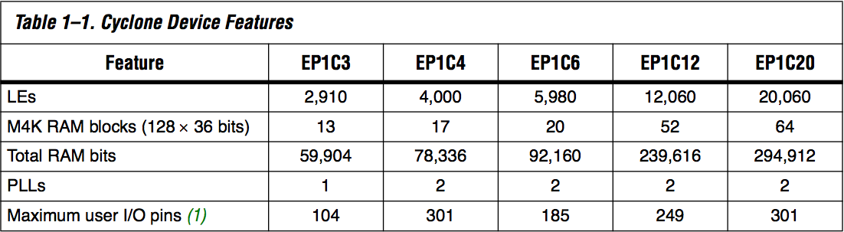

note that you should be able to simulate devices from other altera families--add in this information please.

c. Describe the information you can obtain from the design tools about gate usage, speed, power, layout, etc. which will be needed to analyze the performance of your processor.
Once compiled in Quartus II, we can obtain various measures of the performance of our processor including total propagation delay between any given points, as well as other resources used including PLLs, pins, logic elements, etc.
can you be more specific here (info from compilation and simulation, also Altera tools such as the timing analyzer and the chip planner and the power analyzer.

d. Explain the procedure you will use for testing a hardware module with the given tools and documenting your test results.
We need to create the desired waveforms, called test vectors, to represent the input signals. The simulator applies the test vectors to the model of the implemented circuit and determines the expected response. We use the Quartus II Waveform Editor to draw the test vectors. We choose 'Vector Waveform File' and include the input and output nodes of the circuit to be simulated. Then either by 'Functional simulation' or by 'Timing Simulation', the Quartus II simulator takes the inputs and generates the outputs defined in the '.vwf' file.
note above information about testbenches

e. Perform the following simple experiments and report the results:
1. What is the length of a critical path between two flip-flops? Does this depend on the placement of the flip-flops? Do "glitches" occur in the simulation? In the circuit? Are these significant?
The length of the critical path between flip flops will certainly depend on the placement of those flip-flops, due to the nature of wire-routing in an FPGA. Since the routing is programmable, and not intrinsic in the fabrication of the chip, there must be some combinational delay associated with each wiring segment within the chip, in addition to any combinational logic that is a part of the actual design.
Presumably, the simulator would be able to simulate any delays associated with routing, and it is possible that these delays could be so significant as to cause a glitch when using a very fast clock speed.
you need to do an experiment here--put some simple gates (an inverter chain e.g.) between two flip-flops--how many inverters can you have and still store the correct value in one clock cycle?

2. Design a D flip-flop starting from the gate level. Compare its behavior with the D flip-flop in the Altera VHDL library. Can you vary the clocking strategy—rising-edge, falling-edge, level triggered? Is one strategy preferable for this hardware?
The only clocking strategy that appears to be in the Altera library is the dff object, which is positive edge-triggered.
The performance of this device was similar to that of the straightforward implementation of a D flip-Flop (see http://en.wikipedia.org/wiki/File:Edge_triggered_D_flip-flop.png) with the following differences:
The simple gate-based implementation of the D Flip-Flop using 5 2-input NAND gates and a 3-input NAND gate offers a Q_Bar output as well as a Q output.
The VHDL design offers PRN and CLRN inputs, which are presumably there for asynchronous control.
The speed of the VHDL design is faster (6.8ns compared to 11.8ns) than the gate-based design.

3. Repeat problem 2 for a 4-bit adder.
Similar to the flip flop, the Verilog adder was a little faster.
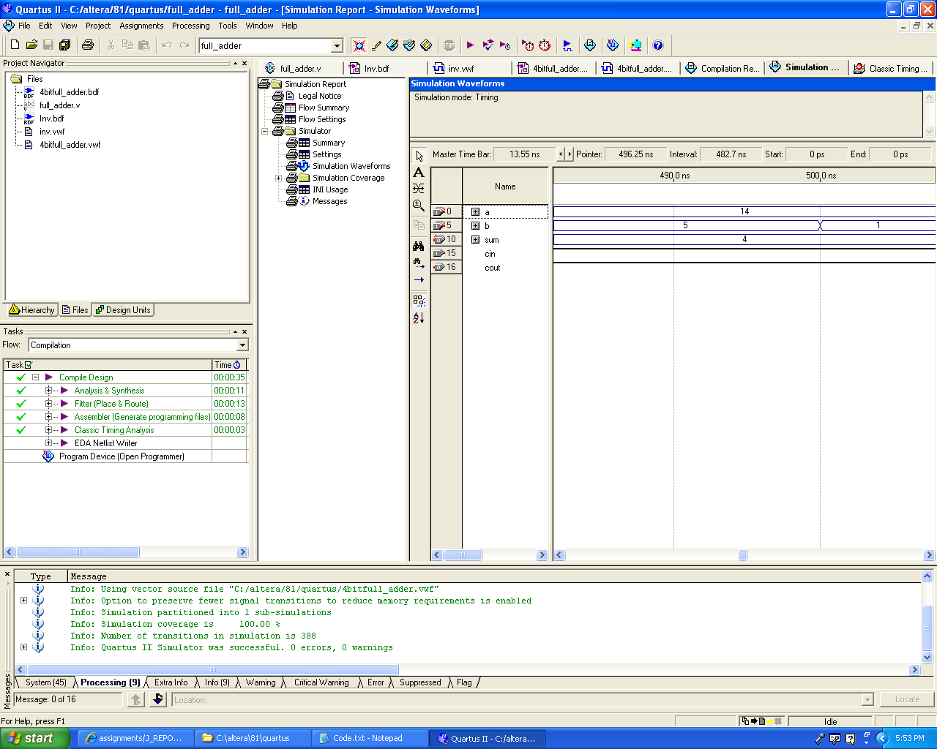

4. Can you detect changes in a simple gate's switching behavior which depend on its fan-out?
There wasn’t a significant difference in the total propagation delay based on the fan-out. There was some difference in the delay but we think it is related to the path length on the chip not the fan-out because increasing the number of inverters in the fan-out didn’t increase the delay.
