J_REPORT_7

VLSI System Design Project

Team Members:
Sandeep Gone
Greg Mefford
Balachandar Namasivayam
Megan Schneider

May 18, 2009
We are making good progress towards getting our processor implemented. All of our modules have been tested individually and we are trying to put it all together and test it as a unit. The control logic is still in the works, but should be done soon, followed by some debugging and testing.

The presentations on Friday were very helpful, and it was interesting to see the designs the other groups have implemented. We presented some diagrams of our top-level design on Friday as well as the size of matrices and arrays we can accommodate in memory for the benchmarks. We did not have any simulation data to share as we are still working on getting our processor working.

Goals for this week:
1. Have each module finished and tested (using ModelSim):
Greg: Register File, Control
Megan: ALU
Sandeep: Inst Memory, Data Memory
This is done. All modules have been tested individually.
2. Write some test benches using modified LC-3 assembly
Sandeep: Pick a sorting technique (Quick or Merge) to implement
Megan: Matrix multiply
Greg: Write a translator to machine code
We are currently working on this part. Writing the matrix multiply has been difficult using only the 8 registers we are limited to, but this should be figured out soon.
3. Write some ModelSim scripts to test the processor and these benchmarks
This still needs to be done. We have the knowledge to write DO files in ModelSim to test our programs, so once they are written this should not be hard. We will also need some simple programs to test the overall functions of the processor.

4. Put all the modules together in Quartus.
This has been done.

5. Finish the control signals for the processor.
This is still in the works because it is such a complex part of the design and it can’t really be split up between the group members. While Greg is working on this, Megan and Sandeep are working on getting the testbenches, MIF, and ModelSim files ready to test the processor.

6. Memory initialization files
We are still working on how this will work with the two separate memories for data and instructions. This needs to be figured out before we will be able to test our processor.

Overall, we made great progress last week and should be able to meet our goals by next Monday of having a working processor with simulation data to share.

Complete and submit your weekly report, with updated Gantt and tracking charts.

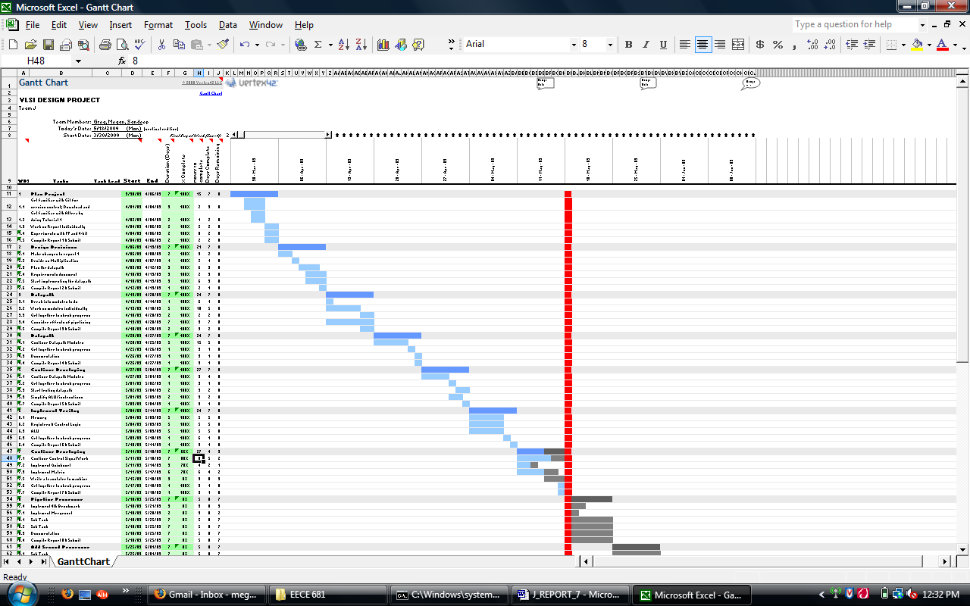

Below are our individual hours for the week. We also have individual work logs on the Git hub to keep track of time spent throughout the project.

Greg:
2009-05-11: 1.50 hours: Top-level architecture and control signal generation.
2009-05-11: 0.50 hours: Starting on the mid-term exam.
2009-05-12: 4.00 hours: Working on the mid-term exam.
2009-05-13: 2.50 hours: Finishing up the mid-term exam.
2009-05-13: 3.50 hours: Developing and testing effective address and ALU control signals.
2009-05-14: 1.50 hours: Drawing diagrams for the status update presentation.
2009-05-15: 3.50 hours: Working on control signal designs.
2009-05-16: 5.00 hours: Getting the whole design into Quartus so it can be simulated.
2009-05-17: 3.00 hours: Developing and testing control signal generation.

Megan:
2009-05-12: 4.00 hours: Working on take-home midterm
2009-05-13: 4.00 hours: Finishing up the take-home midterm
2009-05-13: 1.00 hours: Trying to figure out the MIF & how that works
2009-05-14: 2.00 hours: ALU verification with Altera
2009-05-15: 2.00 hours: Working on writing matrix multiply prgm
2009-05-15: 2.00 hours: Testing ALU with ModelSim DO file
2009-05-16: 3.50 hours: Matrix multiply prgm in assembly and MIF file implementation
2009-05-18: 0.50 hours: Compiling hours and submitting Report 7

Sandeep:
2009-05-12: 3 hours -- Worked on take home midterm
2009-05-13: 2 hours -- Worked on take home midterm
2009-05-14: 4 hours -- Worked on the Data and Instruction memory along with the Modelsim testing
2009-05-16: 2 hours -- Writing code for Sorting of data using modified LC3 instructions.

