Title+Abstract

Team J

VLSI System Design Project

Team Members:
Sandeep Gone
Greg Mefford
Balachandar Namasivayam
Megan Schneider

Our overall goal for this quarter was to design and implement an "optimal" processor on the provided Altera boards based on the LC-3 architecture developed by Patt and Patel. Parameters for optimization include speed, size, and power usage. Our processor has a 16 bit data path and maximal clock speed. We initialize the memory of the processor with a memory initialization file and output the results after the program is run to the LCD using a push button. Our processor can execute two programs – sorting a list of integers and matrix multiplication.

Chapter_1_Planning
SECTION 1: RESOURCES
a. List all personnel and skills of each.
Greg:
VHDL: Intermediate Skill
Verilog: No Experience
Altera: No Experience
Xilinx: Some Experience
Hardware Development: Basic experience based on VLSI Design courses
Software Development: Lots of professional and personal software development experience
Writing Skills: Some experience writing professional reports and proposals
Version Control: Extensive experience with SVN, some with CVS, and quickly learning to use git

Megan:
VHDL: Intermediate Skill
Verilog: Intermediate Skill
Altera: Experience from Embedded Systems class
Xilinx: No Experience
Hardware Development: Basic experience based on VLSI Design courses
Software Development: Basic programming experience
Writing Skills: Prior experience with project reports
Version Control: Learning to use git, but no prior experience

Sandeep:
VHDL: Intermediate Skill
Verilog: No Experience
Altera: No Experience
Xilinx: No Experience
Hardware Development: Basic experience based on VLSI Design courses
Software Development: Very good professional software development experience
Writing Skills: some experience writing project reports
Version Control: Learning to use git, but no prior experience

b. List the number of hours each team member has available to devote to the project over the quarter.
Greg: 8 hours per week
Megan: 8 hours per week
Sandeep: 8 hours per week

c. List all hardware and software resources that will be used for development.

Greg:
Primary: Apple Macbook Pro
2.5 GHz Core 2 Duo
4 GB 667 MHz DDR2 SDRAM
Operating System: Mac OS X 10.5.6

Secondary: Dell Dimension E521
2 GHz Athlon X2
4 GB 667 MHz DDR2 SDRAM
Operating System: Windows XP

Megan: HP Pavilion dv5 Notebook PC
AMD Turion(tm) X2 Dual-Core Mobile RM-70 2.00 GHz
3.00 GB RAM
Operating System: Windows Vista

Sandeep: Dell XPS M1330 Notebook PC
Intel(R) Core(TM) 2Duo CPU T5750 @2.00GHz
4GB RAM
Operating System: Windows Vista

Desktop PC in the lab 890 Rhodes:

Intel Pentium(c)
4 CPU 2.80 GHz
2.79 GHz, 504MB of RAM
Operating System: Windows XP version 2002 (SP 2)

Altera Board in the lab 890 Rhodes:

Cyclone*
EP1C6Q240C8

SECTION 2: PLANNING
a. List who will be assigned to oversee each of the following:
Documentation - Megan
Testing - Sandeep
Version control and backups - Greg
Tracking and productivity - Megan

b. Describe how the team members will communicate and how they will coordinate their work.
Communication will be primarily through email in order to easily maintain a paper-trail of what was said.
Email Addresses:
Greg - gregory.mefford@gmail.com
Megan - mmswim22@gmail.com
Sandeep - gsandyreddy@gmail.com

Also, we will have some impromptu face-to-face time as needed before and after VLSI System Design class on Monday, Wednesday, and Friday 12-1.20pm.

In case other contact methods are impossible, our phone numbers are as follows:
Greg - 513-673-1912
Megan - 614-370-6368
Sandeep - 337-515-2357

c. Give the time and place of weekly team meetings.
Tentatively, we will plan on meeting Wednesdays after class in/outside the classroom until we can come up with a more permanent time and place.

d. Describe completely how you will handle version control and backups.
Version control: git
For version control of source code and assets associated with this project, the team will be using the git version control system (http://www.git-scm.com).
The primary reason for choosing this version control system is that is a distributed version control system by design.
What this means is that each team member will have a complete snapshot of the entire history of the project in their local repository, and that history will be automatically merged with the changes made by other team members as they are committed.
In order to make the collaboration process easier, we will be using github (http://www.github.com) as the official master repository through which we will sync each of our respective local repositories.

Backups: git + github + Dropbox
Because git was designed to be a distributed version control system, it inherently represents a backup system in itself, since each team member and also the github server, has a complete copy of the entire history of the project. So not only will be always have a copy of the most recent version of the project code, but we will also maintain every previously-committed state of the project code.
In addition to the protection inherently offered by the git version control system, Greg will be using Dropbox (Http://www.getdropbox.com) to sync code between his computers. Not only does Dropbox offer an additional server, on which the current state of the project assets will be stored, but it also allows for older versions of the files to be downloaded in the unlikely event that every other precaution fails and the whole git repository is lost on each computer and on github.

e. Describe your plan for testing. Altera does not support testbenches, only .vec files. How will you document your testing?
As Quartus II software includes simulation support, we can test that any new synthesis algorithms we develop in fact produce correct circuits by simulating the circuits with our algorithm on and off and checking that the output is the same.
The simulator allows the user to apply test vectors (.vec files) as inputs to the designed circuit and to observe the outputs generated in response.
However, using waveforms to simulate FPGA designs is not generally desirable. That is why we can write the code to run on Altera devices and use the Xilinx Modelsim simulator to test the design. We can later fit the same design to the Altera devices. I haven't tried this yet, but it’s a possibility that can be explored.
f. Provide both a Gantt chart and Tracking Document for your project.
Our Gantt chart will serve as both a planning and tracking document. It is an Excel file that we will update as often as necessary and provide in the weekly reports. Here is a screen shot of the Gantt chart.

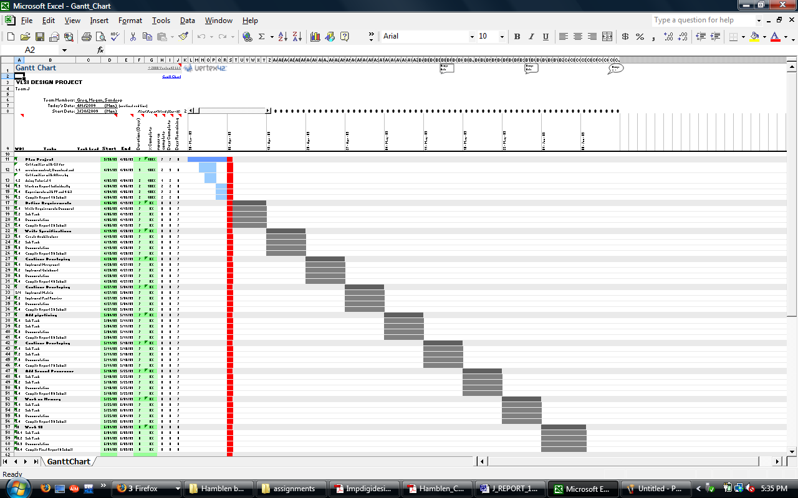

g. Describe the coding and documentation standards you will use.
We will be using the following Verilog coding standards: http://www.engr.sjsu.edu/cpham/VERILOG/VerilogCodingStyle.pdf

h. Describe how you will produce up-to-date documentation (content and form—online?) in parallel with the project. You will need to produce supporting documents, including a user manual, along with code documentation.
For the moment we will update our documentation manually (as a task in the Gantt chart), until we can find a way to do this automatically.

Chapter_2_Requirements

Your overall goal for this quarter is to design and implement on the provided Altera boards an "optimal" processor. Parameters for optimization include speed, size, power usage, and potential for upgrading with wider datapath, more instructions, etc. The processor will be designed in three phases. The basic architecture for your project will be the LC-3 architecture defined in the book by Patt and Patel. Your basic processor should be able to perform all the operations of this processor. Your processor must have the following characteristics:

Phase 1: --8 or 16 bit datapath
--maximal clock speed
--input may be through a preloaded data file, along with a menu on the
CRT which is accessed through the mouse
--output may be to a file which can be displayed appropriately on the
CRT
--ability to execute 4 benchmark programs:
a. mergesort of a list of integers
b quicksort of the same list
c. matrix multiplication

Phase II: add pipelining

Phase III: add a second processor and memory management for dual-core processing.

This was originally going to be done in VHDL, but the language was changed to Verilog.

Chapter_3_Specifications
LC-3 Instruction Set:
  *ADD |  |  |  | R1 |  |  | R2 |  |  |  |  |  | R3
  0 | 0 | 0 | 1 | 0 | 0 | 1 | 0 | 1 | 0 | 0 | 0 | 0 | 0 | 1 | 1
  Op |  |  |  | DR |  |  | SR1 |  |  |  |  |  | SR2
  *ADD |  |  |  | R1 |  |  | R2 |  |  | #7
  0 | 0 | 0 | 1 | 0 | 0 | 1 | 0 | 1 | 0 | 1 | 0 | 0 | 1 | 1 | 1
  Op |  |  |  | DR |  |  | SR1 |  |  |  | imm5 (⁻16-⁺15)
  *AND |  |  |  | R1 |  |  | R2 |  |  |  |  |  | R3
  0 | 1 | 0 | 1 | 0 | 0 | 1 | 0 | 1 | 0 | 0 | 0 | 0 | 0 | 1 | 1
  Op |  |  |  | DR |  |  | SR1 |  |  |  |  |  | SR2
  *AND |  |  |  | R1 |  |  | R2 |  |  | #-2
  0 | 1 | 0 | 1 | 0 | 0 | 1 | 0 | 1 | 0 | 1 | 1 | 1 | 1 | 1 | 0
  Op |  |  |  | DR |  |  | SR1 |  |  |  | imm5 (⁻16-⁺15)
  BR |  |  |  | p |  |  | x000C
  0 | 0 | 0 | 0 | 0 | 0 | 1 | 0 | 0 | 0 | 0 | 0 | 1 | 1 | 0 | 0
  Op |  |  |  | n | z | p | PCoffset9 (xFF00-x00FF)
  JMP |  |  |  |  |  |  | R2
  1 | 1 | 0 | 0 | 0 | 0 | 0 | 0 | 1 | 0 | 0 | 0 | 0 | 0 | 0 | 0
  Op |  |  |  |  |  |  | BaseR
  JSR |  |  |  |  |  |  |  |  |  |  | #169
  0 | 1 | 0 | 0 | 1 | 0 | 0 | 0 |  | 1 | 0 | 1 | 0 | 1 | 0 | 0 | 1
  Op |  |  |  |  |  |  |  | PCoffset11 (xFC00-x03FF)
  JSRR |  |  |  |  |  |  | R2
  0 | 1 | 0 | 0 | 0 | 0 | 0 | 0 | 1 | 0 | 0 | 0 | 0 | 0 | 0 | 0
  Op |  |  |  |  |  |  | BaseR
  *LD |  |  |  | R4 |  |  | x0027
  0 | 0 | 1 | 0 | 1 | 0 | 0 | 0 | 0 | 0 | 1 | 0 | 0 | 1 | 1 | 1
  Op |  |  |  | DR |  |  | PCoffset9 (xFF00-x00FF)
  *LDI |  |  |  | R6 |  |  | xFF07
  1 | 0 | 1 | 0 | 1 | 1 | 0 | 1 | 0 | 0 | 0 | 0 | 0 | 1 | 1 | 1
  Op |  |  |  | DR |  |  | PCoffset9 (xFF00-x00FF)
  *LDR |  |  |  | R0 |  |  | R2 |  |  | #-31
  0 | 1 | 1 | 0 | 0 | 0 | 0 | 0 | 1 | 0 | 1 | 0 | 0 | 0 | 0 | 1
  Op |  |  |  | DR |  |  | BaseR |  |  | offset6 (⁻32-⁺31)
  *LEA |  |  |  | R1 |  |  | 0x0060
  1 | 1 | 1 | 0 | 0 | 0 | 1 | 0 | 0 | 1 | 1 | 0 | 0 | 0 | 0 | 0
  Op |  |  |  | DR |  |  | PCoffset9 (xFF00-x00FF)
  *NOT |  |  |  | R1 |  |  | R2
  1 | 0 | 0 | 1 | 0 | 0 | 1 | 0 | 1 | 0 | 1 | 1 | 1 | 1 | 1 | 1
  Op |  |  |  | DR |  |  | SR1
  RET
  1 | 1 | 0 | 0 | 0 | 0 | 0 | 1 | 1 | 1 | 0 | 0 | 0 | 0 | 0 | 0
  Op
  RTI
  1 | 0 | 0 | 0 | 0 | 0 | 0 | 0 | 0 | 0 | 0 | 0 | 0 | 0 | 0 | 0
  Op
  ST |  |  |  | R0 |  |  | x0085
  0 | 0 | 1 | 1 | 0 | 0 | 0 | 0 | 1 | 0 | 0 | 0 | 0 | 1 | 0 | 1
  Op |  |  |  | SR |  |  | PCoffset9 (xFF00-x00FF)
  STI |  |  |  | R3 |  |  | x01C7
  1 | 0 | 1 | 1 | 0 | 1 | 1 | 1 | 1 | 1 | 0 | 0 | 0 | 1 | 1 | 1
  Op |  |  |  | SR |  |  | PCoffset9 (xFF00-x00FF)
  STR |  |  |  | R0 |  |  | R2 |  |  | #-9
  0 | 1 | 1 | 1 | 0 | 0 | 0 | 0 | 1 | 0 | 1 | 1 | 0 | 1 | 1 | 1
  Op |  |  |  | SR |  |  | BaseR |  |  | offset6 (⁻32-⁺31)
  TRAP |  |  |  |  |  |  |  | x0023
  1 | 1 | 1 | 1 | 0 | 0 | 0 | 0 | 0 | 0 | 1 | 0 | 0 | 0 | 1 | 1
  Op |  |  |  |  |  |  |  | trapvect8 (x0000-x00FF)
  reserved
  1 | 1 | 0 | 1 | x | x | x | x | x | x | x | x | x | x | x | x
  Op
* indicates instructions modify condition codes.
ISA Changes:
We will be replacing the unused opcode 1101 with a MUL instruction to support hardware multiplication:
2-Register: [Overflow, Dest] = Src1 * Src2
15 12 | 11 9 | 8 6 | 5 | 4 3 | 2 0
1 1 0 1 | Dest Reg | Src Reg 1 | 0 | 0 0 | SRC Reg 2

Register-Immediate: [Overflow, Dest] Src1 * IMM5
15 12 | 11 9 | 8 6 | 5 | 4 0
1 1 0 1 | Dest Reg | Src Reg 1 | 1 | Immediate 5 Bits

Shift-Left: Dest = Src1 << 1
15 12 | 11 9 | 8 6 | 5 | 4 3 | 2 0
1 1 0 1 | Dest Reg | Src Reg 1 | 0 | 1 0 | 0 0 0

Shift-Right: Dest = Src1 >> 1
15 12 | 11 9 | 8 6 | 5 | 4 3 | 2 0
1 1 0 1 | Dest Reg | Src Reg 1 | 0 | 1 1 | 0 0 0

This change will allow us to perform fast multiplications in hardware, rather than having to perform multiple shifts and adds over many clock cycles. The advantage will be particularly significant because the instruction set did not originally have a shift operation either, so even the shifting portion would have been complicated. As a convenience, a Shift Left and Shift Right operation are also available using this same opcode. Additionally, using the reserved opcode for multiplication will save us some trouble in the implementation of the illegal opcode exception, as there is no longer any illegal opcode possible.
Further, the instruction format for these additional operations closely matches the ALU operations designed with the LC-3, so the control signals associated with directing the values in and out of the ALU should be simple compared to some other arbitrary instruction format.

Chapter_4_Design

Chapter_5_Implementation / Testing

Chapter_6_Tracking+Productivity

Must contain
a.) completed Gantt chart & completed tracking chart (our Gantt has all info in it)
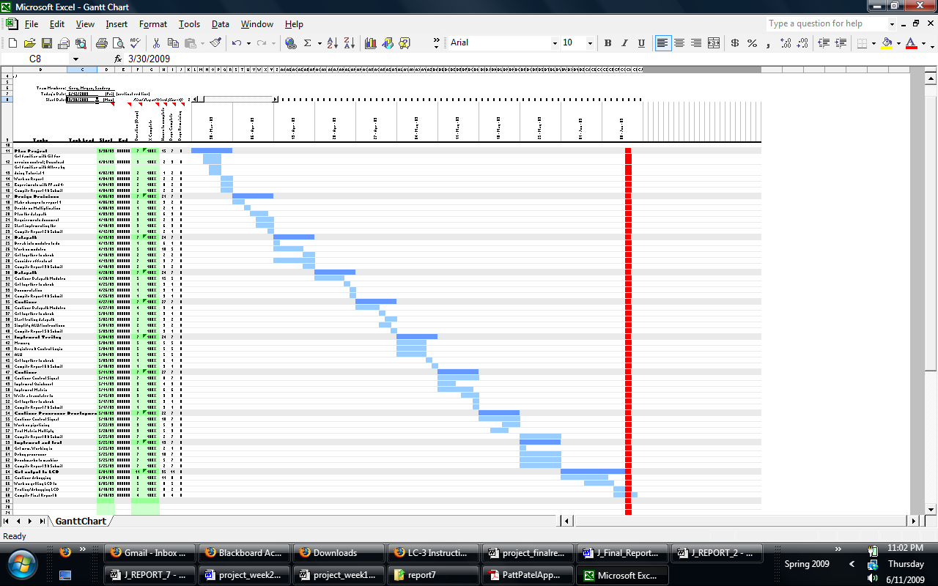
b.) week-by-week graph of the number of hours each team member worked on the project

Chapter_7_Performance
Chip resources used: get this from the altera development software; be sure to include, e.g., number of logic elements used, % of resources used, amount of memory used, number of I/O pins used
Clock speed: what is the maximum clock speed for each of your designs?
Problem size:what is the largest size array you can sort? matrix mult you can do?
Power usage: get this information from the altera tools
Speed/speedup: how long does it take to do each problem (give graph or table based on problem size and, for matrices, density); what is pipelined/dual core speedup? (if necessary, use a counter to keep track of processing time)

Chapter_8_Lessons_Learned

a. How well does your project match the initial design? Did you meet the requirements? If not, why not?
b. What should be added in version 2?
c. Did project match your plan? Were there major surprises (good or bad)?

Chapter_9_Project_Documentation

user manual (with instructions on how to compile and run project)

