J_REPORT_5

VLSI System Design Project

Team Members:
Sandeep Gone
Greg Mefford
Balachandar Namasivayam
Megan Schneider

May 4, 2009
Complete and submit your weekly report, with updated Gantt and tracking charts.

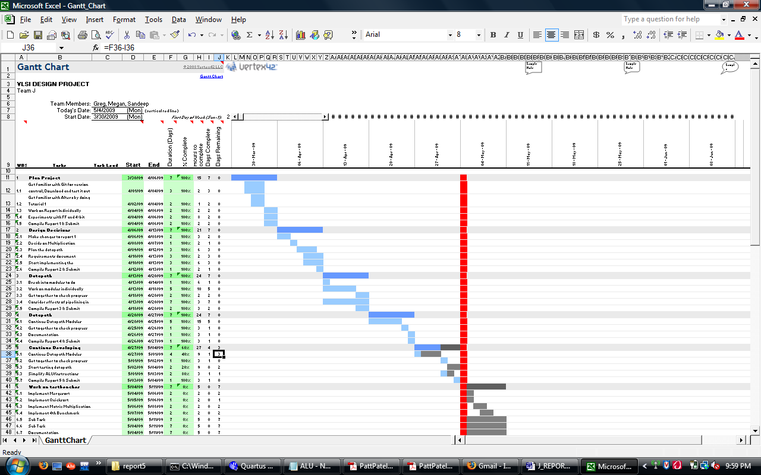

Below are our individual hours for the week. We also have individual work logs on the Git hub to keep track of time spent throughout the project.

Greg:
2009-04-27: 1.00 hours: Writing up summaries for Homework 2
2009-04-27: 1.00 hours: Getting started on the register file Verilog module
2009-04-27: 0.50 hours: Working on a single-register module
2009-04-27: 2.50 hours: Working on 8-register file and overall architecture
2009-04-27: 1.50 hours: Working on the overall architecture files in Quartus
2009-05-04: 1.00 hours: Meeting to update Report 5 status and plan next steps
2009-05-04: 2.00 hours: Working on basic control logic

Megan:
2009-04-27: 1.00 hours: Writing up summaries for Homework 2
2009-04-27: 1.00 hours: Discussion on the basic data path structure
2009-04-27: 1.00 hours: Finishing up with Report 4
2009-04-29: 1.00 hours: Reading LC-3 documentation and instruction set
2009-05-01: 1.50 hours: Reading up on implementation of ALU
2009-05-04: 1.00 hours: Meeting to update Report 5 status and plan next steps
2009-05-04: 2.00 hours: Working on ALU code/diagram

Sandeep:
2009-04-27: 1.00 hours: Discussion on the basic data path structure
2009-04-27: 0.50 hours: Finishing up with Report 4
2009-05-02: 2.50 hours: Designing the top level structure and learning more details on the implementation of Verilog code
2009-05-02: 2.00 hours: Understanding the memory architecture
2009-05-03: 1.00 hours: Going through the instruction set of LC3 architecture and paper reg. the implementation.
2009-05-04: 1.00 hours: Meeting to update Report 5 status and plan next steps
2009-05-04: 1.00 hours: Finishing up the homework2

(Bala was just added to our team so I don’t have any hours for him yet.)

