J_REPORT_6

VLSI System Design Project

Team Members:
Sandeep Gone
Greg Mefford
Balachandar Namasivayam
Megan Schneider

May 11, 2009
We are making good progress towards getting our processor implemented in tested modules and we’ll be trying to put it all together and test it as a unit soon. The control logic is still in the works, but should be done quickly.

Goals for this week for the project demonstration on Friday:
1. Have each module finished and tested (using ModelSim):
Greg: Register File, Control
Megan: ALU
Sandeep: Inst Memory, Data Memory
This is almost done. We’ll still need to put everything together and test it as a cohesive unit with ModelSim and Altera.
2. Write some test benches using modified LC-3 assembly
Sandeep: Pick a sorting technique (Quick or Merge) to implement
Megan: Matrix multiply
Greg: Write a translator to machine code
We are currently working on this part.
3. Write some ModelSim scripts to test these benchmarks
This will get done before Friday.

We’ll also have diagrams of our top-level design to present.

Complete and submit your weekly report, with updated Gantt and tracking charts.

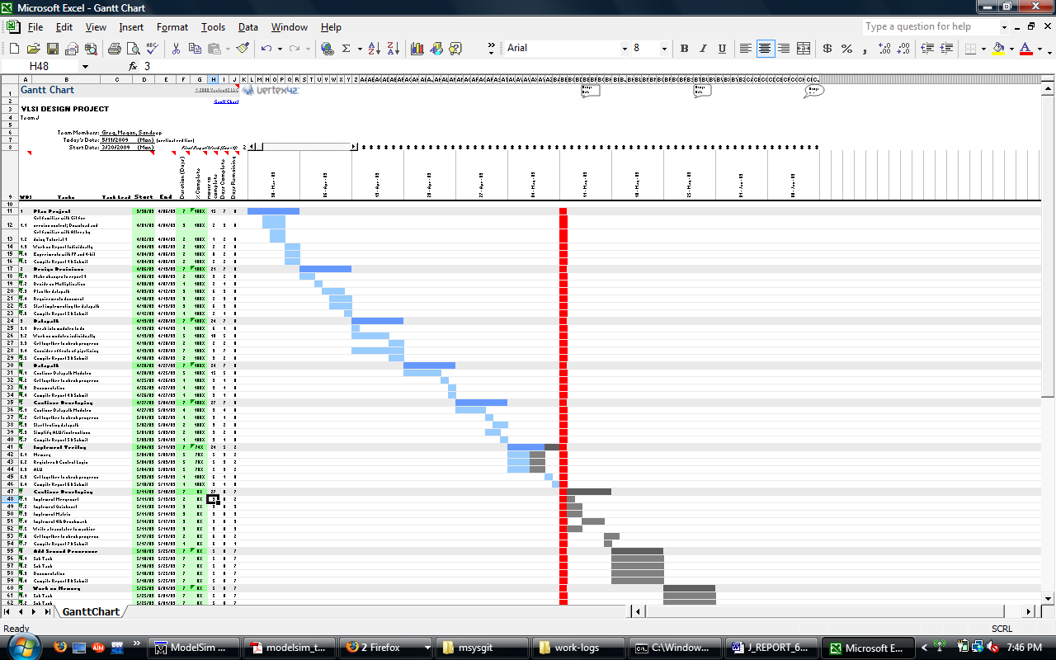

Below are our individual hours for the week. We also have individual work logs on the Git hub to keep track of time spent throughout the project.

Greg:
2009-05-04: 2.00 hours: Working on basic control logic
2009-05-08: 1.50 hours: Meeting for a status update, and getting started with ModelSim.
2009-05-08: 1.50 hours: Working through ModelSim tutorials and testing the register File.
2009-05-10: 1.00 hours: Control signal generation.
2009-05-11: 1.50 hours: Top-level architecture and control signal generation.
2009-05-11: 0.50 hours: Starting on the mid-term exam.

Megan:
2009-05-04: 2.00 hours: Working on ALU code/diagram
2009-05-08: 1.50 hours: Meeting for a status update, and getting started with ModelSim.
2009-05-08: 1.50 hours: Working through ModelSim tutorials and testing the ALU
2009-05-10: 1.00 hours: Continued testing ALU
2009-05-11: 1.50 hours: Working on take-home midterm
2009-05-11: 0.50 hours: Compiling everyone’s hours and submitting Report 6

Sandeep:
2009-05-06: 2.00 hours: Implementation of memory module
2009-05-08: 3.00 hours: Worked on take home midterm
2009-05-09: 2.00 hours: Installing and working on Modelsim
2009-05-10: 1.50 hours: Worked on random testing of memory module

