J_REPORT_3

VLSI System Design Project

Team Members:
Sandeep Gone
Greg Mefford
Megan Schneider

April 20, 2009
Project report 3 should document any changes you are making based on our class discussion this week or on the comments on your report 2; in particular, are you now making any modifications which will help deal with pipelining in the next phase? (you do not need to make changes at this point, it is your decision, just keep track of the number of hours you are putting into the project so we can look back at the end of the course and see how your decision influenced the time you spent per week during the quarter)
It should also included Gantt and tracking charts, with the number of hours for each team member reported.

3. Begin work on the data path of your processor.
Step 1. Explain completely and justify any changes you will be making to the ISA (instruction set architecture) of your machine. These should be related to operations needed by the benchmark problems or optimizations you plan to carry out in steps 2 (pipelining) and 3 (dual processors). Explain any changes to the capability of the LC-3 processor which your modifications will make and justify these.

ISA Changes:
None since Report2.

Step 2. Design and test the data path of your processor. This step will take two weeks, so the report you submit next week should have the top-level design requirements and test and as much of the rest of the design as you have completed. The rest will be done for Project Report 3.

For the last report we said that we would implement something very similar to the LC-3 architecture with the following exceptions:
The ALU output is 32 bits wide, to support addition and multiplication overflow. Overflow is always stored to the Overflow Register, R0, at the same time as the condition codes are set. An operation that writes to the overflow register can not also specify R0 as the destination register, or an exception will be raised.

Since we discussed pipelining in class, we have changed our architecture to the MIPS. Because we did not get too far into designing the data path and writing code before this discussion, we felt that changing to the MIPS would make implementing pipelining much easier down the road without too much rework at this stage. We still have decided to stick with the exceptions stated above to accommodate multiplication.

We have split the implementation of data path modules up and Sandeep will be working on memory, Greg will be working on the registers, and Megan will be working on the ALU. More specifications to come.

Step 3. Complete and submit your weekly report, with updated Gantt and tracking charts.

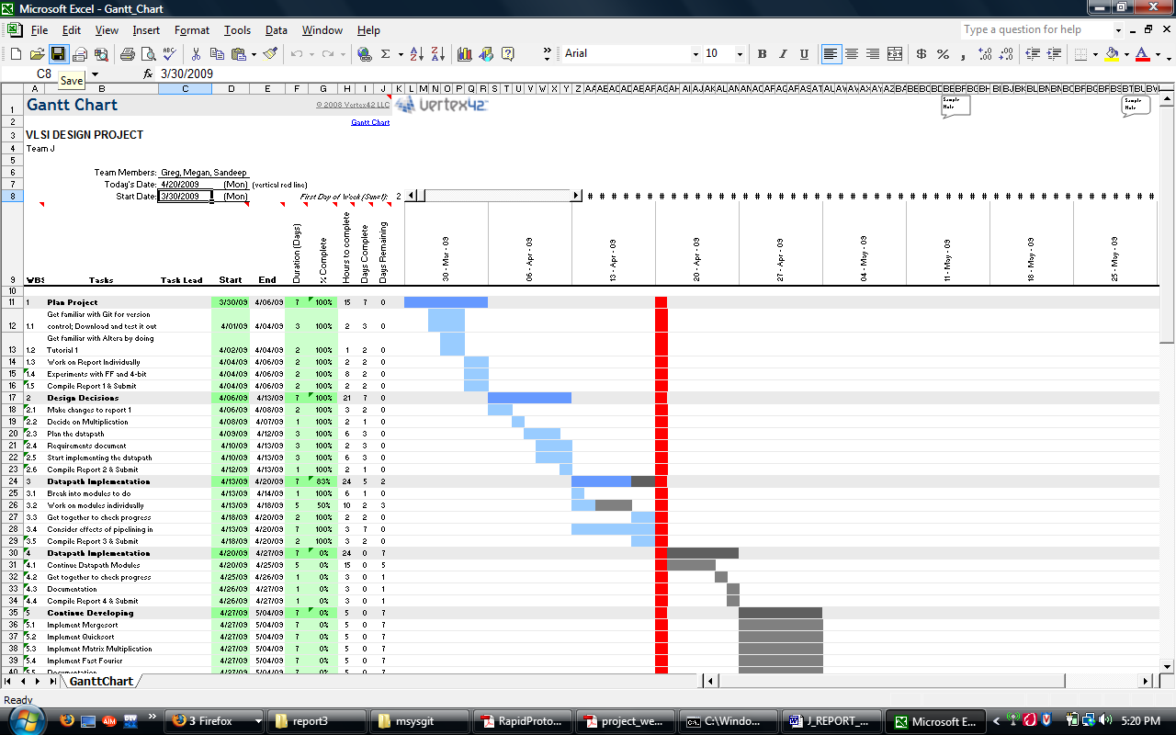

We are a little behind our schedule for implementing the data path because of design decisions/changes, and we know we will have to work harder this week to catch up. We also have individual work logs on the Git hub to keep track of time spent.

Greg:
2009-04-12: 1.00 hours: Getting started on tasks for Report 2
2009-04-13: 1.00 hours: Working on ISA requirements for multiply instruction
2009-04-13: 1.25 hours: Meeting to discuss ISA and bus architectures
2009-04-13: 0.50 hours: Learning the basics of Verilog
2009-04-15: 0.50 hours: Revising the instruction format changes for MUL, SL, and SR
2009-04-15: 1.00 hours: Writing some specification requirements for the data path
2009-04-17: 1.50 hours: Meeting to discuss pipelining/changes to design
2009-04-20: 1.00 hours: Discussing, finishing, submitting Report 3

Megan:
2009-04-13: 1.25 hours: Meeting to discuss ISA and bus architectures
2009-04-14: 1.00 hours: Reading the Verilog documentation
2009-04-15: 0.75 hours: Reading up on different architectures
2009-04-17: 1.50 hours: Meeting to discuss pipelining/changes to design
2009-04-17: 1.00 hours: Reading Cyclone literature
2009-04-20: 1.00 hours: Discussing, finishing, submitting Report 3

Sandeep:
2009-04-13: 1.25 hours: Meeting to discuss ISA and bus architectures
2009-04-14: 1.00 hours: Practicing version control with Git
2009-04-15: 1.00 hours: Learning Verilog/reading documentation
2009-04-16: 1.00 hours: Reading MIPS architecture documentation
2009-04-17: 1.50 hours: Meeting to discuss pipelining/changes to design
2009-04-20: 1.00 hours: Discussing, finishing, submitting Report 3

