Cubing On Up Solution

Greg Netols

Code: <https://github.com/GregNetolsOpex/FunPuzzles/tree/master/CubingOnUp>

Randomly rotates around cubes in the cube stack. Prints out cube stack configurations that meet the requirements.

|  |  |  |
| --- | --- | --- |
| Cube # | Side Facing Top | Side Facing Front |
| 1 | A | E |
| 2 | A | C |
| 3 | A | D |
| 4 | F | B |

Front:

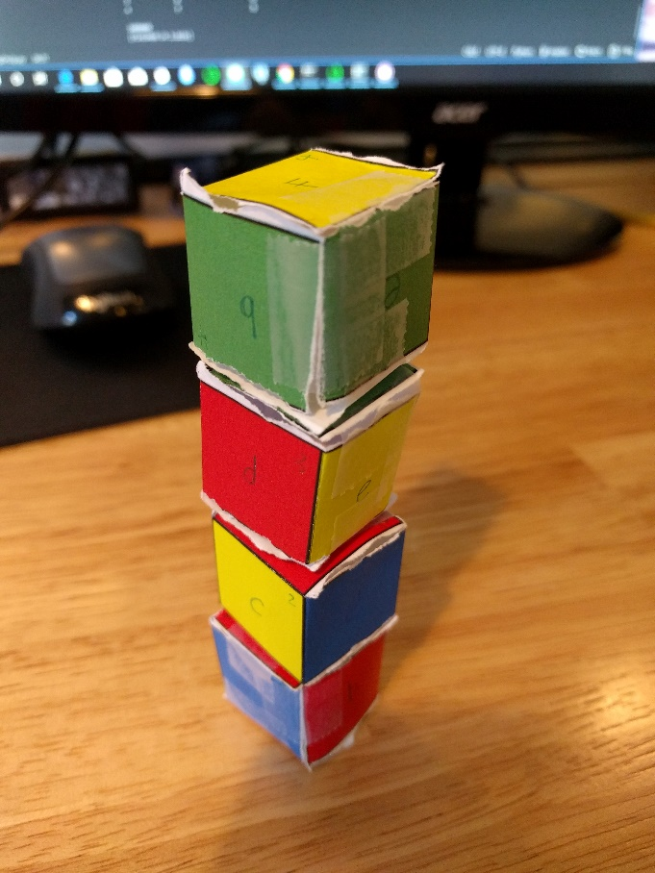

Right:

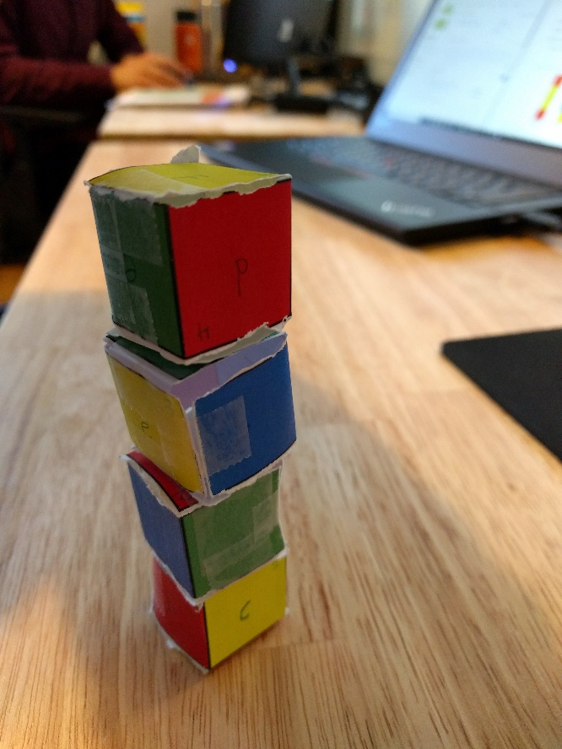

Back:

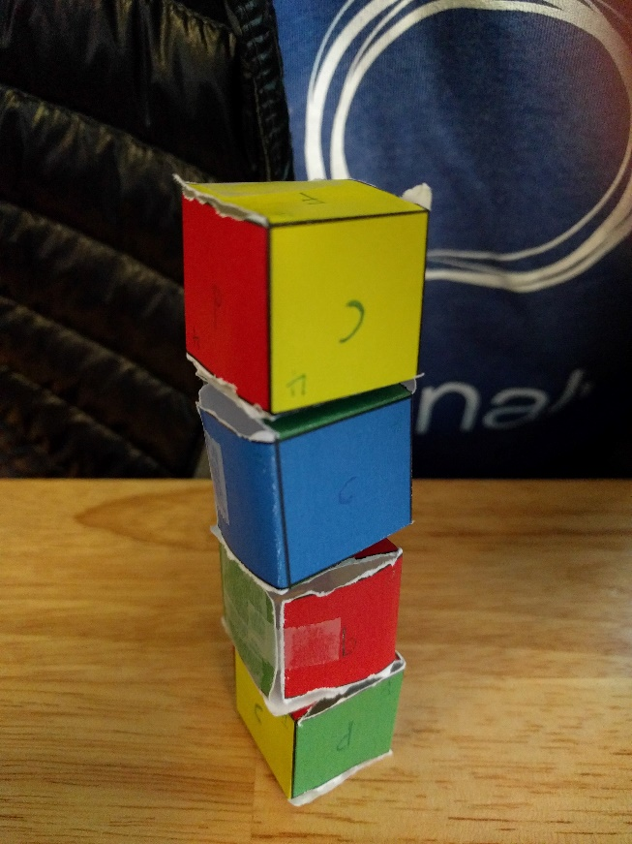

Left:

