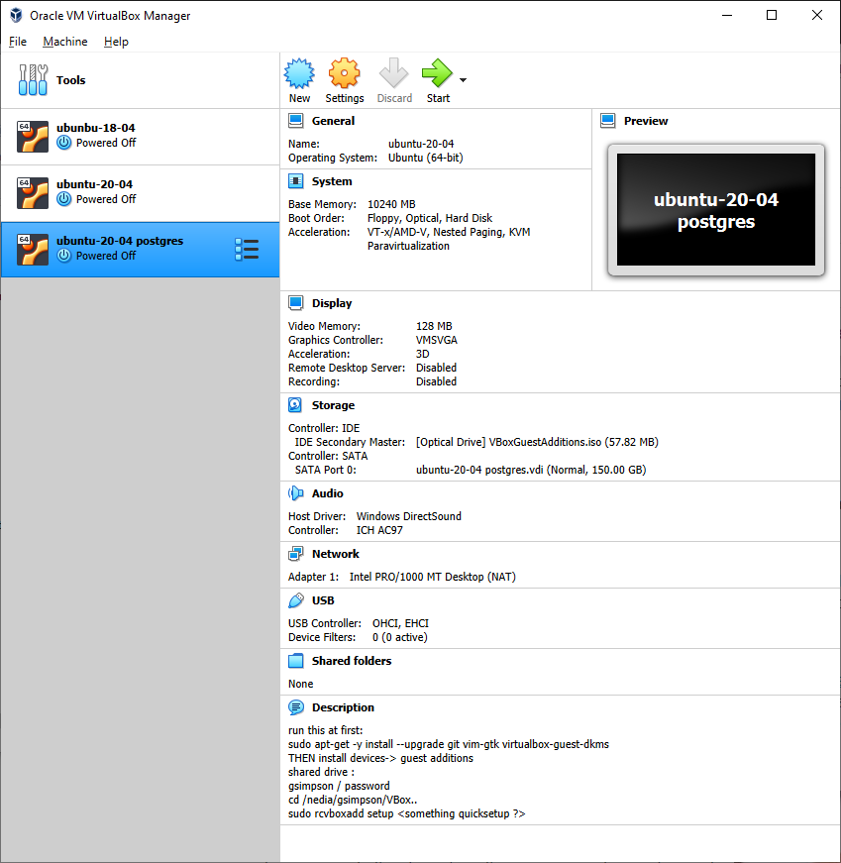

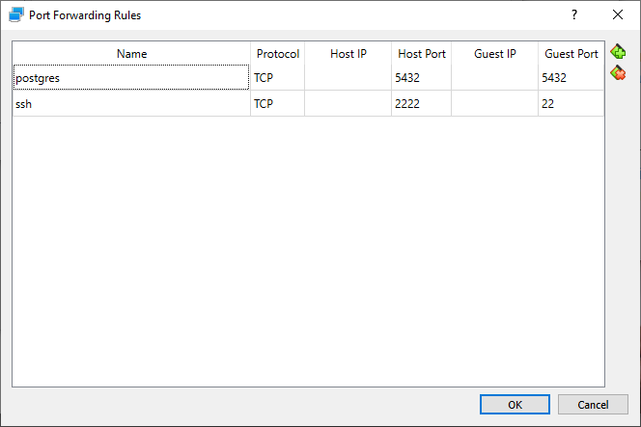

/etc/postgresql/12/main/pg_hba.conf

"local" is for Unix domain socket connections only

local all all peer

# IPv4 local connections:

#host all all 127.0.0.1/32 md5

host all all all md5

/etc/postgresql/12/main/postgresql.conf

listen_addresses = '*' # what IP address(es) to listen on;

#listen_addresses = 'localhost' # what IP address(es) to listen on;