

Faculty of Engineering and Computing

Department of Computing, Electronics, and Mathematics

**M32COM Internet Systems Development**

Web/Cloud Application development

By Group C

Augustine Nwosu - 9148011

## Bosen Zhang - 8523282

Cheng-Chieh Chuang - 8980902

## Gregory Taylor - 9247196

Siva Sethu - 7616123

25.03.2019

Dr. Leon Smalov

**Table of Contents**

**1.0 Introduction**

**2.0 Design and Implementation**

2.1 Design

2.2 Implementation

2.3 Deployment

**3.0 Project Management**

3.1 GitHub and Trello

3.2 Group Allocation

**1.0 Introduction**

We developed a web application for a remote-control racing boat competition. This system allowed the clients to access the related information of the competition.

**2.0 Design and Implementation**

2.1 Design

We developed a web application at a local host in the language of C#. A database is used to set-up the initial data, and to store the related information. The information includes the details of the crew, the racing boats, the competitions related information, and the racing calendar. We also integrated an API into the calendar page which provides the app with real time, up to date weather alerts for the race locations. The API provides, wind speed, humidity and the current temperature.

2.2 Implementation

All areas of the web app are fully functional apart from the membership page which wasn’t finished.

A UDF diagram to show the database design can be viewed below.

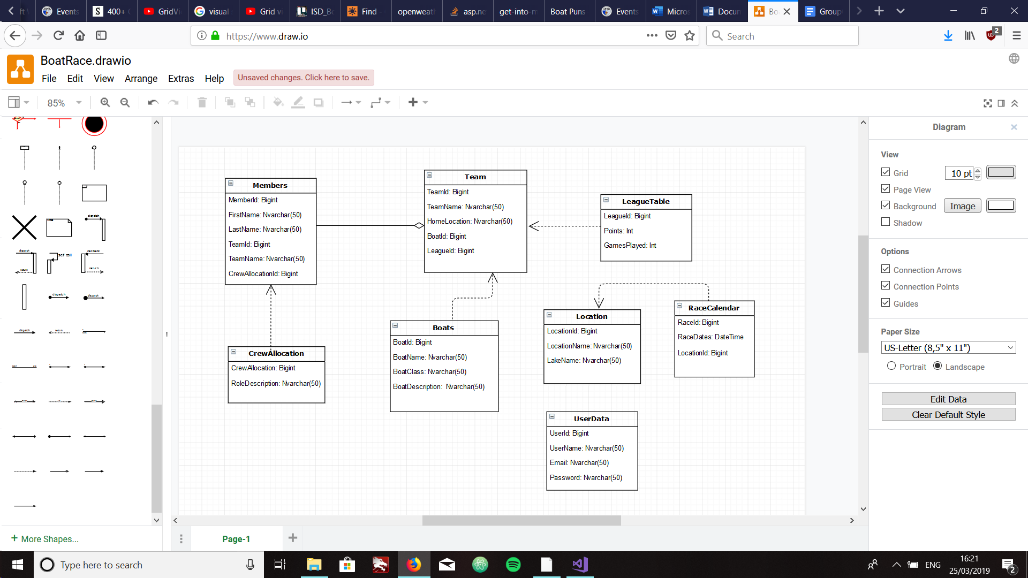

2.3 Deployment

The prototype is deployed through:

GITHUB:<https://github.com/GregTaylor31/M32COM-ISD-Coursework>

TRELLO:<https://trello.com/b/wkSUhjp3/isdboat-racing>

**3.0 Project Management**

3.1 GitHub and Trello

We used GitHub to work for is is easier to track the changes in the code from version to version. We could see who edited what at what time and where the files are stored. The revisions could be viewed and have a version history of the code in case to not lose any previous versions because of iteration. We also used Trello to make sure everything is on track. A board was set up at first and we labeled every tasks on a card under different sections. Each tasks are labeled to the assigned member with a due date and task details. After each group meeting, we added in some new tasks and adjusted some of them based on the discussion. Through GitHub and Trello, we are allowed to work efficiently and to keep the project agenda organized.

3.2 Group Allocation

|  |  |
| --- | --- |
| Member Name | Area of contribution |
| Augustine Nwosu | Designed Home, Register, Login and startup pages. |
| Bosen Zhang |  |
| Cheng-Chieh Chuang | Test log in and registry, documentation. |
| Gregory Taylor | Logic, Database, UI design and development, testing. |
| Siva Sethu |  |