COMPLETE ALL DETAILS ON THIS FORM AND POST TO: Mal Green, P O Box 34552. Birkenhead, Auckland 0746

P O Box 34552, Birkenhead, Auckland 0746, New Zealand  119 Onewa Rd, Northcote, Auckland 0626, New Zealand  Telephone 64-9-9666033 Fax 64-6-9666036  Email: auckland@incedo.org.nz Web Site: www.incedo.org.nz  incedo inc | 

CONSENT TO DISCLOSURE OF INFORMATION
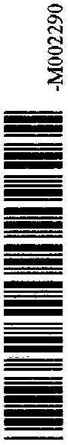

Licensing and Vetting Service Centre
Office of the Commissioner
P O Box 3017
WELLINGTON 6140

I, ......................................................................, ....................................…...........................................….
(surname) (forenames)

...............................................................................................................….............................……………
(maiden name or any other names used)

Sex: ………male/female Date and place of birth:………....................…...............................................

Nationality:....................................…….. Residential Address:………….………………...........................….

Suburb:................................................................City:…………….................................................................

NZ Drivers Licence number:……………………………………………………………………………………..

hereby consent to the disclosure by the New Zealand Police of any information they may have pursuant to this application, to INCEDO INC. I understand that any record of criminal convictions I might have will automatically be concealed if I meet the eligibility criteria stipulated in Section 7 of The Criminal Records (Clean Slate) Act 2004.

Signed:................................................................ Date: ......................................................

COMMENTS OF THE NEW ZEALAND POLICE

