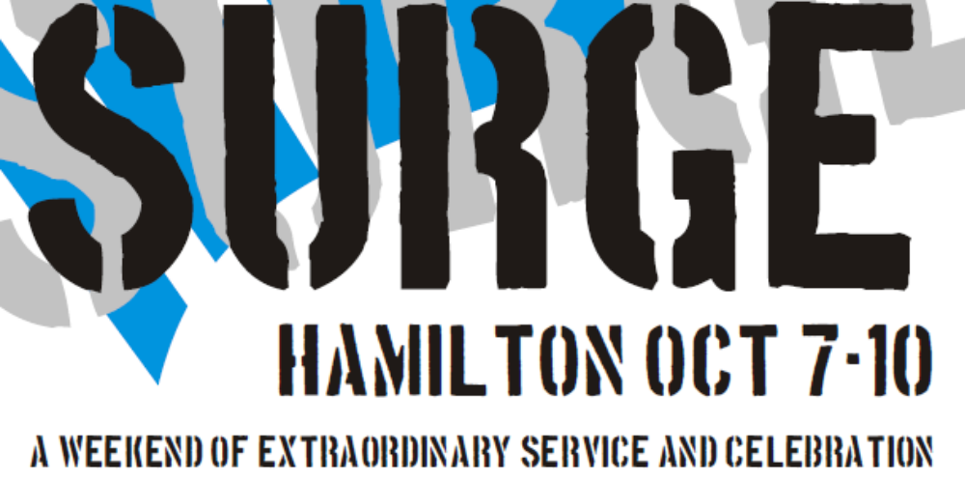

NAME: _______________________________________________________ Age: _________
ADDRESS: __________________________________________________________________
PH: _______________ MOBILE: ________________ EMAIL: __________________________

Parent / Guardian signature if under 18 ____________________________________
Contact in case of emergency: ______________________________________________
Any medical conditions we should know about? _________________________________
__________________________________________________________________________
Food: Allergy?_____________________________________________________________
Vegetarian or Vegan? _________________________________________________

I understand that I will be taking part in physical work, and I accept the responsibility to work hard in completing tasks.
I understand Surge is an alcohol/drug/and whine free event.
Signed: __________________________________________________________________

