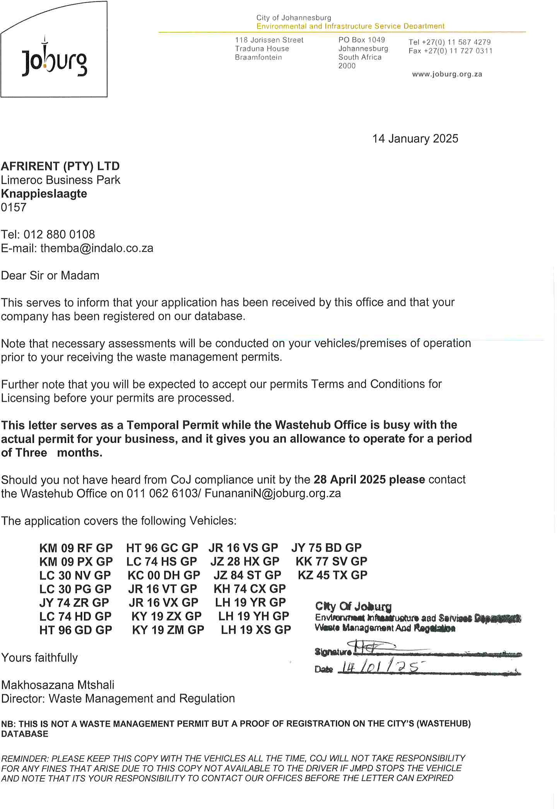

[TODAYDATE]

**[COMPANYNAME]**  
[ADDRESSLINE1]  
**[CITY]**  
[CODE]

Tel: [PHONENUMBER]  
Email: [EMAIL]

Dear Sir or Madam

This serves to inform that your application has been received by this office and that your company has been registered on our database.

Note that necessary assessments will be conducted on your vehicles/premises of operation prior to your receiving the waste management permits.

Further note that you will be expected to accept our permits Terms and Conditions for Licensing before your permits are processed.

**This letter serves as a Temporal Permit while the Wastehub Office is busy with the actual permit for your business, and it gives you an allowance to operate for a period of Three months.**

Should you not have heard from CoJ compliance unit by the **[EXPIRYDATE]**, please contact the Wastehub Office on 011 062 6103 / [FunananiN@joburg.org.za](mailto:FunananiN@joburg.org.za)

The application covers the following Vehicles:

**[LICENCES]**

Yours faithfully

[DIRECTORNAME]  
*Director: Waste Management and Regulation*

**NB: THIS IS NOT A WASTE MANAGEMENT PERMIT BUT A PROOF OF REGISTRATION ON THE CITY’S (WASTEHUB) DATABASE**

*REMINDER****:*** *PLEASE KEEP THIS COPY WITH THE VEHICLES ALL THE TIME. COJ WILL NOT TAKE RESPONSIBILITY FOR ANY FINES THAT ARISE DUE TO THIS COPY NOT BEING AVAILABLE TO THE DRIVER IF JMPD STOPS THE VEHICLE AND NOTE THAT IT'S YOUR RESPONSIBILITY TO CONTACT OUR OFFICES BEFORE THE LETTER CAN EXPIRED.*