Daoism Overseas
Ideas, Practices, and Scriptures
19th International Conference on Daoist Studies
Mount Wufeng, Jinan, Shandong
25-29 May, 2027

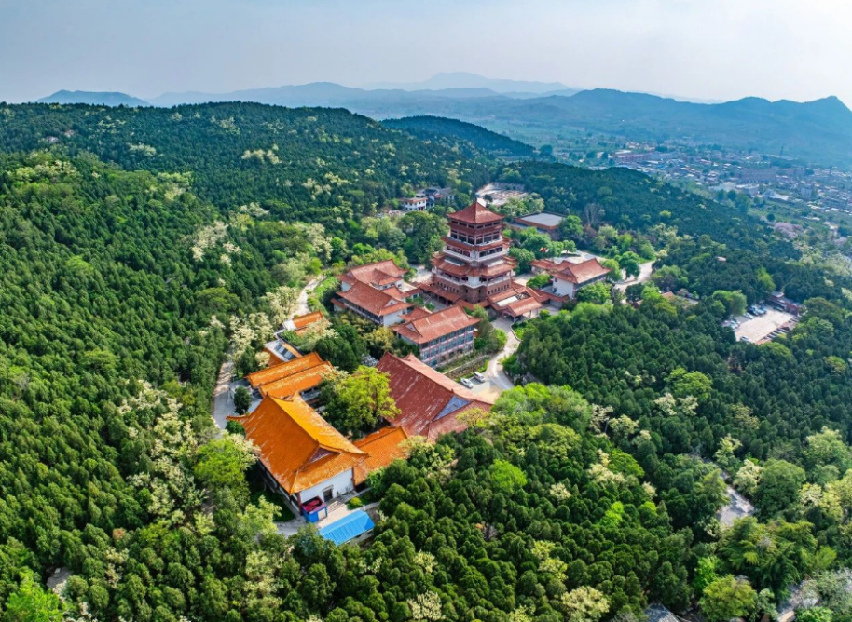
The indigenous higher religion of China, Daoism has not only had a profound impact on ancient Chinese society, culture, lifestyle, and national character, but has also been recognized, and even revered by people overseas. Conducting a comprehensive, systematic and in-depth study of the dissemination and influence of Daoism overseas holds great academic value and cultural significance. In view of this, the theme of the 19th International Conference on Daoist Studies is expected to focus on the dissemination of Daoism overseas. Subjects of discussion include:
1) the religious communities, temples and shrines, inheritance lineages and dissemination methods of Daoism in various parts of the world;
2) the influence of Daoist ideas on the spiritual world and daily life of people overseas;
3) the practice of Daoist medicine, magic, rituals. and cultivation beyond China;
4) the relationship between overseas Daoism and local societies, cultures, ethnic groups, or religions;
5) the relationship between overseas Daoism and traditional Chinese religions as well as folk beliefs;
6) the dissemination and collection of Daoist scriptures in various parts of the world.

KEYNOTES
LAI ChiTim, Chinese University of Hong Kong, Hong Kong
TBA,

ORGANIZERS
Chairs: Guo Wu, Shandong University, with Livia Kohn, Boston University.

Sponsors: Research Center for Overseas Communication of Traditional Chinese Culture, Shandong University; Three Pines Press (USA).

Co-organizers: The Chinese Research Association of Laozi Daoist Culture (China); Daoist Association of Shandong Province (China); Chinese Society for the Study of Religious Philosophy (Taiwan, China); World Taoist Culture Alliance (USA).

Standing Committee: China (Mainland): Guo Wu, Han Jishao. China (Taiwan): Liou Tong-Miin, Fiona Chang. France: Georges Favraud. Germany: Friederike Assandri, Johan Hausen. Romania: Serban Toader. USA: Robin R. Wang, Liu Xun.

FORMAT
After arrival at Mount Wufeng 五峰山in Jinan 济南on Tuesday, May 25, check in is open at the Wufengge Hotel 五峰阁宾馆from 15:00-18:30 and dinner is provided. On Wednesday, May 26, at 9:00, there is a brief opening ceremony, followed by keynote speeches, panels, and workshops. They continue through Thursday, May 27. After the closing plenary session in the afternoon, it is possible to visit nearby Daoist temples. Languages are English and Chinese.

On Friday, May 28, after checking out, there is an optional excursion to Mount Tai泰山,leaving by bus at 8:00 AM. After the visit, the bus continues to Qingdao青岛 for an overnight stay, followed on Saturday, May 29, by a trip to Mount Lao崂山. It returns to Qingdao by late afternoon, from where you need to make your own arrangements (but we can help with airport transit and/or hotel reservation).

––Panels: Three 25-minute or four 20-minute individual paper presentations on the panel theme, followed by open discussion (1.5-2 hours).
––Workshops: Emphasis on the experience of Daoist cultivation, martial arts (taiji quan), and forms of Daoist medicine (1.5-2 hours).The room will not have tables, chairs, or PPT equipment. It is specifically for practical experience.

FEES
Conference fee, including all meals on Mount Wufeng: US $80 (cash upon arrival).
Hotel Wufengge for three nights, double occupancy: US $150 (payable at hotel).
Alternative housing: Fengshan kuaijie峰山快捷宾馆, Xingdong Hotel 星东旅馆 – make your own arrangements.

Excursion fee, including bus, cable cars, entrance tickets, meals, and local guides for two days: US $100 (cash upon arrival).
Hotel in Qingdao for one night, double occupancy: US $80 (payable at hotel).
NOTE: If you stay at the same hotel near Qingdao airport on the evening of May 29th, you will have to pay for two nights (US $160). Otherwise, we will provide options for travel to other places.

REGISTRATION
Register at https://forms.cloud.microsoft/r/7c8DrdS0dw Or send a form containing
name, institution, nationality, ID or passport number, email address, and phone number, plus paper title (if presenting)
to sduforum@163.com.
Also indicate whether you want a room in the main hotel (and name of your roommate or whether you would like us to help you find someone) or will make your own arrangements and whether you intend to join the excursion.

DEADLINES
Registration closes, abstracts due: March 1, 2027.
Program on website: April 1, 2027.

VENDORS
There will be a limited number of tables available to distribute fliers or pamphlets and sell books, CDs, and other materials. This service is complementary.

LOGISTICS
After arrival in China, ideally at Yaoqiang Airport遥墙机场 in Jinan, take local transport (airport bus or train if coming from another city) to the High-speed Railway Station named Jinan xizhan济南西站. From here take the Metro Line 1地铁一号线 to Gongyanyuan Station工研院站, then use a taxi to the Wufengge Hotel 五峰阁宾馆(the price is about US $4). At 18:00 on May 25, we will also provide a shuttle bus from the Subway Station to the Hotel, which will wait at Exit B of Gongyanyuan Station工研院站B出口.

NOTE: It is recommended to download the international version of TRIP App, DIDI App, Nihao China App, then register and bind a bank card or credit card on them, for taking the subway, buses, and taxis in China conveniently. However, it would be best to exchange some RMB upon entering China customs.

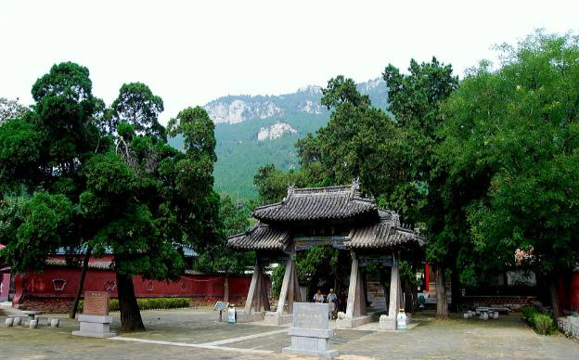
Dongzhen Temple on Mount Wufeng五峰山洞真观

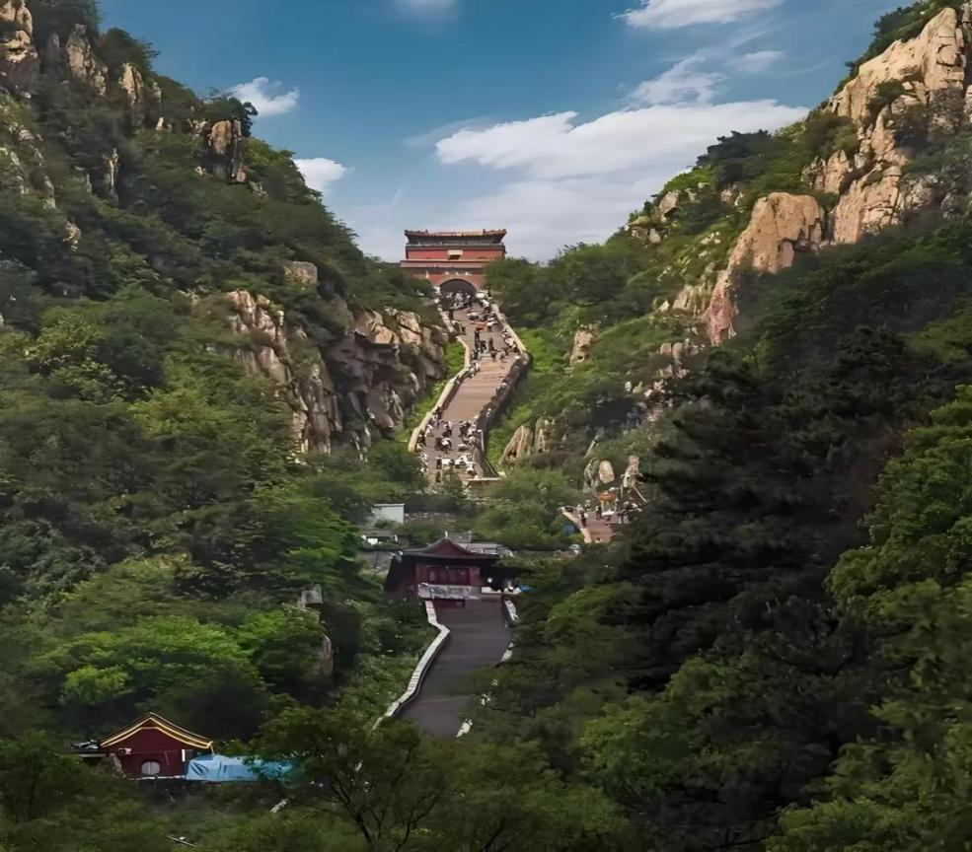
Ladder to Heaven on Mount Tai 泰山天梯
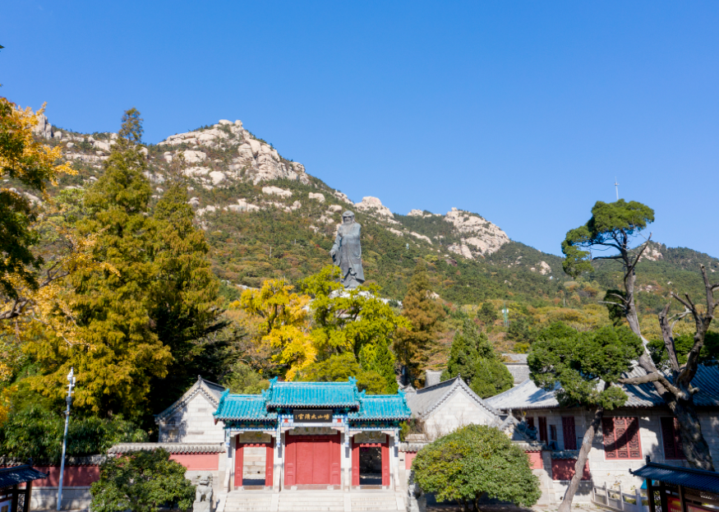Taiqing Temple on Mount Lao 崂山太清宫

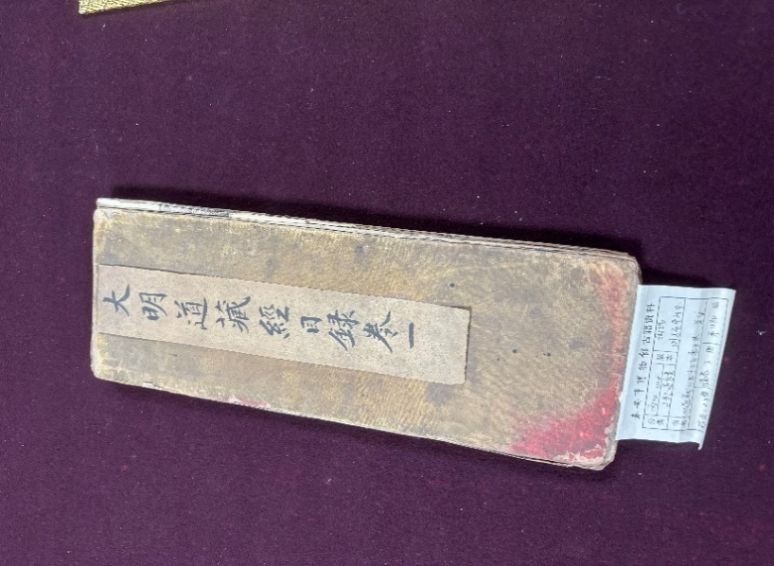
The Daoist Canon collected in Tai’an Museum 泰安博物馆藏明代《道藏》

19th International Conference on Daoist Studies
第19届国际道学研讨会
Registration Form (报名表)
Name  (姓名) |  | Nationality  (国籍) |  | Passport / ID No.  (护照/身份证号码)
Institution (工作单位)
Mobile number (手机号码) |  |  | E-mail (邮箱)
Paper Title (论文题目)
Abstract (内容摘要)
Book the Hotel Wufengge for 3 nights?  (代订3晚五峰阁宾馆) Yes □ No □ |  |  | Book a hotel near Qingdao Airport for May 29?  (代订29日青岛机场附近酒店) Yes □ No □
Join the excursion to Mount Tai &Mount Lao from May 28 to 29?  (参加28-29日泰山和崂山考察) |  |  |  | Yes □ No □
NOTE ：Please fill in all items ；Tick “Yes □ / No □” ；Residents from Hong Kong, Macao and Taiwan, please fill in your passport number for travel to the mainland. If you have any questions, please contact the organizing committee via this mail-box: sduforum@163.com .
注意：请完整填写各项信息；请在“Yes□/No□”处打“√”；港澳台居民请填写往来大陆(内地）通行证号码。若有问题请联系会务组（邮箱 sduforum@163.com）。

