Project 1: The Gas Station

# Introduction

For this project my objective was to figure out how to optimize a gas station so that all customers were served within a certain time and also the owner could make as much money as possible.

# Approach

My plan for getting the data was to create a gas station with a varying amount of pumps and attendants as well as a single line for cars to join to get fuel. I had it set up so that I would just pass in parameters to quickly modify the station. To ensure that I got a different value for a seed each time I used system.time and as I was planning on running the tests back to back the seeds would be different at each test.

# Methods

To run the experiment I created a shell script that would count from 1 to 5 for both pumps and attendants. This shell script ran each test 50 time to highlight any outliers. I then piped the standard output to individual CSV files so that I could import the data into excel as its own sheet. In excel I created a VBA script to quickly import all of the CSVs into their own sheet and average the appropriate columns. I also modified my code to show the wait time for each car that was served.

# Data and Analysis

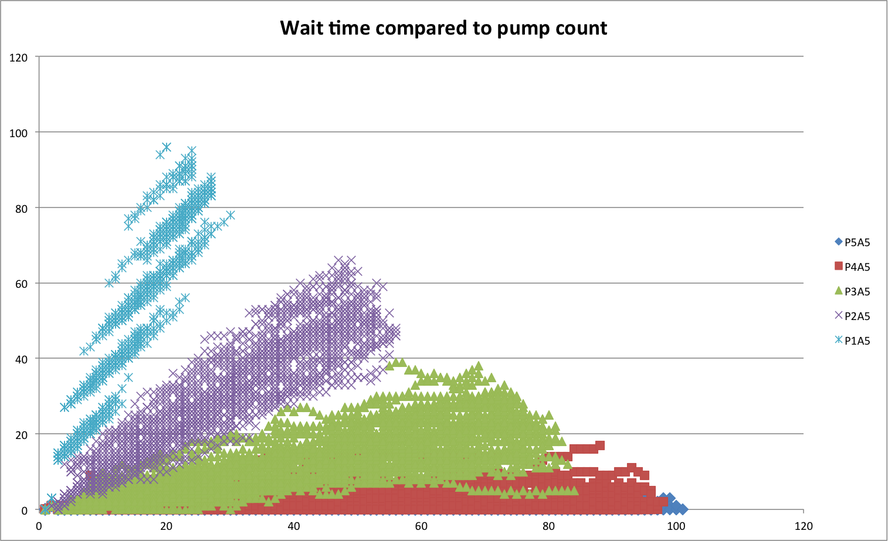

The first problem I wanted to solve was what caused the bottle neck, was it the number of attendants or the number of pumps. To do this I plotted each car against its wait time for different amounts of pumps. I maxed the number of attendants out so I was not limited by them. One interesting pattern I saw was with one pump there seemed to be a large jump up every once and a while and that is when the diesel vehicle arrives since it takes so much longer to fill up. Also, as the amount of pumps goes down the total amount of cars served decrease as well. This suggests that the maximum profit will be when there are 5 pumps since that would generate the largest gross profit.

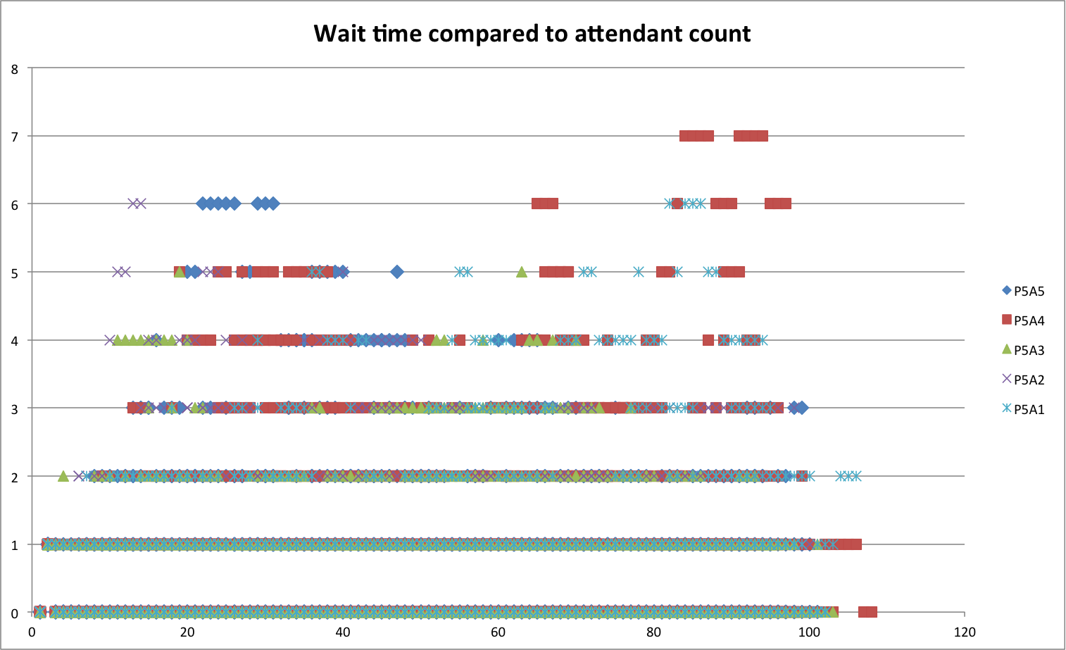

The next graph I plotted was to see how the attendants affected the time to serve customers. This showed that there was no trend at all. This suggested that the maximum net profit would be when there were very few attendants.

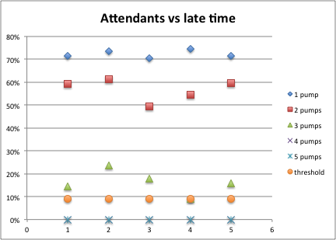

The first 2 graphs were vey cluttered and I couldn't clearly see what the limit was to serve customers quickly enough. As a solution I plotted the percent of late cars compared to number of attendants and pumps. I did this 5 times, one for each pump count. This graph quickly showed that I needed at least 4 attendants if I wanted to serve customers with at least 91% on time.

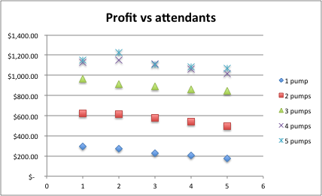

Once I had that done I plotted another graph showing the profit compared to number of attendants. Again I did this 5 times, one for each pump count. The first trend that became apparent was that the number of attendants generally decreased profit. This makes sense since the bottle neck is at the pumps until there are 5 pumps, then it becomes the attendants. After that the cost of hiring another attendant is offset by the work that they do. The graph shows that the optimum position is 5 pumps and 2 attendants. This resulted in a net profit of $1229.40 on average.

# Conclusion

I completed my objective in optimizing the petrol station to keep customers happy but also maximize profit. It appears that values of 5 pumps and 2 attendants is the optimum time.

# References

Project description: https://moodle.lafayette.edu/pluginfile.php/127564/mod_resource/content/1/p1.pdf

Gaussian Distribution tutorial:

http://javapractices.com/topic/TopicAction.do?Id=62

Linked list tutorial:

http://cs.lafayette.edu/~liew/courses/cs150/lab/labs/lab04g/

Queuing theory:

Data Structures & Problem Solving Using Java

p260

VBA tutorials:

http://stackoverflow.com/questions/12933279/how-to-comment-and-uncomment-blocks-of-code-in-the-office-vba-editor

http://www.cpearson.com/excel/declaringvariables.aspx

bash tutorials:

http://www.tldp.org/LDP/Bash-Beginners-Guide/html/sect_07_01.html