Project 2: NIM

# Introduction

For this project my objective was to create and analyze a variation of NIM. I had to make an AI which was capable of playing the game perfectly. My variation involved a pile of marbles of a predetermined size which the player or computer could take out a certain amount. The loser is whoever has no moves at the end.

# Approach

I had to create a file which would allow the user to play against the computer using the scanner input. It would prompt the user for 4 values: the initial size of the pile, what moves are legal, who should go first and how deep should the game tree for the computer be. As the game tree went deeper the compute became smarter and could play better. The number for the tree depth included the current node so a depth of 1 would result in a random choice of moves.

# Methods

Since manually entering every possible move would take a very long time it made sense for the computer to play itself so I created a variation of the game which involved creating 2 game trees. Inside this class the computer played at every pile size, from 20 to 40 and with a game tree depth of 1 to 9. One issue was how to decide what moves were legal. Since there were 5 options to pick I created a binary encoding for the moves where 00000 meant that no moves were permitted and 11111 meant that all moves were permitted. The class then iterated through all possible moves to get data points for every possible setup.

The data from the program was printed out into a csv file which I imported into excel to manipulate further. Since I would need more than one run through I did every game 10 times.

# Data and Analysis

Due to my setup I realized that there was no point in plotting when the human went first or if the computer went first since I used two identical trees. Instead, while assessing the tree depths I plotted the certainty of getting the same outcome again. A value of certain meant that after 10 tests every result was identical, either a win or a loss for the player.

The first set of graphs I plotted was to assess how tree depth affects the outcome of the game. Initially I wasn't sure how to plot it so I decided on performing a 3D plot. I created 2 plots, one of a tree depth of 2 and one of a tree depth of 9.

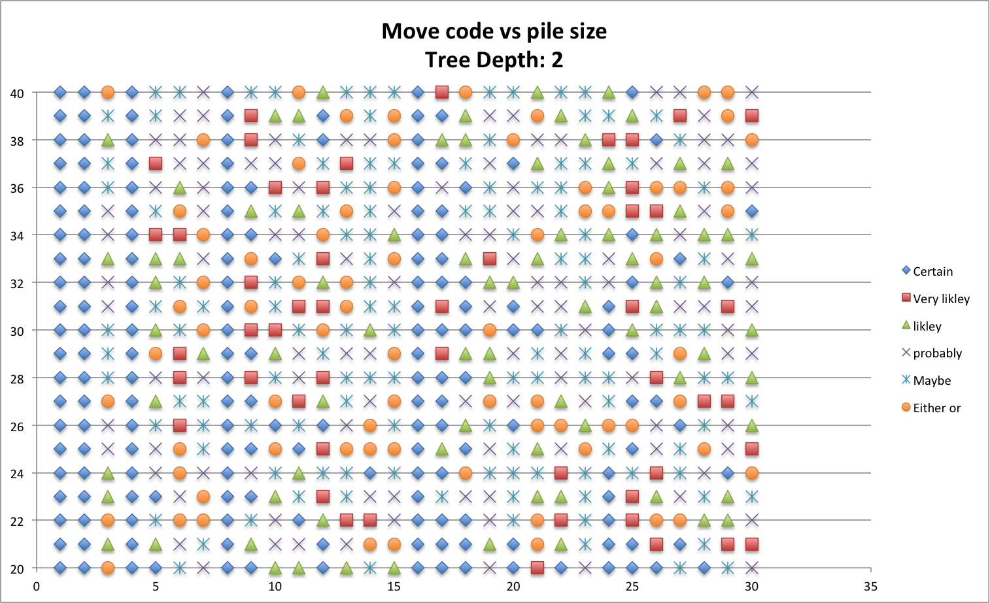

With a depth of 2 the computer picks basically random moves each time, it can only see one move ahead. In some places (move codes 1,2,4,8,16) the outcome is always certain. This is because these codes imply that only one move is legal so whoever won would always win.

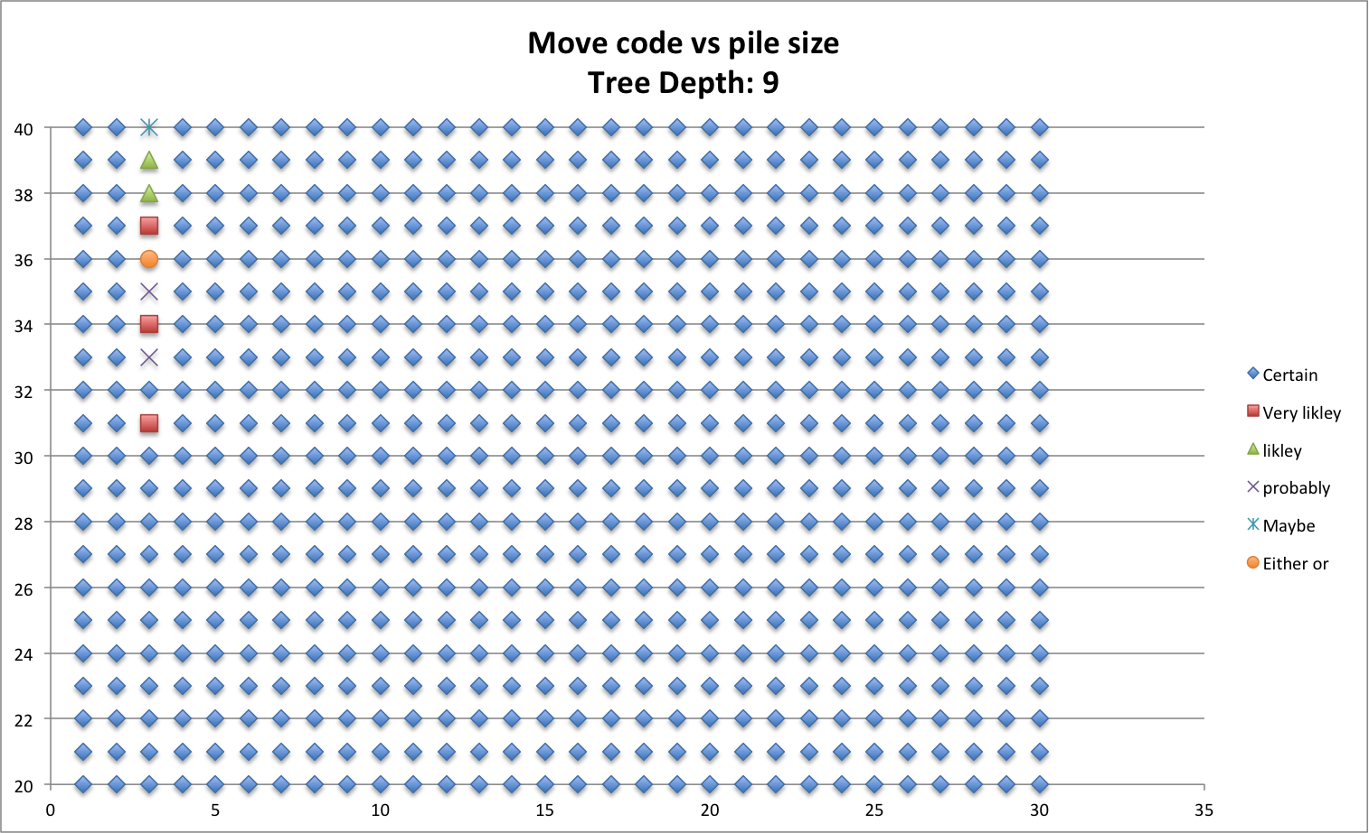

With a depth of 9 almost every position could be predicted perfectly as to what the outcome would be. The only exception was when the pile size was above 30 with 2 or 3 pieces allowed to be removed. This is because the only position that results in a win is if there is one piece left. If only 2 or 3 pieces can be removed it is easy to try and force a win; if the amount left is even take 3 else take 2.

While looking at these graphs I thought that a pile size of 30 would be an interesting value to look at in more detail so I plotted the amount of time the player that went first would win for different move codes and tree depths.

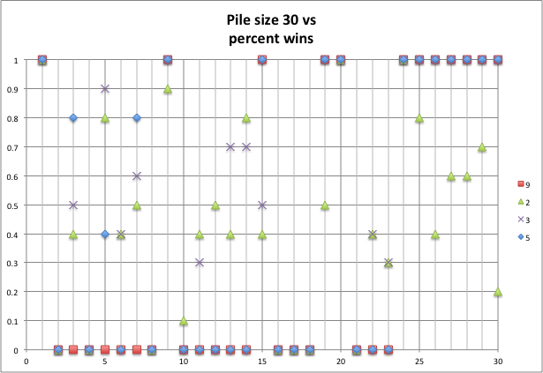

This graph clearly shows that as the tree depth increases the outcome of the game is more certain, either the player will always win or always lose. Once a depth of 5 is passed it doesn't matter what moves are performed the outcomes is predetermined by the moves permitted.

# Conclusion

Overall I think that a game tree size of more than 5 takes the fun out of the game since the computer will almost always outsmart the player. Also, a larger size and more permitted moves result in a better game since there are more options for the player to try and outsmart the computer.

# References

Project description: https://moodle.lafayette.edu/pluginfile.php/132085/mod_resource/content/3/p2.pdf

Excel tutorials:

http://stackoverflow.com/questions/15124103/excel-how-can-i-make-a-scatter-plot-which-colors-by-a-third-column

http://www.excelbanter.com/showthread.php?t=117549

VBA tutorials:

http://stackoverflow.com/questions/12933279/how-to-comment-and-uncomment-blocks-of-code-in-the-office-vba-editor

http://www.cpearson.com/excel/declaringvariables.aspx

http://stackoverflow.com/questions/17194105/how-can-i-color-dots-in-a-xy-scatterplot-according-to-column-value

http://stackoverflow.com/questions/15981802/changing-the-colors-of-the-specific-dots-in-scatterplot-vba-excel/15982217#15982217

Bash tutorials:

http://www.tldp.org/LDP/Bash-Beginners-Guide/html/sect_07_01.html