Restaurante Mananger

Product features:

- Layout manager (secondary)
Create your restaurant layout

- Booking manager (secondary)
Make bookings
- Digital menu
A menu to select from
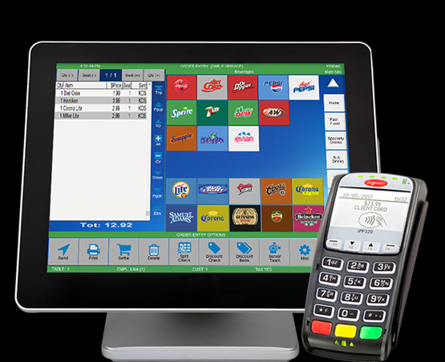

Drill down items that are auto
generated to select items from
a tree menu

- Reporting
Daily, monthly, quarterly and yearly reports about food statistics, earnings and most commonly purchased items
- Printing
Print to the kitchen or other terminals

1. Layout manager

The main layout will be stored in an xml file on the main server side. So if someone is going to request the layout later, then that is where the data comes from.
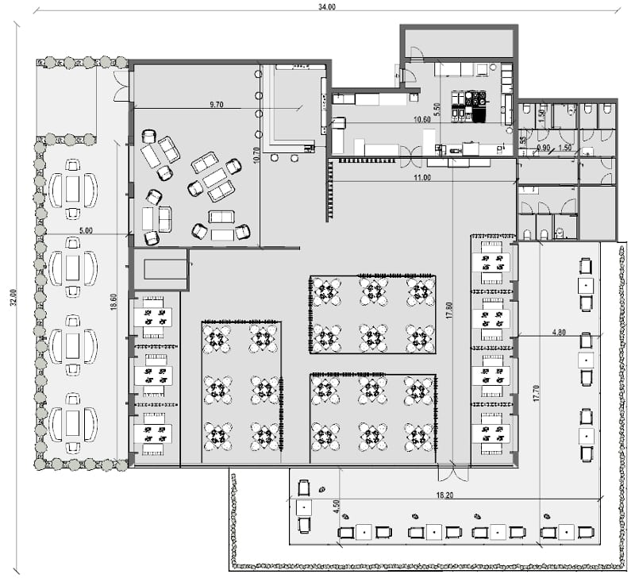
Edit in
software

XML
GUI

Table 1

The user is able to add tables and chairs to the currently selected level layout.
Each element in a layout is resize able, translatable and rotate able.
Also the user can select an image which is displayed as background information.

The tables and chairs are indicating with a name and an index their current position and status using colors (black is not occupied, yellow is occupied, red needs service)
Table(1): prime
Table(1): prime
Table(1): prime
Chair(0)
Chair(0)
Chair(0)

Right mouse button menu for tables in layout:

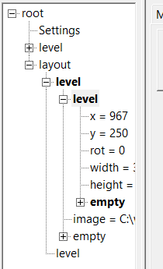
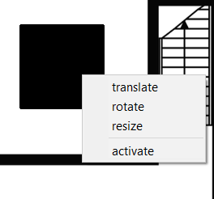
Select active levely
Make active and resize
Select active table
Make active and rotate
Make active and translate

Select active chair

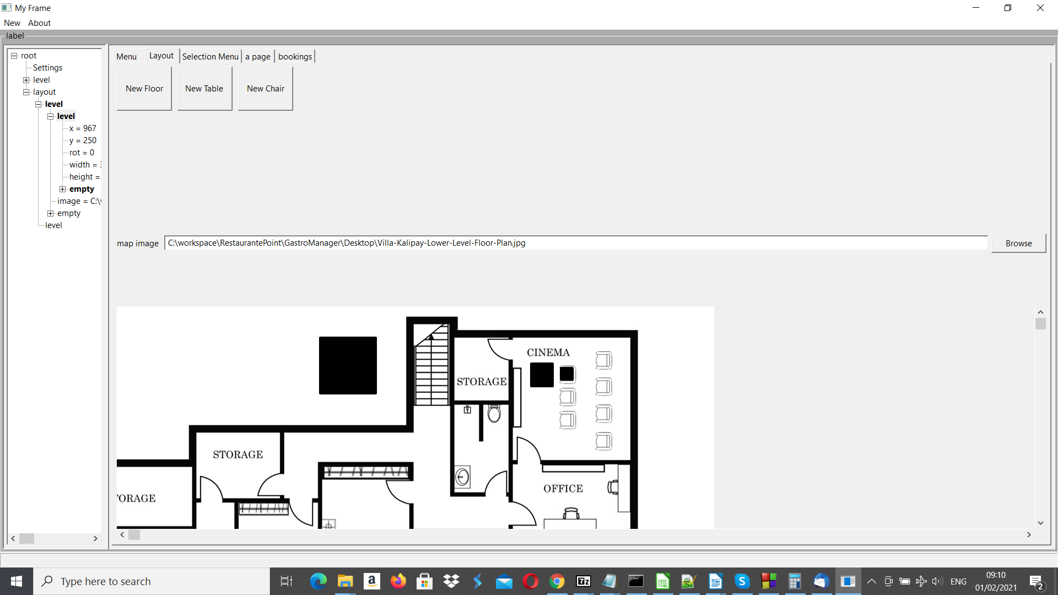
Tree overview Floors, tables and chairs are select able by double clicking them in the tree overview. Each floor can have one image and multiple tables and chairs.
Each selected item can be edited or tables and chairs added to by clicking the corresponding button “New Table” or “New Chair” on the selected item.
2. Bookings manager

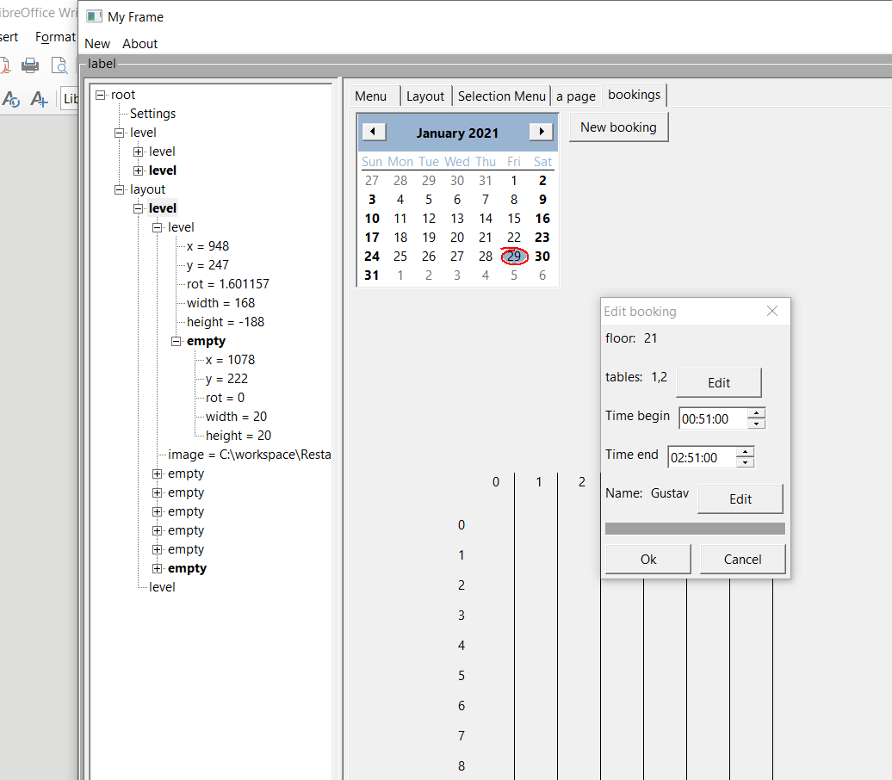
Date
Table
Time

The booking manager stores the bookings in an sqlite table:
id | floors | tables | name | begin | end
int | int | varchar | varchar | datetime | datetime

The table is loaded regularly into the overview (each second). If an element that is supposed to be added is overlapping another entry, then an error message is posted. The currently displayed date is selected by a date picker at the top.
The user can scroll around using the left mouse button. Times can be picked by clicking into the time table or by editing the time in the “Edit booking” dialog.
3. Drill down menu editor

On the left hand side is the tree view, where drill down menus can be selected. According to these drill down menus, a menu is generated and can be edited indicated by the black buttons.

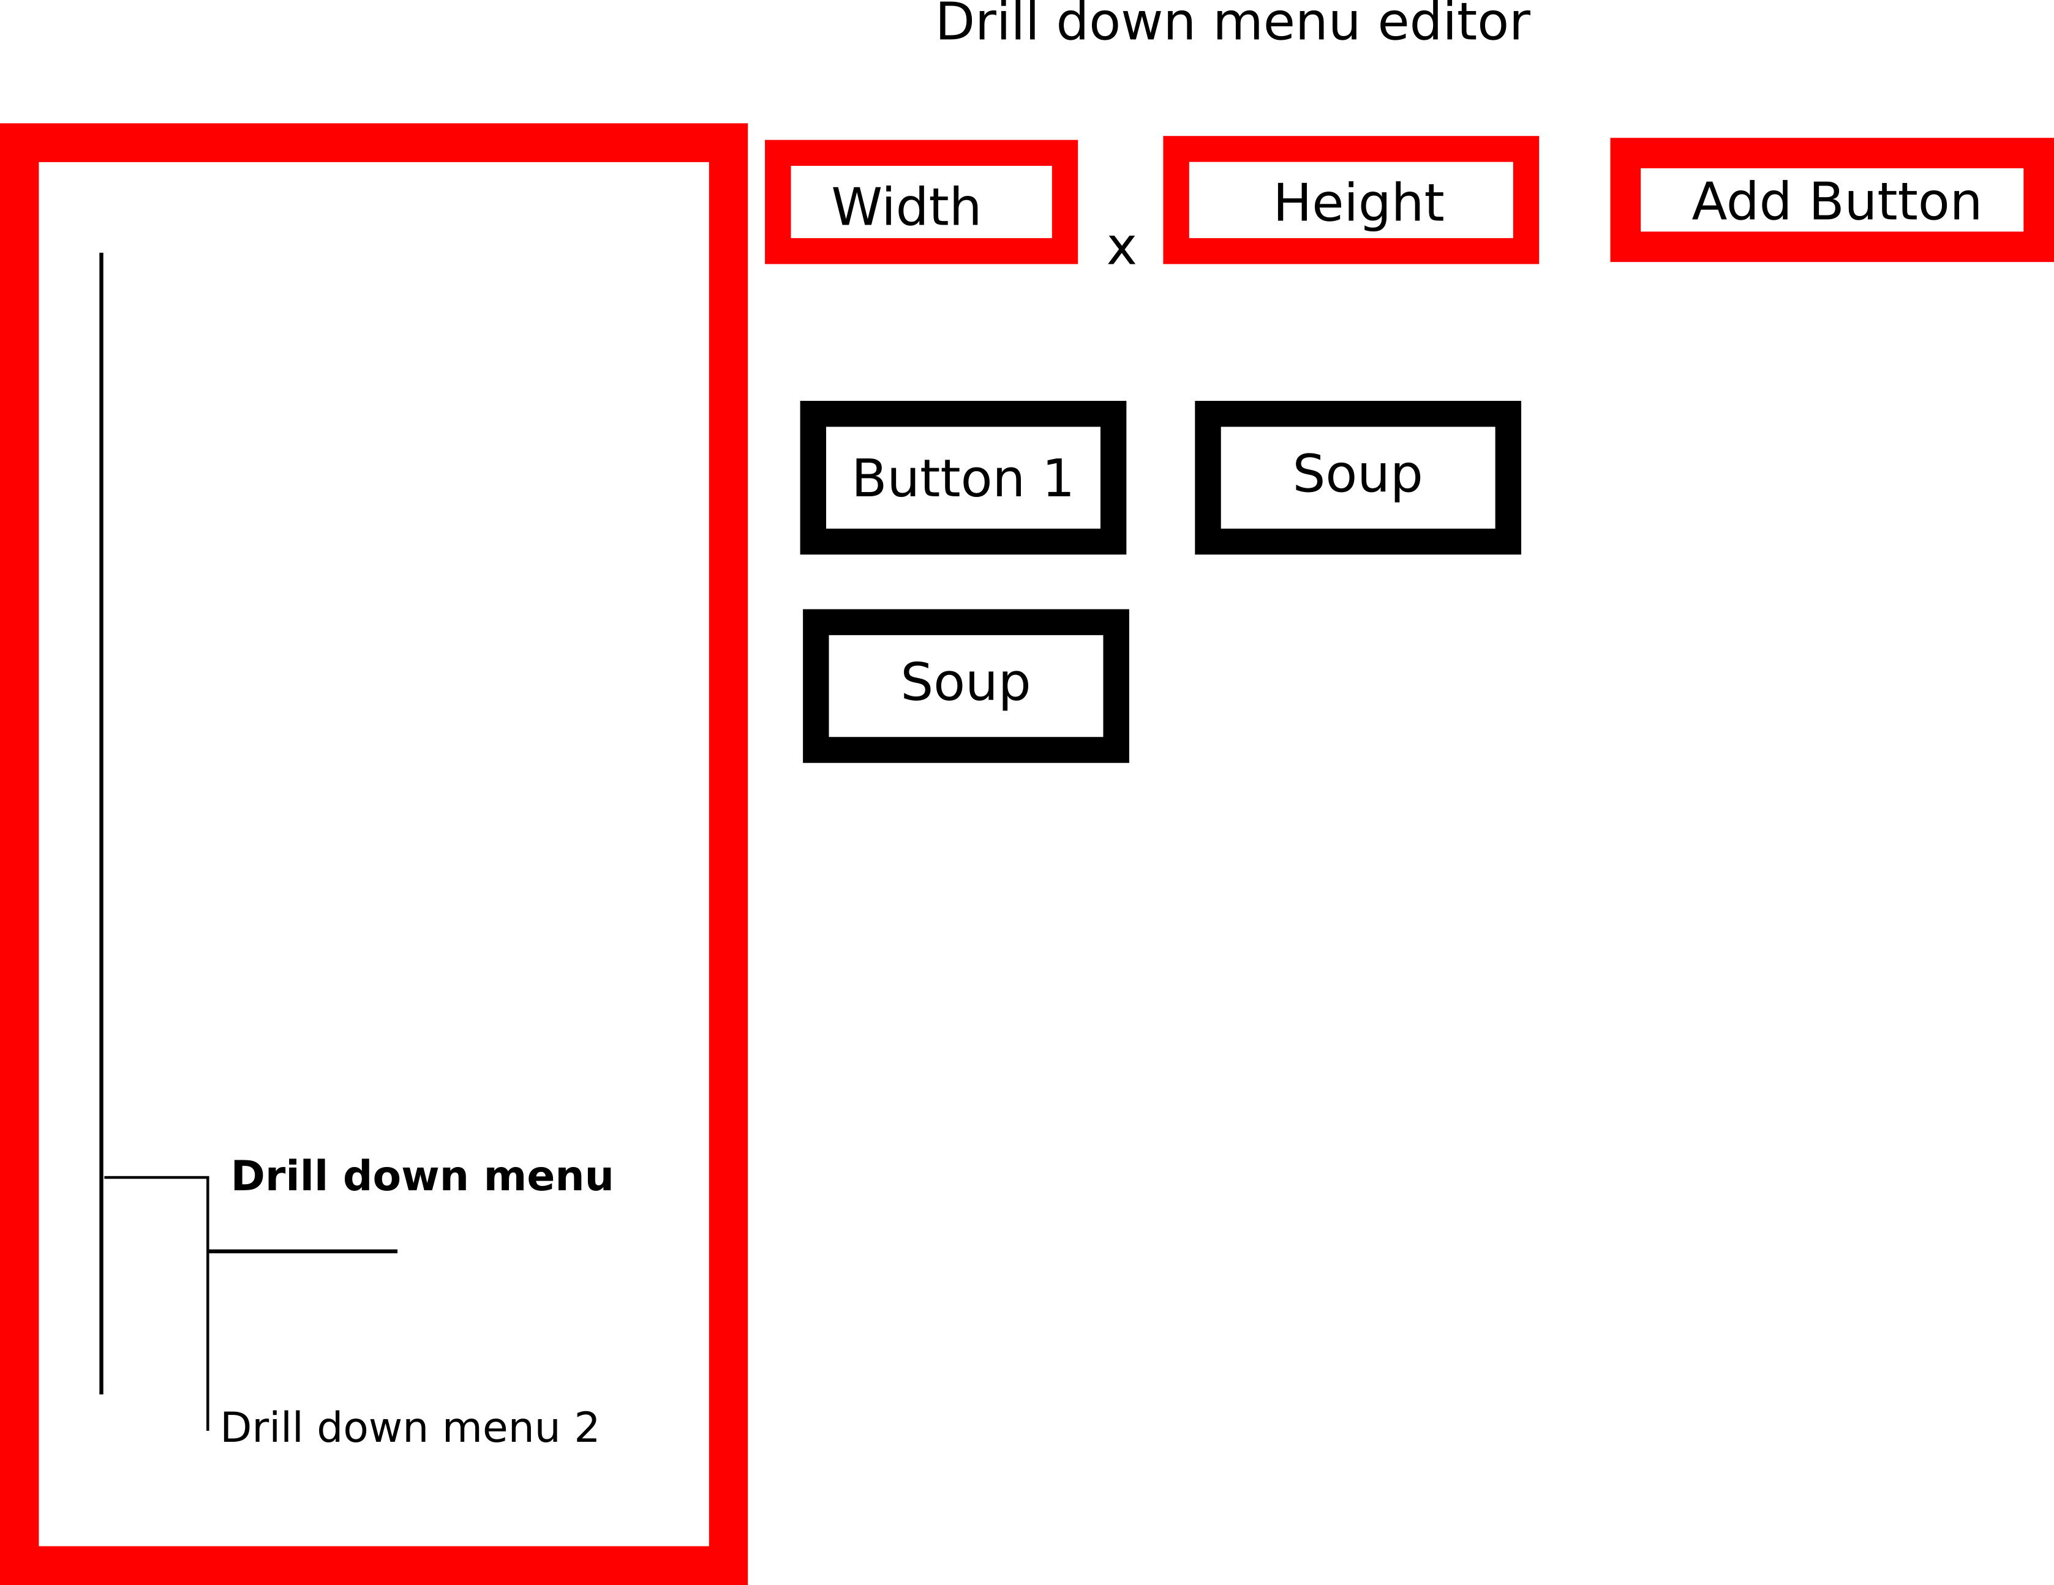
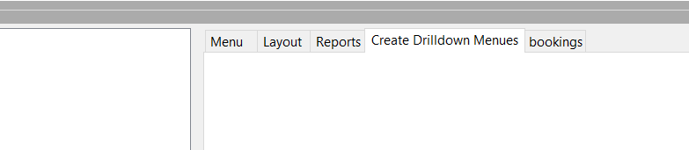

Each button is linked to a menu node, see digital menu. If the user presses on the menu, a drill down menu is automatically generated.
4. Digital menu

<menues>
<item name="Pizza">
<option id="size" name="small" price="0.5" uuid="124456611" />
<option id="size" name="medium" price="0.8" />
<option id="size" name="large" price="1.2" />
<item name="topping" displayname_en="topping" displayname_sp="cubierta">
<option id="toppingammount" name="few" price="0.5" />
<option id="toppingammount" name="more" price="0.8" />
<option id="toppingammount" name="lots" price="1.2" />
<item name="margarita">
<option id="size" name="small" overwrite_price="5.5" />
<option id="size" name="medium" overwrite_price="5.8" />
<option id="size" name="large" price="1.2" />
</item>
</item>
</item>
<item name="Drink" displayname_en="drink">
<option id="size" name="small" price="0.5" />
<option id="size" name="medium" price="0.8" />
<option id="size" name="large" price="1.2" />
<ingridients name="suggar,water"/>
<item name="Coca Cola" displayname_en="Coce">
<option id="size" name="small" displayname_de="klein" overwrite_price="2.0" />
<option id="size" name="medium" displayname_de="mittel" />
<option id="size" name="large" displayname_de="gross" overwrite_price="2.5" />
</item>
<item name="Fanta" displayname_en="Fanta" price="0.5"/>

</item>
</menues>

Menu layout manager
1. Connect push buttons with
menu layout buttons using
their id.
2. Menus will auto generate
from that button
downwards
3. Options are kept throughout the selection process. They
are identified via option id.
4. On the left hand side is a drop down menu listing the selected items

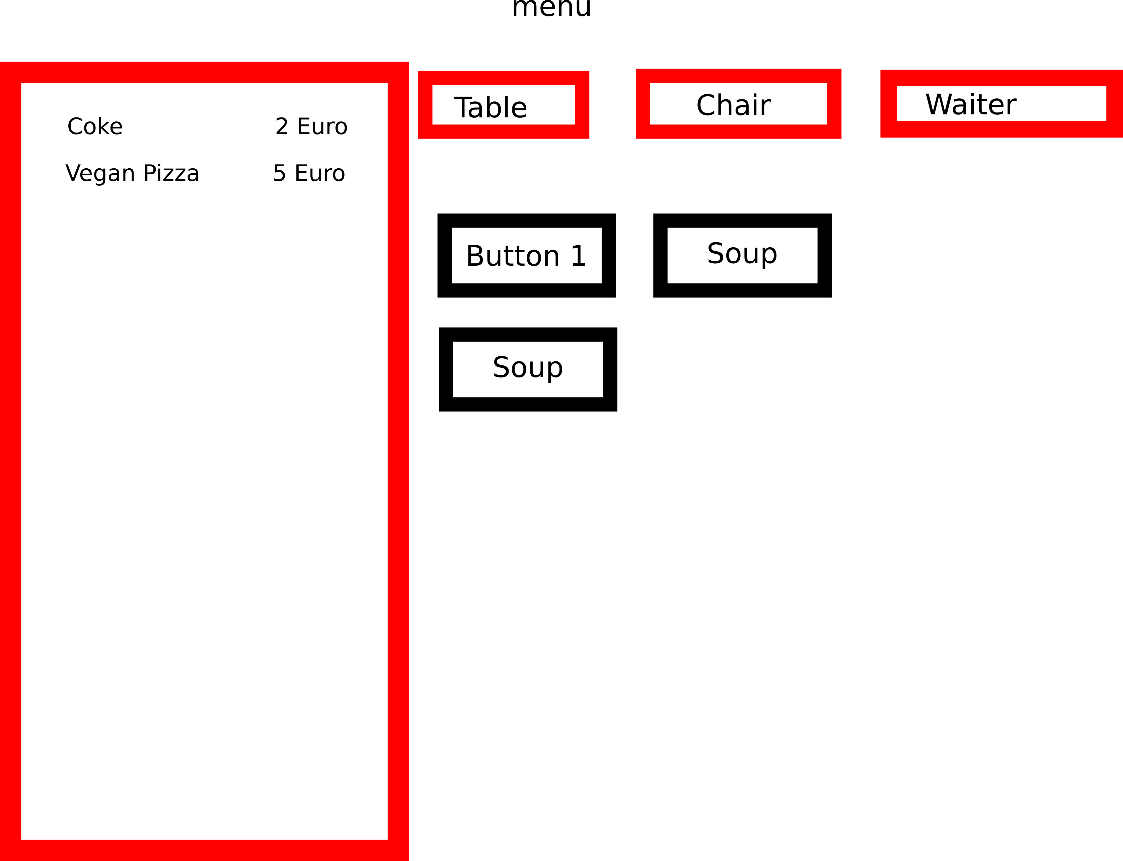

Orders are stored in a table as followed (ordering_table)

id | floor | table | chair | waiter | xml | endpoint | status | Printedstatus | datetime
payed | orderid | displayid | cost

- id – index
- floor – the floor (varchar)
- table – the selected table (varchar)
- chair – the selected chair (varchar)
waiter – waiter id
- xml (Text) – the corresponding XML for the selected node (generated from a leave to last parent node, all relevant xml nodes), the first parent node should have information about which printer to use for this item
- endpoint – is the node leafs id
- status – status of the entry (ready to order, ordered, served, payed)
- print status – status of the printer (not printed, printed)
- datetime – datetime created
- payed – is payed
- orderid – to what order group does this order belong (total index)
- displayid – to what displayid does this order belong (0 to about 1000 per day). This is a daily id that indexes orders
- cost – the total resulting cost of the item

5. Payment section

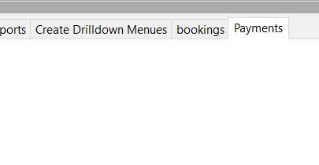

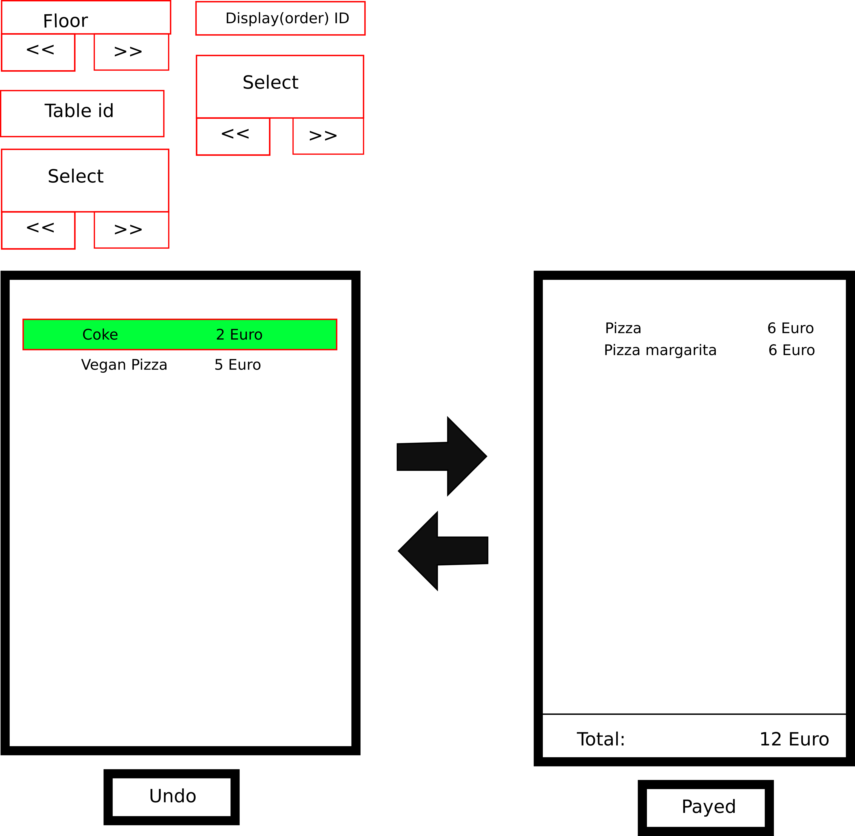

6. Reports

Reports are generated using template documents that are filled with cost estimations and use statistics. For the use statistics there are four tables that count the usage statistics.

id | itemid | timestamp | count | Total revenue
 | Id in xml file | Created timestamp | Count since created within the counting time | Total amount of revenue

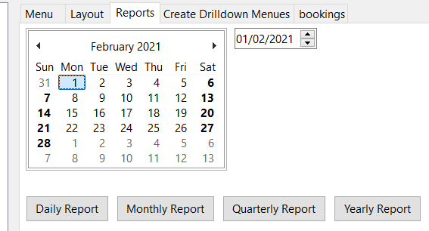

Server

The socket server serves as a binding element for client requests from Android app, communicating using xml

