SUPPLEMENTARY MATERIAL for DOIXXXXXXXXXX Young Children’s Spontaneous Comprehension of Symbol-Referent Relationships in the Graphic Domain

SUPPLEMENTARY MATERIAL for DOIXXXXXXXXXX Young Children’s Spontaneous Comprehension of Symbol-Referent Relationships in the Graphic Domain

Graphic Overview of Participants and Exclusions
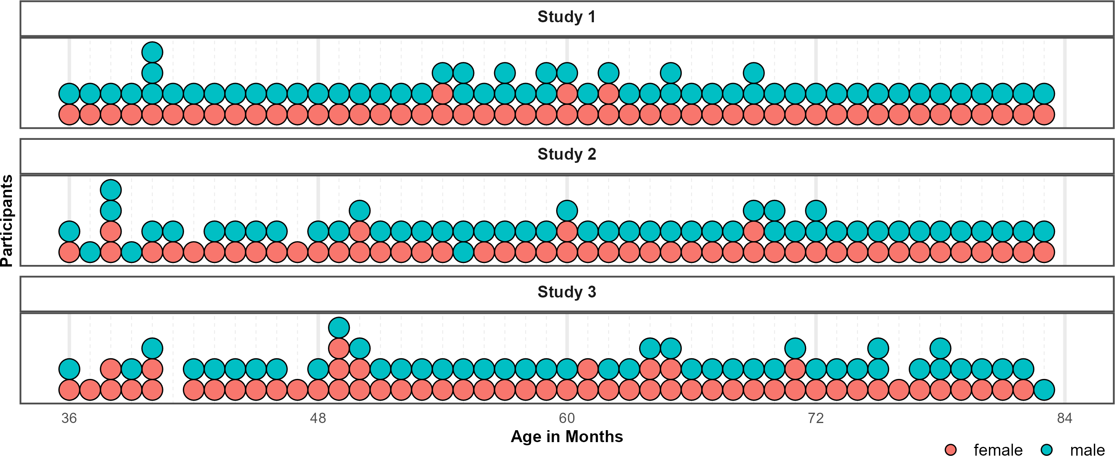
Figure 1. Distribution of Participants across the age-range in all three studies. Dots represent individuals. Colors indicate their respective sex.
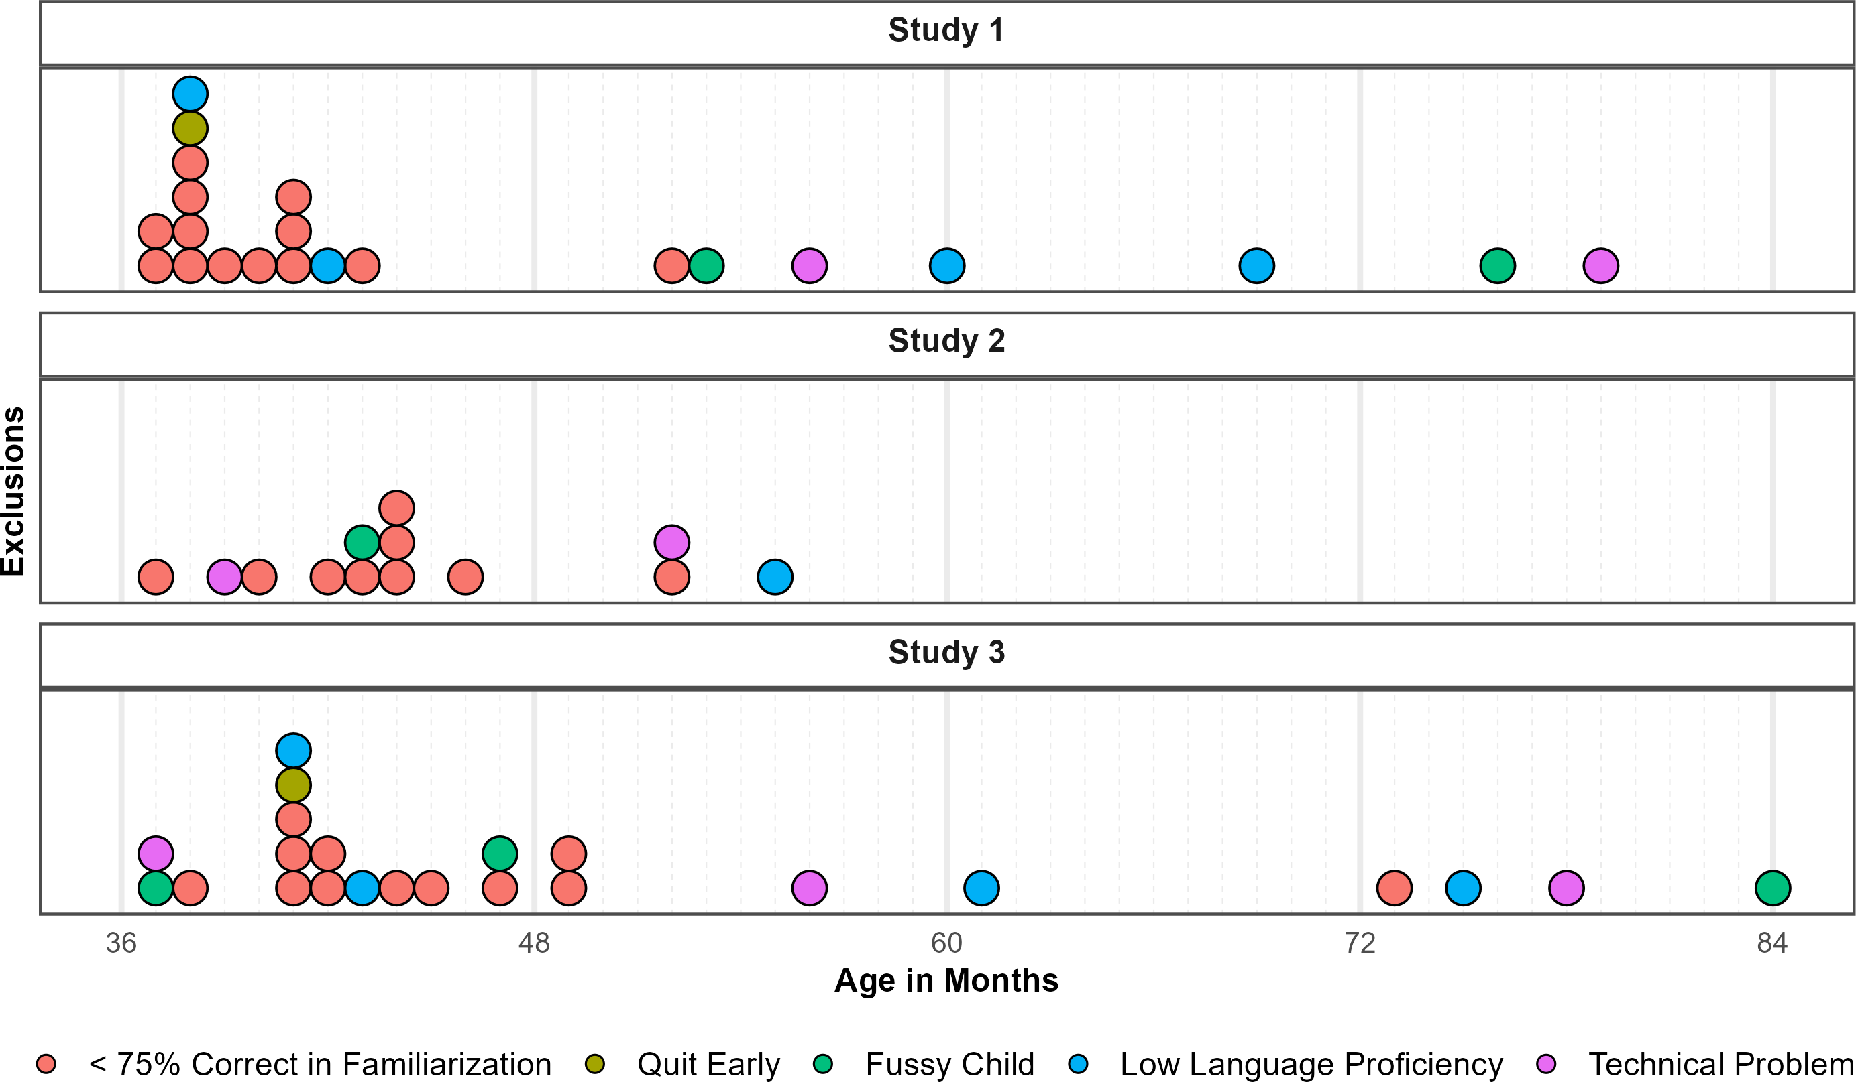
Figure 2. Distribution of Exclusions across the age-range in all three studies. Dots represent individuals. Colors indicate why children where not submitted to analyses.

Posterior Estimates, Descriptives and Conventional Analyses

Study 1
Table 1: Study 1 - Posterior Estimates for the Full Model.
Predictor | Estimate | SD | MAD | 95% CrI | Bulk ESS | Tail ESS
Intercept | 2.03 | 0.20 | 0.20 | [1.64, 2.43] | 5,184 | 6,617
Pars Pro Toto | -0.14 | 0.21 | 0.21 | [-0.54, 0.28] | 7,491 | 7,577
Simple Form Analogy | -1.39 | 0.18 | 0.18 | [-1.75, -1.03] | 6,933 | 7,821
Complex Form Analogy | -1.36 | 0.19 | 0.18 | [-1.73, -1.00] | 6,810 | 6,666
Age* | 0.42 | 0.15 | 0.15 | [0.13, 0.72] | 4,323 | 5,827
Trial* | -0.01 | 0.07 | 0.07 | [-0.15, 0.12] | 10,098 | 7,496
Sex (Male) | -0.29 | 0.20 | 0.20 | [-0.70, 0.10] | 4,512 | 6,169
Pars Pro Toto × Age* | 0.30 | 0.18 | 0.18 | [-0.05, 0.67] | 5,856 | 7,147
Simple Form Analogy × Age* | -0.20 | 0.16 | 0.16 | [-0.52, 0.13] | 5,344 | 6,849
Complex Form Analogy × Age* | -0.08 | 0.17 | 0.17 | [-0.40, 0.25] | 5,673 | 7,198
Note. Estimates represent posterior means with 95% equal-tailed credible intervals (CrIs). MAD indicates Median Absolute Deviation. ESS refers to effective sample size. R̂ values omitted as they are all ~1 indicating convergence. * = variables were standardized.

Table 2: Study 1 - Descriptives and Conventional Analyses.
Condition | Age | N | Trials | Trials/N | M | SD | p | df | t(N-1) | d
Representation | 3-year-olds | 26 | 103 | 3.96 | 75.00 | 22.36 | <0.001 | 25.00 | 5.70 | 1.12
 | 4-year-olds | 28 | 109 | 3.89 | 81.25 | 33.07 | <0.001 | 27.00 | 5.00 | 0.94
 | 5-year-olds | 28 | 112 | 4.00 | 87.50 | 28.46 | <0.001 | 27.00 | 6.97 | 1.32
 | 6-year-olds | 24 | 96 | 4.00 | 87.50 | 20.85 | <0.001 | 23.00 | 8.81 | 1.80
Pars Pro Toto | 3-year-olds | 26 | 104 | 4.00 | 66.35 | 22.30 | <0.001 | 25.00 | 3.74 | 0.73
 | 4-year-olds | 28 | 112 | 4.00 | 75.00 | 31.91 | <0.001 | 27.00 | 4.15 | 0.78
 | 5-year-olds | 28 | 112 | 4.00 | 85.71 | 21.97 | <0.001 | 27.00 | 8.60 | 1.63
 | 6-year-olds | 24 | 96 | 4.00 | 91.67 | 15.93 | <0.001 | 23.00 | 12.82 | 2.62
Simple Form Analogy | 3-year-olds | 26 | 104 | 4.00 | 53.85 | 23.12 | 0.404 | 25.00 | 0.85 | 0.17
 | 4-year-olds | 28 | 112 | 4.00 | 59.82 | 28.33 | 0.078 | 27.00 | 1.83 | 0.35
 | 5-year-olds | 28 | 112 | 4.00 | 58.93 | 28.23 | 0.106 | 27.00 | 1.67 | 0.32
 | 6-year-olds | 24 | 96 | 4.00 | 69.79 | 23.29 | <0.001 | 23.00 | 4.16 | 0.85
Complex Form Analogy | 3-year-olds | 25 | 100 | 4.00 | 53.00 | 25.33 | 0.559 | 24.00 | 0.59 | 0.12
 | 4-year-olds | 28 | 112 | 4.00 | 54.46 | 23.62 | 0.326 | 27.00 | 1.00 | 0.19
 | 5-year-olds | 28 | 112 | 4.00 | 59.82 | 25.77 | 0.054 | 27.00 | 2.02 | 0.38
 | 6-year-olds | 24 | 96 | 4.00 | 76.04 | 18.77 | <0.001 | 23.00 | 6.80 | 1.39
Note. Descriptive and inferential statistics by age group and condition. Performance (*M*, *SD*) is percent correct responses.*p*, *t*, and *d* reflect one-sample t-tests vs. chance level (0.5). *Trials* = total trials across participants; *Trials/N* = average per participant.

Study 2
Table 3: Study 2 - Posterior Estimates for the Full Model.
Predictor | Estimate | SD | MAD | 95% CrI | Bulk ESS | Tail ESS
Intercept | 1.08 | 0.20 | 0.20 | [0.69, 1.48] | 3,776 | 6,041
Relative Position | -0.28 | 0.18 | 0.18 | [-0.64, 0.08] | 7,227 | 7,370
Orientation of Object | -0.10 | 0.19 | 0.19 | [-0.46, 0.27] | 7,545 | 7,408
Orientation of Feature | -0.12 | 0.18 | 0.18 | [-0.48, 0.23] | 7,402 | 7,559
Age* | 0.40 | 0.14 | 0.14 | [0.14, 0.68] | 4,012 | 4,964
Trial* | 0.26 | 0.08 | 0.08 | [0.10, 0.43] | 5,662 | 7,109
Sex (Male) | -0.01 | 0.22 | 0.22 | [-0.45, 0.43] | 3,485 | 5,359
Relative Position × Age* | -0.06 | 0.16 | 0.16 | [-0.37, 0.25] | 7,445 | 7,754
Orientation of Object × Age* | 0.19 | 0.16 | 0.16 | [-0.12, 0.51] | 7,513 | 7,844
Orientation of Feature × Age* | -0.01 | 0.16 | 0.16 | [-0.32, 0.31] | 7,428 | 8,385
Note. Estimates represent posterior means with 95% equal-tailed credible intervals (CrIs). MAD indicates Median Absolute Deviation. ESS refers to effective sample size. R̂ values omitted as they are all ~1 indicating convergence. * = variables were standardized.

Table 4: Study 2 - Descriptives and Conventional Analyses.
Condition | Age | N | Trials | Trials/N | M | SD | p | df | t(N-1) | d
Absolute Position | 3-year-olds | 20 | 80 | 4.00 | 58.75 | 18.63 | 0.049 | 19.00 | 2.10 | 0.47
 | 4-year-olds | 25 | 100 | 4.00 | 62.00 | 33.17 | 0.083 | 24.00 | 1.81 | 0.36
 | 5-year-olds | 27 | 108 | 4.00 | 73.15 | 30.95 | <0.001 | 26.00 | 3.89 | 0.75
 | 6-year-olds | 25 | 100 | 4.00 | 81.00 | 29.12 | <0.001 | 24.00 | 5.32 | 1.06
Relative Position | 3-year-olds | 22 | 88 | 4.00 | 54.55 | 21.32 | 0.329 | 21.00 | 1.00 | 0.21
 | 4-year-olds | 24 | 96 | 4.00 | 59.38 | 26.39 | 0.095 | 23.00 | 1.74 | 0.36
 | 5-year-olds | 27 | 108 | 4.00 | 68.52 | 34.39 | 0.010 | 26.00 | 2.80 | 0.54
 | 6-year-olds | 25 | 100 | 4.00 | 76.00 | 34.97 | 0.001 | 24.00 | 3.72 | 0.74
Orientation of Object | 3-year-olds | 22 | 85 | 3.86 | 48.86 | 19.64 | 0.789 | 21.00 | -0.27 | 0.06
 | 4-year-olds | 25 | 100 | 4.00 | 57.00 | 25.54 | 0.183 | 24.00 | 1.37 | 0.27
 | 5-year-olds | 27 | 108 | 4.00 | 75.93 | 24.50 | <0.001 | 26.00 | 5.50 | 1.06
 | 6-year-olds | 25 | 100 | 4.00 | 81.00 | 25.29 | <0.001 | 24.00 | 6.13 | 1.23
Orientation of Feature | 3-year-olds | 21 | 80 | 3.81 | 55.95 | 28.40 | 0.348 | 20.00 | 0.96 | 0.21
 | 4-year-olds | 25 | 100 | 4.00 | 67.00 | 28.61 | 0.007 | 24.00 | 2.97 | 0.59
 | 5-year-olds | 27 | 108 | 4.00 | 65.74 | 34.77 | 0.027 | 26.00 | 2.35 | 0.45
 | 6-year-olds | 25 | 100 | 4.00 | 79.00 | 33.60 | <0.001 | 24.00 | 4.32 | 0.86
Note. Descriptive and inferential statistics by age group and condition. Performance (*M*, *SD*) is percent correct responses.*p*, *t*, and *d* reflect one-sample t-tests vs. chance level (0.5). *Trials* = total trials across participants; *Trials/N* = average per participant.

Study 3
Table 5: Study 3 - Posterior Estimates for the Full Model.
Predictor | Estimate | SD | MAD | 95% CrI | Bulk ESS | Tail ESS
Intercept | 1.04 | 0.18 | 0.18 | [0.70, 1.38] | 5,074 | 6,931
Size of Feature | -0.71 | 0.18 | 0.18 | [-1.06, -0.36] | 7,351 | 7,601
Number of Object | -0.08 | 0.18 | 0.18 | [-0.43, 0.28] | 7,735 | 8,265
Number of Feature | -0.31 | 0.18 | 0.18 | [-0.67, 0.05] | 7,429 | 7,348
Age* | 0.70 | 0.14 | 0.13 | [0.44, 0.97] | 4,556 | 6,771
Trial* | 0.21 | 0.08 | 0.08 | [0.06, 0.36] | 8,586 | 7,671
Sex (Male) | -0.18 | 0.19 | 0.18 | [-0.55, 0.18] | 5,392 | 6,583
Size of Feature × Age* | -0.50 | 0.16 | 0.16 | [-0.82, -0.20] | 6,020 | 6,979
Number of Object × Age* | 0.00 | 0.16 | 0.16 | [-0.32, 0.32] | 6,741 | 7,976
Number of Feature × Age* | -0.29 | 0.16 | 0.16 | [-0.60, 0.03] | 6,633 | 6,930
Note. Estimates represent posterior means with 95% equal-tailed credible intervals (CrIs). MAD indicates Median Absolute Deviation. ESS refers to effective sample size. R̂ values omitted as they are all ~1 indicating convergence. * = variables were standardized.

Table 6: Study 3 - Descriptives and Conventional Analyses.
Condition | Age | N | Trials | Trials/N | M | SD | p | df | t(N-1) | d
Size of Object | 3-year-olds | 21 | 84 | 4.00 | 51.19 | 23.02 | 0.815 | 20.00 | 0.24 | 0.05
 | 4-year-olds | 27 | 105 | 3.89 | 54.63 | 31.80 | 0.456 | 26.00 | 0.76 | 0.15
 | 5-year-olds | 26 | 104 | 4.00 | 84.62 | 25.57 | <0.001 | 25.00 | 6.90 | 1.35
 | 6-year-olds | 24 | 96 | 4.00 | 78.12 | 22.50 | <0.001 | 23.00 | 6.12 | 1.25
Size of Feature | 3-year-olds | 21 | 84 | 4.00 | 46.43 | 19.82 | 0.419 | 20.00 | -0.83 | 0.18
 | 4-year-olds | 26 | 104 | 4.00 | 51.92 | 23.37 | 0.678 | 25.00 | 0.42 | 0.08
 | 5-year-olds | 26 | 104 | 4.00 | 56.73 | 32.06 | 0.295 | 25.00 | 1.07 | 0.21
 | 6-year-olds | 24 | 96 | 4.00 | 62.50 | 19.50 | 0.005 | 23.00 | 3.14 | 0.64
Number of Object | 3-year-olds | 21 | 84 | 4.00 | 42.86 | 21.13 | 0.137 | 20.00 | -1.55 | 0.34
 | 4-year-olds | 27 | 108 | 4.00 | 61.11 | 30.49 | 0.069 | 26.00 | 1.89 | 0.36
 | 5-year-olds | 26 | 104 | 4.00 | 72.12 | 34.88 | 0.003 | 25.00 | 3.23 | 0.63
 | 6-year-olds | 24 | 96 | 4.00 | 83.33 | 32.69 | <0.001 | 23.00 | 4.99 | 1.02
Number of Feature | 3-year-olds | 21 | 82 | 3.90 | 50.00 | 19.36 | >0.999 | 20.00 | 0.00 | 0.00
 | 4-year-olds | 27 | 108 | 4.00 | 62.96 | 24.39 | 0.010 | 26.00 | 2.76 | 0.53
 | 5-year-olds | 26 | 104 | 4.00 | 65.38 | 31.68 | 0.020 | 25.00 | 2.48 | 0.49
 | 6-year-olds | 24 | 96 | 4.00 | 76.04 | 27.07 | <0.001 | 23.00 | 4.71 | 0.96
Note. Descriptive and inferential statistics by age group and condition. Performance (*M*, *SD*) is percent correct responses.*p*, *t*, and *d* reflect one-sample t-tests vs. chance level (0.5). *Trials* = total trials across participants; *Trials/N* = average per participant.

Exploratory Analyses Including Item-Level Random Effects
In addition to our main analyses, we preregistered additional exploratory analyses for evaluating item-level effects separately in each study. For this we added a crossed random effects for items, allowing the relationship between age and performance to vary across items (correct ~ condition*z.age + z.trial + sex + (z.trial |subid)). Due to the lower number of individual items within a task, we expected these models to be less diagnostic with regard to our main research question. However, the analyses provides detail about the equivalence of items within conditions.

Study 1
An exploratory model with additional item-level random effects showed that the variability of intercepts at the item level was small ($β$ = 0.17, 95% CrI [0.01,0.40]). Likewise there was only modest variation for the effect of age across items ($β$ = 0.14, 95% CrI [0.01,0.34]). The correlation between item difficulty and item-specific age slopes was highly uncertain (ρ = 0.35, 95% CrI [-0.83,0.98]). Model weights based on the WAIC suggested that the full model was more likely to provide accurate predictions (weight = 82.92% ) compared to the item model (weight = 17.08%).The estimated difference in expected log predictive density (elpd) between models, however, was not much larger than the difference itself (ELPD diff = -0.91), indicating considerable uncertainty as to whether either model was preferable. For on overview of logg odds for all items across conditions see figure 3. For a full overview of coefficients and the random effects structure of the item model see table 7.

Study 2
An exploratory model including item-level random effects indicated modest variability ($β$ = 0.25, 95% CrI [0.02,0.53]). The variability of age effects across items was small ($β$ = 0.11, 95% CrI [0.00, 0.30]), suggesting that the effect of age was fairly consistent across items. The correlation between item intercepts and age slopes was near zero and highly uncertain (ρ = 0.01, 95% CrI [-0.94,0.94]), providing no reliable evidence that slightly easier or difficult items varied in age-related gains. Comparing the models using WAIC weights showed that including item-level random effects in Study 2 did not provide a clear advantage in out-of-sample predictive accuracy (full model 39.32%; item model 60.68%). Comparing the models corroborates this (ELPD WAIC; full model = -889.99; item model = -889.28). The difference in expected log predictive density was negligible (ELPD diff = 0), and within the range of sampling uncertainty (SE =0). For an overview of item level variability across conditions see figure 3. For a full table of coefficients and random effects of the exploratory model see table 8.

Study 3
To evaluate the equivalence of items within conditions, item-level random effects were included in an exploratory model showing that item variation at the intercept was moderate ($β$ = 0.20, 95% CrI [0.02,0.44]) and that the effect of age varied slightly across items ($β$ = 0.22, 95% CrI [0.03,0.45]). Again, the correlation between item difficulty and item-specific age slopes was moderately positive but uncertain (ρ = 0.55, 95% CrI [-0.57,0.99]) providing weak evidence that easier items had stronger age-related gains. Comparing the models using WAIC weights showed that the item model had higher predictive power (full model 31.70%; item model 68.30%). Comparing the models’ WAIC via ELPDs corroborates this (full model = -941.75; item model = -939.71). The difference in expected log predictive density favored the item model (ELPD diff = -2.04), though the uncertainty around this estimate suggests that the evidence is not decisive (SE =3.19). Graphically exploring item-level variability via logg odds indicates that the estimated deviation from the intercept is still including zero (cf. figure 3). For an overview of coefficients and random effects see table 9 in appendix 3.

Discussion
In studies 1 and 2, the inclusion of item-level random effects did not meaningfully improve model fit. The main analyses reported in the manuscript and the exploratory models reported here account for the data equally well. For study 3, including item-level random effects yielded moderate variability. Here the analysis provides modest evidence for variability due to item level effects. As in all studies reported above, these were small compared to the participant random effects. None of the model comparisons provided substantial evidence for a better fit of the exploratory models. Hence, the additional analyses provided here provide no grounds for deterring from the preregistered analysis reported in the manuscript.

Table 7: Study 1 - Posterior Estimates for Exploratory Model with Item-Level Random Effects.
Predictor | Estimate | SD | MAD | 95% CrI | Bulk ESS | Tail ESS
Intercept | 2.04 | 0.23 | 0.22 | [1.60, 2.50] | 6,827 | 6,155
Pars Pro Toto | -0.13 | 0.25 | 0.24 | [-0.63, 0.36] | 9,329 | 7,194
Simple Form Analogy | -1.40 | 0.23 | 0.23 | [-1.85, -0.94] | 8,693 | 7,089
Complex Form Analogy | -1.36 | 0.23 | 0.22 | [-1.82, -0.91] | 8,770 | 7,373
Age* | 0.43 | 0.17 | 0.17 | [0.09, 0.77] | 6,101 | 5,738
Trial* | -0.01 | 0.07 | 0.07 | [-0.15, 0.12] | 12,068 | 8,047
Sex (Male) | -0.29 | 0.21 | 0.20 | [-0.70, 0.11] | 7,184 | 7,229
Pars Pro Toto × Age* | 0.31 | 0.22 | 0.21 | [-0.12, 0.73] | 8,061 | 6,743
Simple Form Analogy × Age* | -0.20 | 0.20 | 0.19 | [-0.60, 0.19] | 7,048 | 6,608
Complex Form Analogy × Age* | -0.07 | 0.20 | 0.19 | [-0.48, 0.32] | 7,479 | 6,036
Random Effects
Item Intercept (SD) | 0.17 | 0.10 | 0.10 | [0.01, 0.40] | 3,324 | 5,071
Item × Age Slope (SD) | 0.14 | 0.09 | 0.09 | [0.01, 0.34] | 4,348 | 5,360
Subject Intercept (SD) | 0.85 | 0.10 | 0.10 | [0.66, 1.06] | 4,038 | 6,548
Subject × Trial slope (SD) | 0.17 | 0.10 | 0.11 | [0.01, 0.37] | 4,163 | 5,072
Correlation: Item Intercept & Age Slope | 0.35 | 0.52 | 0.53 | [-0.83, 0.98] | 6,312 | 7,115
Correlation: Subject Intercept & Trial Slope | -0.48 | 0.42 | 0.37 | [-0.98, 0.62] | 9,528 | 6,694
Note. Estimates represent posterior means with 95% equal-tailed credible intervals (CrIs). MAD indicates Median Absolute Deviation. ESS refers to effective sample size. R̂ values omitted as they are all ~1 indicating convergence. * = variables were standardized.

Table 8: Study 2 - Posterior Estimates for Exploratory Model with Item-Level Random Effects.
Predictor | Estimate | SD | MAD | 95% CrI | Bulk ESS | Tail ESS
Intercept | 1.10 | 0.24 | 0.24 | [0.63, 1.58] | 6,790 | 6,800
Relative Position | -0.29 | 0.27 | 0.25 | [-0.82, 0.24] | 8,525 | 6,333
Orientation of Object | -0.10 | 0.27 | 0.25 | [-0.63, 0.45] | 8,989 | 6,423
Orientation of Feature | -0.13 | 0.27 | 0.25 | [-0.68, 0.42] | 8,951 | 6,857
Age* | 0.41 | 0.15 | 0.15 | [0.11, 0.72] | 7,413 | 7,361
Trial* | 0.26 | 0.08 | 0.08 | [0.10, 0.43] | 9,367 | 8,404
Sex (Male) | -0.01 | 0.23 | 0.23 | [-0.46, 0.44] | 6,139 | 6,947
Relative Position × Age* | -0.06 | 0.19 | 0.18 | [-0.43, 0.31] | 9,354 | 7,529
Orientation of Object × Age* | 0.19 | 0.19 | 0.18 | [-0.16, 0.56] | 9,640 | 7,368
Orientation of Feature × Age* | -0.01 | 0.19 | 0.18 | [-0.37, 0.36] | 9,415 | 7,527
Random Effects
Item Intercept (SD) | 0.25 | 0.13 | 0.12 | [0.02, 0.53] | 2,919 | 4,096
Item × Age Slope (SD) | 0.11 | 0.08 | 0.08 | [0.00, 0.30] | 4,974 | 6,461
Subject Intercept (SD) | 0.99 | 0.12 | 0.12 | [0.76, 1.25] | 3,605 | 5,886
Subject × Trial slope (SD) | 0.48 | 0.12 | 0.12 | [0.25, 0.71] | 3,534 | 4,754
Correlation: Item Intercept & Age Slope | 0.01 | 0.55 | 0.69 | [-0.94, 0.94] | 12,775 | 7,849
Correlation: Subject Intercept & Trial Slope | 0.64 | 0.19 | 0.19 | [0.20, 0.95] | 3,746 | 3,362
Note. Estimates represent posterior means with 95% equal-tailed credible intervals (CrIs). MAD indicates Median Absolute Deviation. ESS refers to effective sample size. R̂ values omitted as they are all ~1 indicating convergence. * = variables were standardized.

Table 9: Study 3 - Posterior Estimates for Exploratory Model with Item-Level Random Effects.
Predictor | Estimate | SD | MAD | 95% CrI | Bulk ESS | Tail ESS
Intercept | 1.06 | 0.21 | 0.20 | [0.66, 1.48] | 7,161 | 5,863
Size of Feature | -0.71 | 0.24 | 0.23 | [-1.20, -0.22] | 7,855 | 7,019
Number of Object | -0.08 | 0.25 | 0.24 | [-0.56, 0.42] | 7,859 | 7,461
Number of Feature | -0.31 | 0.25 | 0.23 | [-0.81, 0.19] | 8,119 | 6,635
Age* | 0.71 | 0.19 | 0.18 | [0.34, 1.09] | 6,586 | 6,280
Trial* | 0.21 | 0.08 | 0.08 | [0.06, 0.37] | 12,182 | 7,945
Sex (Male) | -0.18 | 0.19 | 0.19 | [-0.57, 0.20] | 8,353 | 7,734
Size of Feature × Age* | -0.50 | 0.24 | 0.23 | [-0.98, -0.03] | 7,251 | 6,897
Number of Object × Age* | 0.01 | 0.24 | 0.23 | [-0.47, 0.49] | 6,793 | 6,483
Number of Feature × Age* | -0.28 | 0.24 | 0.23 | [-0.76, 0.21] | 7,445 | 7,168
Random Effects
Item Intercept (SD) | 0.20 | 0.11 | 0.10 | [0.02, 0.44] | 3,252 | 3,250
Item × Age Slope (SD) | 0.22 | 0.10 | 0.09 | [0.03, 0.45] | 3,196 | 3,365
Subject Intercept (SD) | 0.73 | 0.10 | 0.10 | [0.54, 0.94] | 4,031 | 5,630
Subject × Trial slope (SD) | 0.42 | 0.11 | 0.10 | [0.18, 0.62] | 2,907 | 2,870
Correlation: Item Intercept & Age Slope | 0.55 | 0.41 | 0.33 | [-0.57, 0.99] | 4,265 | 4,116
Correlation: Subject Intercept & Trial Slope | 0.16 | 0.26 | 0.26 | [-0.36, 0.66] | 4,836 | 4,585
Note. Estimates represent posterior means with 95% equal-tailed credible intervals (CrIs). MAD indicates Median Absolute Deviation. ESS refers to effective sample size. R̂ values omitted as they are all ~1 indicating convergence. * = variables were standardized.

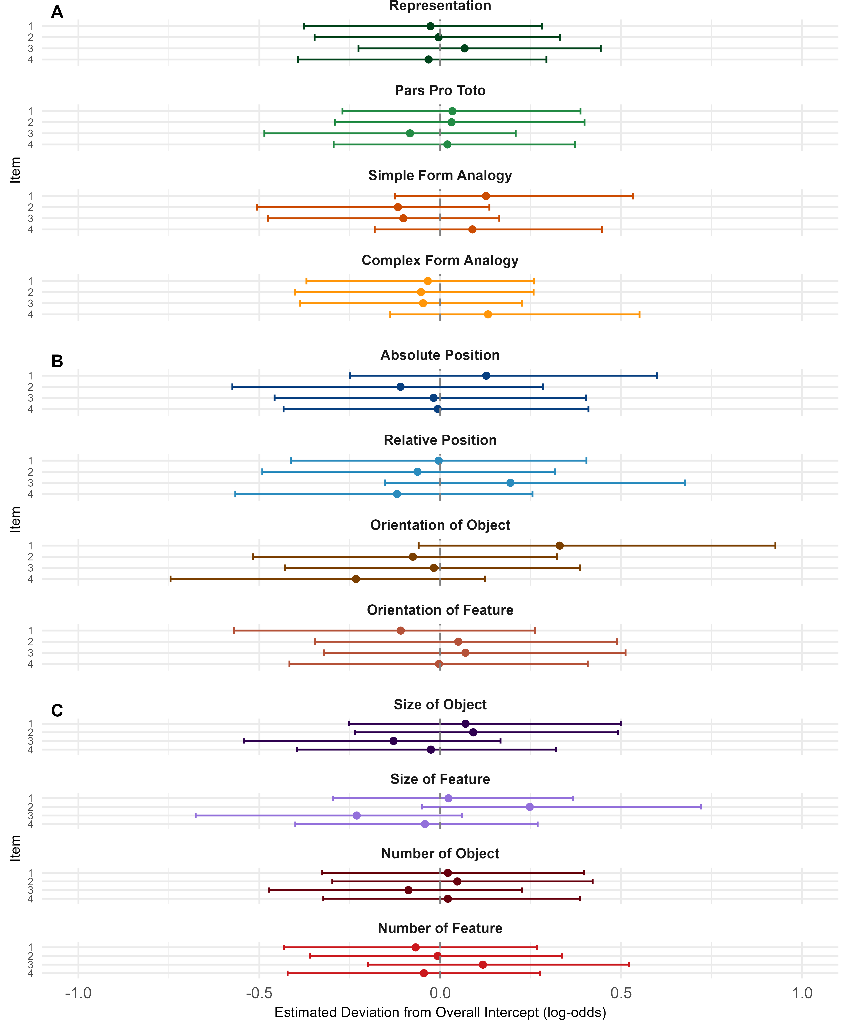
Figure 3. Item-Level Random Intercepts by Condition.

