SUPPLEMENTARY MATERIAL for Young Children’s Spontaneous Comprehension of Symbol-Referent Relationships in the Graphic Domain
Gregor Kachel¹, Daniel Haun², & Manuel Bohn¹
¹ Leuphana University
² Max-Planck-Institute for Evolutionary Anthropology

Author note
Correspondence concerning this article should be addressed to Gregor Kachel, Universitätsallee 1, C1.008a, 21335 Lüneburg. E-mail: gregor.kachel@leuphana.de

SUPPLEMENTARY MATERIAL for Young Children’s Spontaneous Comprehension of Symbol-Referent Relationships in the Graphic Domain

Graphic Overview of Participants and Exclusions
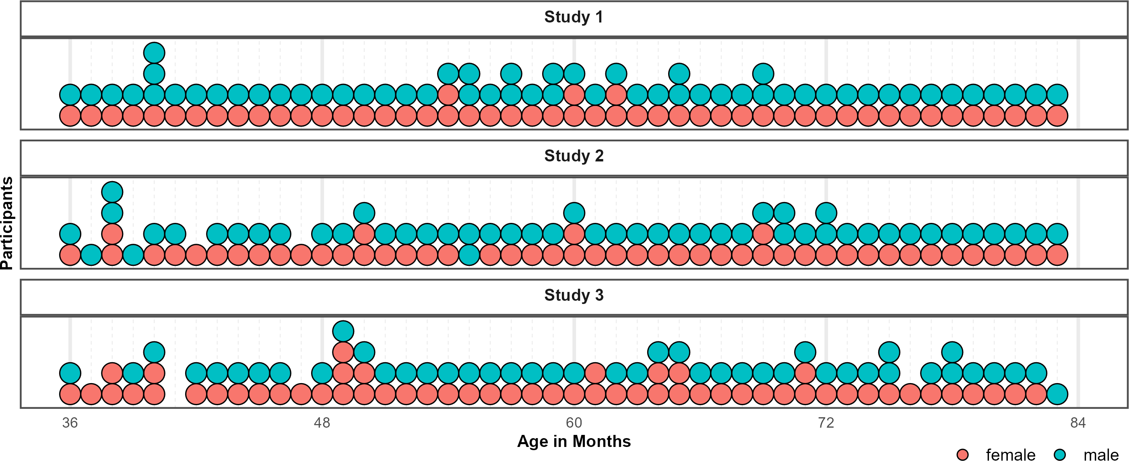
Figure 1. Distribution of Participants across the age-range in all three studies. Dots represent individuals. Colors indicate their respective sex.
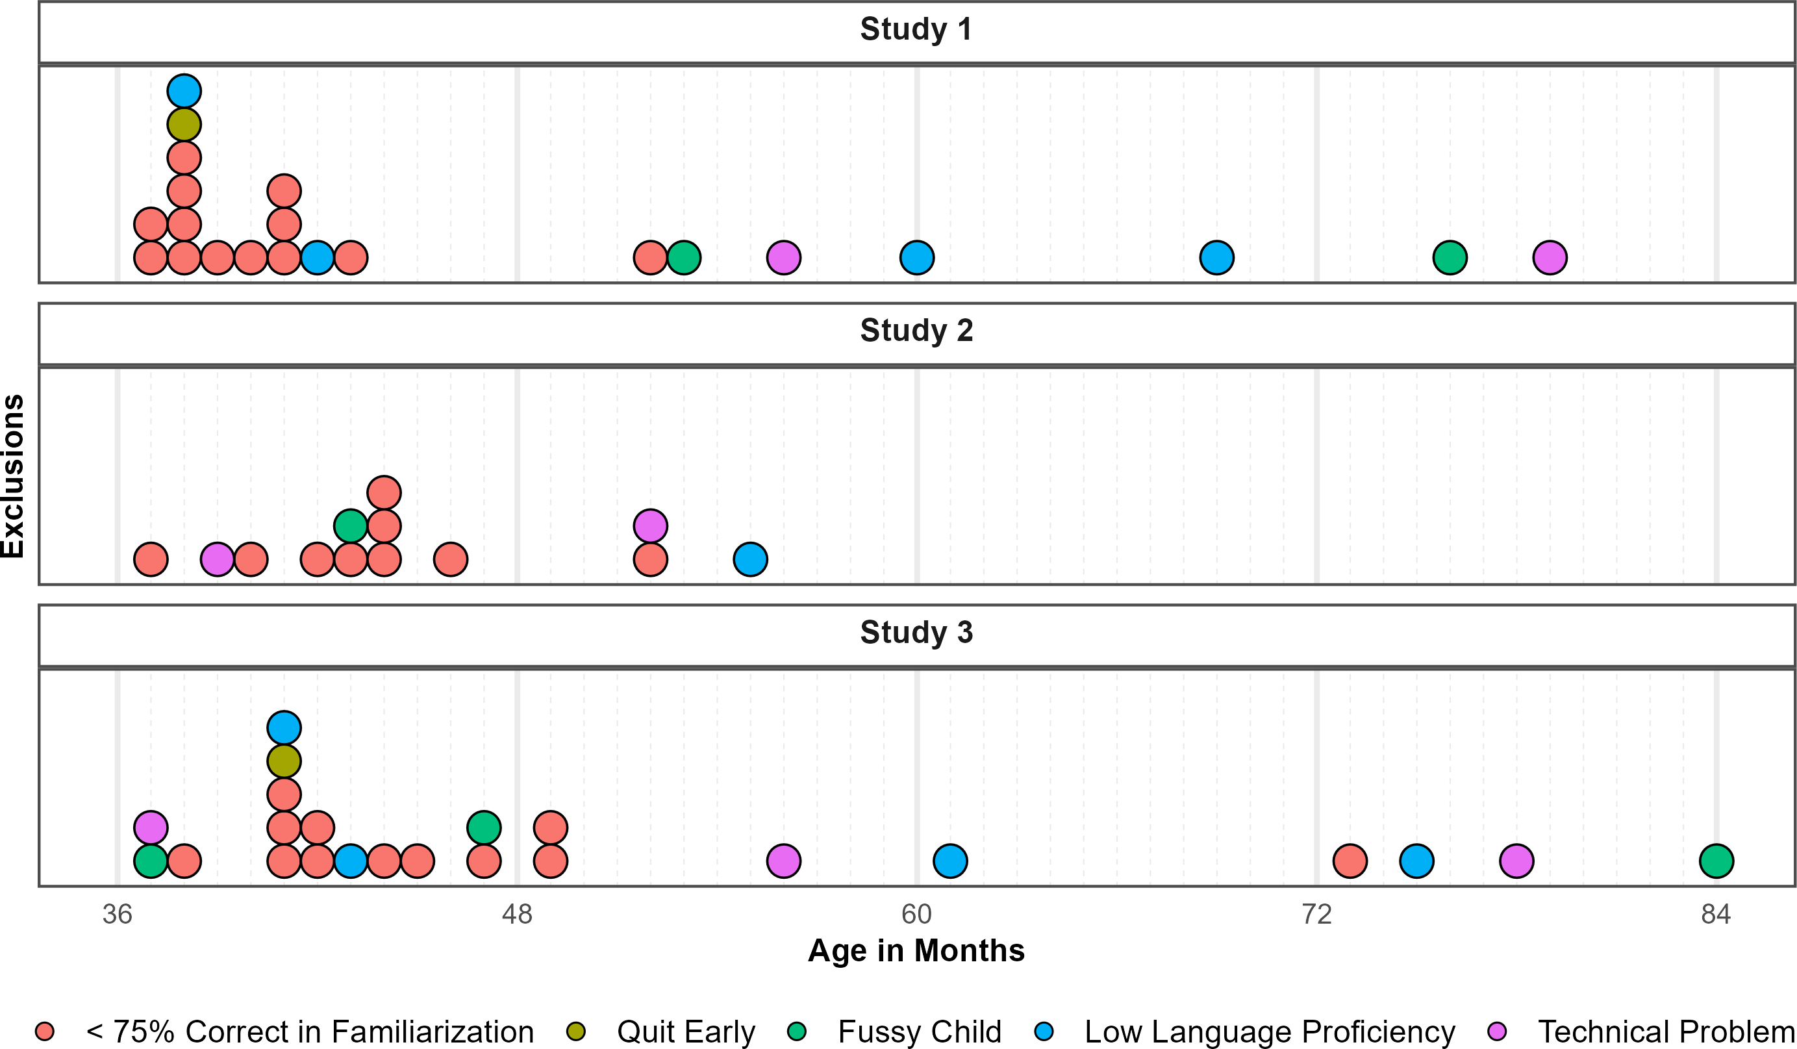
Figure 2. Distribution of Exclusions across the age-range in all three studies. Dots represent individuals. Colors indicate why children where not submitted to analyses.

Model Diagnostics and Comparisons

Study 1
Posterior predictive checks (PPC) for both full and null model indicated excellent fit of observed data and model predictions. Rhat values in both models were equal to one, indicating convergence across all chains. Effective sample sizes for all fixed effects in the full model (Bulk ESS, mean = 4608, range 3209 - 8348) and the null model (Bulk ESS, mean = 6337, range 4373 - 10192) were > 1000, indicating reliable posterior estimations.
Comparing the models using weights based on the Widely Applicable Information Criterion (WAIC) yielded 73.02% of the model weight for the full model, and 26.98% for the null model. Hence, the full model generally had a higher probability of making accurate predictions. Directly comparing the models’ WAIC via expected log predictive density (ELPD) corroborates this (ELPD WAIC; full model = -901.37; null model = -903.66). The standard error of the difference in predictive accuracy (SE = 3.14) is not much larger than the difference itself (ELPD diff = -2.29). Hence, evidence in favor of this model is not decisive. A similar comparison via Leave-One-Out Cross-Validation (LOO) provided essentially the same results. In absence of conclusive evidence for either model, we report the results for the full model in line with the preregistration.

Study 2
For both full and null model, PPCs indicate excellent fit of observed data and model predictions. Rhat values in both models were equal to one, indicating convergence across all chains. Effective sample sizes for all fixed effects in the full model (Bulk ESS, mean = 6216, range 3865 - 8328) and the null model (Bulk ESS, mean = 6646, range 4106 - 9393) were > 1000, indicating reliable posterior estimations.
To compare model performance, we evaluated the WAIC estimates. The null model showed a slightly better predictive performance (ELPD = -888.01) compared to the full model (ELPD = -889.23). WAIC values also indicate better performance of the null model (WAIC = 1,776.02) over the full model (WAIC = 1,778.46). However, the difference between models (ELPD Diff = -1.22) falls within the bounds of uncertainty (SE = 1.74), suggesting no advantage in predictive accuracy. Hence, the preregistered analyses using the full model is reported below.

Study 3
PPCs indicated excellent fit of observed data and model predictions in both models. Model diagnostics were drawn for the full and null model in study 3. Rhat values in both models were equal to one, indicating convergence across all chains. Effective sample sizes for all fixed effects in the full model (Bulk ESS, mean = 6360, range 4327 - 8154) and the null model (Bulk ESS, mean = 6658, range 4776 - 8664) were > 1000, indicating reliable posterior estimations.
When comparing performance, the full model showed a better fit (ELPD = -942.12) relative to the null model (ELPD = -945.98). The WAIC values also favored the full model (WAIC = 1,884.24) over the null model (WAIC = 1,891.96). Despite the slightly lower WAIC and higher ELPD of the full model, the difference in predictive accuracy (ELPD Diff = -3.86) remains almost within the range of sampling uncertainty (SE = 3.96). In the absence of substantial differences, the full model is reported below in line with the preregistration.

Posterior Estimates, Descriptives and Conventional Analyses

Study 1
Table 1: Study 1 - Posterior Estimates for the Full Model.
Predictor | Estimate | SD | MAD | 95% CrI | Bulk ESS | Tail ESS
Intercept | 2.03 | 0.21 | 0.20 | [1.63, 2.44] | 3,717 | 4,578
Pars Pro Toto | -0.14 | 0.21 | 0.21 | [-0.55, 0.28] | 4,882 | 6,669
Simple Form Analogy | -1.39 | 0.19 | 0.19 | [-1.75, -1.03] | 4,893 | 6,137
Complex Form Analogy | -1.36 | 0.19 | 0.19 | [-1.73, -0.99] | 4,456 | 6,357
Age* | 0.42 | 0.15 | 0.15 | [0.12, 0.71] | 3,209 | 5,078
Trial* | -0.01 | 0.07 | 0.07 | [-0.15, 0.12] | 8,348 | 6,608
Sex (Male) | -0.29 | 0.21 | 0.20 | [-0.70, 0.11] | 3,616 | 5,043
Pars Pro Toto × Age* | 0.30 | 0.18 | 0.19 | [-0.05, 0.67] | 4,685 | 6,237
Simple Form Analogy × Age* | -0.20 | 0.16 | 0.17 | [-0.52, 0.12] | 4,046 | 6,170
Complex Form Analogy × Age* | -0.08 | 0.17 | 0.17 | [-0.40, 0.24] | 4,227 | 5,939
Note. Estimates represent posterior means with 95% equal-tailed credible intervals (CrIs). MAD indicates Median Absolute Deviation. ESS refers to effective sample size. R̂ values omitted as they are all ~1 indicating convergence. * = variables were standardized.

Table 2: Study 1 - Descriptives and Conventional Analyses.
Condition | Age | N | Trials | Trials/N | M | SD | p | df | t(N-1) | d
Representation | 3-year-olds | 26 | 103 | 3.96 | 75.00 | 22.36 | <0.001 | 25.00 | 5.70 | 1.12
 | 4-year-olds | 28 | 109 | 3.89 | 81.25 | 33.07 | <0.001 | 27.00 | 5.00 | 0.94
 | 5-year-olds | 28 | 112 | 4.00 | 87.50 | 28.46 | <0.001 | 27.00 | 6.97 | 1.32
 | 6-year-olds | 24 | 96 | 4.00 | 87.50 | 20.85 | <0.001 | 23.00 | 8.81 | 1.80
Pars Pro Toto | 3-year-olds | 26 | 104 | 4.00 | 66.35 | 22.30 | <0.001 | 25.00 | 3.74 | 0.73
 | 4-year-olds | 28 | 112 | 4.00 | 75.00 | 31.91 | <0.001 | 27.00 | 4.15 | 0.78
 | 5-year-olds | 28 | 112 | 4.00 | 85.71 | 21.97 | <0.001 | 27.00 | 8.60 | 1.63
 | 6-year-olds | 24 | 96 | 4.00 | 91.67 | 15.93 | <0.001 | 23.00 | 12.82 | 2.62
Simple Form Analogy | 3-year-olds | 26 | 104 | 4.00 | 53.85 | 23.12 | 0.404 | 25.00 | 0.85 | 0.17
 | 4-year-olds | 28 | 112 | 4.00 | 59.82 | 28.33 | 0.078 | 27.00 | 1.83 | 0.35
 | 5-year-olds | 28 | 112 | 4.00 | 58.93 | 28.23 | 0.106 | 27.00 | 1.67 | 0.32
 | 6-year-olds | 24 | 96 | 4.00 | 69.79 | 23.29 | <0.001 | 23.00 | 4.16 | 0.85
Complex Form Analogy | 3-year-olds | 25 | 100 | 4.00 | 53.00 | 25.33 | 0.559 | 24.00 | 0.59 | 0.12
 | 4-year-olds | 28 | 112 | 4.00 | 54.46 | 23.62 | 0.326 | 27.00 | 1.00 | 0.19
 | 5-year-olds | 28 | 112 | 4.00 | 59.82 | 25.77 | 0.054 | 27.00 | 2.02 | 0.38
 | 6-year-olds | 24 | 96 | 4.00 | 76.04 | 18.77 | <0.001 | 23.00 | 6.80 | 1.39
Note. Descriptive and inferential statistics by age group and condition. Performance (*M*, *SD*) is percent correct responses.*p*, *t*, and *d* reflect one-sample t-tests vs. chance level (0.5). *Trials* = total trials across participants; *Trials/N* = average per participant.

Study 2
Table 3: Study 2 - Posterior Estimates for the Full Model.
Predictor | Estimate | SD | MAD | 95% CrI | Bulk ESS | Tail ESS
Intercept | 1.09 | 0.20 | 0.20 | [0.69, 1.50] | 4,041 | 5,381
Relative Position | -0.28 | 0.18 | 0.18 | [-0.64, 0.07] | 7,864 | 7,962
Orientation of Object | -0.10 | 0.19 | 0.19 | [-0.46, 0.26] | 8,074 | 7,944
Orientation of Feature | -0.13 | 0.18 | 0.18 | [-0.48, 0.23] | 8,328 | 8,142
Age* | 0.40 | 0.14 | 0.13 | [0.13, 0.68] | 4,114 | 5,524
Trial* | 0.26 | 0.08 | 0.08 | [0.10, 0.43] | 5,382 | 6,384
Sex (Male) | -0.01 | 0.22 | 0.22 | [-0.45, 0.42] | 3,865 | 6,269
Relative Position × Age* | -0.06 | 0.16 | 0.16 | [-0.38, 0.25] | 6,381 | 7,915
Orientation of Object × Age* | 0.19 | 0.16 | 0.16 | [-0.13, 0.51] | 7,077 | 7,337
Orientation of Feature × Age* | -0.01 | 0.16 | 0.16 | [-0.33, 0.31] | 7,037 | 7,611
Note. Estimates represent posterior means with 95% equal-tailed credible intervals (CrIs). MAD indicates Median Absolute Deviation. ESS refers to effective sample size. R̂ values omitted as they are all ~1 indicating convergence. * = variables were standardized.

Table 4: Study 2 - Descriptives and Conventional Analyses.
Condition | Age | N | Trials | Trials/N | M | SD | p | df | t(N-1) | d
Absolute Position | 3-year-olds | 20 | 80 | 4.00 | 58.75 | 18.63 | 0.049 | 19.00 | 2.10 | 0.47
 | 4-year-olds | 25 | 100 | 4.00 | 62.00 | 33.17 | 0.083 | 24.00 | 1.81 | 0.36
 | 5-year-olds | 27 | 108 | 4.00 | 73.15 | 30.95 | <0.001 | 26.00 | 3.89 | 0.75
 | 6-year-olds | 25 | 100 | 4.00 | 81.00 | 29.12 | <0.001 | 24.00 | 5.32 | 1.06
Relative Position | 3-year-olds | 22 | 88 | 4.00 | 54.55 | 21.32 | 0.329 | 21.00 | 1.00 | 0.21
 | 4-year-olds | 24 | 96 | 4.00 | 59.38 | 26.39 | 0.095 | 23.00 | 1.74 | 0.36
 | 5-year-olds | 27 | 108 | 4.00 | 68.52 | 34.39 | 0.010 | 26.00 | 2.80 | 0.54
 | 6-year-olds | 25 | 100 | 4.00 | 76.00 | 34.97 | 0.001 | 24.00 | 3.72 | 0.74
Orientation of Object | 3-year-olds | 22 | 85 | 3.86 | 48.86 | 19.64 | 0.789 | 21.00 | -0.27 | 0.06
 | 4-year-olds | 25 | 100 | 4.00 | 57.00 | 25.54 | 0.183 | 24.00 | 1.37 | 0.27
 | 5-year-olds | 27 | 108 | 4.00 | 75.93 | 24.50 | <0.001 | 26.00 | 5.50 | 1.06
 | 6-year-olds | 25 | 100 | 4.00 | 81.00 | 25.29 | <0.001 | 24.00 | 6.13 | 1.23
Orientation of Feature | 3-year-olds | 21 | 80 | 3.81 | 55.95 | 28.40 | 0.348 | 20.00 | 0.96 | 0.21
 | 4-year-olds | 25 | 100 | 4.00 | 67.00 | 28.61 | 0.007 | 24.00 | 2.97 | 0.59
 | 5-year-olds | 27 | 108 | 4.00 | 65.74 | 34.77 | 0.027 | 26.00 | 2.35 | 0.45
 | 6-year-olds | 25 | 100 | 4.00 | 79.00 | 33.60 | <0.001 | 24.00 | 4.32 | 0.86
Note. Descriptive and inferential statistics by age group and condition. Performance (*M*, *SD*) is percent correct responses.*p*, *t*, and *d* reflect one-sample t-tests vs. chance level (0.5). *Trials* = total trials across participants; *Trials/N* = average per participant.

Study 3
Table 5: Study 3 - Posterior Estimates for the Full Model.
Predictor | Estimate | SD | MAD | 95% CrI | Bulk ESS | Tail ESS
Intercept | 1.04 | 0.18 | 0.18 | [0.69, 1.40] | 5,260 | 6,948
Size of Feature | -0.71 | 0.18 | 0.18 | [-1.07, -0.36] | 6,626 | 7,405
Number of Object | -0.08 | 0.19 | 0.18 | [-0.45, 0.28] | 7,791 | 6,991
Number of Feature | -0.31 | 0.18 | 0.18 | [-0.67, 0.05] | 7,537 | 7,985
Age* | 0.70 | 0.14 | 0.14 | [0.44, 0.97] | 4,327 | 6,433
Trial* | 0.21 | 0.08 | 0.07 | [0.06, 0.36] | 8,154 | 6,710
Sex (Male) | -0.18 | 0.19 | 0.19 | [-0.53, 0.19] | 5,512 | 7,371
Size of Feature × Age* | -0.50 | 0.16 | 0.16 | [-0.81, -0.20] | 5,923 | 7,626
Number of Object × Age* | 0.00 | 0.17 | 0.16 | [-0.32, 0.33] | 6,073 | 7,002
Number of Feature × Age* | -0.28 | 0.16 | 0.16 | [-0.60, 0.04] | 6,398 | 7,162
Note. Estimates represent posterior means with 95% equal-tailed credible intervals (CrIs). MAD indicates Median Absolute Deviation. ESS refers to effective sample size. R̂ values omitted as they are all ~1 indicating convergence. * = variables were standardized.

Table 6: Study 3 - Descriptives and Conventional Analyses.
Condition | Age | N | Trials | Trials/N | M | SD | p | df | t(N-1) | d
Size of Object | 3-year-olds | 21 | 84 | 4.00 | 51.19 | 23.02 | 0.815 | 20.00 | 0.24 | 0.05
 | 4-year-olds | 27 | 105 | 3.89 | 54.63 | 31.80 | 0.456 | 26.00 | 0.76 | 0.15
 | 5-year-olds | 26 | 104 | 4.00 | 84.62 | 25.57 | <0.001 | 25.00 | 6.90 | 1.35
 | 6-year-olds | 24 | 96 | 4.00 | 78.12 | 22.50 | <0.001 | 23.00 | 6.12 | 1.25
Size of Feature | 3-year-olds | 21 | 84 | 4.00 | 46.43 | 19.82 | 0.419 | 20.00 | -0.83 | 0.18
 | 4-year-olds | 26 | 104 | 4.00 | 51.92 | 23.37 | 0.678 | 25.00 | 0.42 | 0.08
 | 5-year-olds | 26 | 104 | 4.00 | 56.73 | 32.06 | 0.295 | 25.00 | 1.07 | 0.21
 | 6-year-olds | 24 | 96 | 4.00 | 62.50 | 19.50 | 0.005 | 23.00 | 3.14 | 0.64
Number of Object | 3-year-olds | 21 | 84 | 4.00 | 42.86 | 21.13 | 0.137 | 20.00 | -1.55 | 0.34
 | 4-year-olds | 27 | 108 | 4.00 | 61.11 | 30.49 | 0.069 | 26.00 | 1.89 | 0.36
 | 5-year-olds | 26 | 104 | 4.00 | 72.12 | 34.88 | 0.003 | 25.00 | 3.23 | 0.63
 | 6-year-olds | 24 | 96 | 4.00 | 83.33 | 32.69 | <0.001 | 23.00 | 4.99 | 1.02
Number of Feature | 3-year-olds | 21 | 82 | 3.90 | 50.00 | 19.36 | >0.999 | 20.00 | 0.00 | 0.00
 | 4-year-olds | 27 | 108 | 4.00 | 62.96 | 24.39 | 0.010 | 26.00 | 2.76 | 0.53
 | 5-year-olds | 26 | 104 | 4.00 | 65.38 | 31.68 | 0.020 | 25.00 | 2.48 | 0.49
 | 6-year-olds | 24 | 96 | 4.00 | 76.04 | 27.07 | <0.001 | 23.00 | 4.71 | 0.96
Note. Descriptive and inferential statistics by age group and condition. Performance (*M*, *SD*) is percent correct responses.*p*, *t*, and *d* reflect one-sample t-tests vs. chance level (0.5). *Trials* = total trials across participants; *Trials/N* = average per participant.

Exploratory Analyses Including Item-Level Random Effects
In addition to our main analyses, we preregistered additional exploratory analyses for evaluating item-level effects separately in each study. For this we added a crossed random effects for items, allowing the relationship between age and performance to vary across items (correct ~ condition*z.age + z.trial + sex + (z.trial |subid)). Due to the lower number of individual items within a task, we expected these models to be less diagnostic with regard to our main research question. However, the analyses provides detail about the equivalence of items within conditions.

Study 1
An exploratory model with additional item-level random effects showed that the variability of intercepts at the item level was small ($β$ = 0.16, 95% CrI [0.01,0.40]). Likewise there was only modest variation for the effect of age across items ($β$ = 0.14, 95% CrI [0.01,0.34]). The correlation between item difficulty and item-specific age slopes was highly uncertain (ρ = 0.35, 95% CrI [-0.85,0.98]). Model weights based on the WAIC suggested that the full model was more likely to provide accurate predictions (weight = 75.17% ) compared to the item model (weight = 24.83%).The estimated difference in expected log predictive density (elpd) between models, however, was not much larger than the difference itself (ELPD diff = -0.63), indicating considerable uncertainty as to whether either model was preferable. For on overview of logg odds for all items across conditions see figure 3. For a full overview of coefficients and the random effects structure of the item model see table 7.

Study 2
An exploratory model including item-level random effects indicated modest variability ($β$ = 0.25, 95% CrI [0.03,0.53]). The variability of age effects across items was small ($β$ = 0.11, 95% CrI [0.00, 0.30]), suggesting that the effect of age was fairly consistent across items. The correlation between item intercepts and age slopes was near zero and highly uncertain (ρ = 0.02, 95% CrI [-0.93,0.94]), providing no reliable evidence that slightly easier or difficult items varied in age-related gains. Comparing the models using WAIC weights showed that including item-level random effects in Study 2 did not provide a clear advantage in out-of-sample predictive accuracy (full model 55.08%; item model 44.92%). Comparing the models corroborates this (ELPD WAIC; full model = -889.23; item model = -889.33). The difference in expected log predictive density was negligible (ELPD diff = -0.09), and within the range of sampling uncertainty (SE =2.35). For an overview of item level variability across conditions see figure 3. For a full table of coefficients and random effects of the exploratory model see table 8.

Study 3
To evaluate the equivalence of items within conditions, item-level random effects were included in an exploratory model showing that item variation at the intercept was moderate ($β$ = 0.20, 95% CrI [0.02,0.44]) and that the effect of age varied slightly across items ($β$ = 0.23, 95% CrI [0.04,0.46]). Again, the correlation between item difficulty and item-specific age slopes was moderately positive but uncertain (ρ = 0.55, 95% CrI [-0.51,0.99]) providing weak evidence that easier items had stronger age-related gains. Comparing the models using WAIC weights showed that the item model had higher predictive power (full model 24.32%; item model 75.68%). Comparing the models’ WAIC via ELPDs corroborates this (full model = -942.12; item model = -939.19). The difference in expected log predictive density favored the item model (ELPD diff = -2.92), though the uncertainty around this estimate suggests that the evidence is not decisive (SE =3.25). Graphically exploring item-level variability via logg odds indicates that the estimated deviation from the intercept is still including zero (cf. figure 3). For an overview of coefficients and random effects see table 9 in appendix 3.

Discussion
In studies 1 and 2, the inclusion of item-level random effects did not meaningfully improve model fit. The main analyses reported in the manuscript and the exploratory models reported here account for the data equally well. For study 3, including item-level random effects yielded moderate variability. Here the analysis provides modest evidence for variability due to item level effects. As in all studies reported above, these were small compared to the participant random effects. None of the model comparisons provided substantial evidence for a better fit of the exploratory models. Hence, the additional analyses provided here provide no grounds for deterring from the preregistered analysis reported in the manuscript.

Table 7: Study 1 - Posterior Estimates for Exploratory Model with Item-Level Random Effects.
Predictor | Estimate | SD | MAD | 95% CrI | Bulk ESS | Tail ESS
Intercept | 2.04 | 0.23 | 0.22 | [1.61, 2.50] | 8,098 | 6,792
Pars Pro Toto | -0.13 | 0.25 | 0.24 | [-0.62, 0.36] | 10,365 | 7,699
Simple Form Analogy | -1.40 | 0.24 | 0.23 | [-1.87, -0.94] | 9,788 | 6,732
Complex Form Analogy | -1.36 | 0.23 | 0.22 | [-1.81, -0.91] | 9,969 | 6,540
Age* | 0.43 | 0.17 | 0.17 | [0.10, 0.78] | 7,514 | 6,053
Trial* | -0.01 | 0.07 | 0.07 | [-0.15, 0.12] | 15,811 | 7,325
Sex (Male) | -0.30 | 0.20 | 0.20 | [-0.70, 0.10] | 8,463 | 7,756
Pars Pro Toto × Age* | 0.31 | 0.22 | 0.21 | [-0.13, 0.73] | 9,593 | 7,913
Simple Form Analogy × Age* | -0.20 | 0.20 | 0.19 | [-0.61, 0.19] | 8,172 | 6,246
Complex Form Analogy × Age* | -0.08 | 0.20 | 0.20 | [-0.48, 0.32] | 8,437 | 7,057
Random Effects
Item Intercept (SD) | 0.16 | 0.10 | 0.10 | [0.01, 0.40] | 3,717 | 5,692
Item × Age Slope (SD) | 0.14 | 0.09 | 0.09 | [0.01, 0.34] | 3,921 | 6,437
Subject Intercept (SD) | 0.85 | 0.10 | 0.10 | [0.67, 1.06] | 4,365 | 6,407
Subject × Trial slope (SD) | 0.17 | 0.10 | 0.11 | [0.01, 0.38] | 4,266 | 5,333
Correlation: Item Intercept & Age Slope | 0.35 | 0.52 | 0.52 | [-0.85, 0.98] | 7,186 | 7,451
Correlation: Subject Intercept & Trial Slope | -0.48 | 0.41 | 0.37 | [-0.98, 0.60] | 9,980 | 6,471
Note. Estimates represent posterior means with 95% equal-tailed credible intervals (CrIs). MAD indicates Median Absolute Deviation. ESS refers to effective sample size. R̂ values omitted as they are all ~1 indicating convergence. * = variables were standardized.

Table 8: Study 2 - Posterior Estimates for Exploratory Model with Item-Level Random Effects.
Predictor | Estimate | SD | MAD | 95% CrI | Bulk ESS | Tail ESS
Intercept | 1.09 | 0.25 | 0.24 | [0.60, 1.59] | 6,040 | 6,436
Relative Position | -0.28 | 0.27 | 0.26 | [-0.82, 0.27] | 7,220 | 6,788
Orientation of Object | -0.09 | 0.27 | 0.25 | [-0.62, 0.46] | 8,491 | 6,575
Orientation of Feature | -0.12 | 0.27 | 0.25 | [-0.64, 0.44] | 7,589 | 6,356
Age* | 0.41 | 0.15 | 0.15 | [0.11, 0.72] | 6,314 | 6,154
Trial* | 0.26 | 0.09 | 0.08 | [0.10, 0.44] | 8,159 | 7,504
Sex (Male) | -0.01 | 0.22 | 0.22 | [-0.45, 0.43] | 5,695 | 7,070
Relative Position × Age* | -0.06 | 0.19 | 0.18 | [-0.44, 0.30] | 7,887 | 6,593
Orientation of Object × Age* | 0.20 | 0.19 | 0.18 | [-0.17, 0.57] | 8,791 | 6,929
Orientation of Feature × Age* | -0.00 | 0.19 | 0.18 | [-0.38, 0.36] | 8,517 | 7,457
Random Effects
Item Intercept (SD) | 0.25 | 0.13 | 0.12 | [0.03, 0.53] | 3,018 | 4,135
Item × Age Slope (SD) | 0.11 | 0.08 | 0.08 | [0.00, 0.30] | 4,753 | 5,777
Subject Intercept (SD) | 0.99 | 0.12 | 0.12 | [0.76, 1.25] | 3,359 | 5,631
Subject × Trial slope (SD) | 0.47 | 0.12 | 0.12 | [0.24, 0.71] | 2,939 | 3,426
Correlation: Item Intercept & Age Slope | 0.02 | 0.55 | 0.67 | [-0.93, 0.94] | 9,710 | 6,518
Correlation: Subject Intercept & Trial Slope | 0.64 | 0.20 | 0.19 | [0.20, 0.95] | 3,911 | 4,741
Note. Estimates represent posterior means with 95% equal-tailed credible intervals (CrIs). MAD indicates Median Absolute Deviation. ESS refers to effective sample size. R̂ values omitted as they are all ~1 indicating convergence. * = variables were standardized.

Table 9: Study 3 - Posterior Estimates for Exploratory Model with Item-Level Random Effects.
Predictor | Estimate | SD | MAD | 95% CrI | Bulk ESS | Tail ESS
Intercept | 1.06 | 0.21 | 0.21 | [0.66, 1.49] | 6,425 | 5,945
Size of Feature | -0.72 | 0.24 | 0.23 | [-1.22, -0.26] | 6,935 | 6,112
Number of Object | -0.09 | 0.25 | 0.24 | [-0.59, 0.39] | 7,420 | 6,234
Number of Feature | -0.32 | 0.24 | 0.23 | [-0.81, 0.14] | 6,609 | 5,994
Age* | 0.72 | 0.19 | 0.18 | [0.36, 1.09] | 5,654 | 5,545
Trial* | 0.21 | 0.08 | 0.08 | [0.06, 0.37] | 10,413 | 7,362
Sex (Male) | -0.18 | 0.19 | 0.19 | [-0.56, 0.20] | 8,049 | 7,146
Size of Feature × Age* | -0.51 | 0.24 | 0.23 | [-1.00, -0.04] | 6,421 | 5,429
Number of Object × Age* | -0.00 | 0.24 | 0.23 | [-0.48, 0.49] | 6,662 | 5,472
Number of Feature × Age* | -0.29 | 0.24 | 0.23 | [-0.76, 0.19] | 6,150 | 6,305
Random Effects
Item Intercept (SD) | 0.20 | 0.11 | 0.10 | [0.02, 0.44] | 3,368 | 3,404
Item × Age Slope (SD) | 0.23 | 0.10 | 0.09 | [0.04, 0.46] | 3,071 | 3,169
Subject Intercept (SD) | 0.73 | 0.10 | 0.10 | [0.54, 0.94] | 3,756 | 6,288
Subject × Trial slope (SD) | 0.41 | 0.12 | 0.11 | [0.16, 0.63] | 2,134 | 1,553
Correlation: Item Intercept & Age Slope | 0.55 | 0.40 | 0.33 | [-0.51, 0.99] | 4,483 | 4,469
Correlation: Subject Intercept & Trial Slope | 0.16 | 0.26 | 0.25 | [-0.36, 0.64] | 5,815 | 5,570
Note. Estimates represent posterior means with 95% equal-tailed credible intervals (CrIs). MAD indicates Median Absolute Deviation. ESS refers to effective sample size. R̂ values omitted as they are all ~1 indicating convergence. * = variables were standardized.

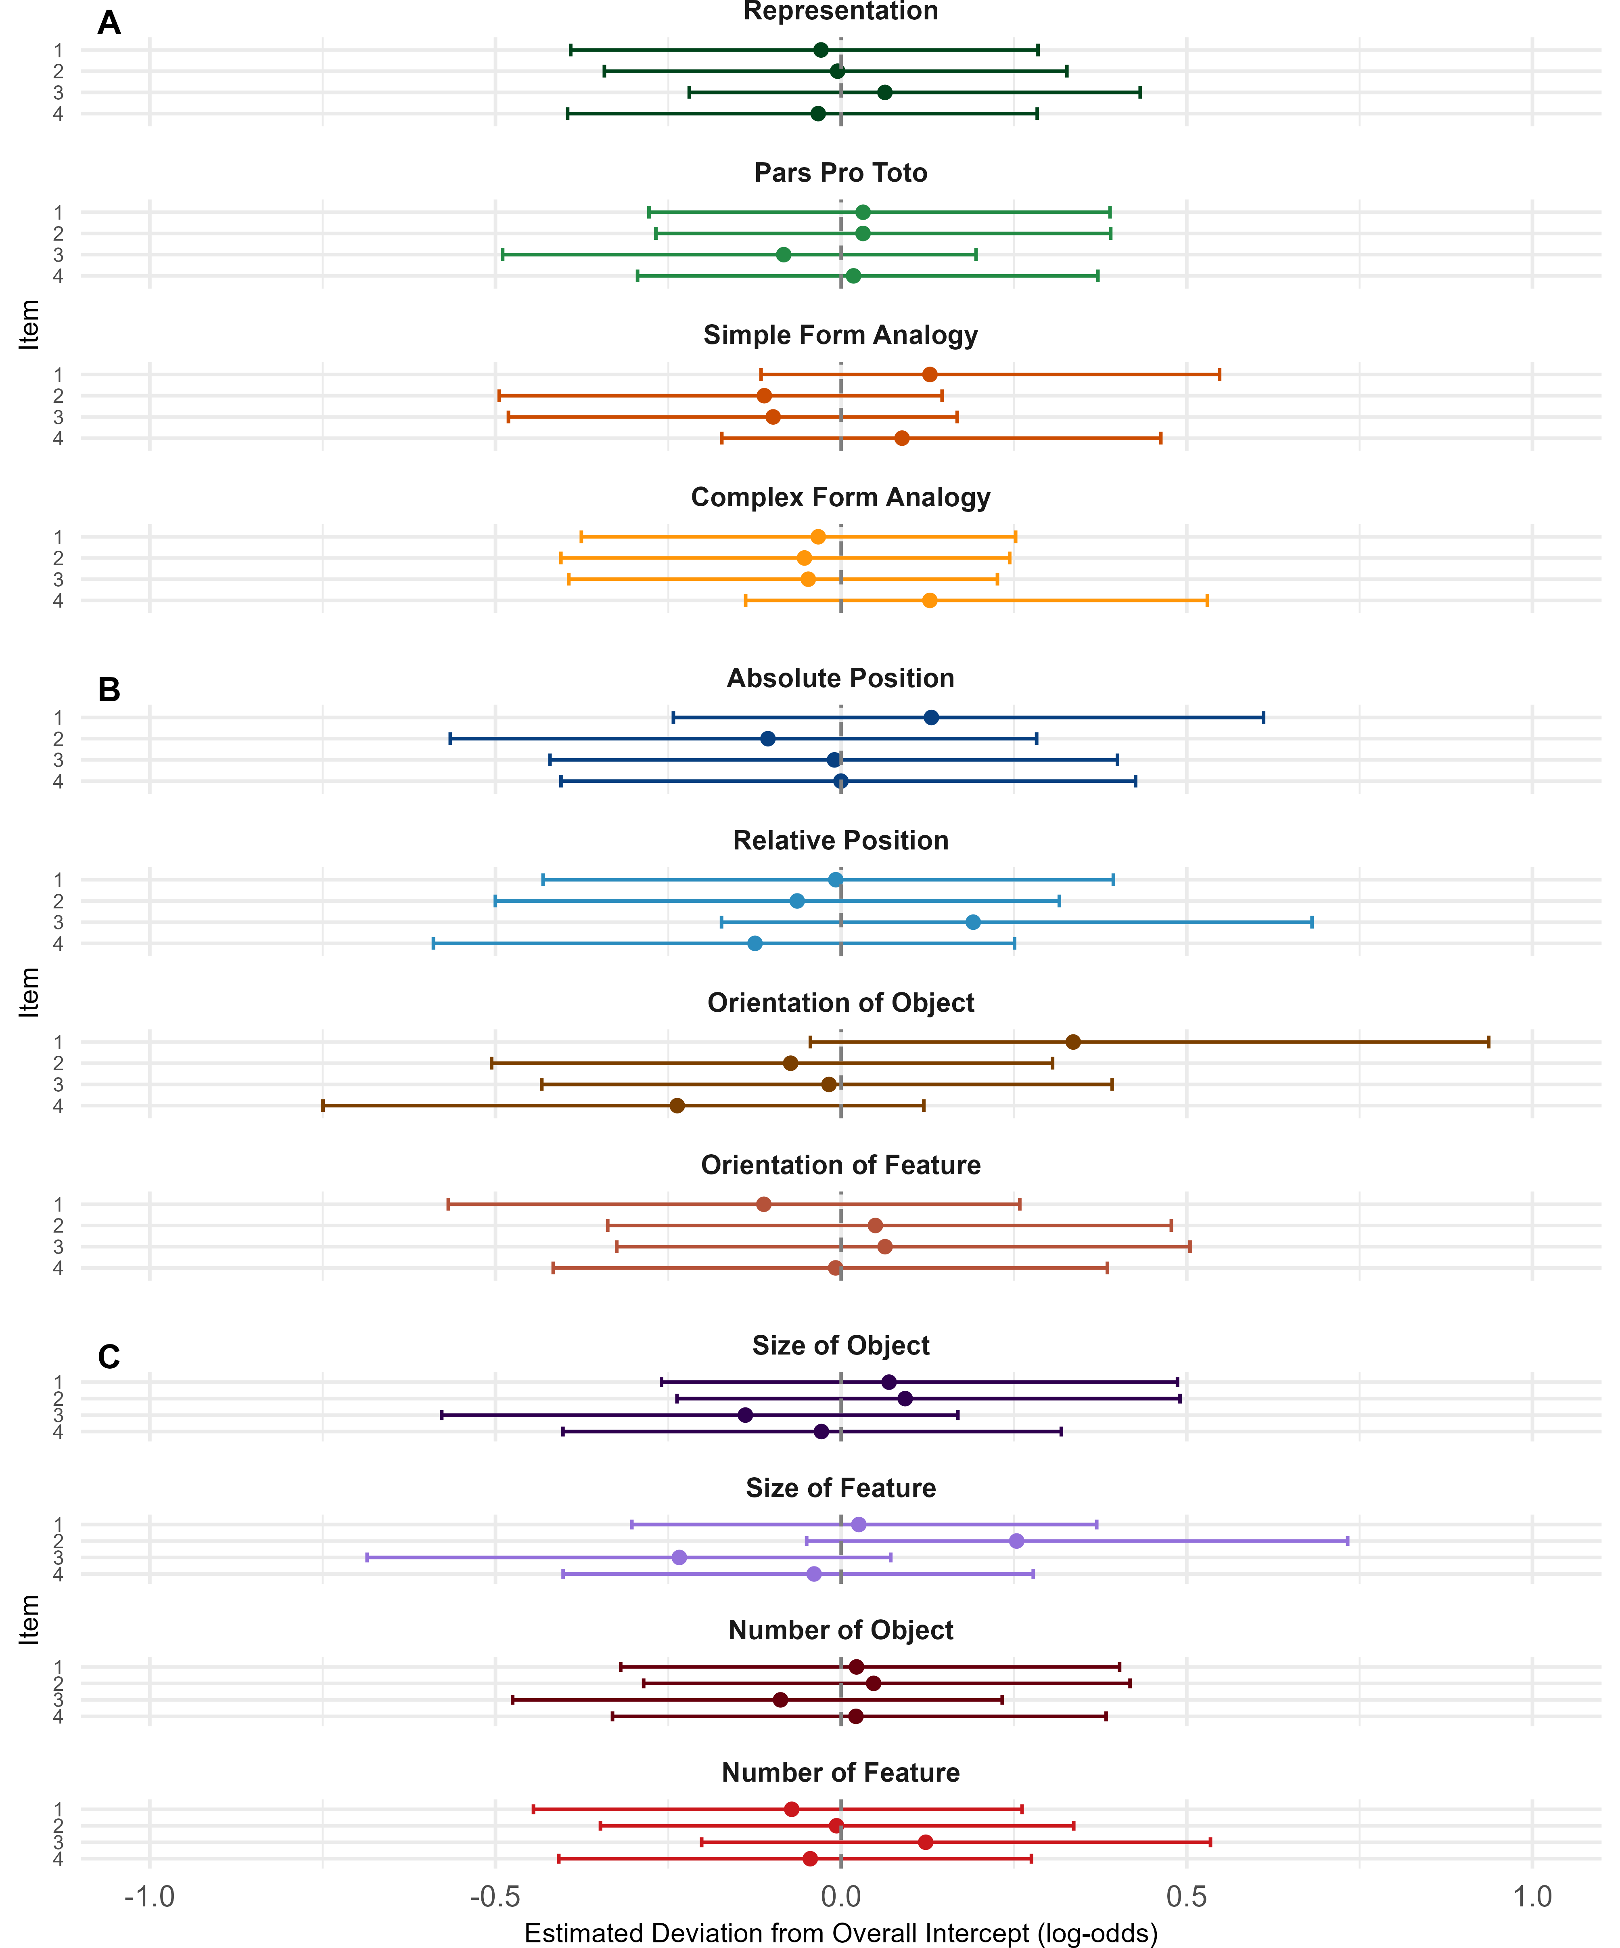
Figure 3. Item-Level Random Intercepts by Condition.

