DRIVR – User Manual

# Installation

Download the correct software: [Unity](https://unity3d.com/get-unity/download) and [Arduino](https://www.arduino.cc/en/software). Download the source code files from this [link](https://github.com/gmitchell2000/DRIVR-HonoursProject).

**Arduino**

Begin by plugging in the DRIVR device via the micro-USB port. The esp32 needs to be installed onto the Arduino IDE, you can do so by following the steps in this [link](https://randomnerdtutorials.com/installing-the-esp32-board-in-arduino-ide-windows-instructions/). Open up the Arduino IDE Library Manager and install “Adafruit MPU6050” in order for the gyroscope to work. You can upload the source code to the device. These can be found in “/SourceCode/Arduino”, upload “DRIVR” for use of the system whilst attached to the computer, or upload “DRIVR_Bluetooth” for using the device wirelessly. If using the device wirelessly you must also attach it to a portable charging device.

**Unity**

After installing Unity open the Unity hub. Click the “Add Project” button and select the “/SourceCode/Unity” folder. This will install the game fully.

# User Guide

Ensure the DRIVR device is connected to the computer, either through the micro-USB cable or via Bluetooth and that the correct Serial Port has been selected.

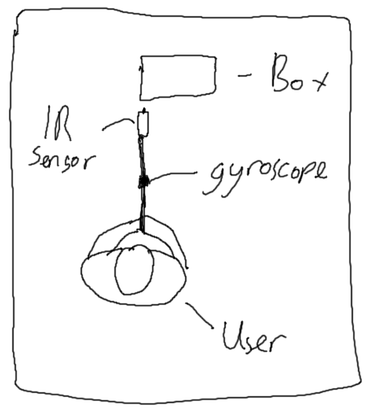Begin the game by clicking the Start button in Unity. You will be met with the Main Menu, here you can click to Start the game or Quit. Once you have selected Start, you will be on the Driving Range screen. You will see a warning message on the screen, warning the user to only use the device when it is safe to do so. Press the spacebar to hide this message.

Line yourself up with the box placed in front of you, close to the head of the golf club but not so close that you will hit it. Make sure the end of the box is in line with the club head, as seen in the picture above. When you are ready to swing, press the button on the device, which will spawn in a ball. Now swing the golf club. This will cause the ball in the game to fly off, reading you the statistics of your shot on the HUD. After the ball has landed, it will show you a simulation of the ball’s direction. Once it has gone back to the original screen, press the button on the club to start the process again.

# Known Problems

* When pressing the button to spawn in a new ball, sometimes it can glitch and spawn lots of them. If the program does this, please just restart.
* Very rarely when swinging the club, the device can register a shot whilst still on your backswing, this will result in a shot in the game you have not hit. You must wait until the birds-eye view of this shot has been completed before starting again.
* When swinging the club for the first time, it will sometimes not register a speed for the shot. If this happens, reset your stance, press the button on the club and swing again. This will no register a shot.