Assignment 2: Show-off, Texture and Background

Gregor Mitchell – 170010314

## Description of Design

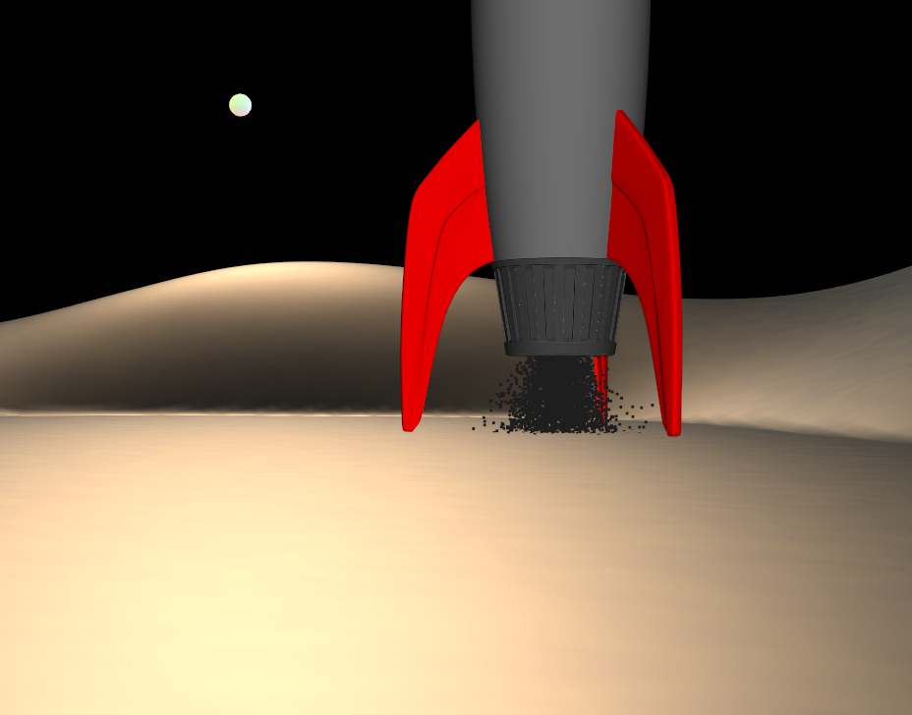 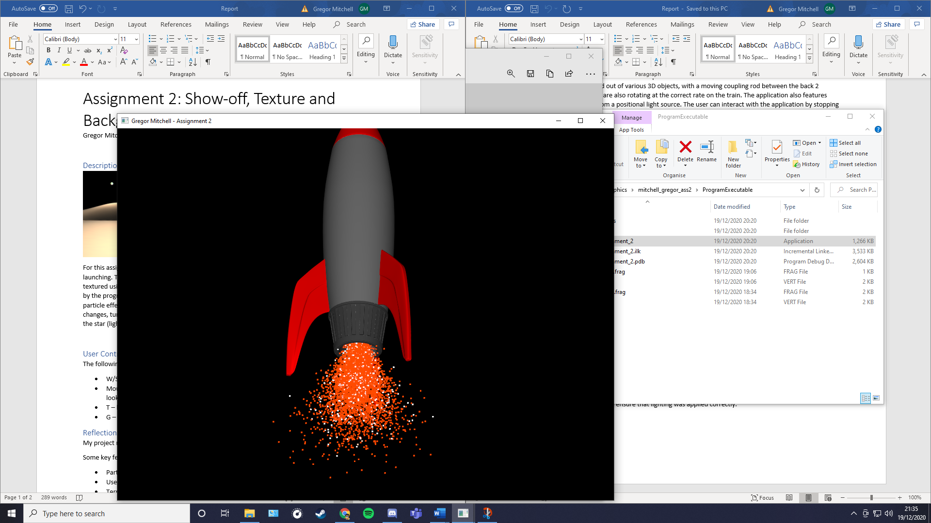

For this assignment I chose to use OpenGL to create a 3D model and animation of a rocket launching. The model features a rocket ship loaded using the Tiny Object Loader, which is then textured using different images for the separate parts. The rocket is placed upon a terrain generated by the program. The user can walk around the rocket freely, inspecting each side and the smoke particle effects, before launching the rocket into space. At this point the texture of the particle’s changes, turning into the flames from the engine. The rocket is also lit from a point source, shown by the star (light orb) in the background

## User Controls

The following is a list of ways that the user can interact with the application:

* W/S/A/D – move the camera forwards, backwards, left and right
* Mouse pointer – use the mouse to alter where the camera is looking (can spin round and look up/down)
* T – launch ship
* G – reset ship

## Reflections

My project runs with no major errors and is animated in a way that is realistic.

Some notable features:

* Particle animations change when launching ship
* User is able to move up/down the y-axis, simulating walking
* Terrain manipulated to create flat launching pad
* Mouse controls for moving the camera

During the implementation of the project there were some problems that I ran into. The main one of which is to do with the lighting of the objects. When loading in my rocket object, I was unable to get the lighting to work fully on the textures. This means that when the project loads, the lighting is calculated properly, but won’t update whilst the program runs, meaning that the rocket is well lit at all times.

Another problem I ran into was to do with finding objects to use. Most objects were very complicated, with normals that would not calculate properly. I eventually managed to find a low-poly object to use, meaning normals could be calculated properly. To combat this in the future, I would create my own rocket using Blender.