- Odkrivanje ranljivosti iz znanih URL naslovov
- https://hackycorp.com/admin/
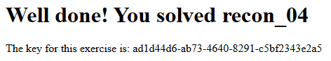
- https://hackycorp.com/login/
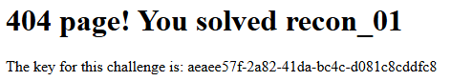
- Odkrivanje ranljivosti iz javnih datotek
- https://assets.hackycorp.com/key.txt

- Odkrivanje ranljivosti v Javascript datotekah
- https://assets.hackycorp.com/js/script.js
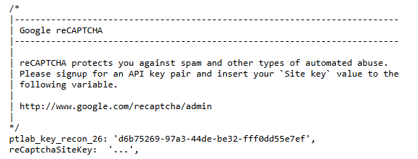
- Odkrivanje ranljivosti na spletnem strežniku
- https://hackycorp.com/robots.txt
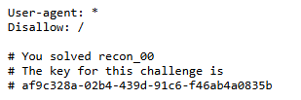

- curl -I https://hackycorp.com/
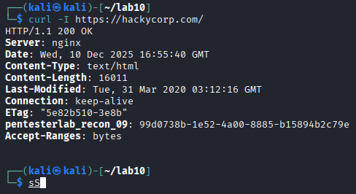
- https://hackycorp.com/.well-known/security.txt
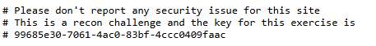
- curl -I https://hackycorp.com/blablabla
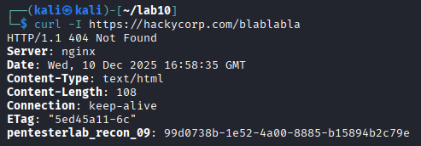
- Odkrivanje ranljivosti preko IP naslova
- dig hackycorp.com +short
  - 51.158.147.132
- curl http://51.158.147.132/
  - <h1>Well done! You solved recon_06 </h1>
  - The key for this exercise is 5cf83b5d-eb6c-4eee-af6c-945f9aed8dfd
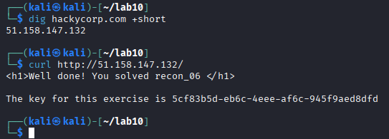
- Odkrivanje ranljivosti v Github repozitorijih
- https://github.com/hackycorpdev/test1/blob/master/TEST
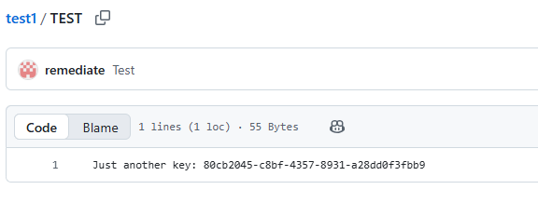
- https://github.com/hackycorp/repo3
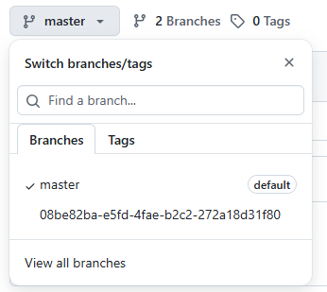
- https://github.com/hackycorp/repo4/blob/test/KEY
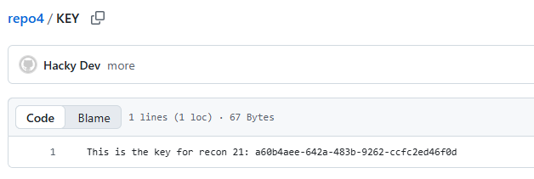
- git clone https://github.com/hackycorp/repo9.git
for file in *; do cat $file; done
git log --diff-filter=D --summary
git show 397a2a64461258112821015221a9b33220ece058:KEY.txt
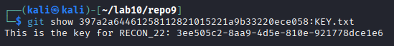
- git clone https://github.com/hackycorp/repo0a.git
git log –oneline
git log --oneline --grep=key -i¸
- Odkrivanje ranljivosti v DNS zapisih
- dig TXT key.z.hackycorp.com +short
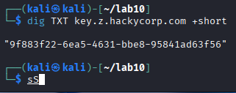
- Uporaba mehanizma za sinhronizacijo DNS zapisov
- dig AXFR z.hackycorp.com @z.hackycorp.com
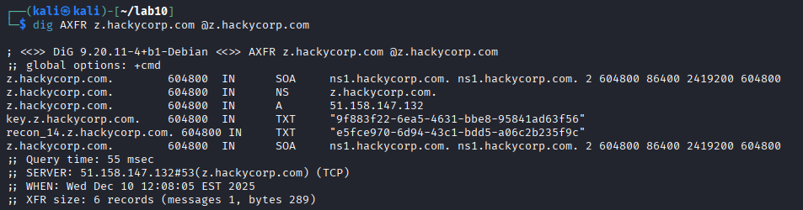
- Razkrivanje informacij s pomočjo poizvedb programske opreme
- dig -c chaos -t txt VERSION.BIND @z.hackycorp.com
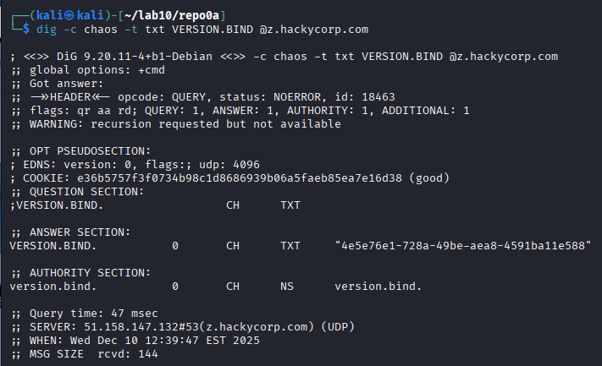
- Skriptno programiranje in avtomatizacija
- chmod +x script1.sh
- ./script1.sh
- chmod +x script2.sh
- ./script2.sh
- 0x81.a.hackycorp.com
