Team 03 – Report

Log in details

|  |  |  |  |
| --- | --- | --- | --- |
| **Which form to use** | **Who** | **Username** | **Password** |
| Customer | Customer | Customer | nolandspring |
| Staff | Shop floor staff member | ShopFloorStaffMember | lowlandspring |
| Staff | Manager | Manager | mediumlandspring |
| Staff | Executive | Executive | highlandspring |

User guide

This is the splash screen users see when they first visit the site or rather when they are not logged in.

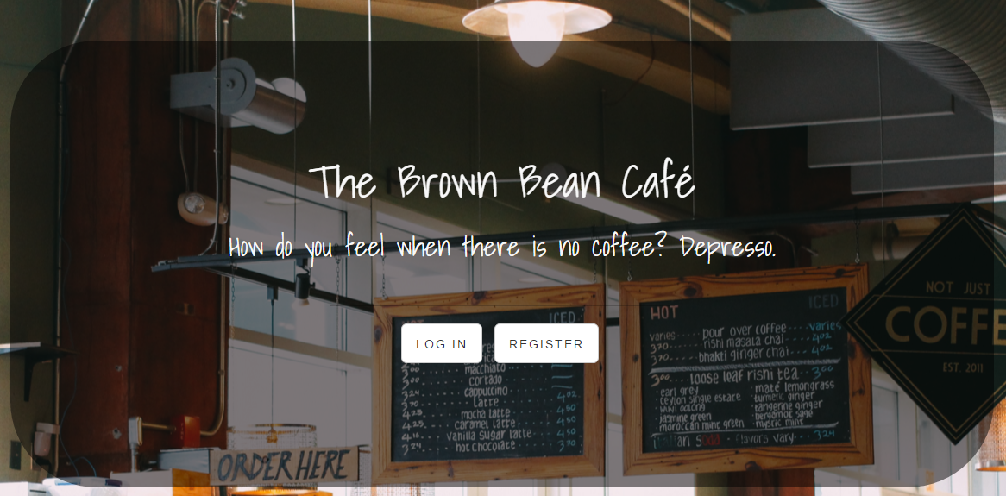

This is the register page for customers.

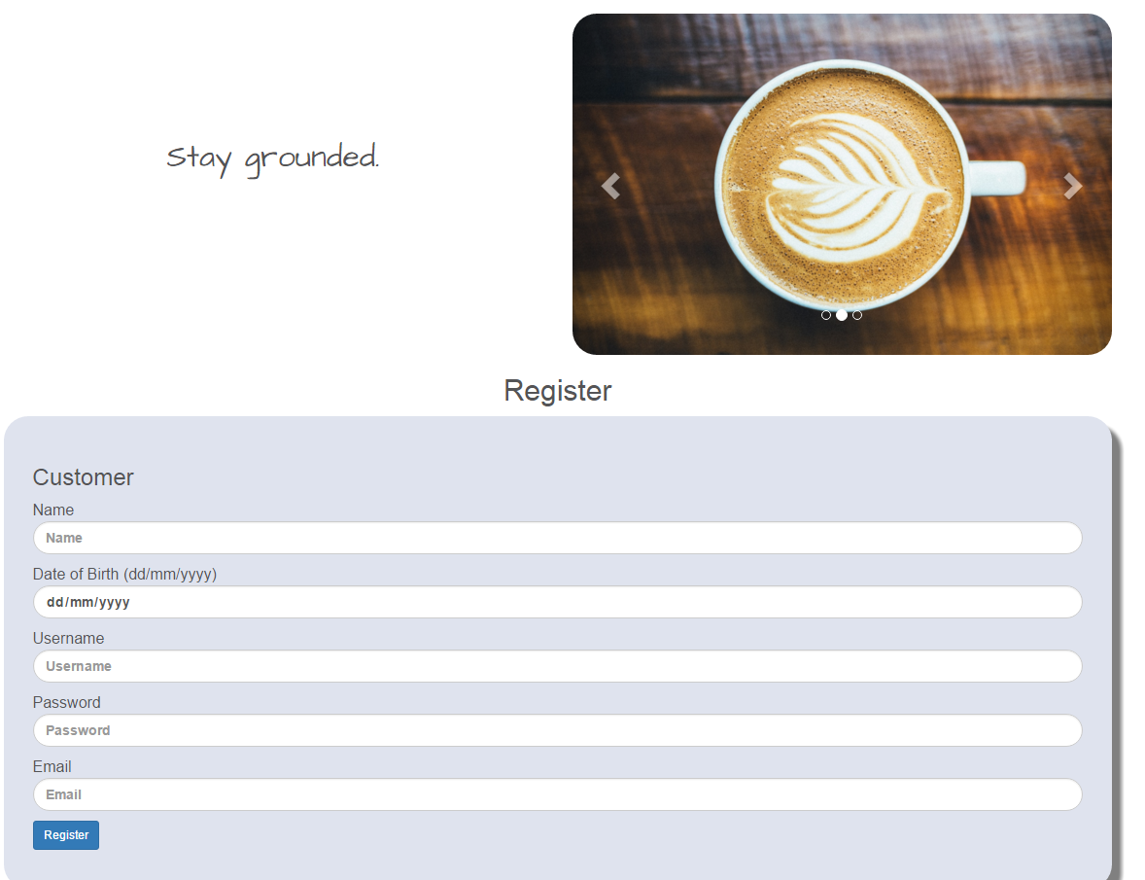

This is the log in screen for both customers and staff members, shop floor staff members, managers and executives all use the same log in form.

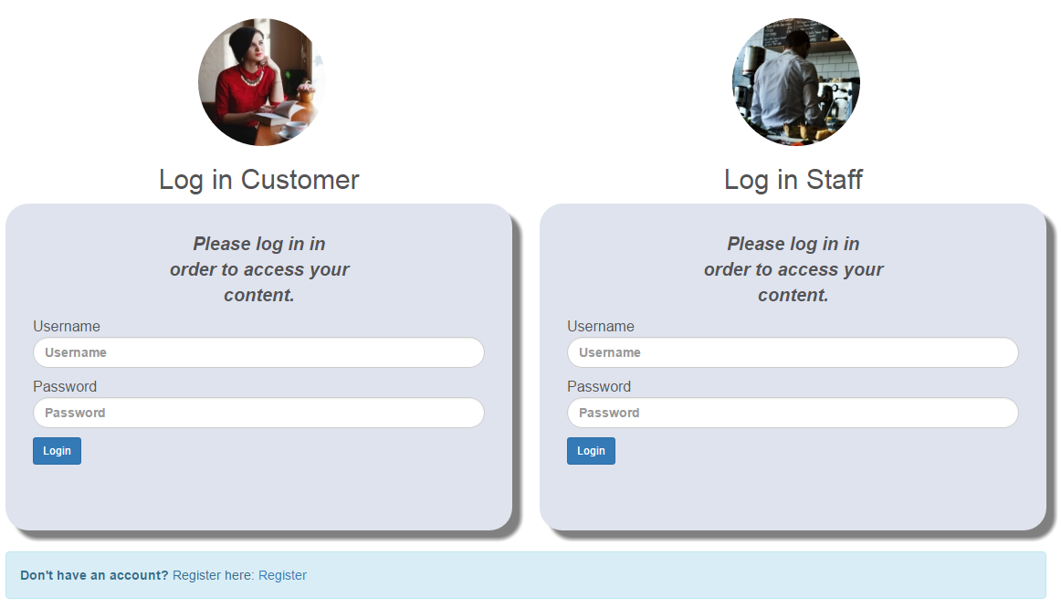

The log in forms check if the fields are empty If the log in fails, user feedback is given.

before submitting and gives user feedback if so.

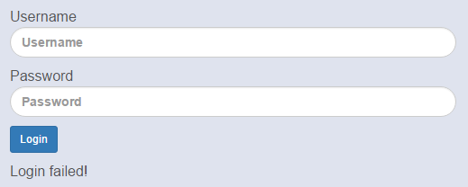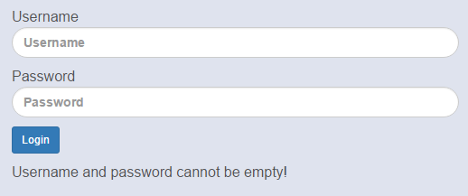

Customer

This is the menu the customer can see when they are logged in.



The customer’s profile page. This shows the customer’s details, including their loyalty points.



