Memory Path Operator Manual
The Fool’s Memory Path uses a finite arrangement of playing cards and Tarot cards to cue personal memories. Its purpose is fast, accurate recall of deliberately indexed material.
The diagram defines the arrangement and its labels. The accompanying first-person account explains the practice. The operator learns the card relationships, associates them with personal material, and follows those relationships during recall.
One card can cue many things in different contexts. A memory can also depend on several cards. The method therefore needs both a stable card map and the operator’s learned associations.

1 What the path organizes

A finite map with personal content
The card arrangement is finite. The associations attached to it depend on the operator’s interests, experiences, and study. A card’s rank, suit, and meaning guide those associations.
A familiar person can represent an archetype. A familiar object can supply another part of a scene. The account describes recall as strongly visual and often nonverbal. The operator follows symbolic links between cards to recover associated information.
The number of cards does not specify the number of memories. A shared card cue is permitted. Context helps distinguish what that card recalls on a particular occasion.

Fragments and reconstruction
The account describes cards as cues for fractions of information. A combination of cards can describe a fuller memory. The operator uses these related cues to recover the details relevant to the present question.
Recall has a limited resolution. The map can recover an applicable detail that helps the operator remember more. It does not provide every detail of every experience. The author also reports poor recall for material that was not deliberately archived.

The role of narrative
Scenes give the symbolic links a personal form. Their people and objects come from the operator’s life or study. The first example scene contains the Fool, the Magician, the Wheel of Fortune, and the Sun.
The story supports the card arrangement. Personal artwork and interpretation can vary while the arrangement remains stable. The author uses the deck for recall and explicitly rejects divination as its purpose.

2 How to read the map

The diagram and the imagined space
The sheet shows adjacency rules for an imagined space. It is a two-dimensional representation of a space that the account describes as three-dimensional. The same account also calls the cards dynamically structured in four dimensions.
These statements do not name a complete set of independent coordinates. The visual layout alone therefore does not establish rank as an additional spatial dimension. The card values, folded positions, suit labels, and layer labels can still be read directly.

Values and layers
The numbered Major Arcana run from 1 to 21 in this chart. The vertical labels divide these values into three layers. The panel captions state the meaning of each layer within this map.
Layer | Values | Caption in the diagram | Status in the diagram
Super-Ego | 1–9 | Internalized societal values and standards | Unconscious
Ego | 10–18 | Amoral strategies to obtain pleasure | Unconscious
Identity | 19–21 | All the urges and impulses | Conscious

The vertical value bands and the horizontal panels both use these layer names. The panels align related Arcana and give the suits different readings. Their alignment shows a structural relation. It does not by itself require a temporal sequence of psychological development.

The modulus 9 fold
The fold groups values that differ by nine. It gives the palace nine folded locations rather than twenty-one separate Major Arcana locations. The first three locations contain three Arcana each. The other six contain two each.
Position | Super-Ego value | Ego value | Identity value
1 | Magician 1 | Wheel of Fortune 10 | Sun 19
2 | High Priestess 2 | Justice 11 | Judgement 20
3 | Empress 3 | Hanged Man 12 | World 21
4 | Emperor 4 | Death 13 | None shown
5 | Hierophant 5 | Temperance 14 | None shown
6 | Lovers 6 | Devil 15 | None shown
7 | Chariot 7 | Tower 16 | None shown
8 | Strength 8 | Star 17 | None shown
9 | Hermit 9 | Moon 18 | None shown

For example, values 1, 10, and 19 share position 1. Adding nine moves from Magician to Wheel, then from Wheel to Sun. These cards remain distinct cues within the shared location.
Folding brings the related values into one location. Unfolding distinguishes the cards and their associated meanings. The account identifies this movement as helpful for mechanical access to memories.

Card rank and folded position
A card’s printed rank and its folded position have different uses. An Ace and a ten keep their different ranks, but both belong to folded position 1. Sun 19 belongs to that position as well.
Here, rank refers to the card sequence. The account does not define it by equation terms or memory vertices. Ace has value 1. Numbered cards use their printed numbers.
The court sequences differ between the two deck families:
Rank position | Minor suits | Standard suits
11 | Page, shown as P | Jack, shown as J
12 | Knight, shown as N | Queen, shown as Q
13 | Queen, shown as Q | King, shown as K
14 | King, shown as K | No court shown

The Minor courts extend to position 14. The Standard courts extend to position 13. This difference explains the uneven edge of the suit grid. The letter N distinguishes Knight from King.
The diagram does not give ten additional ranks inside every folded position and suit. A count of 720 independent memory cells does not follow from this map.

Identity and the recurring cycles
The Identity register names three forms:
- Sun 19: Ouranic, Grandiose
- Judgement 20: Cthonic, Deep
- World 21: Ge, Grounded
These values share folded positions with the first three Super-Ego and Ego values. The chart therefore connects them to the rest of the map. It does not specify a separate store of disconnected Identity entries.
The account describes the first three positions alongside these paired themes:
- Intuition and Memory
- Conscious and Decision
- Inaction and Action
It also states that the Id cycle repeats three times over the Ego cycle. The Ego cycle occurs in parallel with the Super-Ego cycle. The exact traversal for this recurrence is not yet specified. The labels “Id” and “Identity” also need an explicit statement of their relationship.

3 Suits and personal associations

The suit readings
The diagram gives each suit a domain in the Super-Ego panel and a reading in the Ego panel. These labels provide broad anchors for personal associations.
Suit | Super-Ego domain | Ego reading
Cup | Psychology | Sympathy
Sword | Politics | Honesty
Coin | Economy | Practicality
Wand | Science | Creativity
Heart | Families | Rapport
Spade | Labors | Wisdom
Diamond | Resources | Wealth
Club | Institutions | Knowledge

Cup, Sword, Coin, and Wand appear under Minor in both panels. Heart, Spade, Diamond, and Club appear under Standard in the Super-Ego panel and Major in the Ego panel.
Here, Major labels that second group of suits. The named Major Arcana form a separate sequence. Both uses of the word appear in the diagram.

Broad domains and specific memories
The domains are deliberately broad. A specific association also depends on the card’s rank, the scene, and the current context. One card can therefore recall several experiences without changing its place in the map.
The account does not make a suit a container that fills after one memory occupies each card. It supplies no rule to fill Wand before placing scientific material elsewhere. The card meanings guide associations across the operator’s interests.

Standard cards within the scenes
The standard deck was the original memory system. Tarot later supplied a broader Arcana structure. The account retains the earlier associations within that expanded arrangement.
People in the Arcana scenes use standard playing cards to represent their thoughts and priorities. A scene can therefore relate a person’s archetypal role to another set of card cues.
This use adds associations within a scene. It does not make rank an independent measure of the scene’s complexity.

4 Archetypes and conceptual layers

Personal figures in archetypal roles
Different people can occupy the same archetypal role. The Magician can cue different associations when the operator imagines two different familiar people in that role. The account also asks how different psychological types express the Magician or understand the Sun.
The stable role and the personal figure contribute different information. The role supplies an organizing pattern. The figure supplies particular experiences, objects, relationships, and remembered details.

Coherent episodes and dynamic possibilities
The account treats coherent episodes as archetypal patterns. It calls each archetype a “justification architecture.” This term names a structure of meaning through which the operator relates information.
The account compares the dynamic and episodic to superposition and position. It presents this as an analogy. It does not specify a mathematical model for the comparison. Jung’s archetypes serve here as a way to organize complexity.

Several vocabularies on the same map
The author layers Jungian terms, neo-Jungian terms, and modern diagnostic terms within the card map. These vocabularies connect material from reading, observations, and psychological type models.
Extraverted feeling, abbreviated Fe, provides one example. The account relates its manifestations across psychological types to other functions in the following ways:
Other function | Relationship to Fe in the account
Fi | Oppositional suppression or extinguishment
Ti | Complement
Te | Synthesis
Se and Ne | Beneficiary relationships
Si and Ni | Revision relationships

This table records the relationships used in the described index. Their role is to connect associations across different concepts and observations. It is not a new rule for the numerical fold.

5 Practice through card sorting

How the practice began
The author first developed the map with standard playing cards during repeated games of Peanuts. The practice involved rapid searches, sorting, and repeated attention to suits and ranks.
The linked Peanuts rules describe simultaneous play. Shared foundation piles rise from Ace to King within one suit. Private building piles descend in rank and alternate colors.
Peanuts rules from Gather Together Games
During play, the author repeated associations by suit and rank. Different arrangements prompted consideration of meanings that could fit the groups of cards. The account describes this repetition as a spaced repetition exercise.

Arrangements supply the questions
The cards do not display written questions and answers. Their arrangement supplies the prompt. The operator associates the answer with the correctly sorted deck.
In this sense, the deck has a syntax: its ordering and grouping create different prompts. The learned personal associations supply the content recalled through those prompts.
The game trains familiarity with the deck’s ordering. The memory exercise adds the operator’s repeated associations to that activity. The account reports practical value in the resulting speed and accuracy of recall.

Learn the card structure
- Learn the suits and ranks of the standard deck.
- Practice the sorting relationships used in the card game.
- Repeat your associations as you encounter the suits and ranks.
- Learn the Minor suits and the Major Arcana sequence in the diagram.
- Learn the nine folded positions.
- Distinguish the cards that share each folded position.
- Retain the standard-deck associations within the broader Tarot map.
The order follows the development described in the account. It provides a starting route through the material. The account does not set a required number of sessions or a speed threshold.

6 Build and follow a personal scene

The first folded location
The example scene places the Fool before the Magician, who offers an Ace of each of the four Minor suits. The Wheel of Fortune turns nearby. The Sun warms children who play around it.
The scene combines Magician 1, Wheel 10, and Sun 19 in folded position 1. The Wheel also brings the Minor tens into that location. The different cards retain their own meanings.
The account gives these associations for the tens:
Card at ten | Association in the account
Wand or Wands | Burden
Cup or Cups | Fulfillment
Sword or Swords | Tragedy
Coin, called Pentacles in this example | Security

The imagery draws loosely on Rider-Waite artwork. The account permits other artwork and personal interpretations. The card arrangement provides the stable relationships that the scene expresses.
The Fool acts as the traveler in this scene. The supplied chart contains no numbered location for the Fool. The scene uses the figure without adding another numbered position to the nine-location fold.

A starting exercise
The account proposes two important male figures from the operator’s life as possible Magicians. Each figure brings a different set of experiences to the same role. The four offered suits organize four aspects of that figure’s impact.
- Choose two important male figures from your life, as in the account’s example.
- Consider each figure in the Magician role.
- Relate the four offered suits to that figure’s impact on your life.
- Choose one suit to follow.
- Follow that suit through the nine folded locations.
- Repeat the journey while you associate the cards with personally relevant material.
- Keep each association connected to the card’s suit, rank, and meaning.
The two figures do not require two different Magician locations. Their different contexts and experiences supply different associations within the same structure.

Recall through linked cues
Recall starts from the current question or context. A relevant card, person, or scene can supply an initial cue. Other linked cards contribute further information.
- Bring the relevant card or scene to mind.
- Recall its associations in the current context.
- Follow the symbolic links that connect it to related cards.
- Combine the information those cards recall.
- Use the applicable details to recover more of the memory.
The account does not prescribe one universal three-vertex replay. It describes navigation through learned symbolic links. A worked account of one complete recall would help specify how the operator selects those links.

Visual reminders
The account also describes visual card cues used like reminders in the surrounding environment. The author calls these “hallucinations of cards.” The passage reports this experience without specifying a training procedure for it.

7 Review the usefulness of an association
The stated goal is useful recall of indexed material. The map’s consistent arrangement supports practice, while personal associations determine which details return.
The following questions express that practical goal:
- Which detail did the card help you recall?
- Which context distinguished this association from other associations on the same card?
- Which other cards contributed parts of the memory?
- How much detail returned, and what remained unclear?
- Was the material deliberately associated with the map?
These questions review recall. They do not establish an automatic diagnosis of an incorrect suit, rank, or folded position. The supplied account gives no such diagnostic test.

8 Terms for the revised model
Card. A symbolic cue with learned associations. One card can recall different things in different contexts.
Rank. The card’s place in its deck sequence, including its court position where applicable.
Value. A number attached to a Major Arcana in the chart, from 1 to 21.
Folded position. One of nine locations that group values separated by nine. The earlier manual called this grouping a residue.
Layer. A labeled part of the map: Super-Ego, Ego, or Identity. The chart supplies both value bands and panel captions.
Suit. A family of card cues with the domain and Ego reading shown in the diagram.
Scene. Personal imagery that combines related card cues with familiar people, objects, and events.
Archetype. An organizing pattern that the account associates with coherent episodes and uses to relate information.
Syntax. The ordering and grouping of cards that supplies a prompt during the sorting exercise.
Association. A learned connection between a card cue and personally relevant information.
Memory fragment. Part of the information recalled through a card. Several cards can contribute to a fuller memory.
Archive. Material that the operator deliberately associates with the map for later recall.

9 Scope of the remaining definitions
The source material establishes the card arrangement, the nine-location fold, and the use of personal associations. It also supplies a starting scene and a history of practice.
Three parts still need fuller descriptions:
- The independent dimensions of the imagined and dynamic spaces
- The exact relationship between the repeating Id cycle, Identity, and the nine folded locations
- A complete example of link selection during the recall of one memory
These questions concern the further description of the practice. The use of one card for several memories is already explicit. A fixed memory capacity, a mandatory three-vertex loop, and identical interpretations across operators are not requirements of this account.

Reference diagram
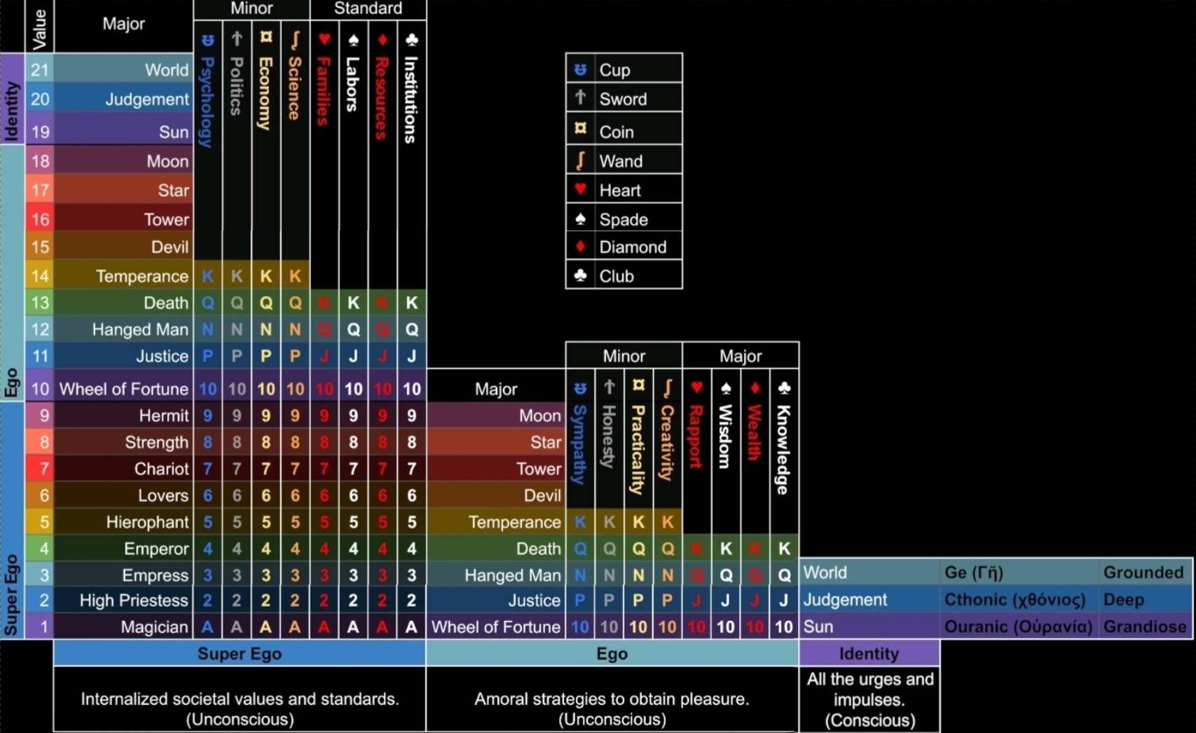
Reference image supplied with the account. The preceding tables transcribe its card positions and domain labels.

