PARAMETRIC FIELD PSYCHOLOGY
DENSE CONSCIOUSNESS
Developed Edition — Version 6.0
Psychiatry, Psychology, and the Growth of Stable Organization
Rebuilt against kernel 5.2, Unified Shell Geometry v1.1, the Topographical Atlas v0.1, A Fresh Perspective on Disorder v1.0, and Holonic Living Engine Consolidated Edition 1.0. Incorporates the August 28 closure ledger. This edition develops the clinical reading as a standalone document: it carries the tables the clinic needs, operationalizes the observations the theory already states, and does not add a theorem.
Scope and status.
This is a formal-model document with a clinical reading attached, not a clinical document. Every psychological, physiological, or social reading herein is [interpretive] and non-load-bearing for the algebra. Nothing in this document diagnoses, treats, or describes any person.
v5.1 carried a seven-grade status ledger. This edition maps that ledger onto the ten-grade scale of Holonic Living Engine Consolidated Edition 1.0, Appendix A, so the two documents can be read against one another without translation.
The development adds no theorem, no completion, and no election. Where a table is absorbed from the Atlas or the Disorder paper it is marked carried. Where an observational protocol is written, it operationalizes a prediction the sources already state. Sentences that exist only to make the clinical reading self-sufficient carry the tag [development note] and can be struck without touching the algebra.

The model in three statements.
1. Biological instability can disrupt thought, emotion, and action.
2. Stable psychological organization — density — can keep a person oriented during that instability.
3. Psychiatry and psychology support different levels of one nested living system, and the kernel now states exactly where each level enters.

What changed since v5.1, in one paragraph.
v5.1 closed the v4 holes: density identified with the retained complement under A23 refined; effective dimensionality retired; Item 10 dissolved and replaced by Item 10′; fifth Shell sign and Demand-Blindness adopted; CAPE mapped to the crossing and the gate; Practice priced by time reversal; joint load × lap-step prediction stated. What v5.1 could not do, as a standalone paper, was be used. The ordering prediction lived in the Atlas. The expected / necessary / converted grammar lived in the Disorder paper. Demand-Blindness was stated and not operationalized. The dual-first stall — the clinical face of Item 10’s dissolution — was one sentence. There were no figures. This edition carries those tables, writes the protocols the predictions already imply, expands the dual findings, adds five figures, and keeps every open item open.

How to read this edition
The paper has four movements. Part I states the object: density, the four levels, capacity under load, and the two load terms. Part II states the dynamics the clinic walks: conductivity and the five signs, CAPE as crossing and gate, the terrain, and the Disorder paper’s three claims. Part III is practice: the division of labor, the four-stage path, how density grows, an observational protocol, and worked examples. Part IV is the ledger.
A reader who wants only the clinical path can start at §9 and follow the pointers down. Nothing in an upper section is asserted that a lower section does not carry. A reader who wants only what the kernel proves can read the status ledger in §19 and stop.
Two projections observe one object. The Crux projection answers what transformation is being attempted. The OIG projection answers what changed, what persisted, what cancelled, what returned. They are two resolutions of one realized trajectory, never two mechanisms. Demand is required to tell them apart from rest.

Source | What this edition carries from it | Grade of the carrying
Kernel 5.2 (sealed pyref) | Facet law; A23 refined; no-altitude-branch; 2+2 under relay+gate; State queue | derived / implemented
Unified Shell Geometry v1.1 | Five signs; demand clause; joint detector; generator; altitude as search | source
Topographical Atlas v0.1 | Terrain, clock, portages, theorems, Chart T4 itineraries | carried; derived in Atlas
A Fresh Perspective on Disorder v1.0 | Expected / necessary / converted; five inversions; falsifiers | carried; grades as sourced
HLE Consolidated Edition 1.0 | Ten-grade scale; Part VI compression; C-register numbers | alignment [development note]
Dense Consciousness v5.1 | Every closed claim of that edition, restated, not re-argued | prior edition

Terms to know first
Term | Plain meaning | Kernel-adjacent statement
Density | Strong internal organization. Values, skills, relationships, and goals form a stable whole that contains lower-level turbulence. | The retained complement in the holon tower. Under A23 refined, retention is the only thing that stops the relay from dropping to the Super-Ego under pressure.
Capacity under load | How much of the situation a function can hold and use while turbulence is present. Replaces v4 “effective dimensionality.” | Locked facets of the position (facet law) plus what the tower has retained. Development changes what arrives at a position, never how many parameters it processes.
Conductivity | A movement completes cleanly under demand. No persistent defensive distortion remains. | C(H, D) ≠ ∅ for the required movement; realization (m, ∅, 0).
Shell | A self-maintaining distortion of an otherwise coherent movement, present only under demand. | x = (m, S, ι), S ≠ ∅, π(m, S, ι) = m. Detected jointly: D_Shell = (D, Π_C, Π_O).
Foreclosure | Demand is present and the required movement never starts. Fifth Shell sign. | Pure A under demand. Indistinguishable from rest without the demand term (Demand-Blindness).
Ground state | The native self-route of the current holon, running on two strong valued functions at displacement 00. | Free, non-pathological, no architectural gradient out of it. Demand is required to initiate movement.
CAPE | A four-phase cycle — Release, Leadership, Reversion, Re-ownership — that tests and restores conductivity. | Phase φ_t in the unified state X_t. Not in the kernel. Proxies: hold-charge (A37), cp crossing, time-reversal, A23 gate.
Function State | Short-term change in available bandwidth and demand threshold from acute chemistry. | A reading of the pending Super-Ego queue at the occupied seat. Already in State. No float.
Function Profile | Stable shift in circuit baselines from chronic exposure and plasticity. | No effect in 5.2 as a Shell-threshold gate at Role/Vulnerable. If it enters, it enters as persistence of the Super-Ego queue across laps.
Altitude | Developmental organization earned through repeated high-conductivity closures. | h(H) = recursive depth of completed coherent closure. No successor function on tiers; counted, not indexed.
Portage | One of three cube translations that move a distortion without changing its accepting/producing directive. | n compensation +(0,1,0); cp individuation +(0,0,1); a opposition +(0,1,1).
Lap | One four-step orbit of the estafette. Valued: 1→5→6→2. Subdued: 3→7→8→4. | Directive bits 0,0,1,1 on both. The 2+2 anabolic/catabolic rhythm.

Part I — The object

1. The core idea
Dense consciousness means strong internal organization. It does not mean physical thickness or constant mental activity.
A dense psyche connects experience, values, skills, relationships, and long-term direction so that these parts support one another during stress. Lower-level changes can still be intense. The person notices the disturbance and keeps the larger direction of life in view.
v4 could describe this; it could not say what it was in the model. The engine can now. Under the refined gate A23, a holon under pressure relays to its Super-Ego — the compensatory block — only while the complementary perspective is not retained. Once the tower has retained the complement, the same pressure no longer produces the drop. That retention is density. It is not a mood, a skill, or a chemical level; it is what the system carries back from the crossing and keeps.

Formal mapping [derived from A23 refinement; identification with v4 “density” is interpretive].
Density(H) = the retained complementary capacity of the current holon. At a given altitude, density contains lower-level turbulence without residual Shell exactly when the pressure produced by that turbulence does not trigger the relay drop. Repeated high-conductivity closures increase retention, and retention is the only channel through which development changes the tick.

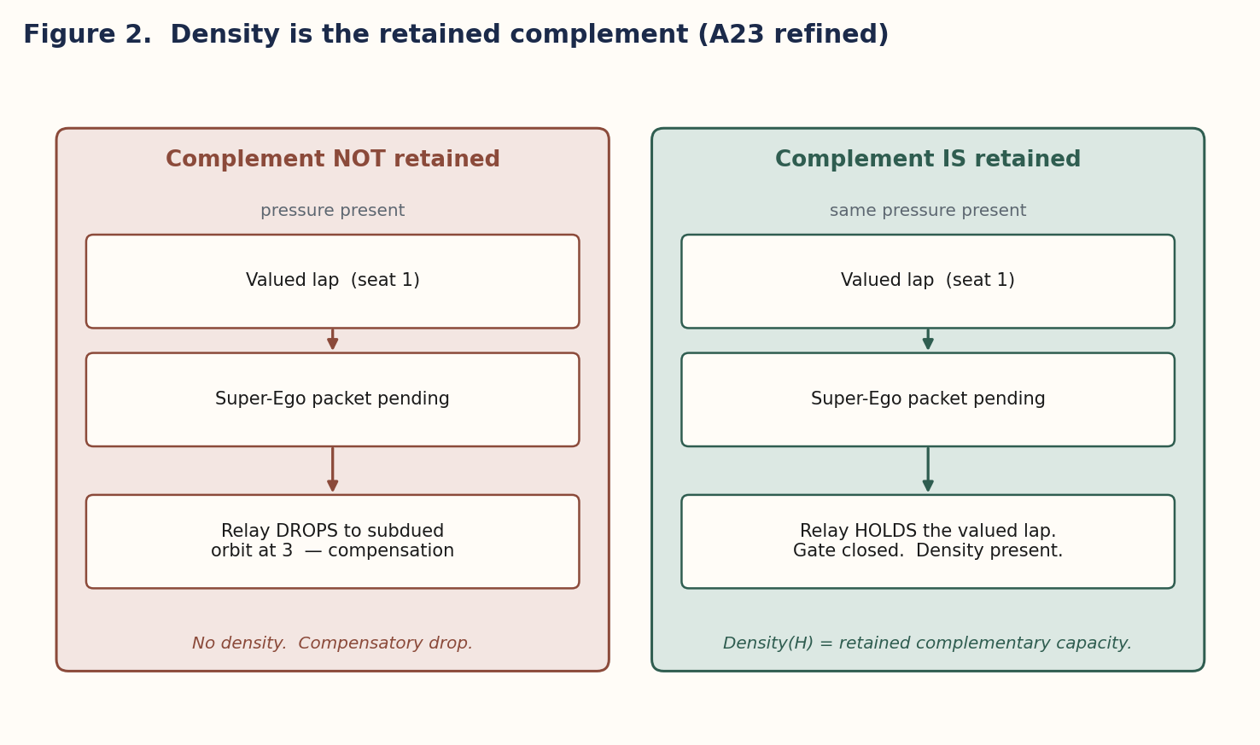
Figure 2. Density is the retained complement under A23 refined.

2. Four nested levels, and where the kernel begins
The model describes four nested levels. Each depends on the levels below it and organizes their activity; influence also moves downward, as a stable value, habit, or relationship guides the response to a chemical change. The kernel begins at level 3. Levels 1 and 2 are below the sealed algebra and enter it, if at all, only as modulation of access parameters.
The higher levels do not separate from biology. They describe more organized patterns within the same living system. The kernel’s discipline is the converse: the lower levels do not rewrite the higher ones. Chemistry changes access, not informational primitives, not the Model A baseline, not the sixteen-route grammar.

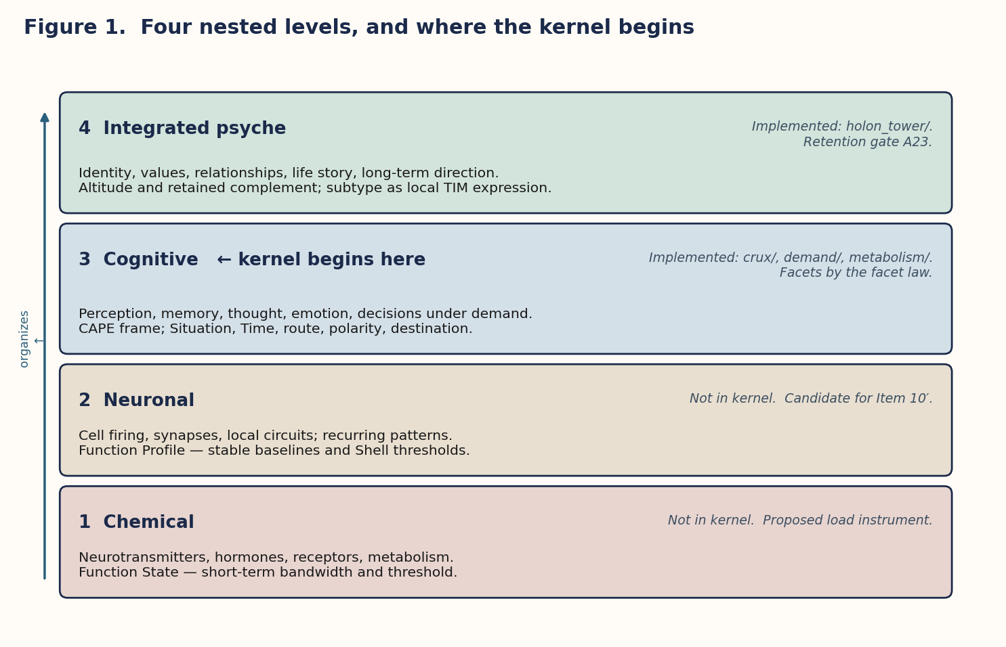
Figure 1. Four nested levels. The kernel begins at level 3.
Level | What it includes | Model term | Kernel status
1. Chemical | Neurotransmitters, hormones, ions, receptors, metabolism. | Function State — short-term bandwidth and threshold. | Not in kernel. Proposed load instrument.
2. Neuronal | Cell firing, synapses, local circuits; recurring activity patterns. | Function Profile — stable baselines and Shell thresholds. | Not in kernel. Candidate for Item 10′.
3. Cognitive | Perception, memory, thought, emotion, decisions coordinating the current situation. | CAPE frame; Situation, Time, route, polarity, destination under demand. | Implemented: crux/, demand/, metabolism/. Facets by the facet law.
4. Integrated psyche | Identity, values, relationships, life story, long-term direction. | Altitude and retained complement; subtype as local expression of the TIM. | Implemented: holon_tower/ with no tier successor; retention gate A23.

The four-level picture is [interpretive] as a clinical frame. The level-3 / level-4 boundary is not: it is the kernel boundary. A different elected clinical vocabulary would relabel the levels without changing a theorem.

3. Capacity under load (formerly Residual #2)
v4 stated that effective dimensionality has two independent sources: the locked Model A baseline and a developmental radial contribution. The idea survives; the noun does not.

3.1 Why “dimensionality” cannot carry the developmental term
In the kernel, dimensionality is a defined quantity: the number of parameters a function processes (P1, Bukalov). verify_v5 enumerates all assignments of the four facets to boolean functions of (strong, bold) and finds exactly one nested law consistent with the dimension formula dim = 1 + 2·strong + bold.
Facet | Present when | Positions
experience | always | all eight
norms | strong ∨ bold | absent only on the 1D pair {4, 5}
situation | strong | the strong/weak dichotomy itself
time | strong ∧ bold | the 4D pair {1, 8}

Nothing developmental can add a facet. v4 already conceded this — “development does not equalize dimensions” — while using a phrase that implied otherwise. This edition retires “effective dimensionality” and uses capacity under load. A 1D function is 1D at every altitude.

3.2 The two sources, restated
- Locked baseline. Position fixes dimensionality (4-3-2-1-1-2-3-4), valuation, mental/vital ring, and accepting/producing directive. These are the three coordinates (a, v, r) of the terrain and the facet law over them.
- Retained complement. The tower’s retained complementary capacity changes what arrives at a position under pressure. It does not change the position. A 1D function remains 1D; what changes is whether pressure on it is registered as demand the current holon can meet or as a trigger for the compensatory relay.
Chemical and neuronal conditions modulate how much of the retained contribution is available under load. They do not change the information element, and they do not make positions equal. The same chemical event affects positions differently, and the ordering of that effect is fixed by the facet count.

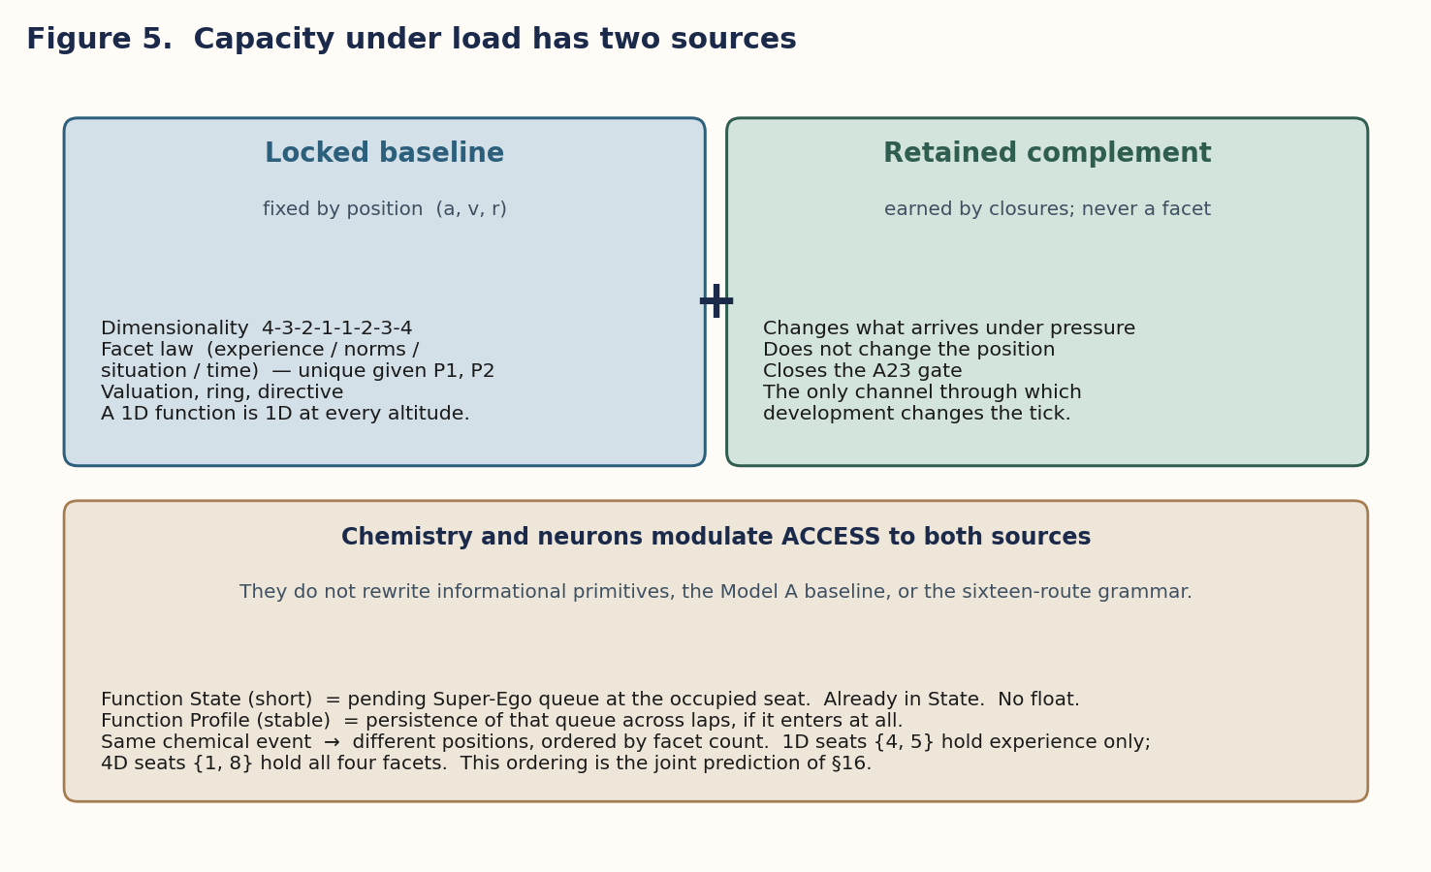
Figure 5. Capacity under load has two sources. Chemistry modulates access to both.

3.3 Item 10 dissolved; Item 10′ recorded
The kernel’s ledger recorded a theory-level tension: with dimensionality fixed by Model A, continuous directed pressure on a Role or Vulnerable function overloads it on every tick it arrives, so Shell Geometry §16.2 (“same or greater demand + less persistent distortion”) cannot be met under sustained load, and clearance is observed only when pressure pauses. The dual-first stall was cited as the reproduction. The ledger stated two ways out: either retention must change how Role/Vulnerable register pressure on the retained perspective — a reading of compensation — or clearance must be judged elsewhere.
Function Profile was the first option written in prose, and v5.0 proposed it as the Item 10 term. It was then tested (probe_item10_clearance.py, 9/9). Both halves of Item 10 fail to reproduce in 5.2.
- Directed pressure at Role or Vulnerable never produces a persistent overload, because R3 queues mental-block input and A23 engages the Super-Ego for one tick and returns, so hits alternate and the streak never exceeds one.
- The dual-first plateau cited as the reproduction is starvation — an empty world with developed hunger — not overload.
What the dynamics obstruct is retention, not clearance. A Function Profile gate on the complex threshold at 3/4 changes nothing in any regime; there is no activation to gate. Item 10′ replaces it: A27’s clearance test at the compensation carriers is vacuous in 5.2 (in a full socion flood the complex activates only at positions 2, 5, 6, 7, never at 3 or 4). Two readings stand, neither elected: count the overload streak per engagement of the block; or read the pending Super-Ego queue as the Shell’s metabolic observable. The second matches Demand-Blindness and Atlas 8.6. This edition does not elect (C9).

What survives of Residual #2.
The two-source structure of capacity under load is intact, and density as the retained complement is intact — that rests on A23, not on Item 10. What is retired is the claim that the developmental term enters at a Shell threshold. In engine terms the only load the seat ever sees is (i) facets it cannot process, already recorded as dropped residue under R1, and (ii) the queue of Super-Ego packets pending while the relay is elsewhere. Neither is a new number. Function Profile is no_effect_in_5_2; Function State survives as a reading of the queue.

4. Function State and Function Profile as load terms
Term | Time scale | Meaning | Where it would enter the engine | Grade
Function State | Short term | Acute chemical and neuronal change alters current bandwidth and the demand threshold. | The pending Super-Ego queue at the occupied compensation carrier — demand present, movement not yet processed. Seat-level foreclosure geometry (Atlas 8.6). Already in State. | proposed completion
Function Profile | More stable | Chronic exposure and plasticity alter usual baselines and Shell thresholds. | Formerly the Item 10 term (a Shell-threshold gate at Role/Vulnerable). Tested: no effect in 5.2. If it enters at all, it enters as the persistence of the Super-Ego queue across laps. | no effect in 5.2

Constraint carried from the kernel.
No float, no weight, no rate. The kernel and every V5 package are exact. A load term that enters as a continuous number would breach the seal. Two admissible forms remain: (i) an instrument switch with a small ordered set of values, default off, in the pattern of FIRING_POLICY and RELAY_GATE; (ii) a demand-magnitude ordering on D, which is already a first-class object. Which form is a build decision to be made against a source or a preregistered observation, not here (C13).

Neither term touches dimensionality, the facet law, the estafette, the chords, or POS_COORD. They modulate access. This is the same posture the v4 edition took; it is now stated at the interface where it would be enforced.

Part II — Dynamics the clinic walks

5. Conductivity, the five Shell signs, and Demand-Blindness
Conductivity asks one question: does the movement complete cleanly when demand increases? A conductive movement leaves no persistent defensive distortion after CAPE. A non-conductive movement leaves one or more Shell signs. v4 listed four; Shell Geometry 1.1 has five, and the fifth is the one that matters most for this document.
Shell sign | What it means | Movement started? | Π_O visibility
Premature translation | The active drive becomes a story, strategy, or opposite-polarity function too early. | Yes | Partial (144/192); remainder needs Π_C
Forced placement | The content moves toward a destination that does not match the active parameters. | Yes | Partial (1920/2040); remainder needs Π_C
New defensive structure | A defensive structure appears only after demand increases. | Yes | Fully Π_O-visible
Residual fragmentation | The same material still produces Shell signs after CAPE phases 1–3. | Yes | Fully Π_O-visible
Foreclosure | Under a specified demand requiring a non-current movement, the movement does not activate; the prevention persists through the conductivity test. | No | Fully Π_O-visible (pure A under demand)

Π_O signatures for all five signs are derived (probe_shell_signatures.py, 13/13). Implementation remaining: metabolism/observe.py should carry the three fully-visible signatures; the two partial ones belong with Π_C in demand/detector.py. One protocol correction is owed: content_path(foreign=…) carries foreign content from the origin and cannot render sign 3, which is about appearance (C8).

5.1 The demand clause
The ground state — the native self-route of the current holon, running on two strong valued functions at displacement 00 — is free and non-pathological. There is no architectural gradient out of it; demand is required to initiate movement. Rest (no demand, self-route running) and foreclosure (demand present, movement not initiated) are therefore indistinguishable from the trajectory alone. This is the Demand-Blindness theorem, and it is why the detector is joint: D_Shell = (D, Π_C, Π_O).
For a clinical reading the consequence is direct. A stabilized patient at rest and a stabilized patient foreclosed look the same to any observation that omits demand. The chemical stage of care cannot be judged successful on trajectory evidence without a specified demand.

5.2 Rest versus foreclosure — the operational differential [development note]
v5.1 stated Demand-Blindness and stopped. The differential is already in the joint detector; this subsection only writes the observation in order.
Step | What is specified | What is observed | Reading if the sign is present | Reading if the sign is absent
0 | Nothing. Trajectory only. | Self-route running, or stillness. | Indeterminate. Rest and foreclosure are identical here. | Indeterminate.
1 | A demand D that requires a non-current movement. | Whether m initiates. | Foreclosure: pure A under demand. Prevention persists. | Movement started. Not foreclosure. Inspect the other four signs.
2 | The same D, after CAPE 1–3. | Whether any of the five signs remain. | Non-conductive. Name the sign. Do not call it altitude. | Conductive under this D. Density may or may not yet hold under a harder D.
3 | A harder D′ (more detail, more time, or a different route). | Whether the A23 drop recurs. | Complement not retained under D′. Gate still open. | Gate holds under D′. Retention present at this demand.

The differential does not invent an instrument. It uses D, Π_C and Π_O in the order Shell Geometry already requires. What it forbids is the sentence “the person is stable” said of a trajectory that was never placed under demand.

6. CAPE as the crossing and the gate
CAPE is a four-phase cycle that tests and restores conductivity. Phase φ_t is carried in the unified state X_t and is not in the kernel. The engine’s proxies are hold-charge under A37, the cp portage, time-reversal, and the A23 retention gate. The mapping is [interpretive] as a clinical cycle and derived as a correspondence to those proxies.

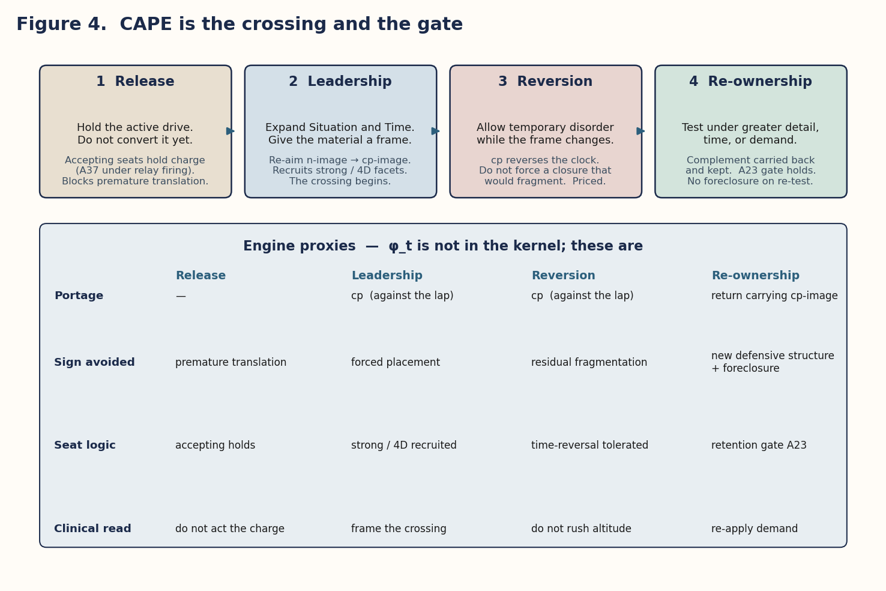
Figure 4. CAPE mapped onto engine proxies. φ_t is not in the kernel; these are.
Phase | Plain instruction | Engine proxy | Sign the phase is designed not to leave | Portage / gate
1. Release | Let the active drive remain present. Do not convert it into a story or action too early. | Accepting seats hold charge (A37: under relay firing, charge waits for the expenditure turn rather than leaking). | Premature translation | None. Hold.
2. Leadership | Expand Situation and Time until the raw material has a stable frame. | Re-aim from the n-image of the seat to its cp-image, against the lap. Situation and time are the strong and 4D facets. | Forced placement | cp begins
3. Reversion | Allow temporary disorder while the frame changes. | Do not force a closure that would produce residual fragmentation. Terrain theorem 2: cp reverses the clock, so this phase runs against traffic and is priced accordingly. | Residual fragmentation | cp continues (against traffic)
4. Re-ownership | Test the stance under greater detail, time, or demand. | The complement is carried back and kept. The relay no longer drops under the re-applied demand. | New defensive structure; foreclosure | Return + A23 gate

Conductivity returns only when no Shell sign — including foreclosure — remains under re-applied demand. Insight can re-aim. It cannot walk the lap. That is §7.3.

7. The terrain reading: which distortion, when, and at what cost
The Atlas and the Disorder paper supply three results that v4 had no access to. Each changes a clinical sentence in this document from an assertion into a consequence. This edition carries the charts a clinical reader needs, so the prediction in §16 can be stated without opening a second file.

7.1 Which distortion
Each type seats the eight elements at the corners of the (a, v, r) cube, and each element carries an elected disorder label. distortion(T, p) = DISORDER[element_at(T, p)]. There is no distortion-free position and no distortion-free type; a system that shows compensatory distortion is exhibiting the model, not malfunctioning relative to it.
The clinical corollary: “falling into chemicals” does not produce arbitrary disorganization. It produces the distortion of the seat under load, and the seat is known.
Pos | (a, v, r) | Archetype | Directive | Tonicity | Ring | Dim
1 | (0,0,0) | Saint | accepting | valued | mental | 4
2 | (1,0,0) | Missionary | producing | valued | mental | 3
3 | (0,1,0) | Devil | accepting | subdued | mental | 2
4 | (1,1,0) | Serpent | producing | subdued | mental | 1
5 | (0,0,1) | God | accepting | valued | vital | 1
6 | (1,0,1) | Innocent | producing | valued | vital | 2
7 | (0,1,1) | Savage | accepting | subdued | vital | 3
8 | (1,1,1) | Prophet | producing | subdued | vital | 4

Carried from Atlas Chart T0. Archetypes are position labels. The disorder vocabulary is an election from the Shadow Complex tables; a different elected table would relabel the corners without changing a theorem. The Si compulsion-versus-paranoia inconsistency is load-free for every topography verdict (Atlas T9; C37).

7.2 When
The estafette tours each type’s terrain in two four-step laps, valued and subdued, with the directive bits in the order 0, 0, 1, 1 on both — two accepting steps, then two producing. This is the 2+2 anabolic/catabolic rhythm the V5.2 pure finding measures at altitude (balance 0.000 under relay firing with the gate), here following from cube geometry. A distortion attributed to a seat should surface at that seat’s lap step.
Psychiatric stabilization, in these terms, is what lets the lap run: it lowers turbulence so that accumulation is not spent on the wrong turn and the creative does not arrive to an empty psyche. That sentence inherits the off-by-default status of FIRING_POLICY = "relay" and RELAY_GATE = True (C16).

7.3 At what cost
Compensation n is the unique portage that commutes with the clock; individuation cp and opposition a reverse it. No portage changes the directive: only the estafette carries content across the accepting/producing divide. Together: a Shell is cheap to maintain because its upkeep runs with traffic; unwinding is expensive because it runs against the lap; and transformation cannot be performed instantaneously by any symmetry operation of the model. Content that must change directive has to be lived through the clock.

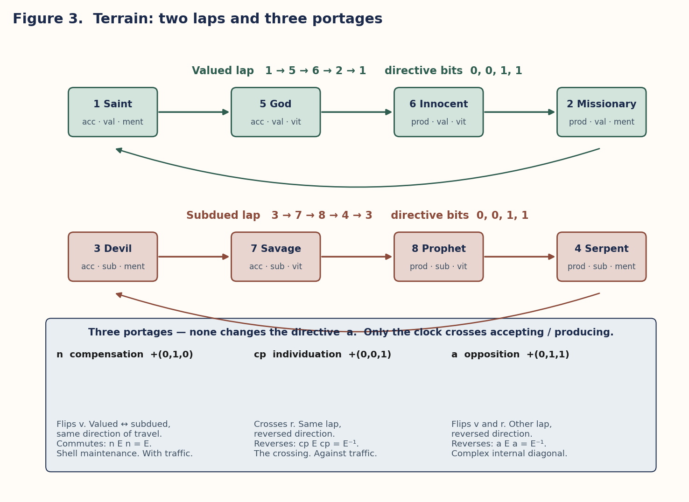
Figure 3. Two laps, three portages. Only the clock crosses the directive.
What this buys the clinical reading.
v4’s Practice stage — “use the new patterns during ordinary stress until they become reliable” — was good advice with no formal ground. It now has one. Insight is a symmetry operation; it can re-aim from the n-image to the cp-image of a seat. It cannot cross the directive. The laps have to be walked. This is the formal skeleton under the old observation that insight alone does not cure, and it is why stabilization is a platform and not altitude.

7.4 Carried itineraries — Atlas Chart T4
Each row is the temporal order in which distortions appear as the relay tours that type’s terrain. The valued itinerary is the terrain of ordinary development. The subdued itinerary is the shadow country reached by the opposition portage, and it is the n-image of the valued lap read at the same steps. All sixteen valued itineraries are distinct. Carried from the Atlas; regenerated August 28 by probe_consolidated_terrain.py, 24/24.
TIM | Valued lap Saint → God → Innocent → Missionary | Subdued lap Devil → Savage → Prophet → Serpent
EIE | dissociative → avoidant → passive-aggr. → narcissism | schizoid → dependent → antisocial → paranoia
EII | dependent → schizoid → paranoia → antisocial | avoidant → dissociative → narcissism → passive-aggr.
ESE | dissociative → avoidant → antisocial → paranoia | schizoid → dependent → passive-aggr. → narcissism
ESI | dependent → schizoid → narcissism → passive-aggr. | avoidant → dissociative → paranoia → antisocial
IEE | antisocial → paranoia → schizoid → dependent | passive-aggr. → narcissism → dissociative → avoidant
IEI | narcissism → passive-aggr. → avoidant → dissociative | paranoia → antisocial → dependent → schizoid
ILE | antisocial → paranoia → dissociative → avoidant | passive-aggr. → narcissism → schizoid → dependent
ILI | narcissism → passive-aggr. → dependent → schizoid | paranoia → antisocial → avoidant → dissociative
LIE | schizoid → dependent → passive-aggr. → narcissism | dissociative → avoidant → antisocial → paranoia
LII | avoidant → dissociative → paranoia → antisocial | dependent → schizoid → narcissism → passive-aggr.
LSE | schizoid → dependent → antisocial → paranoia | dissociative → avoidant → passive-aggr. → narcissism
LSI | avoidant → dissociative → narcissism → passive-aggr. | dependent → schizoid → paranoia → antisocial
SEE | passive-aggr. → narcissism → schizoid → dependent | antisocial → paranoia → dissociative → avoidant
SEI | paranoia → antisocial → avoidant → dissociative | narcissism → passive-aggr. → dependent → schizoid
SLE | passive-aggr. → narcissism → dissociative → avoidant | antisocial → paranoia → schizoid → dependent
SLI | paranoia → antisocial → dependent → schizoid | narcissism → passive-aggr. → avoidant → dissociative

These labels name corners of a terrain, not persons. A study that uses this table specifies a TIM, a lap step, and a demand; it does not type a patient from a sign, and this paper does not either.

8. Expected, necessary, converted
A Fresh Perspective on Disorder v1.0 states the framework’s reading of compensatory distortion as three claims, each at a different epistemic grade, and records what would falsify it. The sentence documented is: compensatory cognitive distortions are expected, necessary, and the path forward that must be overcome. The framework endorses a corrected form, and the correction in the third clause is not a softening; it is what the algebra and the engine both say. This section carries that document into the clinical reading.
Claim | Statement | Grade
Expected — totality | Every type carries a disorder label at every corner. A system showing compensatory distortion is exhibiting the model. | derived, given the elected tables
Expected — ordering | A distortion attributed to a seat surfaces at that seat’s lap step, in the itinerary fixed per type. | derived; stated testable (C31)
Necessary | Compensatory distortion is necessary at altitude boundaries, and only there, by the definition of the altitude law. | definitional
Converted | Unwinding is transport, not erasure: n-image → cp-image of the same seat, against the lap, at the cost of time reversal. Retention is the closure condition. | model-specified / derived / completion implemented
Not instantaneous | Transformation cannot be performed by any symmetry operation of the model. Content that must change directive has to be lived through the clock. | derived (terrain theorems 1 and 2)

8.1 Five inversions [interpretive]
If the three claims hold, five properties of “disorder” invert. None of this romanticizes distortion. The unhealthy trajectory is stated with equal force. The perspective is fresh because it declares distortion legible.
Inversion | Instead of | The model says
Positional, not essential | what a system is | where content sits on a terrain
Scheduled, not random | noise, or a type-free crisis | it surfaces at its lap step; the itinerary differs by type
Priced, not gratuitous | perverse persistence | maintenance is the one time-invariant route, so persistence is rational
Informative, not merely obstructive | a problem to silence | a persistent Shell under demand marks the exact boundary where the current organization ends
Material, not waste | content to discard | the compensatory regime carries what the higher closure retains; discard it and there is nothing to convert

8.2 What would falsify it
Three observables carry the synthetic content. All are stated by the sources as testable under specified conditions without new assumptions. None has been tested against human data. Until then the empirical column of the theory is a set of commitments, not results.
- C31 Ordering. Failure = off-schedule surface, or no type difference across itineraries.
- C32 Boundary signature. V high, N limited, K ≠ ∅ with recurrent Shell at boundaries; absent at horizontal adaptation. Failure = the signature under conductive realization, or its absence at boundaries.
- C33 Post-closure relief. Less compensatory complexity, less cancellation, less recurrence, greater retention after integration. Failure = closure without cost reduction, or reduction without retention.

Part III — Practice

9. Psychiatry and psychology support different levels
Approach | Primary work | Purpose in this model | In terrain terms
Psychiatry | Chemical and neuronal levels. | Reduce severe instability; create a platform on which CAPE can operate under load. | Lower Function State load so the lap runs 2+2 and foreclosure lifts.
Psychology | Thought, emotion, relationships, skills, identity, meaning. | Build durable organization: density and conductive nesting. | Transport n-image → cp-image against the lap; carry the complement back; close the retention gate.
Joint work | Connect biological stability with psychological growth. | Meet greater demand without residual Shell. | Same demand, fewer signs, greater retained complementary capacity (Shell Geometry §16.2).

Medication can leave psychological work unfinished: the lap runs but nothing is transported. Psychological work can fail when biological instability remains severe: the crossing is attempted at a load the seat cannot hold and leaves residual fragmentation or foreclosure. The chemical platform supports development, but it is not altitude. Altitude is counted in closures, and closures require retention.
The division of labor is [interpretive]. The claim it rests on is not: chemistry modulates access and does not rewrite primitives.

10. A four-stage path toward greater stability
The stages can overlap. A person can return to an earlier stage when conditions change. Autonomy is a direction, not a demand.
Stage | Plain purpose | Integrated reading
1. Stabilize | Reduce severe turbulence when it blocks sleep, learning, reflection, or self-control. | Lower the load at the occupied seat until Release can hold the active drive without premature translation and without foreclosure. The lap begins to run 2+2.
2. Integrate | Build stronger patterns of thought, identity, relationship, meaning, and action. | Leadership: expand Situation and Time; re-aim from the compensating seat to its individuating partner. The crossing into the complement.
3. Practice | Use the new patterns during ordinary stress until they become reliable. | Live the change through the clock. Repeated conductive laps under re-applied demand consolidate whatever Profile exists and build reversion tolerance. No shortcut exists (terrain theorems 1 and 2).
4. Increase autonomy | Use the least external support that remains safe and effective. | The retention gate closes: the relay no longer drops to the Super-Ego under pressure because the complement is retained. The altitude is owned with less scaffolding.

Important limit.
Autonomy is a direction, not a demand. Some people need long-term support, and development does not equalize dimensions. Nothing in the model licenses withdrawing support on schedule; the gate closes when retention is present, and retention is observable only under specified demand.

11. How psychological density grows
Density grows through repeated experiences that strengthen higher-level organization. The formal model reads these experiences as conductive route compositions whose retained material survives the return. As these capacities strengthen, lower-level signals enter a larger context. The weather remains within the climate.
Capacity | Plain effect | Model interpretation
Coherence | Thoughts, emotions, goals, and actions support one another. | Routes remain distinct; their composition does not fragment. Low cancellation K relative to cumulative visibility V.
Self-regulation | The person notices a signal without immediately obeying it. | Release holds the charge on an accepting seat; no premature translation.
Secure relationships | Trust reduces fear and corrects distorted expectations. | WE-scale nesting; the dual carries the destination content at the mirrored archetype, so the complement is available from outside before it is retained inside.
Narrative continuity | A connected life story links past, present, and future. | ITS-scale ordering; the temporal profile R preserves the history of closures that endpoint summaries miss.
Values and purpose | Commitments guide action when mood or conditions change. | Retained complement prevents a secondary chemical event from cancelling the primary route — the A23 gate holding.
Competence and community | Useful work and shared responsibility strengthen identity. | IT and WE composition; joint provenance (A38): content produced across holons and owned by neither.

11.1 The dual as external complement
v5.1 gave this one sentence. It is the paper’s cleanest clinical mechanism and it is already in the algebra.
The return route is complementary → native for every TIM. The dual’s leading function is the requester’s suggestive; the dual’s creative lands on the requester’s activating. Both are checked for all sixteen TIMs. Content the current holon has not retained is therefore available, in the pair, from outside — at the mirrored archetype, along the return chord A6→A1 gated on retention.
In clinical vocabulary [interpretive]: a reliable dual-scale relationship can hold the destination content while the crossing is unfinished. That is not altitude. It is an external scaffold for the complement. Density is what remains when the scaffold is no longer doing the holding — when A23 no longer drops because the complement has been carried back and kept. This is why Stage 4 is a direction measured under demand, not a calendar.

11.2 Dual-first starvation — the clinical face of Item 10’s dissolution
The dual-first plateau was cited in v4/v5.0 as the reproduction of Item 10: Role/Vulnerable overload under sustained load, clearance only when pressure pauses. In 5.2 the plateau is not overload. It is starvation. An empty world with developed hunger. The holon has requested on the suggestive; nothing arrives; retention cannot complete; the generator stalls at altitude 2.
The clinical reading [interpretive] is exact and limited. Pairing with the dual does not by itself produce density. If the dual is absent, silent, or itself undeveloped, the suggestive request has nowhere to land and the activating never receives the creative that would feed the next closure. Flooding the field (a full socion) produces a different stall — activation at 2, 5, 6, 7, never at 3 or 4 — which is why Item 10′ is about the queue, not the Role/Vulnerable threshold.
What the finding forbids: treating “find the dual” as a developmental completion. Regime I says pair development is a function of relation alone. It does not say the pair is sufficient under every delivery policy, and it does not say the pair writes retention. Retention is still the gate.

12. Observational protocol
The joint prediction and the ordering prediction are already stated. This section writes the observation in an order a study can follow. It adds no assumption. Every step names a term that already exists.

12.1 Specifying demand
A demand D is first-class. For a conductivity test it must name at least: the required movement (origin perspective, destination perspective, polarity), the TIM under observation, and whether the world is empty, paired, or populated. Without D, rest and foreclosure are the same observation (Demand-Blindness). Without the TIM, the itinerary is not fixed and C31 cannot fail.

12.2 Reading D_Shell
The detector is joint: D_Shell = (D, Π_C, Π_O). Π_C answers what transformation is being attempted. Π_O answers what changed (V), persisted (N), cancelled (K), returned (R). Maintenance is V = 1, N = 0, K = 1. Foreclosure is pure A under demand. New defensive structure and residual fragmentation are fully Π_O-visible. Premature translation and forced placement are partly Π_O-visible and need Π_C for the remainder.

12.3 Protocol for the joint load × lap-step prediction (C34)
# | Specify | Observe | Predicted | Failure
1 | TIM T; current lap step (seat p); demand D of stated magnitude. | Which Shell sign appears first, and at which seat. | The first sign is the Atlas label of the occupied seat p. | A sign surfaces at a seat other than p.
2 | The same event at two seats of different facet count. | Relative severity (queue length at the occupied carrier; residue dropped under R1). | Severity orders inversely by facet count. {4, 5} worse than {1, 8}. | Severity fails to order by facet count.
3 | The Super-Ego queue at the occupied carrier. | Whether the queue grows while the relay is elsewhere. | Function State as queue growth, not as a rewritten dimension. | Queue silent while signs appear, or dimensions appear to equalize.

This is the first place Function State would enter the engine as something other than prose: a load term at the occupied seat, not a change to dimensionality. The form of that term remains open (C13).

12.4 Protocol for the ordering prediction (C31)
A distortion attributed to a seat should surface at that seat’s lap step, in the itinerary of Chart T4 for that TIM. Failure = off-schedule surface, or itineraries that do not differ by type. The study must specify demand and lap step. A retrospective chart that does not record seat and demand cannot test this claim, and cannot be cited as supporting it.

13. Worked examples
Every example below is [interpretive] as a reading and uses only terms already introduced. None describes a person.

13.1 Four-layer reading of the podcast scenario
The scenario describes an acute rattlesnake encounter followed by chronic hypervigilance, fragmented processing, spatial disorientation, stalled learning, and residual fear memories. It cites Baik (2020) on cortisol and serotonin effects and a 125–250 percent mesolimbic dopamine increase. The physiological figures are external_secondary and carried, not adjudicated.
Chemical layer — Function State. An acute threat produces rapid cortisol and dopamine changes. The racing heart, impaired decisions, and cited dopamine surge fit Function State: a transient rise in load at the occupied seat. Se registers embodied force and boundary threat; Fe registers internal activation and fear charge. These are readings of the stimulus, not assignments of elements to brain structures (C15). Chemistry changes access, not primitives.
Neuronal layer — Function Profile. Persistent startle weeks later is not Function State. The podcast links prolonged cortisol to reduced hippocampal volume and plasticity, dopamine fluctuation to impaired plasticity, low serotonin to impaired neurogenesis. Together these form a Profile shift: baselines move, and less of the retained contribution remains available under load. In 5.2 this cannot be a Role/Vulnerable threshold. If it is anything in the engine, it is persistence of the Super-Ego queue across laps.
Cognitive layer — CAPE frame. The false “run” signal, flashbacks, fragmented retrieval, and spatial disorientation show incomplete processing under load. They map to four of the five signs: premature translation (the survival charge becomes an immediate story); forced placement (the charge goes to a mismatched destination); residual fragmentation (the material still produces signs after CAPE 1–3); and foreclosure (“stalled learning” and the “continuous state of survival”) — under a demand that requires a non-current movement, the movement does not initiate. Spatial disruption can also impair Si simultaneous-state indexing or Ni temporal indexing. Applying CAPE: Release holds the raw charge without an immediate story; Leadership expands Situation and Time and re-anchors the map; Reversion tolerates the trough; Re-ownership re-applies real demand. Conductivity returns only when no sign remains.
Integrated psyche — density and altitude. A “continuous state of survival” is an arrested generator: C(H_k, D) = ∅ with no minimal higher closure found, because the load prevents the crossing from completing. Density cannot contain the chemical load; the relay drops under pressure because the complement is not retained; foreclosure holds the seat. Repeated successful CAPE cycles restore availability; each closure adds to retention. The weather then stays within the climate of direction.
Limits of the mapping.
This example assigns no informational primitives to brain structures. It uses the architecture to organize the scenario’s load dynamics — retained capacity becoming less available and CAPE failing to complete — and nothing more. The Baik citation is carried from v2.1 and v4 unchanged.

13.2 Rest versus foreclosure under specified demand [development note]
Two observations that look identical on a quiet afternoon.
Observation A. No demand is named. The self-route is running. Π_O is silent. This is rest, or it is foreclosure. The trajectory cannot say which.
Observation B. Demand is named: a WE-destination route that the current holon does not dwell in, of stated polarity, under a world that actually requires the coordination. The movement does not initiate. Π_O reads pure A. The prevention persists through the conductivity test. This is foreclosure.
A chemical intervention that returns Observation B to Observation A has built a platform. It has not closed an altitude. The next test is Observation B again, after CAPE, under the same D, then under a harder D′. Retention is the difference between “the afternoon is quiet” and “the gate holds.”

13.3 Type itinerary under load — IEE as an Atlas row
The IEE row of Chart T4 is used here as a terrain, not as a person. Valued lap, Saint → God → Innocent → Missionary: antisocial → paranoia → schizoid → dependent. Subdued lap: passive-aggressive → narcissism → dissociative → avoidant.
Under acute load, C34 says the first Shell sign is the distortion of the currently occupied seat, with severity inverse to facet count. If the relay is on seat 1 (Saint, 4D, Ne in IEE), the predicted first sign is antisocial / immorality — the leading function depreciating the pole it regulates, per the Atlas distortion grammar. If the relay is on seat 5 (God, 1D, Si in IEE), the predicted first sign is paranoia, and the 1D seat holds experience only, so the same chemical event is predicted to present more severely here than at seat 1.
Unwinding a Shell that has settled at the n-image of a seat is not insight. For IEE the compensation of leading Ne-antisocial is the n-flip onto the subdued lap at the same directive. Individuation is the cp-image, against the lap. The dual (SLI) already carries the destination content at the mirrored archetype. The pair can scaffold. It cannot close the gate.
Failure of this reading is C31 and C34: the sign surfaces off-seat, or IEE and LII itineraries do not differ, or severity does not order by facet count.

13.4 Type itinerary under load — LII as contrast
The LII row, valued lap: avoidant → dissociative → paranoia → antisocial. Same clock, different seating. Seat 1 in LII is Ti, 4D, avoidant. Seat 5 is Fe, 1D, dissociative. The same chemical event that presented as antisocial-at-1 in the IEE row presents as avoidant-at-1 in the LII row. That is the whole content of the ordering claim. If a study cannot tell these two rows apart under specified demand and specified lap step, C31 has failed, and the clinical reading of §7.1 has nothing to stand on.
The contrast also shows what the paper will not do. It will not say that IEE “is” antisocial or that LII “is” avoidant. Every type carries every label, at a different corner, on a schedule. Totality first; then the itinerary.

Part IV — Ledger

14. Rising into information and falling into chemicals

14.1 Rising
Rising into information means that repeated experience creates a more stable level of organization. The phrase does not describe escape from biology; it describes a higher organization of biological and psychological activity. v4’s five-stage “generative radial engine” is the development generator of Shell Geometry §11–13:
- A capacity solves the current problem: the current holon H_k meets demand D conductively.
- Success changes the conditions: persistent consequence N_W of the action, not temporary excursion V_W, generates a new demand.
- Repetition of the old pattern leaves a new problem or residual Shell: C(H_k, D_(k+1)) = ∅.
- The same sixteen-route grammar makes a new class of clean solutions available: H_(k+1) = min{H′ > H_k : C(H′, D) ≠ ∅}.
- The dominant character of those solutions becomes the next altitude: χ_(k+1) = Profile(C(H_(k+1), D) − C(H_k, D)). If several minimal solutions exist, development branches, and the theory keeps the branch.
The earlier capacity remains available inside the new altitude. Layers are preserved without collapse. Tiers are emergent summaries of generated trajectories, not primitive coordinates. Stage colours, if used, are names for clusters and nothing more. The derivation claim for the colour line was withdrawn in the Crux Examined Edition.

14.2 Falling
Formal mapping [proposed; reading interpretive].
Chemical turbulence raises the load at the occupied seat above what the retained complement can absorb. The relay drops to the Super-Ego (A23 not yet satisfied). The realization leaves one of the five signs — and foreclosure is the sign v4 could not name: the required movement never initiates, and the system preserves its current organization under a demand it cannot meet. CAPE does not complete.

The Beige → Purple illustration of v4 is kept as a profile, not a tier: immediate survival under scarcity (ST-origin expenditure) succeeds; isolated survival creates no shared memory; WE-destination routes create coordination; the generated character is dominated by IT → WE displacement. A stage colour is a name for this cluster.

15. What remains fixed in the formal model
- Chemistry and neuronal dynamics modulate access parameters; they do not rewrite informational primitives.
- The facet law is unique given P1 and P2 and admits no developmental facet.
- A Shell changes the realization of a route; it does not create a seventeenth route.
- No portage changes the directive; only the estafette does.
- Subtype is a local developmental expression of the TIM, not a separate Cross.
- Perspective, route, polarity, conductivity, retention, and altitude remain separate coordinates.
- Altitude is counted in closures and has no successor function on tiers.
- Development changes the tick only through retention. tick() contains no altitude branch.
- Stimulus-to-element readings (Se for boundary threat, Fe for fear charge) are assignments made by the reader, not by the model (C15).
- The clinical vocabulary of this document is an election. A different elected frame would relabel the levels without changing the theorems.

16. The joint prediction the sources do not state separately
Three documents together yield synthetic content none of them contains alone.
- Atlas: a seat’s attributed distortion surfaces at that seat’s lap step, in a per-type itinerary.
- Dense Consciousness: the same chemical event affects positions unequally; dimensions remain unequal.
- Facet law: the inequality is ordered — 1D seats {4, 5} carry experience only; 4D seats {1, 8} carry all four facets.
Prediction [stated testable; untested].
Under acute load, the Shell sign that appears is the distortion of the seat the relay currently occupies, and its severity is ordered inversely by that seat’s facet count. This is a per-type, per-lap-step, load-conditioned ordering claim. It is testable with the existing joint detector D_Shell = (D, Π_C, Π_O), provided the demand and the lap step are specified, and it would be the first place Function State enters the engine as something other than prose: a load term at the occupied seat, not a change to dimensionality.
Failure mode. Signs surface at seats other than the occupied one; or severity fails to order by facet count; or the itinerary does not differ by type as charted.

17. Limits and clinical realities
Biology and personal history vary. Some conditions require long-term chemical support. Over-medicalization can neglect density-building work; under-treatment can demand growth before biological stability is sufficient. Development can improve recognition, cooperation, external calibration, and circuit integrity, but it does not erase locked access regimes. The same chemical event can affect Model A positions differently. Dimensions remain unequal.
Nothing in this document licenses a treatment plan, a medication decision, a typing, or the withdrawal of support. Retention is observable only under specified demand. Demand is specified by a study or a clinician who accepts that responsibility; the model does not.

18. Open items
Carried forward without resolution, in the tradition of recording rather than repairing. Numbers in parentheses are the HLE Consolidated Edition C-register.
# | Item | What would close it
C9 | Item 10′. Two readings, neither elected: overload streak per block engagement, or the pending Super-Ego queue as the Shell’s metabolic observable. | An election against a source, or a preregistered observation. The queue reading matches Demand-Blindness and Atlas 8.6.
C13 | Form of the load term. No complex threshold exists to modulate. Remaining candidates: a magnitude ordering on D, or the queue. No float either way. | A build decision against a source or a preregistered observation.
C8 / C39 | Sign → (K, R) remaining implementation; probes not in the canon zip. | Ship observe.py / detector.py changes; pin probes by hash.
C16 | Relay firing with the refined gate is not the default. The 2+2 finding and “stabilization lets the lap run” inherit that status. | Empirical: supervisor’s first closure under the two policies; more broadly whether supervision structures transmit content under distance.
C31–C34 | Ordering; boundary signature; post-closure relief; joint load × lap-step. Stated testable; untested against human data. | Studies with demand and lap step specified. Failure modes are written in §8.2 and §12.
C15 | Stimulus-to-element readings are the reader’s assignments, unverified. | Not a model item. Recorded so it is not mistaken for one.
C7 | Mode-pair polarity on the trails. | An election against a source; none proposed.
C37 | Si compulsion (headers) vs paranoia (tables). Tables authoritative; relabel load-free. | Nothing rests on it unless a source decides the header.

19. Status ledger
Grades follow HLE Consolidated Edition 1.0, Appendix A. Interpretive readings remain non-load-bearing for the algebra.
Claim | Grade
Model A dimensionality 4-3-2-1-1-2-3-4 and the facet law | derived, conditional on P1 and P2; verified in verify_v5
No developmental term can add a facet; “effective dimensionality” retired | derived (facet uniqueness)
Density = retained complement gating the relay drop | derived from A23 refined; identification with v4 “density” is interpretive
Development changes the tick only through retention (no altitude branch) | implemented; verified textually in verify_v5_2
2+2 rhythm on both laps | derived from cube geometry; measured as V5.2 pure finding under relay + gate
n uniquely commutes with the clock; cp and a reverse it; no portage crosses the directive | derived (terrain theorems)
Transformation cannot be instantaneous; Practice is priced by time reversal | derived; clinical reading interpretive
Five Shell signs; demand clause; joint detector | source-defined (Shell Geometry 1.1); implemented; Π_O signatures derived 13/13
Rest vs foreclosure operational differential | development note; uses only D, Π_C, Π_O
Chart T4 itineraries as carried data in this paper | derived in Atlas; regenerated 24/24 August 28
Expected / necessary / converted; five inversions | carried from Disorder v1.0; inversions interpretive
Foreclosure as the sign of “falling into chemicals” and “stalled learning” | interpretive; non-load-bearing
Function State as the Super-Ego queue at the occupied seat | proposed_completion; observable exists in State; no float
Function Profile as a Shell-threshold gate at Role/Vulnerable | no_effect_in_5_2; Item 10 dissolved, Item 10′ recorded
Dual as external complement; return route complementary → native | derived (all 16 TIMs); clinical scaffold reading interpretive
Dual-first plateau is starvation, not overload | derived (re-read in 5.2); clinical reading interpretive
Four nested levels; psychiatry / psychology division of labor | interpretive; the level-3/4 boundary is the kernel boundary
Generator stages (§14.1) | restatement of Shell Geometry §11–13
Stage colours | illustrative only; colour derivation withdrawn
Podcast physiology (Baik 2020; dopamine figures) | external_secondary; carried, not adjudicated
Joint load × lap-step prediction (§16), operationalized in §12 | stated testable; untested against human data
Observational protocols in §12 | development note; no new assumption
Every clinical sentence in this document | interpretive; stands or falls with §16 and §19

20. Provenance
Kernel: HolonicLivingEngine5_2_canon.zip; sealed pyref imported read-only. Facet law, Kępiński coordinates, return chord: NOTE_V5 and algebra/facets.py, algebra/kepinski.py. Pure finding, relay firing (A37), provenance walks (A38), A23 refinement, no-altitude-branch check: NOTE_V5_2 and verify_v5_2. Unresolved Item 10: docs/UNRESOLVED_SOURCE_ITEMS.md. Dimensionality by position: crux/typemap.py.
Shell, five signs, demand clause, joint detector, altitude rule, generator, health criteria: Unified Shell Geometry and Developmental Dynamics, Readable Edition of Version 1.1. Terrain, portages, laps, dyad calculus, itineraries, terrain theorems: A Topographical Atlas of Transformation, Version 0.1 Readable Edition; companion probe_consolidated_terrain.py 24/24, August 28. Expected / necessary / converted, cost derivation, retention as closure condition: A Fresh Perspective on Disorder, Version 1.0. Alignment of grades and C-register: Holonic Living Engine, Consolidated Edition 1.0. Prior editions: Dense Consciousness v2.1, Readable Parametric Field Edition v4 (July 2026), Integrated Edition v5.1 (August 28, 2026).
All [interpretive] readings remain non-load-bearing for the algebra. All [development note] sentences can be struck without touching a theorem.

Version note.
Version 6.0 (August 29, 2026) develops v5.1 as a standalone clinical reading. Added: how-to-read and reading map; five figures; rest-versus-foreclosure operational differential; exhaustive CAPE correspondence; carried Chart T0 and Chart T4; carried expected / necessary / converted with five inversions and falsifiers; expanded dual-as-external-complement and dual-first starvation; observational protocols for C31 and C34; two type-itinerary worked examples (IEE and LII as Atlas rows); ten-grade ledger aligned to HLE Appendix A.
Not added: a theorem, a completion, an election of C9 / C13 / C16 / C7, a test against human data, a treatment recommendation, or a description of any person.
Version 5.1 applied the August 28 closure ledger. Version 5.0 replaced v4. Locked terms, sixteen-route grammar, four CAPE phases, and position-to-access asymmetry are preserved.

Parametric Field — Dense Consciousness, Developed Edition v6.0 — August 29, 2026
Nothing in this document diagnoses, treats, or describes any person.

