Assignment - 1

Raj Jain (CH17B066)

Department of Chemical Engineering, IIT Madras

Question-1

* 1. Controlled Variable: Temperature of the room.
  2. Manipulated Variable: Switch Position (On/Off).
  3. Disturbance Variable: Ambient Air temperature

1. Feedback control diagram:  
     
   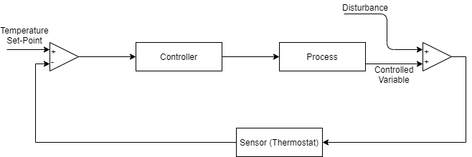
2. Feedforward control diagram:  
     
   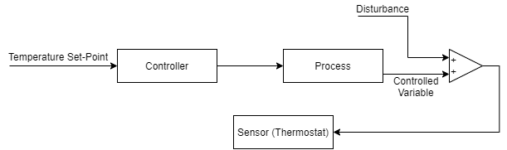

**Question – 2**

The process given in this problem is a continuous process.

1. Controlled variable: Flow rate of the blood.
2. Manipulated Variable: Temperature of the unit, concentration of waste substances in blood.
3. Disturbance Variable: Changes in waste concentration due to metabolic activities in the body.

**Question – 3**

**For finding steady state values-**  
At steady state $\frac{dw}{dt}=0 and \frac{dz}{dt}=0$

$$\frac{dw}{dt}=-\frac{L+Va}{M}w+\frac{Va}{M}z=0$$

$$\frac{dz}{dt}=\frac{L}{M}w-\frac{L+Va}{M}z+\frac{V}{M}z_{f}=0$$

Solving these two equations, we get:

$$w_{ss}=\frac{V^{2}aZ_{f}}{V^{2}a^{2}+L^{2}+VaL}$$

$$z_{ss}=\left(\frac{L}{Va}+1\right)w_{ss}$$

L = 80 gmol/min; V = 100 gmol/min; M = 20 gmol/min; a = 0.5; zf = 0.1 gmol solute/gmol vapour

From these, we get, $w_{ss}=0.0387; z_{ss}=0.1006$

**For linearizing the system of ODEs:**

The model has two states, w and z.

And two outputs, again w and z.

We define-

State vector: $x= \left[\begin{aligned}w \\ z\end{aligned}\right]$

Output vector: $g\left(x\right)=y= \left[\begin{aligned}w \\ z\end{aligned}\right]$

Input vector: $u= \left[\begin{aligned}L \\ V\end{aligned}\right]$

Given system of equations:

$$f(x)= \dot{x}= \left[\begin{aligned}\dot{w} \\ \dot{z}\end{aligned}\right]= \left[\begin{aligned}-\frac{L+Va}{M}w+\frac{Va}{M}z \\ \frac{L}{M}w-\frac{L+Va}{M}z+\frac{V}{M}z_{f}\end{aligned}\right]$$

Linearized system is written as:

$$\dot{\overline{x}}=A\overline{x}+B\overline{u} \\ \overline{y}=C\overline{x}+D\overline{u}$$

Where, $\overline{x}=x-x_{ss}; \overline{y}=y- y_{ss}; \overline{u}=u- u_{ss}$

$$A={\left[\begin{matrix}\frac{{∂f}_{1}}{∂w} & \frac{{∂f}_{1}}{∂z} \\ \frac{{∂f}_{2}}{∂w} & \frac{{∂f}_{2} }{∂z}\end{matrix}\right]}_{ss}= \left[\begin{matrix}-\frac{L+Va}{M} & \frac{Va}{M} \\ \frac{L}{M} & -\frac{L+Va}{M}\end{matrix}\right]$$

$$B={\left[\begin{matrix}\frac{{∂f}_{1}}{∂L} & \frac{{∂f}_{1}}{∂V} \\ \frac{{∂f}_{2}}{∂L} & \frac{{∂f}_{2} }{∂V}\end{matrix}\right]}_{ss}= \left[\begin{matrix}-\frac{w_{ss}}{M} & \frac{a}{M}\left(z_{ss}-w_{ss}\right) \\ \frac{w_{ss}-z_{ss}}{M} & -\frac{z_{f}-az_{ss}}{M}\end{matrix}\right]$$

Putting all the input, steady state and parameter values to get-

$$A= \left[\begin{matrix}-6.5 & 2.5 \\ 4 & -6.5\end{matrix}\right] B= \left[\begin{matrix}-0.002 & 0.0015 \\ -0.003 & -0.0025\end{matrix}\right] C= \left[\begin{matrix}1 & 0 \\ 0 & 1\end{matrix}\right] D= \left[\begin{matrix}0 & 0 \\ 0 & 0\end{matrix}\right]$$

**Eigen-Values & direction of slowest and fastest change:**

Eigen values of the matrix A are -3.33 and -9.66.

The eigen value -9.66 corresponds to that eigen vector which is the direction of fastest change at the initial steady state.

$\left[\begin{matrix}-0.620 \\ 0.784\end{matrix}\right]$ is the direction of fastest change, and $\left[\begin{matrix}0.620 \\ 0.784\end{matrix}\right]$ is the direction of smallest change.

**SIMULINK Modelling, steady state using ‘trim’, and linearized model using ‘linmod’:**

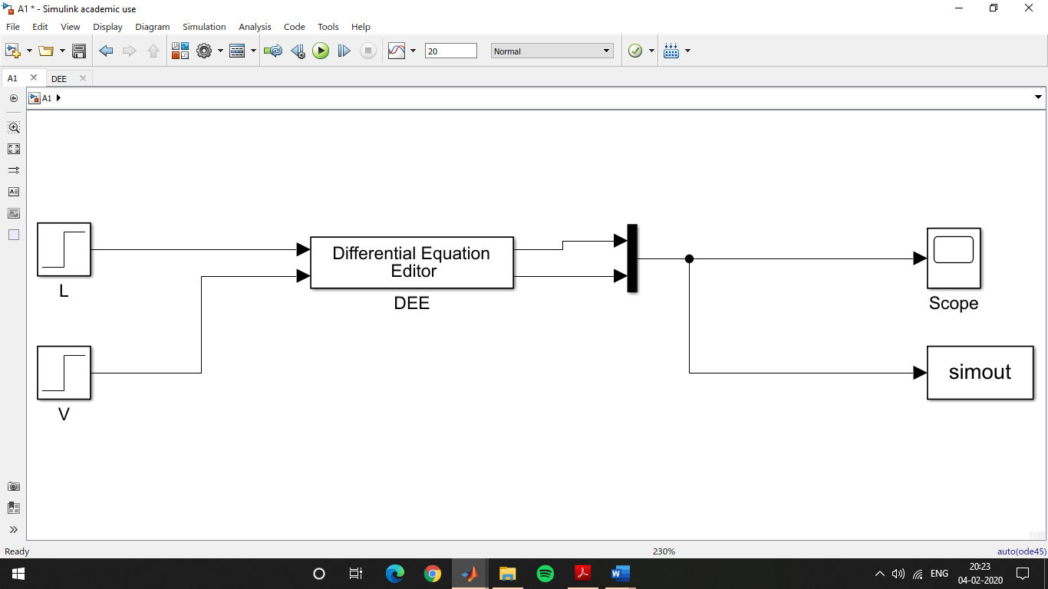

Figure: Block diagram of non-linear system of ODEs

Figure: Output of step input (in L) response

Using ‘trim’ we get, $w_{ss}= 0.0386; z_{ss}=0.1006$.

Using ‘linmod’ we get the linearized model with

$$A= \left[\begin{matrix}-6.5 & 2.5 \\ 4 & -6.5\end{matrix}\right] B= \left[\begin{matrix}-0.002 & 0.0015 \\ -0.003 & -0.0025\end{matrix}\right] C= \left[\begin{matrix}1 & 0 \\ 0 & 1\end{matrix}\right] D= \left[\begin{matrix}0 & 0 \\ 0 & 0\end{matrix}\right]$$

The following code is used:

x0 = [0;0]

y0 = [0;0]

u0 = [80;100]

[X,U,Y] = trim('A1trim', x0, u0)

[A,B,C,D] = linmod('A1trim',X,u0)

**Responses to step input changes in linear and non-linear models:**

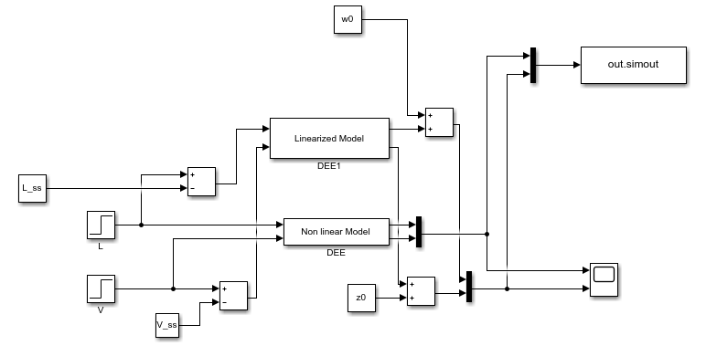

The plots obtained by a 5% and 15% increase in L are as shown below.

For 5% change in flow rate L:

Simout(1) – w as calculated by non linear model

Simout(1) – z as calculated by non linear model

Simout(3) – w as calculated by linear model

Simout(4) – z as calculated by linear model

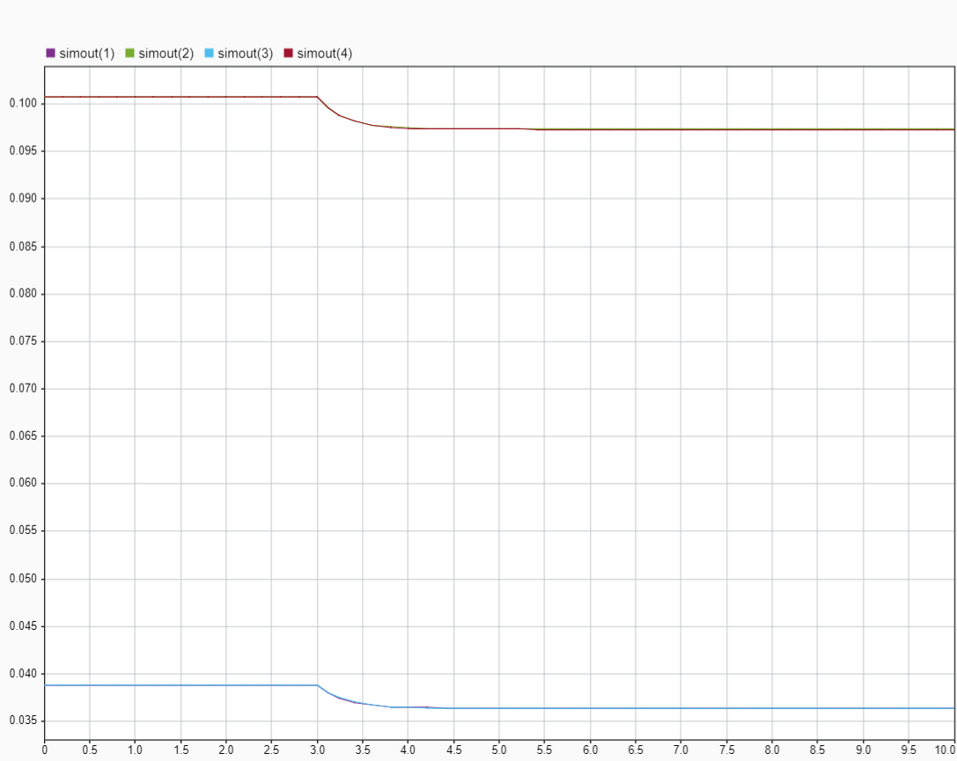

Plot showing the response in w and z as calculated by the linear and non-linear models for a 5% change in L.

The linear model is sufficiently capable of capturing the transience and the final steady state in this case.

For 15% change in flow rate L:

Simout(1) – w as calculated by non-linear model

Simout(1) – z as calculated by non-linear model

Simout(3) – w as calculated by linear model

Simout(4) – z as calculated by linear model

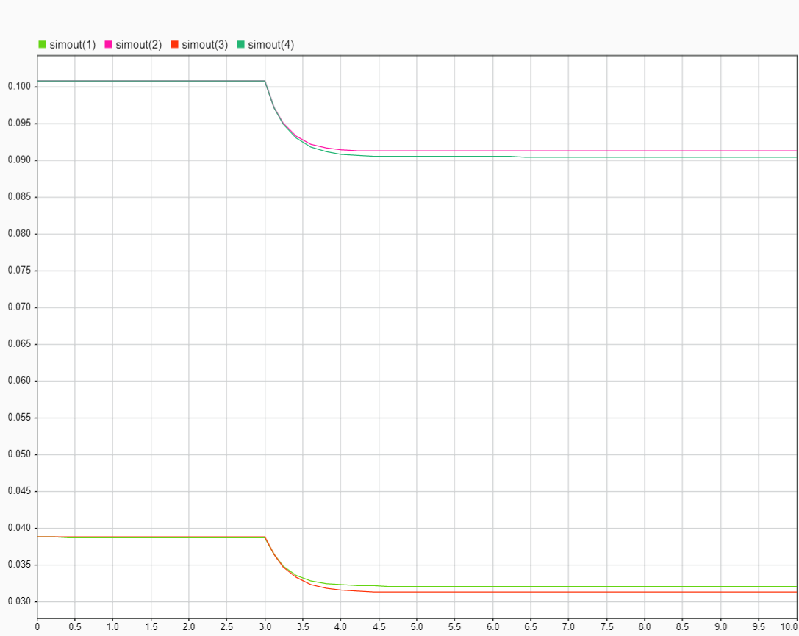

Plot showing the response in w and z as calculated by the linear and non-linear models for a 15% change in L.

In this case the linear model is not sufficient in estimating the steady state but however is capable of modelling the transience to a fair degree as seen from the plots.

**Question-4**

**(a) Laplace transform of function:**

$$x= \left\{\begin{aligned}\begin{matrix}t-3; & 0≤t<3 \\ 0; & 3≤t<4\end{matrix} \\ \begin{matrix}sin⁡(3π\left(t-4\right)); & 4≤t<5\end{matrix} \\ \begin{matrix}e^{-2t}\sin\left(5πt\right); & 5≤t<∞\end{matrix}\end{aligned}\right.$$

$$X\left(s\right)= L\left(x\left(t\right)\right)= \int_{0}^{3}{(t-3)e^{-st}dt}+ \int_{3}^{4}{(0)e^{-st}dt}+ \int_{4}^{5}{sin⁡(3π\left(t-4\right))e^{-st}dt}+\int_{5}^{∞}{e^{-2t}\sin\left(5πt\right)e^{-st}dt}$$

$$I_{1}= \int_{0}^{3}{(t-3)e^{-st}dt}= \frac{-3s+ e^{-3s}-1}{s^{2}}$$

$$I_{2}= \int_{3}^{4}{(0)e^{-st}dt}=0$$

$$I_{3}= \int_{4}^{5}{sin⁡(3π\left(t-4\right))e^{-st}dt}= \frac{3πe^{-5s}(e^{s}+1)}{s^{2}+9π^{2}}$$

$$I_{4}= \int_{5}^{∞}{e^{-2t}\sin\left(5πt\right)e^{-st}dt}= \frac{-5e^{-10}πe^{-5s}}{s^{2}+4s+25π^{2}+4}$$

$$X\left(s\right)= I_{1}+I_{2}+I_{3}+I_{4}= \frac{-3s+ e^{-3s}-1}{s^{2}}+\frac{3πe^{-5s}(e^{s}+1)}{s^{2}+9π^{2}}+\frac{-5e^{-10}πe^{-5s}}{s^{2}+4s+25π^{2}+4}$$

**(b) Inverse Laplace:**

We break up the expression into the constitutive partial fractions.

$\frac{s-1}{s\left(T^{2}s^{2}+2∈Ts+1\right)}= -\frac{1}{s}+\frac{s}{2∈\frac{s}{T}+s^{2}+\frac{1}{T^{2}}}+\frac{1}{T^{2}}\frac{\left(1+2∈T\right)}{2∈\frac{s}{T}+s^{2}+\frac{1}{T^{2}}}$

Rewriting the denominator in terms of a square, we can write:

$$= -\frac{1}{s}+\frac{s}{{\left(s+\frac{∈}{T}\right)}^{2}+\frac{1-∈^{2}}{T^{2}}}+\frac{1}{T^{2}}\frac{\left(1+2∈T\right)}{{\left(s+\frac{∈}{T}\right)}^{2}+\frac{1-∈^{2}}{T^{2}}}$$

Manipulating the second term:

$$= -\frac{1}{s}+\frac{\left(s+\frac{∈}{T}\right)}{{\left(s+\frac{∈}{T}\right)}^{2}+\frac{1-∈^{2}}{T^{2}}}+\frac{1}{T^{2}}\frac{\left(1+∈T\right)}{{\left(s+\frac{∈}{T}\right)}^{2}+\frac{1-∈^{2}}{T^{2}}}$$

For the case where $∈>1$ we have:

$$-L\left(t\right)+e^{\left(\frac{-∈}{T}\right)}\cosh\left(wt\right)+\frac{1+ ∈T}{T}{\frac{1}{{\left(1-∈^{2}\right)}^{0.5}}e}^{-\frac{∈}{T}}\sinh\left(wt\right)where w=\frac{{\left(∈^{2}-1\right)}^{0.5}}{T}$$

For the case where $0<∈<1$ we have:

$$-L\left(t\right)+e^{\left(\frac{-∈}{T}\right)}cos⁡(wt)+\frac{1+ ∈T}{T}{\frac{1}{{\left(1-∈^{2}\right)}^{0.5}}e}^{-\frac{∈}{T}}\sin\left(wt\right)where w=\frac{{\left(1-∈^{2}\right)}^{0.5}}{T}$$

For the case where $∈ =1$ we have:

$$-L\left(t\right)+e^{\left(\frac{-∈}{T}\right)}+\frac{1+ ∈T}{T}e^{-\frac{∈}{T}} where w=\frac{{\left(1-∈^{2}\right)}^{0.5}}{T}$$