Assignment - 2

Raj Jain (CH17B066)

Department of Chemical Engineering, IIT Madras

**Question-1**

(a) **First principles model:**

Assuming,

1. The reactor is perfectly mixed.
2. Heat of reaction is constant.

Component balance gives us-

$$V\frac{dc_{A}}{dt}=qc_{A,i}-qc_{A}+Vk\left(T\right)c_{A}$$

$$⇒\frac{dc_{A}}{dt}=-\left(\frac{q}{V}+k\left(T\right)\right)c_{A}+\frac{qc_{A,i}}{V}$$

The energy balance gives us-

$$Vρc_{p}\frac{dT}{dt}=qρc_{p}T_{i}-qρc_{p}T+\left(-ΔH_{R}\right)\left(-k\left(T\right)C_{A}\right)V$$

$$⇒\frac{dT}{dt}=\left(T_{i}-T\right)\frac{q}{V}+\frac{ΔH_{R}}{ρc_{p}}(k\left(T\right)C_{A})$$

Therefore, the model is-

$$\frac{dc_{A}}{dt}=-\left(\frac{q}{V}+k\left(T\right)\right)c_{A}+\frac{qc_{A,i}}{V} --(1)$$

$$\frac{dT}{dt}=\left(T_{i}-T\right)\frac{q}{V}+\frac{ΔH_{R}}{ρc_{p}}\left(k\left(T\right)C_{A}\right) --(2)$$

Where,

$$k\left(T\right)= -2.4×{10}^{15}e^{-\frac{20000}{T}}\left(\min^{-1}\right); c_{p}=0.8\frac{Btu}{lb℉}$$

$$ρ=52\frac{lb}{ft^{3}}; ΔH_{R}=-500\frac{kJ}{mol}; q=q_{ss}=20\frac{gallons}{minute}$$

(b) **Simulink diagram and steady state:**

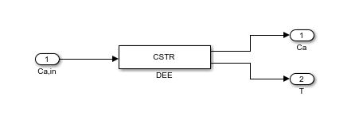

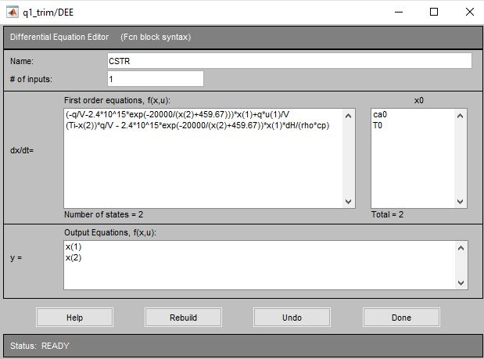

* Following code is used:

[xs,us,ys] = trim('q1_trim',[1;1],0.8,[1;1],[],1,[])

* We get the steady state temperature $T_{ss}=xs\left(2\right)=99.391℉$

(c) **Finding transfer function:**

* Following code is used:

[xs,us,ys] = trim('q1_trim',[1;1],0.8,[1;1],[],1,[]) %Finding steady-state

[A,B,C,D]=linmod('q1_trim',xs,0.8) %Linearzing the model

[num,den]=ss2tf(A,B,C,D) %Finding the coefficients of Num and Den of two transfer functions

Gs=tf(num(2,:),den) %Transfer function relating T and Ca,in

* Evaluated transfer function is-

$$G_{21}\left(s\right)=\frac{0.1398}{s^{2}+0.721s+0.01174}$$

(d) **Step-Responses:**

* Non-linear Simulink model-

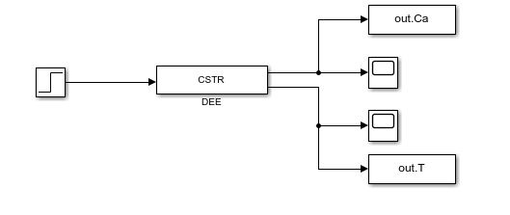

* Step responses for a 10% step in CA,in-

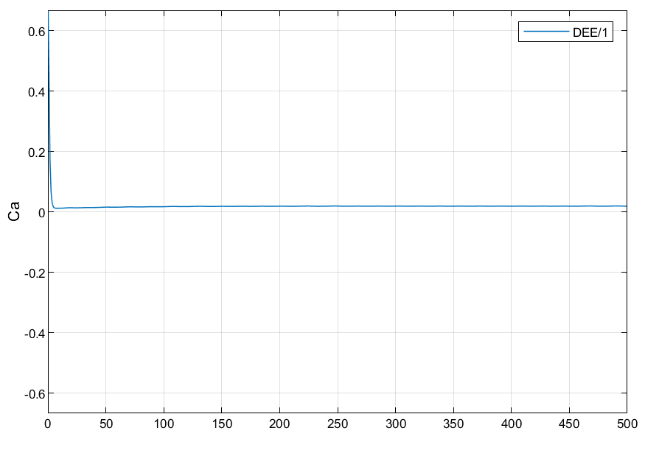

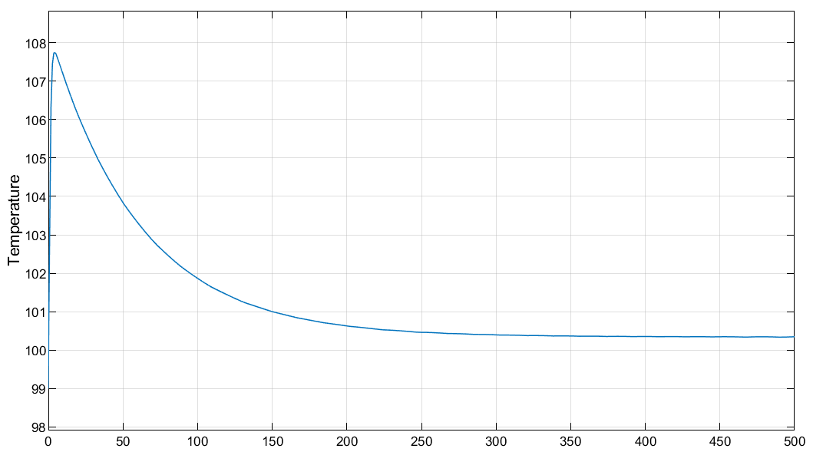

* Linearized Simulink Model in Laplace Domain (between T and CA,in)-

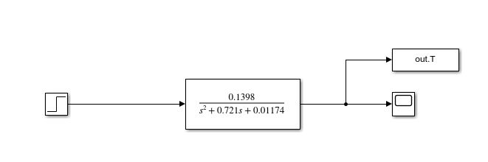

* Step response-

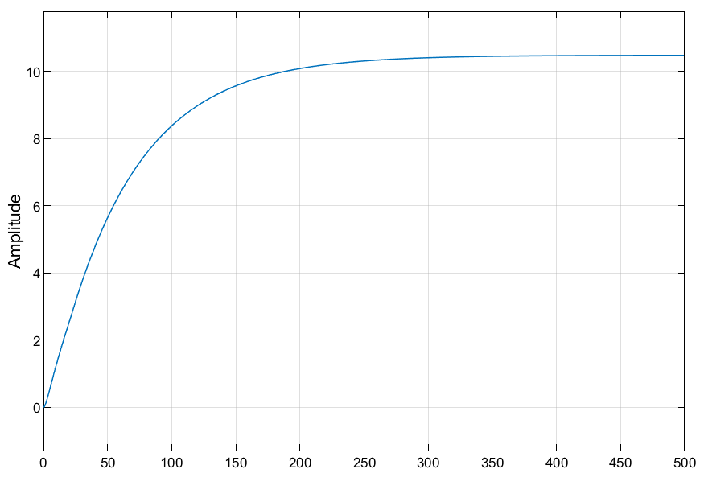

**Question-2**

(a)-(i) **Finding SS description using partial fraction expansion method:**

$$given, G\left(s\right)= \frac{s+1}{s^{3}+10s^{2}+31s+30}= \frac{s+1}{\left(s+2\right)\left(s+3\right)(s+5)}$$

$$⇒\frac{Y(s)}{U(S)}=G\left(s\right)= -\frac{1}{3(s+2)}+ \frac{1}{s+3}-\frac{1}{6(s+5)}$$

$$Let, X_{1}\left(s\right)= -\frac{U\left(s\right)}{3\left(s+2\right)}; X_{2}\left(s\right)= \frac{U\left(s\right)}{\left(s+3\right)}; X_{3}\left(s\right)= -\frac{U\left(s\right)}{6\left(s+5\right)}$$

$$Y\left(s\right)= X_{1}\left(s\right)+X_{2}\left(s\right){+X}_{3}\left(s\right)$$

* Now, the state equations are:
$$\dot{x_{1}}= -2x_{1}- \frac{1}{3}u$$

$$\dot{x_{2}}= -3x_{2}+u$$

$$\dot{x_{3}}= -5x_{3}- \frac{1}{6}u$$

* Corresponding state-space representation is:

$$\left[\begin{aligned}\dot{x_{1}} \\ \dot{\begin{aligned}x_{2} \\ \dot{x_{3}}\end{aligned}}\end{aligned}\right]= \left[\begin{matrix}-2 & 0 & 0 \\ 0 & -3 & 0 \\ 0 & 0 & -5\end{matrix}\right]\left[\begin{aligned}x_{1} \\ x_{2} \\ x_{3}\end{aligned}\right]+ \left[\begin{matrix}-\frac{1}{3} \\ 1 \\ -\frac{1}{6}\end{matrix}\right]u\left(t\right)$$

$$y(t)= \left[\begin{matrix}1 & 1 & 1\end{matrix}\right]\left[\begin{aligned}x_{1} \\ x_{2} \\ x_{3}\end{aligned}\right]$$

(a)-(ii) **Finding SS description using state-transition method:**

$$\frac{Y\left(s\right)}{U\left(s\right)}=G\left(s\right)= \frac{s+1}{s^{3}+10s^{2}+31s+30}$$

$$⇒Define, X\left(s\right)=\frac{Y\left(s\right)}{s+1}=\frac{U\left(s\right)}{s^{3}+10s^{2}+31s+30}$$

$$⇒Y\left(s\right)=sX\left(s\right)+X\left(s\right)$$

$$And, s^{3}X\left(s\right)+10s^{2}X\left(s\right)+31sX\left(s\right)+30X\left(s\right)=U(s)$$

We write state equations as-

$$x_{1}\left(t\right)=x(t)$$

$$x_{2}\left(t\right)=\dot{x_{1}}(t)$$

$$x_{3}\left(t\right)=\dot{x_{2}}(t)$$

$$\dot{x_{3}}\left(t\right)=u\left(t\right)-30x_{1}\left(t\right)-31x_{2}\left(t\right)-10x_{3}(t)$$

State-space model can be written as-

$$\left[\begin{matrix}\dot{x_{1}}(t) \\ \dot{x_{2}}(t) \\ \dot{x_{3}}(t)\end{matrix}\right]=\left[\begin{matrix}0 & 1 & 0 \\ 0 & 0 & 1 \\ -30 & -31 & -10\end{matrix}\right]\left[\begin{matrix}x_{1}(t) \\ x_{2}(t) \\ x_{3}(t)\end{matrix}\right]+\left[\begin{matrix}0 \\ 0 \\ 1\end{matrix}\right]u\left(t\right)$$

$$y(t)=\left[\begin{matrix}1 & 1 & 0\end{matrix}\right]\left[\begin{aligned}\begin{matrix}x_{1}(t) \\ x_{2}(t)\end{matrix} \\ x_{3}(t)\end{aligned}\right]$$

State-transition diagram is-



(b) **SS model for the SITO system:**

$$Given, G_{11}\left(s\right)=\frac{4s+1}{\left(s+1\right)\left(s+3\right)}; G_{21}\left(s\right)=\frac{10s}{\left(s+2\right)\left(s+3\right)}$$

Now,

$$\frac{Y_{1}\left(s\right)}{U\left(s\right)}=\frac{4s+1}{\left(s+1\right)\left(s+3\right)}=-\frac{1.5}{s+1}+\frac{6.5}{s+3}$$

$${⇒Y}_{1}(s)=-\underset{X_{1}}{\underbrace{\frac{1.5U\left(s\right)}{s+1}}}+\underset{X_{2}}{\underbrace{\frac{6.5U\left(s\right)}{s+3}}}$$

$${⇒Y}_{1}\left(s\right)= -X_{1}\left(s\right)+X_{2}(s)$$

Similarly,

$$\frac{Y_{2}\left(s\right)}{U\left(s\right)}=\frac{10s}{\left(s+2\right)\left(s+3\right)}=-\frac{20}{s+2}+\frac{30}{s+3}$$

$${⇒Y}_{2}\left(s\right)=-\underset{X_{3}}{\underbrace{\frac{20U\left(s\right)}{s+2}}}+\frac{30U\left(s\right)}{s+3}$$

$$⇒Y_{3}\left(s\right)= -X_{3}\left(s\right)+{\frac{60}{13}X}_{2}(s)$$

From these, state equations can be written as-

$$\dot{x_{1}}= -x_{1}\left(t\right)+1.5u(t)$$

$$\dot{x_{2}}= -{3x}_{2}\left(t\right)+6.5u(t)$$

$$\dot{x_{3}}= -{2x}_{3}\left(t\right)+20u(t)$$

And,

$$y_{1}= -x_{1}\left(t\right)+x_{2}(t)$$

$$y_{2}= -x_{3}\left(t\right)+{\frac{60}{13}x}_{2}(t)$$

State-space model can be written as-

$$\left[\begin{matrix}\dot{x_{1}}(t) \\ \dot{x_{2}}(t) \\ \dot{x_{3}}(t)\end{matrix}\right]=\left[\begin{matrix}-1 & 0 & 0 \\ 0 & -3 & 0 \\ 0 & 0 & -2\end{matrix}\right]\left[\begin{matrix}x_{1}(t) \\ x_{2}(t) \\ x_{3}(t)\end{matrix}\right]+\left[\begin{matrix}1.5 \\ 6.5 \\ 20\end{matrix}\right]u\left(t\right)$$

$$\left[\begin{matrix}y_{1}(t) \\ y_{2}(t)\end{matrix}\right]=\left[\begin{matrix}-1 & 1 & 0 \\ 0 & \frac{60}{13} & -1\end{matrix}\right]\left[\begin{aligned}\begin{matrix}x_{1}(t) \\ x_{2}(t)\end{matrix} \\ x_{3}(t)\end{aligned}\right]$$

**Question-3**

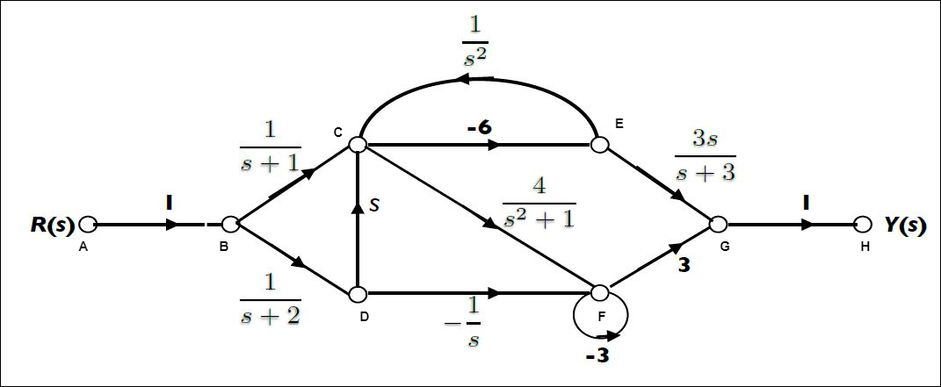

(a) **Block diagram of the given process:**



(b) **For finding transfer function $G\left(S\right)= \frac{Y(S)}{R(S)}:$**

* There are five paths connecting Y(S) and R(S). The transmittance of these are given by-
$$P_{1}\left(ABCEGH\right)= \frac{-18s}{(s+1)(s+3)}$$

$$P_{2}\left(ABDFGH\right)= \frac{-3}{s(s+2)}$$

$$P_{3}\left(ABDCFGH\right)= \frac{12s}{(s+2)(s^{2}+1)}$$

$$P_{4}\left(ABDCEGH\right)= \frac{-18s^{2}}{(s+2)(s+3)}$$

$$P_{5}\left(ABCFGH\right)= \frac{12}{(s+1)(s^{2}+1)}$$

* There are two loops in the given diagram. Transmittance of these are given by-
$$L_{1}\left(CEC\right)= \frac{-6}{s^{2}}$$

$$L_{1}\left(FF\right)= -3$$

* Determinant of the graph is given by-
$$∆ =1- L_{1}- L_{2}+ L_{1}L_{2}= \frac{4s^{2}+24}{s^{2}}$$

* Co-factor of each path $P_{i}$ is given as $∆_{i}$ as-
$$∆_{1} = 4$$

$$∆_{2} = \frac{s^{2}+6}{s^{2}}$$

$$∆_{3} = 1$$

$$∆_{4} = 4$$

$$∆_{5} = 1$$

* With the help of all the above equations, we can get the transfer function-

$$G\left(s\right)= \frac{\sum_{i=1}^{5}{P_{i}∆_{i}}}{∆}$$

$$G\left(s\right)= \frac{1}{∆}\left(\frac{-72s}{(s+1)(s+3)}+ \frac{-3(s^{2}+6)}{s^{3}(s+2)}+\frac{12s}{\left(s+2\right)\left(s^{2}+1\right)}+\frac{-72s^{2}}{(s+2)(s+3)}+\frac{12}{(s+1)(s^{2}+1)}\right)$$

$$Simplifying above expression we get-$$

$$\frac{Y(s)}{R(s)}=G\left(s\right)= \frac{-3(24s^{8}+48s^{7}+69s^{6}+32s^{5}+26s^{4}+4s^{3}+27s^{2}+24s+18)}{4s(s+1)(s+2)(s+3)(s^{2}+1)(s^{2}+6)}$$