Assignment – 3

## CH-3050

Department of Chemical Engineering, IIT Madras

# Question-1

* Given, the transfer function-

$$G\left(s\right)=\frac{10\left(s-4\right)e^{-3s}}{\left(s+2\right)\left(s+5\right)}$$

## PART (A)

* The above transfer function can be written after partial fraction expansion as:
$$G\left(s\right)=\frac{-20e^{-3s}}{\left(s+2\right)}+\frac{30e^{-3s}}{\left(s+5\right)}$$

* **Impulse response:**

$$Y_{IR}\left(s\right)=G\left(s\right)U_{impulse}\left(s\right)=\left(\frac{-20e^{-3s}}{\left(s+2\right)}+\frac{30e^{-3s}}{\left(s+5\right)}\right)×1=\frac{-20e^{-3s}}{\left(s+2\right)}+\frac{30e^{-3s}}{\left(s+5\right)}$$

$$Taking inverse laplace:y_{IR}\left(t\right)=L^{-1}\left(\frac{-20e^{-3s}}{\left(s+2\right)}+\frac{30e^{-3s}}{\left(s+5\right)}\right)$$

|  |  |  |
| --- | --- | --- |
|  | $$y_{IR}\left(t\right)=-20e^{-2\left(t-3\right)}+30e^{-5\left(t-3\right)}$$ | $$t≥3$$ |

* **Step response:** Similarly,

$$Y_{SR}\left(s\right)=G\left(s\right)U_{step}\left(s\right)=\left(\frac{10\left(s-4\right)e^{-3s}}{\left(s+2\right)\left(s+5\right)}\right)×\frac{1}{s}=\frac{-4e^{-3s}}{s}+\frac{10e^{-3s}}{s+2}-\frac{6e^{-3s}}{s+5}$$

$$Taking inverse laplace:y_{SR}\left(t\right)=L^{-1}\left(\frac{-4e^{-3s}}{s}+\frac{10e^{-3s}}{s+2}-\frac{6e^{-3s}}{s+5}\right)$$

|  |  |  |
| --- | --- | --- |
|  | $$y_{SR}\left(t\right)=10e^{-2\left(t-3\right)}-6e^{-5\left(t-3\right)}-4$$ | $$t≥3$$ |

* Sketched Impulse Response (Left) & Step-Response (Right):

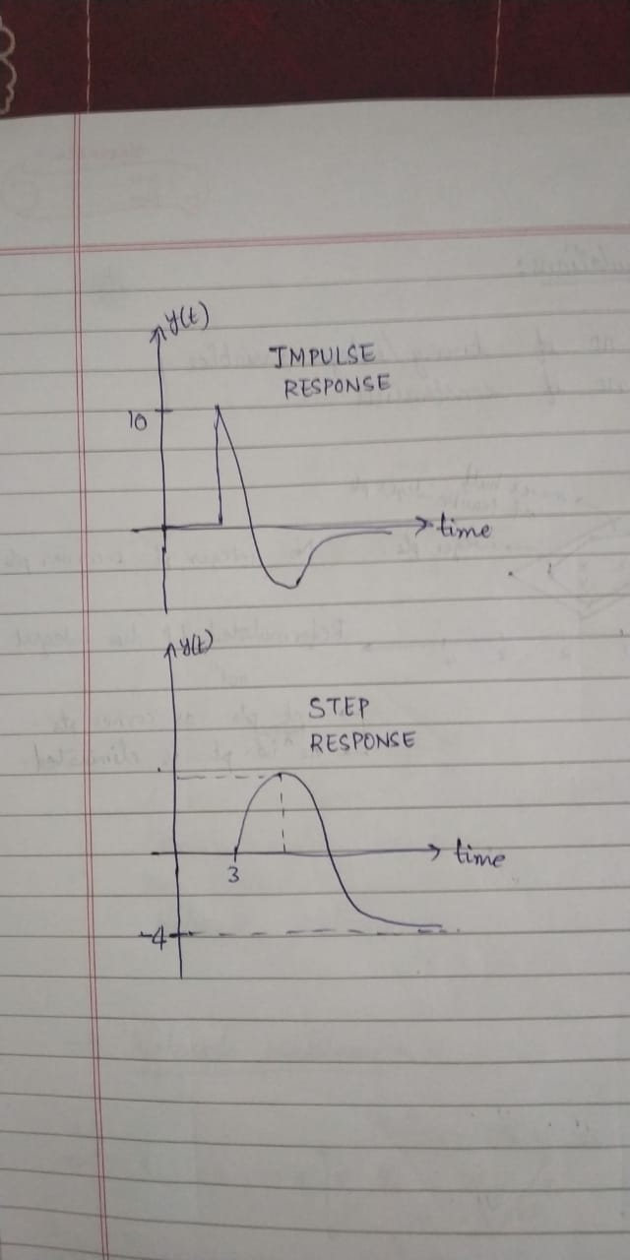

## PART (B)

* Given, input-
$$u\left(t\right)=2\sin{4t}+\cos{0.1t=A_{1}\sin{ω_{1}t} {+ A}_{2}\cos{ω_{2}t}}$$

$$where, A_{1}=2;A_{2}=1;ω_{1}=4; ω_{2}=0.1$$

* First, we will find out the expressions for amplitude ratio (AR) and phase:
$$G\left(jω\right)=\frac{10\left(ωj-4\right)e^{-3ωj}}{\left(ωj+2\right)\left(ωj+5\right)}$$

$$AR=\left|G\left(jω\right)\right|=\frac{10\sqrt{16+ω^{2}}}{\sqrt{\left(4+ω^{2}\right)\left(25+ω^{2}\right)}}$$

$$ϕ=∠G\left(jω\right)=-3ω+\tan^{-1}\left(\frac{ω}{-4}\right)-\tan^{-1}\left(\frac{ω}{2}\right)-\tan^{-1}\left(\frac{ω}{5}\right)$$

* Evaluating the expressions of AR and Phase at $ω_{1}=4$ and $ω_{2}=0.1$:
$$AR_{1}=\left|G\left(jω_{1}\right)\right|=\frac{10\sqrt{16+16}}{\sqrt{\left(4+16\right)\left(25+16\right)}}=1.975$$

$$AR_{2}=\left|G\left(jω_{2}\right)\right|=\frac{10\sqrt{16+0.01}}{\sqrt{\left(4+0.01\right)\left(25+0.01\right)}}=3.995$$

$$ϕ_{1}=-14.565;and ϕ_{2}=-0.395$$

* Finally, long time response is given by-

$$y_{ss}\left(t\right)=\left(1.975×2\right)\sin\left(4t-14.565\right)+ (3.995×1)\cos{(0.1t-0.395)}$$

|  |
| --- |
| $$y_{ss}\left(t\right)=3.95\sin\left(4t-14.565\right)+ 3.995\cos{(0.1t-0.395)}$$ |

## PART (C)

* Bode-Plots sketched by hand are shown below:

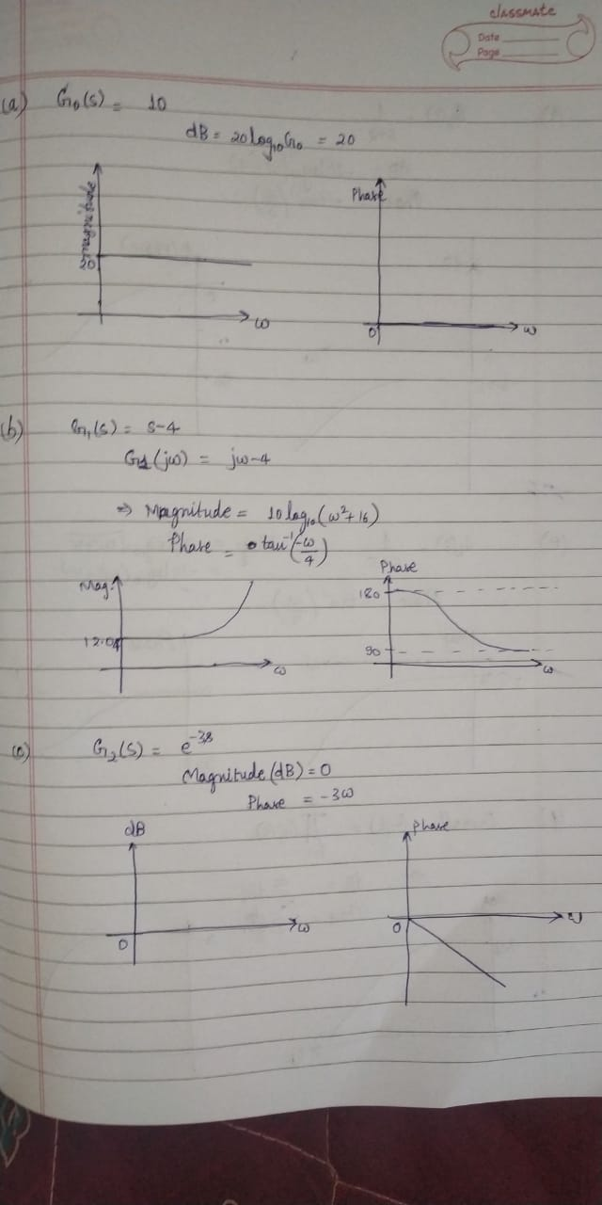

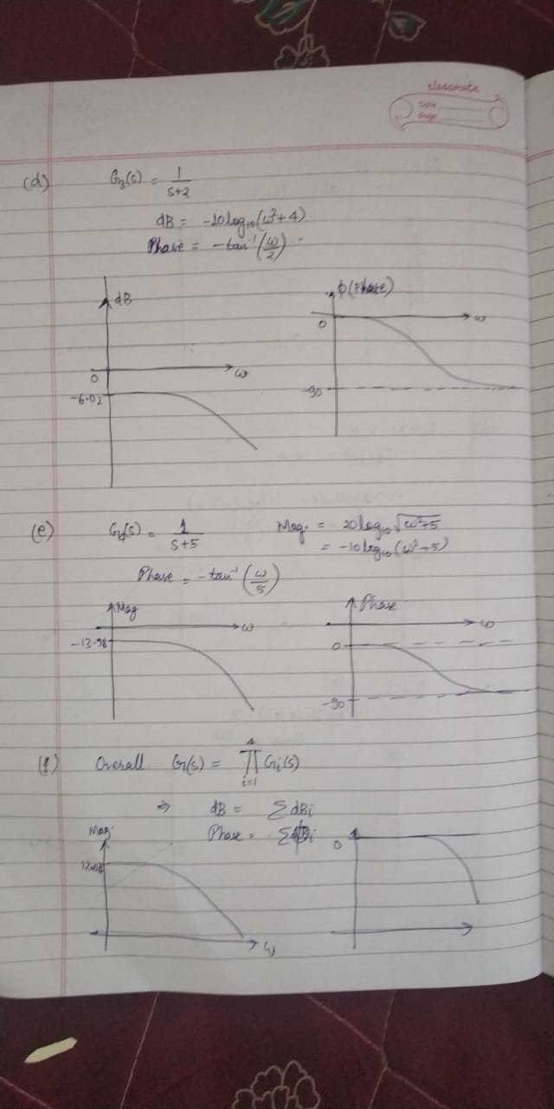

## PART (D)

* LTI system having same magnitude as that of the given system at any given frequency but with minimum phase, is given by the same system but with all its zeros in LHP:

$$G_{MP}\left(s\right)=\frac{10\left(s+4\right)e^{-3s}}{\left(s+2\right)\left(s+5\right)}$$

## PART (E)

* Verifying parts (a) to (c) using MATLAB (using *ltiview*):

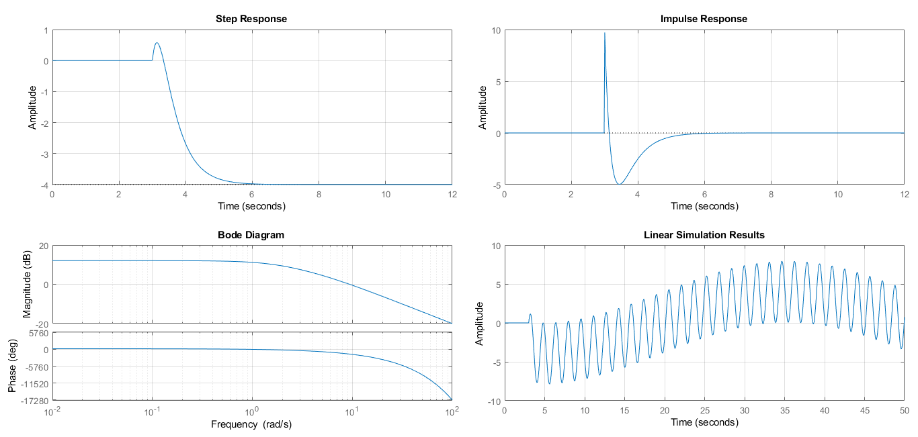

# Question-2

Given,

|  |  |  |
| --- | --- | --- |
|  | $$\frac{d^{2}h^{'}}{dt^{2}}+\frac{6μ}{R^{2}ρ}\frac{dh^{'}}{dt}+\frac{3}{2}\frac{g}{L}h^{'}=\frac{3}{4ρL}p^{'}(t)$$ |  |

Where,

h(t): level of fluid measured with respect to initial steady state value

p(t): pressure change

## PART (A)

* Taking Laplace transform of (1):

|  |  |  |
| --- | --- | --- |
|  | $$\left(s^{2}+\frac{6μ}{R^{2}ρ}+\frac{3g}{2L}\right)H\left(s\right)=\frac{3}{4ρL}P(s)$$ |  |
|  | $$⇒G\left(s\right)=\frac{H\left(s\right)}{P\left(s\right)}=\frac{\frac{3}{4ρL}}{\left(s^{2}+\frac{6μ}{R^{2}ρ}+\frac{3g}{2L}\right)}$$ | (2) |

* Rearranging G(s) in the standard second-order transfer function form-

|  |  |  |
| --- | --- | --- |
|  | $$\frac{Κ}{τs^{2}+2τζs+1}$$ | (3) |

* We get,

|  |  |  |
| --- | --- | --- |
|  | $$⇒G\left(s\right)=\frac{\frac{1}{2gρ}}{\frac{2L}{3g}s^{2}+\frac{4μL}{gR^{2}ρ}s+1}$$ | (4) |

* Comparing the expressions in (3) and (4), we get-

|  |  |  |
| --- | --- | --- |
|  | $$Κ=\frac{1}{2ρg}$$ |  |
|  | $$τ=\sqrt{\frac{2L}{3g}}$$ |  |
|  | $$ζ=\frac{μ}{ρR^{2}}\sqrt{\frac{6L}{g}}$$ |  |

## PART (B)

* For the system response to oscillate, it should be underdamped, i.e.,

$$0<ζ<1 \\ ⇒0<\frac{μ}{ρR^{2}}\sqrt{\frac{6L}{g}}<1$$

## PART(C)

1. Damping factor, $ζ$, characterizes the effect of damping on the oscillations on a system. $ζ=0$ implies no damping or high oscillations, whereas $ζ$ close to 1 means high damping.
2. For more oscillatory response, we need to reduce $ζ$ to bring it closer to zero.
3. For less oscillatory and more damped response, we need to increase $ζ$.
4. Increasing $μ$ or $L$ will result in the increase in value of damping factor $ζ$, hence reducing oscillations, whereas decreasing these parameters would mean more oscillatory response.

# Question-3

* Given transfer function:
$$G_{p}\left(s\right)=\frac{Κe^{-θ_{1}s}\left(1+αe^{-θ_{2}s}\right)}{τs+1}$$

$$where, Κ=-1\frac{mm Hg}{ml/h};α=0.4;θ_{1}=30s; θ_{2}=45s;τ=40s$$

* The above transfer function can be written as a sum of two transfer functions with same time constant and different delays and gains:
$$⇒G_{p}\left(s\right)=\frac{Κe^{-θ_{1}s}}{τs+1}+\frac{αΚe^{-(θ_{1}+θ_{2})s}}{τs+1}$$

* SIMULINK block diagram for the system:

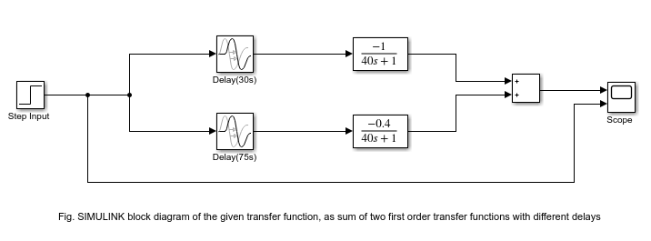

* Step response of the system of a unit step input given (at t=5s) is given below:

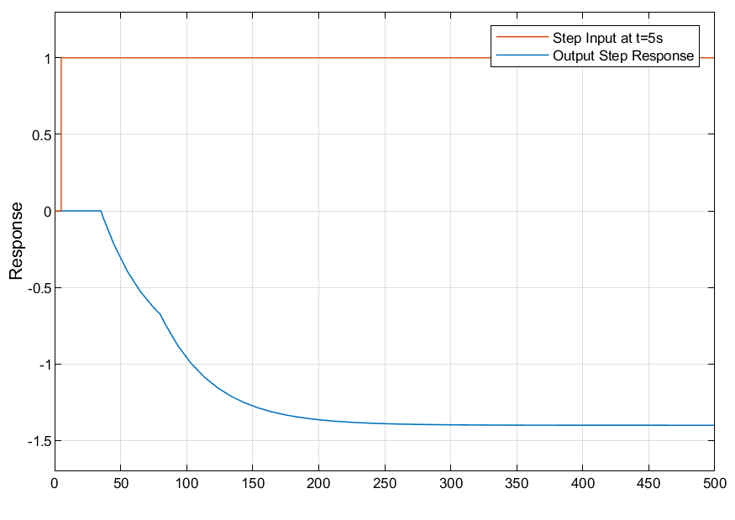

* Transfer functions of parallel systems sum together. Hence, we can see our transfer function as a sum of two first order transfer functions, with delays $D_{1}=θ_{1}=30$, and $D_{2}=θ_{1}+θ_{2}=75s.$