Assignment - 4

Raj Jain (CH17B066) | Department of Chemical Engineering, IIT Madras

# QUESTION 1

* Given,

$$G\left(s\right)=\frac{\left(s+0.5\right)e^{-3s}}{(20s+1)(10s+1)(5s+1)(s+1)}$$

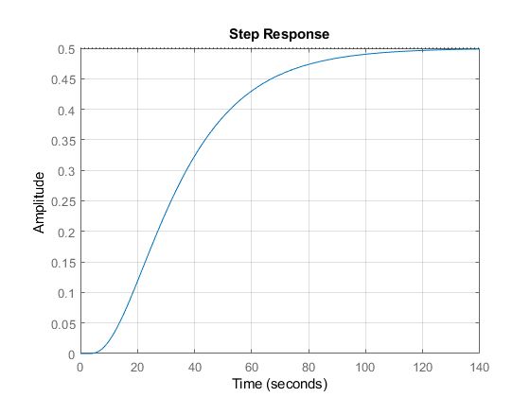

Gain = 0.5; obtained from the step response.

## PART (A)

* Gain (K) = 0.5
* Krishnaswamy & Sundaresan model:
$$G_{KS}=\frac{Κe^{-Ds}}{τs+1}$$

$$D=1.3t_{1}-0.29t_{2}$$

$$τ=0.67(t_{2}-t_{1})$$

* Here,
$$D:delay of FOPTD approximation model \\ τ:Time constant of FOPTD approximation model \\ t_{1}:time at which step response is at 35.3\% of steady state value \\ t_{2}: time at which step response is at 85.3\% of steady state value$$

* From the step response curve, we get,
$$t_{1}=25s;t_{2}=59s$$

* Using these values, we get,
$$D=1.3t_{1}-0.29t_{2}=1.3×25-0.29×59=15.39s \\ τ=0.67\left(t_{2}-t_{1}\right)=0.67\left(59-25\right)=22.78 s$$

* Hence, the FOPTD model is,

|  |
| --- |
| $$G_{KS}=\frac{0.5e^{-15.39s}}{22.78s+1}$$ |

* Comparing step response & bode plots of the system and the FOPTD model,

|  |  |
| --- | --- |
|  |  |

## PART (B)

* FOPTD model approximation using Skogestad’s Half Rule:

$$Κ=0.5$$

$$τ=20+\frac{10}{2}=25$$

$$D=3+\frac{10}{2}+5+1-2=12$$

|  |
| --- |
| $$G_{SHR,FO}=\frac{Κe^{-Ds}}{τs+1}=\frac{0.5e^{-12s}}{25s+1}$$ |

* SOPTD model approximation using Skogestad’s Half Rule:

$$τ_{1}=20;τ_{2}=10+\frac{5}{2}=12.5$$

$$D=\frac{5}{2}+3+1-2=4.5$$

|  |
| --- |
| $$G_{SHR,FO}=\frac{Κe^{-Ds}}{(τ_{1}s+1)(τ_{2}s+1)}=\frac{0.5e^{-4.5s}}{(20s+1)(12.5s+1)}$$ |

* Comparing Step Responses:

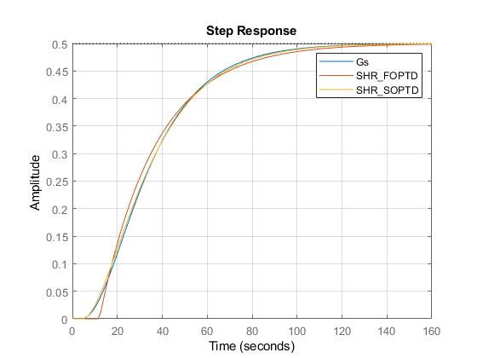

## PART (C)

* SOPTD approximation using Least Squares fitting on FRF; we use the following code:
* %Transfer funcn
* Gs=zpk(-0.5,[-1/20,-1/10,-1/5,-1],1/(10*20*5));
* Gs.iodelay=3;
* Gain=0.5;
* %Least squares apprxn-SOPTD: Gain & Time Constant Estimation using FRF
* [AR,Phi,wout]=bode(Gs);
* options=optimoptions(@lsqcurvefit,'MaxFunctionEvaluations',500);
* mparnew=lsqcurvefit(@(mparnew,wnew) AmpRatio(mparnew,wnew),[1,1,1]',wout,reshape(AR,1,size(wout,1))',[],[],options);
* %Least squares apprxn-SOPTD: Delay Estimation using FRF
* Dnew=lsqcurvefit(@(Dnew,wnew) phase(mparnew,wnew,Dnew),[1],wout,(pi/180).*reshape(Phi,1,size(wout,1))',[],[],options);
* %SOPTD - Least Squares
* LS_SOPTDnew=tf(mparnew(1),conv([mparnew(2),1],[mparnew(3),1]),'iodelay',Dnew);
* %Function
* function AR=AmpRatio(mparnew,w)
* Kpnew=mparnew(1);
* Tau1new=mparnew(2);
* Tau2new=mparnew(3);
* AR=Kpnew./(sqrt(1+Tau1new^2*w.^2).*sqrt(1+Tau2new^2*w.^2));
* end
* function Ph=phase(mparnew,w,Dnew)
* Kpnew=mparnew(1);
* Tau1new=mparnew(2);
* Tau2new=mparnew(3);
* Ph=-atan(Tau1new.*w)-atan(Tau2new.*w)-Dnew.*w;
* end
* Estimated model is given by:
$$Κ=0.4998$$

$$τ_{1}=15.8615$$

$$τ_{2}=15.8615$$

$$D=3.0358$$

* Step response & Bode plot Comparison:

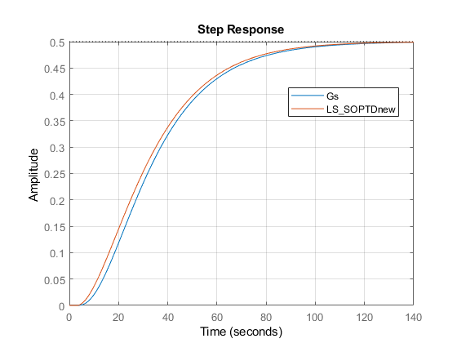



## PART (D)

* Comparing all the step-responses:



* Tabulating Results:

|  |  |  |  |  |
| --- | --- | --- | --- | --- |
| Model | $$Gain(Κ)$$ | $$τ_{1}$$ | $$τ_{2}$$ | $$Delay(D)$$ |
| Krishnaswamy & Sundaresan FOPTD | 0.5 | 22.78 | - | 15.39 |
| SHR FOPTD | 0.5 | 25 | - | 12 |
| SHR SOPTD | 0.5 | 20 | 12.5 | 4.5 |
| Least Squares SOPTD | 0.5 | 15.86 | 15.86 | 3.04 |

* Step-Responses:

|  |  |  |  |  |  |
| --- | --- | --- | --- | --- | --- |
| Time | G(s) | Krishnaswamy & Sundaresan FOPTD | SHR FOPTD | SHR SOPTD | Least Squares SOPTD |
| 0 | 0 | 0 | 0 | 0 | 0 |
| 6 | 0.0027 | 0 | 0 | 0.0021 | 0.0077 |
| 12 | 0.0353 | 0 | 0 | 0.041 | 0.0553 |
| 18 | 0.0954 | 0.0541 | 0.1067 | 0.1041 | 0.1217 |
| 24 | 0.1649 | 0.1574 | 0.1906 | 0.1722 | 0.1903 |
| 30 | 0.2317 | 0.2367 | 0.2566 | 0.2358 | 0.2533 |
| 36 | 0.29 | 0.2977 | 0.3086 | 0.291 | 0.3072 |
| 42 | 0.3382 | 0.3445 | 0.3494 | 0.337 | 0.3517 |
| 48 | 0.3767 | 0.3805 | 0.3815 | 0.3742 | 0.3872 |
| 54 | 0.4068 | 0.4082 | 0.4068 | 0.4037 | 0.415 |
| 60 | 0.4299 | 0.4295 | 0.4267 | 0.4267 | 0.4365 |
| 66 | 0.4475 | 0.4458 | 0.4423 | 0.4445 | 0.4529 |
| 72 | 0.4608 | 0.4583 | 0.4546 | 0.4581 | 0.4652 |
| 78 | 0.4708 | 0.468 | 0.4643 | 0.4685 | 0.4744 |
| 84 | 0.4783 | 0.4754 | 0.4719 | 0.4764 | 0.4812 |
| 90 | 0.4838 | 0.4811 | 0.4779 | 0.4823 | 0.4863 |
| 96 | 0.488 | 0.4855 | 0.4826 | 0.4868 | 0.49 |
| 102 | 0.4911 | 0.4888 | 0.4863 | 0.4902 | 0.4927 |
| 108 | 0.4934 | 0.4914 | 0.4893 | 0.4927 | 0.4947 |
| 114 | 0.4951 | 0.4934 | 0.4915 | 0.4945 | 0.4961 |
| 120 | 0.4964 | 0.4949 | 0.4934 | 0.4959 | 0.4971 |
| 126 | 0.4973 | 0.4961 | 0.4948 | 0.497 | 0.4979 |
| 132 | 0.498 | 0.497 | 0.4959 | 0.4978 | 0.4984 |
| 138 | 0.4985 | 0.4977 | 0.4968 | 0.4983 | 0.4988 |
| 144 | 0.4989 | 0.4982 | 0.4975 | 0.4988 | 0.4991 |
| 150 | 0.4992 | 0.4986 | 0.498 | 0.4991 | 0.4993 |
| 156 | 0.4994 | 0.499 | 0.4984 | 0.4993 | 0.4994 |

# QUESTION-2

* Given,

$$G\left(s\right)=\frac{2\left(-0.5s+1\right)e^{-0.4s}}{\left(5s+1\right)\left(s+1\right)}$$

## PART (A)

* SIMULINK Diagram of the system:

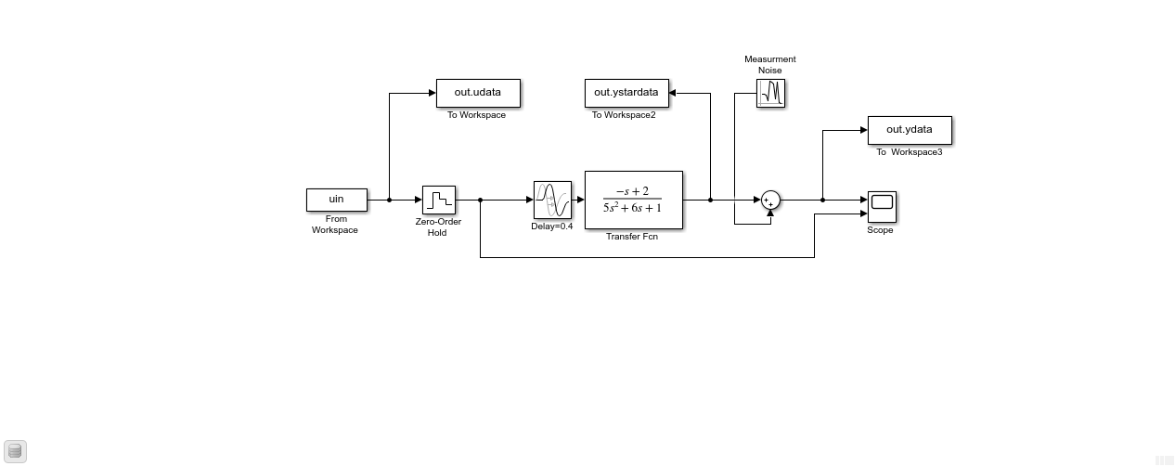

## PART (B)

* Using the following code to design input:

%%

%Generating the input signal

Bmax=0.2;

Range=[-1,1];

N=2555;

Ts=0.2;

u1=idinput(N,'prbs',[0,Bmax],Range);

uin = [(0:1:length(u1)-1)'*Ts (u1)];

%%

%I/O data generation

data=iddata(out.ydata.Data,out.udata.Data,0.2);

figure

plot(data)

%%

%Splitting into train and test data

trndata=data(1:1400);

testdata=data(1401:end);



## PART (C) & (D)

%%

%Removing the mean/Mean shifting

[dtrain,Tr]=detrend(trndata,0);

dtest=detrend(testdata,Tr);

%%

figure

plot(dtrain)

%%

%Estimating the FIR

FIR=impulseest(dtrain,[]);

figure

impulse(FIR,'sd',2)

figure

step(FIR)

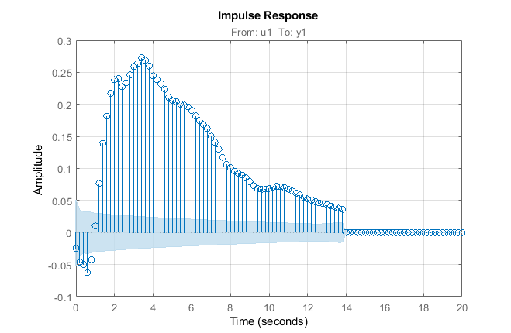

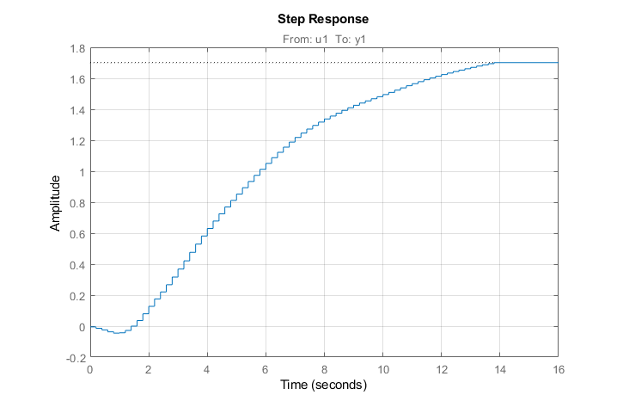

* System is stable with input-ouput delay of n=3 samples, as the first significant non-zero value occurs at the third sample.
* Gain obtained from step-response is 1.7
* As the system has a pole in RHP, the system first responds in the opposite direction of steady state value.

## PART (E), (F) & (G)

* We take m=2, n=2 and d=3.
* For a good model:
  + Inputs should not be correlated with the residuals
  + Residuals should not be correlated among themselves
  + Errors in the estimates should be low
  + Model should fit the trend in the test data set well
* We use the following code:

%%

%Estimating parametric model using OE

model_oe=oe(dtrain,[2,2,3]);

figure

resid(model_oe,dtrain);

figure

compare(model_oe,dtest);

present(model_oe);

%%

datastar=iddata(out.ystardata.Data,out.udata.Data,0.2);

trnstardata=data(1:1400);

teststardata=data(1401:end);

dteststar=detrend(teststardata,Tr);

figure

compare(model_oe,dteststar);

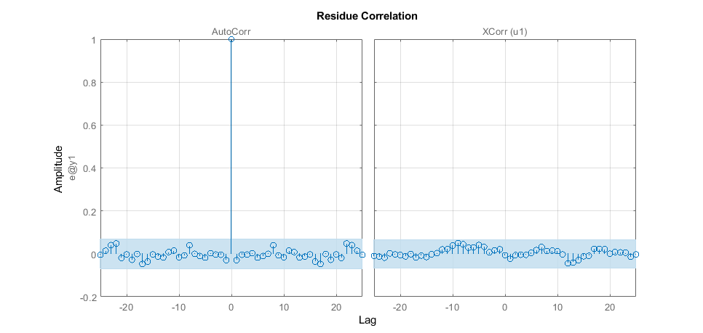

* In the estimated model, we can see that the residuals are not significantly correlated with the input and neither among themselves, hence it is a good estimate.
* Fitness on test set:



* Here, the accuracy of our model on the test set is 55.91%, although it appears to be low numerically, the model is able to capture the trend in the data very well.
* The model is given by:

$$Discrete-time OE model: y(k) = \left[\frac{B\left(z\right)}{F\left(z\right)}\right]u(k) + e(k)$$

$B(z) = -0.02918 \left(+/- 0.004051\right)z^{-3}+ 0.04249 \left(+/- 0.004587\right)z^{-4}$

$$F(z) = 1 - 1.79 \left(+/- 0.012\right)z^{-1} + 0.7968 \left(+/- 0.01169\right)z^{-2}$$

$$Sample time: 0.2 seconds$$

# END