**Delayed Healthcare due to Cost in Colorado**

**Abstract**

The past decade has seen more Americans putting off healthcare for various reasons. Today, over half of Colorado residents experience barriers to obtaining healthcare. High costs of care being a leading cause.

This analysis uses recent data provided by the Colorado Department of Public Health and Environment to locate specific areas in Colorado where adults are more likely to delay healthcare due to cost. Census tract resolution combined with regional count statistical methods give us the tools to identify areas in Colorado where more adults are affected.

In identifying the most at need, it is my hope that the results of this analysis will help inform public outreach dedicated to helping Coloradoans receive the healthcare they deserve at an affordable cost.

# Intro

58% of Colorado residents are experiencing financial obstacles to healthcare. This percentage of residents are either uninsured due to high cost of premiums or foregoing healthcare altogether due to cost. (1) It could be argued that Colorado healthcare is not the worst state when it comes to accessible healthcare. But this statistic suggests a need for some sort of public intervention.

Any plan for addressing this problem would be well equipped with the knowledge of who in Colorado is the worst off when it comes to delaying healthcare due to cost. Regional count spatial data analysis provides a toolbox to identify clusters in Colorado where more people than usual seem to be in the most need for intervention.

# Data

The Colorado Department of Public Health and Environment (CDPHE) published census tract level data on percentage of adults in Colorado who delayed healthcare due to cost in the past 12 months. These data were generated using a statistical model trained on multiple demographic information.

In order to conduct the analysis outlined in this paper, these percentages were converted into counts using the included census tract adult population.

A choropleth map below shows the overall structure of the data. This map is colored according to number of adults who delayed healthcare due to cost.

# Methods

This paper includes two types of statistical analysis. Section 3.1 will cover two methods addressing spatial autocorrelation and goodness-of-fit. It will include Rogerson’s Tango method and the constant Risk version of Moran’s I. Section 3.2 will cover two methods addressing local incidence rates. This section will include the Cluster Evaluation Permutation Procedure (CEPP) and the Spatial Scan statistic.

Methods for detecting spatial autocorrelation and goodness-of-fit are used for detecting the degree to which similar observations tend to appear close together in the former case. They detect deviation between observed data and their expected values in the latter case.

Methods for detecting local incidence rates are used for detecting clusters of unusually high incidence rates.

## Spatial Autocorrelation and Goodness-of-Fit

Two methods were used for detecting spatial autocorrelation goodness-of-fit. Rogerson’s Tango and Walter (1992) constant risk version of Moran’s I. The next two sections outlines the test statistic, null and alternative hypothesis, and conclusions that may be drawn for each test.

### Rogerson Tango

The test statistic for the Rogerson Tango test is

$$T_{ti}=\sum_{i=1}^{N}{W_{ii}^{*}\left(\frac{Y_{i}}{Y_{+}}-\frac{n_{i}}{n_{+}}\right)+\sum_{i=1}^{N}{\sum_{j≠i}^{n}{w_{ij}^{*}\left(\frac{Y_{i}}{Y_{+}}-\frac{n_{i}}{n_{+}}\right)\left(\frac{Y_{j}}{Y_{+}}-\frac{n_{i}}{n_{+}}\right)}}}$$

The first part being a measure of goodness-of-fit and the second part being a measure of spatial similarity between regions.

### Constant Risk Moran’s I

The test statistic used for the Moran’s I test is

$$\frac{\sum_{i}^{N}{\sum_{j}^{N}{w_{ij}}\frac{(Y_{ij}-rn_{i})}{\sqrt{rn_{i}}} \frac{(Y_{j}-rn_{j})}{\sqrt{rn_{j}}}}}{\sum_{i}^{N}{\sum_{j}^{N}{w_{ij}}}}$$

The null hypothesis for this test is that there is no evidence to conclude that adjacent observations have similar data.

## Local Incidence Rates

Two methods were used to detect local incidence rates, Cluster Evaluation Permutation Procedure (CEPP) and the Spatial Scan statistic. The next two sections outlines the test statistic, null and alternative hypothesis, and conclusions that may be drawn for each test.

### CEPP

Test statistic

Null hypothesis.

conclusions

### Spatial Scan

Test statistic

Null hypothesis.

conlusions

# Results

Sections 4.1 and 4.2 show results of our four statistical tests. In general, we detect evidence to reject the null hypothesis for all

our statistical methods.

## Spatial Autocorrelation and Goodness-of-Fit

The p-values for the Rogerson Tango and constant risk Moran’s I tests are displayed in table 1. These values indicate that there is significant evidence of clustering.

**Table 1.** P-values for Rogerson Tango and constant risk Moran’s I.

|  |  |  |
| --- | --- | --- |
| Method | Rogerson Tango | CR Moran’s I |
| P-value | .0001 | 0.002 |

## Local Incidence Rates

### CEPP

The CEPP method returns a p-value of 0.002.

Talk about

Introduce graph of most significant clusters

### Spatial Scan

Introduce map of most unlikely clusters below

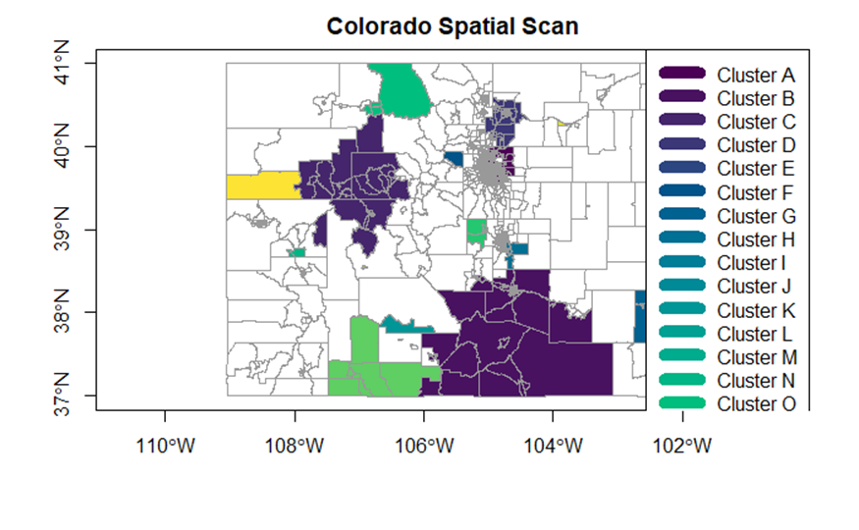

# Discussion

This analysis reveals strong evidence for clusters of adults delaying healthcare due to cost in four main regions: Areas in the north of Denver, Jackson Grand and Jackson, Pueblo to La Platta, and Eagle/Garfield. The analysis provides strong evidence that there is clustering of adults delaying healthcare due to cost in Colorado.

# Policy

Colorado Marketplace is a

# References

Altarum Healthcare Value Hub. (2019, February). Colorado Residents Struggle to Afford High Healthcare Costs; Support a Range of Government Solutions Across Party Lines. Retrieved December 7, 2021, from https://www.healthcarevaluehub.org/advocate-resources/publications/colorado-residents-struggle-afford-high-healthcare-costs-support-range-government-solutions-across-party-lines.

Colorado Department of Public Health and environment (CDPHE). *Delayed Medical Care in Adults ($) - CDPHE Community Level Estimates (Census Tracts)*. Retrieved December 7, 2021, from https://data-cdphe.opendata.arcgis.com/datasets/CDPHE::delayed-medical-care-in-adults-cdphe-community-level-estimates-census-tracts/about