TUGAS

FILTER LOW PASS

Diajukan Untuk Memenuhi Tugas Mata Kuliah Pengolahan Citra Digital

|  |
| --- |
|  |
|  |  |

## 

## Disusun oleh :

Nama: Gregory Nield Apriant

NIM: 200209502102

Kelas: PTIK C 2020

**Program Studi Pend. Teknik Informatika Dan Komputer Fakultas Teknik**

**Universitas Negeri Makassar 2021/2022**

Menjalankan Program tugas.m untuk mendapatkan nilai variabel C

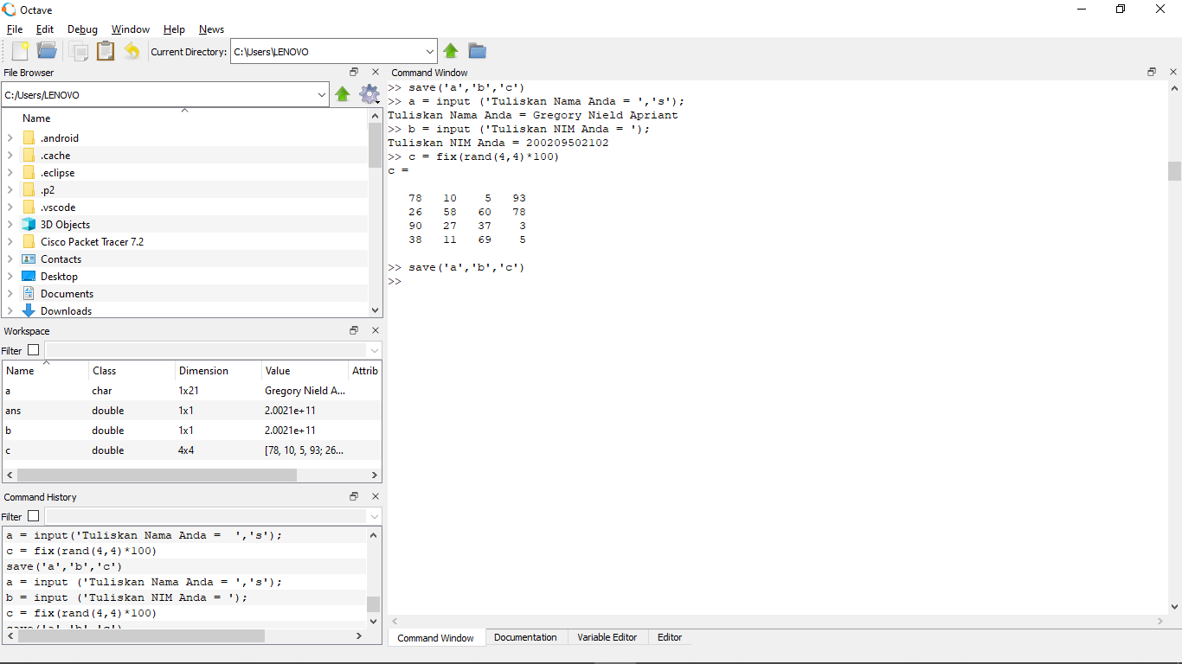

Matriks C dan Kernel LOW PASS

 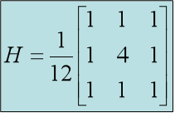

Tahapan Proses Konvolusi dengan kernel Filter LOW PASS:

|  |  |  |
| --- | --- | --- |
| 1/12 | 1/12 | 1/12 |
| 1/12 | 4/12 | 1/12 | 90 | 80 |
| 1/12 | 1/12 | 1/12 | 38 | 35 |
| 9 | 29 | 76 | 2 |
| 74 | 39 | 90 | 18 |

|  |  |  |  |
| --- | --- | --- | --- |
| 14 | 66 | 90 | 80 |
| 85 | 22 | 69 | 35 |
| 9 | 29 | 87 | 2 |
| 74 | 39 | 90 | 18 |

|  |
| --- |
|  |

|  |
| --- |
|  |

Konvolusi = (4 * 14 + 1 * 85 + 1 * 66 + 1 * 22)/12 = 19

|  |  |  |  |
| --- | --- | --- | --- |
| 14 | 66 | 90 | 80 |
| 85 | 22 | 69 | 35 |
| 9 | 29 | 87 | 2 |
| 74 | 39 | 90 | 18 |

|  |  |  |
| --- | --- | --- |
| 1/12 | 1/12 | 1/12 |
| 1/12 | 4/12 | 1/12 | 80 |
| 1/12 | 1/12 | 1/12 | 35 |
| 9 | 29 | 87 | 2 |
| 74 | 39 | 90 | 18 |

|  |
| --- |
|  |

Konvolusi = (1 * 14 + 4 * 66 + 1 * 69 + 1 * 9 + 1 * 29 + 1 * 87) /12 = 39

|  |  |  |  |
| --- | --- | --- | --- |
| 14 | 66 | 90 | 80 |
| 85 | 22 | 69 | 35 |
| 9 | 29 | 87 | 2 |
| 74 | 39 | 90 | 18 |

|  |  |  |
| --- | --- | --- |
| 1/12 | 1/12 | 1/12 |
| 14 | 1/12 | 4/12 | 1/12 | |
| 85 | 1/12 | 1/12 | 1/12 | |
| 9 | 29 | 87 | 2 | |
| 74 | 39 | 90 | 18 | |

Konvolusi = (1 * 66 + 4 * 90 + 1 * 80 + 1 * 22 + 1 * 69 + 1 * 35)/12 = 53

|  |  |  |  |
| --- | --- | --- | --- |
| 14 | 66 | 90 | 80 |
| 85 | 22 | 69 | 35 |
| 9 | 29 | 87 | 2 |
| 74 | 39 | 90 | 18 |

|  |  |  |
| --- | --- | --- |
| 1/12 | 1/12 | 1/12 |
| 14 | 66 | 1/12 | 4/12 | 1/12 |
| 85 | 22 | 1/12 | 1/12 | 1/12 |
| 9 | 29 | 87 | 2 |
| 74 | 39 | 90 | 18 |

Konvolusi = (1 * 90 + 4 * 80 + 1 * 69 + 1 * 35)/12 = 43

|  |  |  |  |
| --- | --- | --- | --- |
| 14 | 66 | 90 | 80 |
| 85 | 22 | 69 | 35 |
| 9 | 29 | 87 | 2 |
| 74 | 39 | 90 | 18 |

|  |  |  |  |  |
| --- | --- | --- | --- | --- |
| 1/12 | 1/12 | 1/12 | 90 | 80 |
| 1/12 | 4/12 | 1/12 | 69 | 35 |
| 1/12 | 1/12 | 1/12 | 87 | 2 |
| 74 | 39 | 90 | 18 |

Konvolusi = (1 * 14 + 1 * 66 + 4 * 85 + 1 * 22 + 1 * 9 + 1 * 29)/12 = 40

|  |  |  |  |
| --- | --- | --- | --- |
| 14 | 66 | 90 | 80 |
| 85 | 22 | 69 | 35 |
| 9 | 29 | 87 | 2 |
| 74 | 39 | 90 | 18 |

|  |  |  |  |
| --- | --- | --- | --- |
| 1/12 | 1/12 | 1/12 | 80 |
| 1/12 | 4/12 | 1/12 | 35 |
| 1/12 | 1/12 | 1/12 | 2 |
| 74 | 39 | 90 | 18 |

Konvolusi = (1 * 14 + 1 * 66 + 1 * 90 + 1 * 85 + 4 * 22 + 1 * 69 + 1 * 9 + 1 * 29 + 1 * 87)/12 = 41

|  |  |  |  |
| --- | --- | --- | --- |
| 14 | 66 | 90 | 80 |
| 85 | 22 | 69 | 35 |
| 9 | 29 | 87 | 2 |
| 74 | 39 | 90 | 18 |

|  |  |  |  |
| --- | --- | --- | --- |
| 14 | 1/12 | 1/12 | 1/12 |
| 85 | 1/12 | 4/12 | 1/12 |
| 9 | 1/12 | 1/12 | 1/12 |
| 74 | 39 | 90 | 18 |

Konvolusi = ( 1 * 66 +1 * 90 + 1 * 80 + 1 * 22 + 4 * 69 + 1 * 35 + 1 * 29 + 1 * 87 + 1 * 2)/12 = 57

|  |  |  |  |
| --- | --- | --- | --- |
| 14 | 66 | 90 | 80 |
| 85 | 22 | 69 | 35 |
| 9 | 29 | 87 | 2 |
| 74 | 39 | 90 | 18 |

|  |  |  |  |  |  |
| --- | --- | --- | --- | --- | --- |
| 14 | 66 | 1/12 | 1/12 | 1/12 | |
| 85 | 22 | 1/12 | 4/12 | 1/12 | |
| 9 | 29 | 1/12 | 1/12 | 1/12 | |
| 74 | 39 | 90 | 18 |  |  |

Konvolusi = ( 1 * 90 + 1 * 80 + 1 * 69 + 4 * 35 + 1 * 87 + 1 * 2) /12= 39

|  |  |  |  |
| --- | --- | --- | --- |
| 14 | 66 | 90 | 80 |
| 85 | 22 | 69 | 35 |
| 9 | 29 | 87 | 2 |
| 74 | 39 | 90 | 18 |

|  |  |  |  |
| --- | --- | --- | --- |
| 14 | 66 | 90 | 80 |
| 1/12 | 1/12 | 1/12 | 35 | 38 |
| 1/12 | 4/12 | 1/12 | 2 | 76 |
| 1/12 | 1/12 | 1/12 | 18 | 79 |

Konvolusi = (1 * 85 + 1 * 22 + 4 * 9 + 1 * 29 + 1 * 74 + 1 * 39)/12 = 24

|  |  |  |  |
| --- | --- | --- | --- |
| 14 | 66 | 90 | 80 |
| 85 | 22 | 69 | 35 |
| 9 | 29 | 87 | 2 |
| 74 | 39 | 90 | 18 |

|  |  |  |  |
| --- | --- | --- | --- |
| 14 | 66 | 90 | 80 |
| 1/12 | 1/12 | 1/12 | 35 |
| 1/12 | 4/12 | 1/12 | 2 |
| 1/12 | 1/12 | 1/12 | 18 |

Konvolusi = (1 * 85 + 1 * 22 + 1 * 69 + 1 * 9 + 4 * 29 + 1 * 87 + 1 * 74 + 1 * 39 + 1 * 90)/12 = 49

|  |  |  |  |
| --- | --- | --- | --- |
| 14 | 66 | 90 | 80 |
| 85 | 22 | 69 | 35 |
| 9 | 29 | 87 | 2 |
| 74 | 39 | 90 | 18 |

|  |  |  |  |
| --- | --- | --- | --- |
| 14 | 66 | 90 | 80 |
| 85 | 1/12 | 1/12 | 1/12 |
| 9 | 1/12 | 4/12 | 1/12 |
| 74 | 1/12 | 1/12 | 1/12 |

Konvolusi = (1 * 22 + 1 * 69 + 1 * 35 + 1 * 29 + 4 * 87 + 1 * 2 + 1 * 39 + 1 * 90 + 1 * 18)/12 = 59

|  |  |  |  |
| --- | --- | --- | --- |
| 14 | 66 | 90 | 80 |
| 85 | 22 | 69 | 35 |
| 9 | 29 | 87 | 2 |
| 74 | 39 | 90 | 18 |

|  |  |  |  |
| --- | --- | --- | --- |
| 14 | 66 | 90 | 80 |
| 85 | 22 | 1/12 | 1/12 | 1/12 |
| 9 | 29 | 1/12 | 4/12 | 1/12 |
| 74 | 39 | 1/12 | 1/12 | 1/12 |

Konvolusi = (1 * 69 + 1 * 35 + 1 * 87 + 4 * 2 + 1 * 90 + 1 * 18)/12 = 26

|  |  |  |  |
| --- | --- | --- | --- |
| 14 | 66 | 90 | 80 |
| 85 | 22 | 69 | 35 |
| 1/12 | 1/12 | 1/12 | 87 | 2 |
| 1/12 | 4/12 | 1/12 | 90 | 18 |
| 1/12 | 1/12 | 1/12 |

|  |  |  |  |
| --- | --- | --- | --- |
| 14 | 66 | 90 | 80 |
| 85 | 22 | 69 | 35 |
| 9 | 29 | 87 | 2 |
| 74 | 39 | 90 | 18 |

|  |
| --- |
|  |

|  |
| --- |
|  |

|  |
| --- |
|  |

Konvolusi = (1 * 9 + 1 * 29 + 4 * 74 + 1 * 39)/12 = 31

|  |  |  |  |
| --- | --- | --- | --- |
| 14 | 66 | 90 | 80 |
| 85 | 22 | 69 | 35 |
| 9 | 29 | 87 | 2 |
| 74 | 39 | 90 | 18 |

|  |  |  |  |
| --- | --- | --- | --- |
| 14 | 66 | 90 | 80 |
| 85 | 22 | 69 | 35 |
| 1/12 | 1/12 | 1/12 | 2 |
| 1/12 | 4/12 | 1/12 | 18 |
| 1/12 | 1/12 | 1/12 |

|  |  |  |  |
| --- | --- | --- | --- |
| 14 | 66 | 90 | 80 |
| 85 | 22 | 69 | 35 |
| 9 | 29 | 87 | 2 |
| 74 | 39 | 90 | 18 |

Konvolusi = (1 * 9 + 1 * 29 + 1 * 87 + 1 * 74 + 4 * 39 + 1 * 90)/12 = 37

|  |  |  |  |
| --- | --- | --- | --- |
| 14 | 66 | 90 | 80 |
| 85 | 22 | 69 | 35 |
| 9 | 1/12 | 1/12 | 1/12 |
| 74 | 1/12 | 4/12 | 1/12 |
| 1/12 | 1/12 | 1/12 |

Konvolusi = (1 * 29 + 1 * 87 + 1 * 2 + 1 * 39 + 4 * 90 + 1 * 18)/12 = 45

|  |  |  |  |
| --- | --- | --- | --- |
| 14 | 66 | 90 | 80 |
| 85 | 22 | 69 | 35 |
| 9 | 29 | 87 | 2 |
| 74 | 39 | 90 | 18 |

|  |  |  |  |
| --- | --- | --- | --- |
| 14 | 66 | 90 | 80 |
| 85 | 22 | 69 | 35 |
| 9 | 29 | 1/12 | 1/12 | 1/12 |
| 74 | 39 | 1/12 | 4/12 | 1/12 |
| 1/12 | 1/12 | 1/12 |

Konvolusi = (1 * 87 + 1 * 2 + 1 * 90 + 4 * 18)/12 = 21

1. Hasil dari Konvolusi kernel filter LowPass

|  |  |  |  |
| --- | --- | --- | --- |
| 14 | 66 | 90 | 80 |
| 85 | 22 | 69 | 35 |
| 9 | 29 | 87 | 2 |
| 74 | 39 | 90 | 18 |