**Software Specifications Requirements**

PathFinder

Greg Quintanilla

Alexander Orellana

Griffin Rhein

Johnathan Montag

Hassan Hassan

**Table of Contents…………………………………………………………………1**

1. **Introduction…………………………………………………………………………...2**
   1. Purpose………………………………………………………………………………………………………………..2
   2. Project Scope……………………………………………………………………………………………………….2
   3. Definitions, Acronyms and Abbreviations……………………………………………………………..2
   4. Intended Use………………………………………………………………………………………………………..3

1.5 Technologies to be used………………………………………………………………………………………..3

1. **Overall Description……………………………………………………………………………..3**
   1. Product Functions………..…………………………………………………………………………..3
   2. Product Perspective………………………………………………………………………………….4
   3. Operating Environment……………………………………………………………………………..5
   4. Design and Implementation Constraints………………………………………………………..5
2. **Functional Requirements…………………………………………………………5**

3.1 Pathfinding………………………………………………………………………………………………………….5-6

3.2 Login……………………………………………………………………………………………………………………...6

3.3 Itinerary………………………………………………………………………………………………………………...6

3.4 Driver Updating …………………………………………………………………………………………………...6-7

3.5 Administrative Control…………………………………………………………………………………………..7

3.6 Cloud hosted Computing……………………………………………………………………………………….7-8

3.7 List of Requirements……………………………………………………………………………………………..8

1. **Interface Requirements…………………………………………………………...9**

4.1 Administrator User Interface...……………………………………………………………………………9-11

4.2 Driver User Interface.………………………………………………………………………………………12-14

1. **Other Nonfunctional Requirements………………………………………14**

5.1 Low Distractions………………………………………………………………….....................................14

5.2 Security Requirements……………………………………………………………………………………………14

5.3 Login……………………………………………………………………………………………………………………...15

5.4 Delivery Information……………………………………………………………………………………………...15

5.5 Scoped View…………………………………………………………………………………………………………..15

**1. Introduction**

* 1. **Purpose**

The purpose is to develop a fully functional and interactive web application that will calculate the most efficient routes between addresses and deliver those routes to the user which will be the drivers.

* 1. **Project Scope**

Goals:

* Calculate efficient routes based on distance and time
* Create a User Interface that’s simple to understand
* Create a login system where only administrators and drivers can access
* Keep an active itinerary with estimated delivery times, arrival times and the ability to update the status of the current delivery
* Implement a way that allows drivers to view their current routes
* Implement a way that allows administrators to cancel routes and redirect drivers
* Implement cloud computing to calculate routes

**1.3 Definitions, Acronyms and Abbreviations**

AWS – Amazon Web Services

API – Application Programming Interface

**1.4 Intended Use**

Our program will be intended to be used by companies that have a need for route

calculations. This includes companies like Amazon which have implemented their own delivery system instead of relying on third parties. It’s also intended for companies like UPS, FedEx, or USPS. It’s also intended for food delivery companies such as door dash, grub hub, Uber eats, because these companies have a number of drivers and the faster they can get to their given destinations then the more money they make.

**1.5 Technologies to Be Used**

* Front End – React
* Address to Coordinates- Google API or GeoPy python library

**2. Overall Descriptions**

**2.1 Product Features**

* Users will be able to login based on their job (driver, administrator)
* Administrator will be able to input addresses, up to 100
* Administrator will be able to change routes
* Administrator will be able to assign routes to drivers
* Administrator will be able to view status of drivers
* Administrators will be able to view problems
* Drivers will be able to view current routes
* Drivers will be able to tell if they’re late, on time, or early
* Drivers will be able to update their status
* Drivers will be able to clock on, clock off

**2.2 Product Description**

Our fleet mapping program consists of a web app that allows administrators to calculate routes for their given drivers. First it will require the administrators to log in and then it will allow the administrator to input up to 100 addresses. Administrators will then be able to click a button that calculates the most efficient routes. Afterwards our system will allow administrators to assign routes to each driver. If the user is a driver then our system will allow drivers to view their current itinerary. Our system will allow itineraries to be edited by the drivers. These edits will include destination reached, problem reporting and requests to change. These edits will be subject to change and can be edited even after the program has been created. The following diagram shows user features.

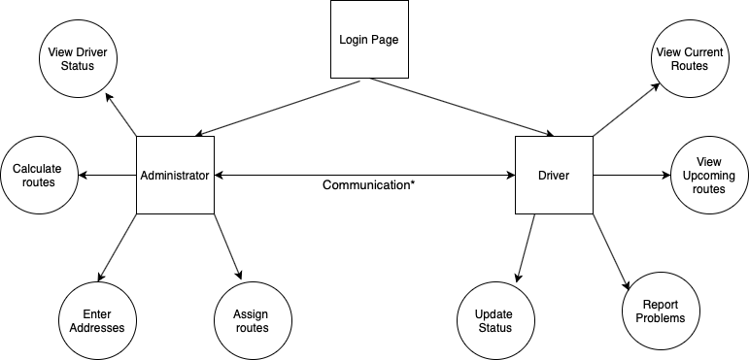

*Communication between administrators and drivers is key. The way it will be implemented will vary.

**2.3 Operating Environment**

Our program is aimed to work on Google Chrome. Our program would require an internet connection to work. Designing a web app is beneficial in because designing a software would require the support of only one or multiple different platforms whereas a web app can in theory be accessible from a number of devices including cell phones and computers.

**2.4 Design and Implementation Constraints**

One of the biggest constraints of the project involves the calculation of the routes. In theory once the addresses get converted to coordinates then graph theory can be applied to find the shortest path between various points. The problem is graph theory makes many assumptions and the main one is the assumption of diagonals. The problem is that in the real world, diagonals may exist but not always. So finding the shortest path between points that are actually addresses isn’t as straightforward as it is on paper. Other constraints include the use of unlicensed software. There are many APIs out that can be used for various parts of the project including the front end and back end but some may require licensing and sometimes those are expensive.

**3. Functional Requirements**

**3.1 Pathfinding**

Using known pathfinding algorithms to be able to calculate efficient routes between all addresses specified by the client by various metrics such as shortest distance and time. The methods that will be used for feature are the best known algorithms for finding paths such as Prim’s, Kruskals, Djikstra’s and the Ford - Bellman algorithms. The system will compute the paths between each node and create a route for the driver to follow and that route will be displayed to the driver as it gives direction on upcoming decisions. Routes can be generated one address at a time or can be sent in as collections of up to 100 addresses and the pathfinder will preprocess the addresses into GPS locations and then calculate the paths from there.

**3.2 Login**

Maintain both driver and administrative login information so that we can have drivers save their routes and administrators save routes in progress. This login will also change the UI displayed depending on whether a driver or an administrator has logged in. There will be a stored system of all the login credentials and their authorizations. New accounts will be able to be created and current accounts will be updateable.

**3.3 Itinerary**

When administrators enter in their addresses and the program computes the route, the program will also produce an itinerary for the route giving total estimated time, total distance driven, estimated arrival times of each address, the distance between each stop, and the estimated time between each stop. The itinerary will also track the real times each stop was made and adjust a new estimated time, so if the driver is ahead of schedule this will be reflected by current estimated time minus the original estimated time. The itinerary will also track how many deliveries have happened and how many are still left.

**3.4 Driver control**

Drivers will have the ability to update the status of their route as they continue along it. They will mark whether a delivery was successful and this will note the time the driver attempted to deliver. With this marked time the itinerary will adjust and continue to track the progress of the route. The driver will also be able to give information to the administrators about the statuses of their route. This will allow them to mark roads and closed for various reasons, be it wrecks, construction or other issues that would impede the route. Drivers will also be able to preview and move along the route to have an idea of where the entire route is taking them.

**3.5 Administrative Control**

Administrators will be able to enter in addresses for the desired deliveries for the day. There will be a max of 100 addresses that can be entered. The administrator will be able to enter them in an address at a time and see a preview of what the route might be with a partial amount of the address, or the administrator will be able to enter in a collection of addresses through an comma separated file and the routing system will compute the collection of addresses.Administrators will be able to update routes that have already been sent and created allowing for the deletion of deliveries while a driver is out on their route incase of cancelations to orders.

**3.6 Cloud Computing**

Cloud hosted software will maintain the digraph of all the nodes and potential addresses to deliver to. This service will maintain all of the nodes that the locations are built upon as well as the directed connections between nodes. This system will also help convert street addresses into GPS coordinates to be stored in the map. This system will also be leveraged to help calculate the routes on the map. This system will also be provided to the UI and display the map, the route along the streets, and the addresses as waypoints.

**3.7 List of Items**

3.7.1 Web application

3.7.2 Login Page

3.7.3 Map display

3.7.4 Itinerary Display

3.7.5 Address Display

3.7.6 Route Display

3.7.7 Driver Update control Display

3.7.8 Direction Display

3.7.9 Clock Displays (Driver View)

3.7.10 Address entry and load

3.7.11 Address to GPS coordinate conversion

3.7.12 Pathfinding

3.7.13 Itinerary creation

3.7.14 Directions

3.7.15 Login Functionality

3.7.16 Database of administrative/driver information

3.7.17 Password Security

3.7.18 Driver updateability

**4. Interface Requirements**

**4.1 Administrator User Interface**

Administrator user interface will primarily feature a map with every target location distinctly marked, which serves as the main hub from which other resources can be accessed through sidebars that contain further tabs and drop-down menus.

Sidebar accessible on the bottom will allow the user to watch the routes play out. Upon opening the menu, the user will access a list of all routes currently scheduled for the day (in-progress or otherwise) and any spots on the map which still require deliveries but are not attached to a route will be emphasized. Routes will be distinguished with different letters (Route A, etc.) and will list the assigned driver if there is one, the estimated time required to complete, the spot where it ends, and the number of deliveries complete out of the number scheduled total. There will be a large button & drop-down menu on the bottom-left to calculate the most efficient method for the drivers listed for the day to visit all areas currently differentiated on the map. If there are no routes in progress, clicking the button or selecting the appropriate option in the menu will make the calculations using all addresses and all drivers. If there is at least one route in progress, the large button will be disabled and the drop-down menu must be used for a similar process that does not change any routes that are currently in motion.

Selecting an individual route in the sidebar will distinguish every location assigned to it on the map, and from there any target on the map can be clicked to open a small adjacent menu where it can be manually added or taken away from the route, with options to add public notes for it that the driver can see, add private notes for it, or give the location special priority. In addition, if there is no driver attached to the route or the assigned driver is not on-duty, right-clicking any target on the map will immediately assign or unassign it from the route without going through the menu. If the delivery list is adjusted in any of these ways, then the user will be asked if they would like the most efficient path for that single set of addresses to be recalculated.

Sidebar accessible on the left will allow the user to manage the drivers more directly. Upon opening the menu, the user will access a list of every driver scheduled for that day, with extra tabs to view only drivers who are not scheduled or all drivers. Selecting an individual driver will display the current route they are servicing or declare that they are not currently attached to a route, as well as provide options to shift them on-duty or off-duty, switch their route, send them a message, or make a private note about them. Additional statistics are offered about each driver’s total number of successful and unsuccessful deliveries, miles travelled, and number of delegated routes completed. Drivers in any given tab may be sorted alphabetically either normally or in reverse, or in order of being added to the program.

Sidebar accessible on the right will allow the user to manage the address listings. Upon opening the sidebar, the user will access a list of every address for which a delivery is scheduled along with the name attached to each delivery, with options to sort the list by geographic location of the address (W to E, etc.), alphabetical order of the receivers’ names, or the mass of the cargo being shipped. Up to 100 addresses can be entered in the program at once, and they can be assigned to drivers’ routes either individually or en masse from this menu as well. More tabs in the sidebar will feature only the addresses which are not currently assigned to any driver only the addresses which have been delegated, only the addresses which have been

completed,or only the addresses which have been cancelled.

**Login Page**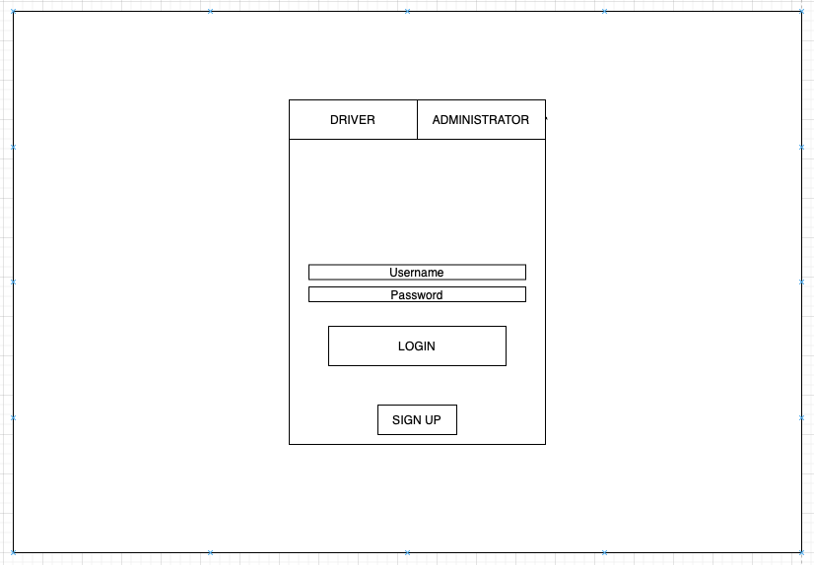

**Administrator Initial View1**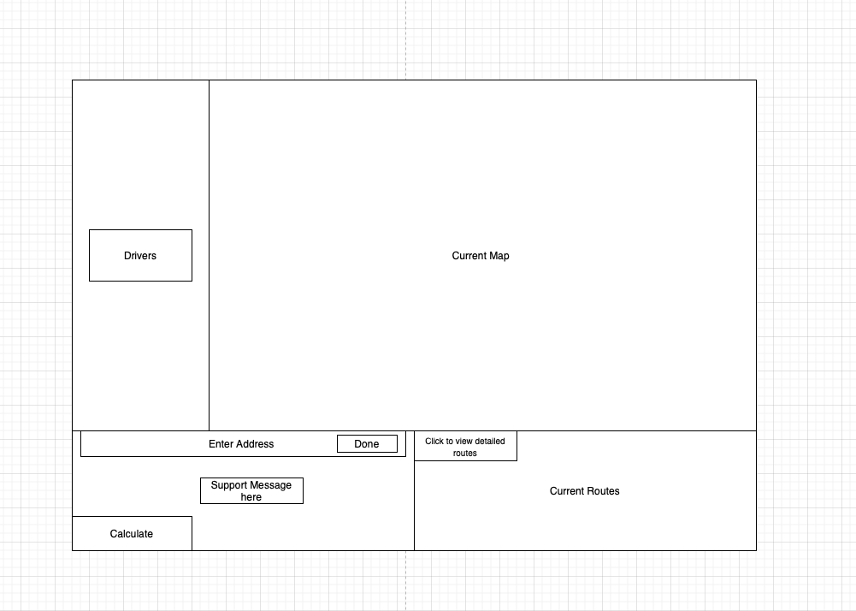

**4.2 Driver Display**

Much like the administrator UI, the driver UI prominently features a map at the center of the screen. For the driver, this map marks the addresses they will visit with numbers indicating their order, with the destinations of the other drivers unknown and inaccessible without special permission. The marker for the next scheduled delivery will appear larger than the others. As a delivery is marked as complete, its marker will change color and revert back to its normal size as the next marker grows and briefly displays the full address on the map itself.

Sidebar accessible on the bottom lists the addresses in the order of visitation, starting with the next one in line. Adjacent to each address is the estimated time in minutes to reach it traveling from the previous address, a suggested time at which the driver should reach the destination to stay on schedule, the weight of the package to be delivered there, and delivery priority. Addresses with similar priority will largely be grouped together in the list, as they are displayed in the order visited, though there will be many exceptions based on the proximity of low-priority targets to existing routes.

Additional tabs viewable on the bottom sidebar will change the address listings to show only locations which have already been visited, locations which were previously scheduled but cancelled, or every location in the day’s route from the beginning with successful deliveries distinguished from planned deliveries. In the cases where addresses which were successfully visited are displayed, their times of completion will be listed where the recommended time to reach them to remain punctual was previously shown, but distinguished by color.

Selecting an address from the bottom will open up a small menu on the left portion of the screen on which the delivery can be marked as complete or incomplete, with an option to add private notes or public notes viewable by the administrator. If the delivery is being marked incomplete, the program will ask the reason for incomplete delivery.

Toolbar on the top will contain statistics such as the total distance travelled, total deliveries made, total time invested, as well as the current date and time.

**Login Page**

**User Initial View2**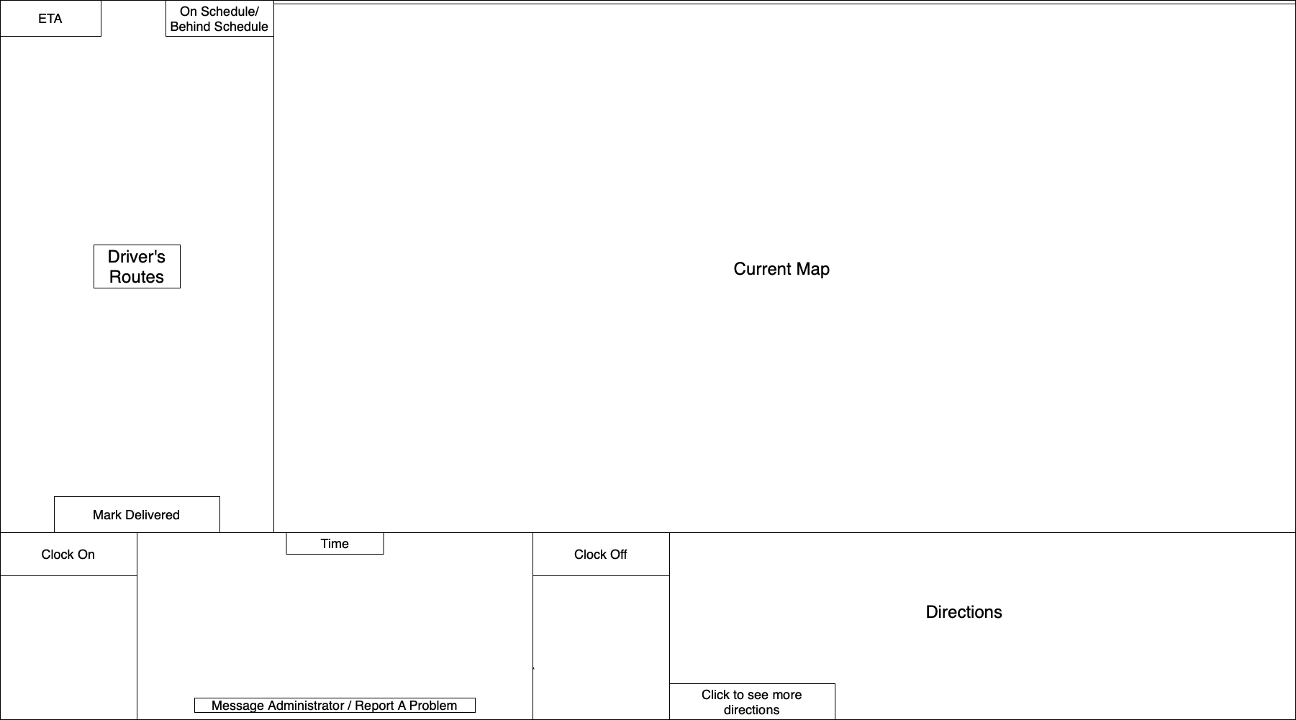

**5. Other Non - Functional Requirements**

**5.1 Low Distraction**

Drivers will have an easy to use UI that will have a mode to make sure to minimize distracted driving as they go from one address to another. This will reduce wrecks and help keep the delivery drivers and other drivers on the road safe.

**5.2 Check-ins**

Drivers will be prompted to go in order and to check in their deliveries to ensure they are going to the right locations and not damaging property

**5.3 Login**

Login Information will be tracked for both administrators and drivers with usernames and passwords that will be hashed and stored.

**5.4 Delivery Information**

Routes will be secure and storable to ensure the security of information on deliveries and so drivers cannot be tracked by anyone other than authorized individuals

**5.5** **Scope View**

A driver will only be able to see their own routes and no other drivers routes. Along with this they will only see where the deliveries are going to and not the items being delivered to reduce temptation for theft.

1 WireFrame for administrator is the initial view and not all frames for administrator are shown. Accuracy from description may vary and is subject to change

2 WireFrame for driver is the initial view and not all frames are shown. Accuracy from description may vary and is subject to change