Computational Notations

Using Python, Abjad, and Lilypond for Music Composition and Engraving

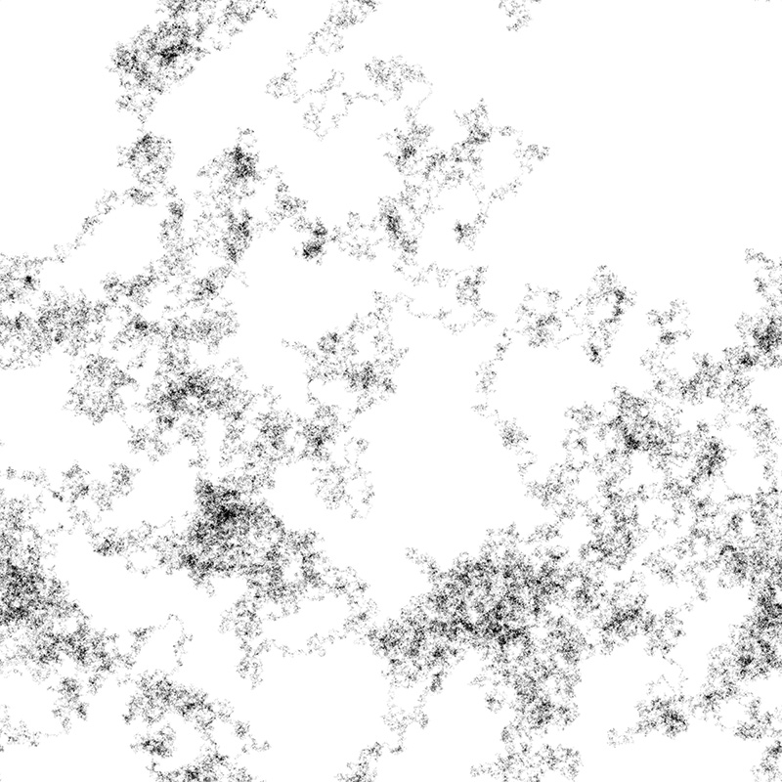

Gregory Rowland Evans