**Microprocessor Lab**

Laboratory Activity No. 1

**Familiarization with TinkerCAD**

|  |
| --- |
|  |

Score

*Submitted by:*

**Baldonado, Greian Kif A.**

**Saturday (1-4pm) / CPE 0412.1-2**

*Date Submitted*

**16-09-2023**

*Submitted to:*

**Engr. Maria Rizette H. Sayo**

1. Exercise

a. A process in Tinkercad where we can develop electronic circuits that can be quickly updated, modified and tested is called prototyping.

b. In Tinkercad, start/stop simulation tests the working of the circuits and the components.

c. The device used to assemble and connect the various components is known as breadboard.

d. In an electronic circuit with LED, the positive end of the circuit should be connected to anode and negative end should be connected to cathode of the LED.

e. A resistor is used to restrict the flow of current to electrical components

2. Label the following:



1. Anode and Cathode in a LED

Anode

Cathode

1. Different parts of breadboard

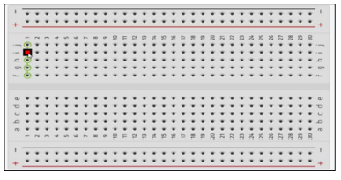

Power rail

Terminal strips

Center divider

Ground rail

1. List the electronic components used in a circuit assembly
2. Light Emitting Diode (LED)
3. Battery
4. Switch
5. Capacitors
6. Relay
7. Motor
8. Inductors
9. Transformer
10. Electrical Wires & Power Cables
11. Resistor
12. Integrated Circuit (IC)
13. Transistors
14. Buzzer
15. Circuit Breaker
16. Fuse