Simulation of the orbit of the four inner planets of our Solar System around the Sun

By Gurg

Introduction

The aim of the simulation was to create a model of the orbits of the four terrestrial planets in our Solar System, and use this simulation to test and predict flight paths of asteroids and satellites. This was achieved by implementing the three step Beeman algorithm which predicts the position at the next timestep by using the current acceleration of the body and the acceleration of the body at the previous timestep (shown below):

r⃗ (t+Δt)= r⃗ (t)+v⃗ (t)Δt+1/6[4a⃗ (t)−a⃗ (t−Δt)]Δt^2

This position vector can then be used to predict the acceleration at the next time step. Acceleration was calculated using the vector form of Newton’s universal law of gravitation (shown below):

F₂₁ =-G(m₁m₂/|r₁₂|²)rhat₁₂

where:
F₁₂ is the force applied on object 2 extered by object 1
G is the universal gravitaional constant
m₁ and m₂ are the masses of objects 1 and 2
|r₁₂| is the magnitude of the vector r₂ – r₁
rhat₁₂ is the unit vector from object 1 to 2

Finally the velocity at the next timestep can be calculated by combining all three accelerations and the current velocity (shown below):

v⃗ (t+Δt)= v⃗ (t)+1/6[2a⃗ (t+Δt)+ 5a⃗(t) - a⃗ (t−Δt)]Δt

where:
r⃗ is the position vector,
v⃗ is the velocity vector,
a⃗ is the accelertion vector,
Δt is the timestep in seconds,

for all equations.

At each timestep, for each planet, the position vector was recalculated and the position of the planet was changed accordingly and then the next acceleration and next velocity were calculated.

The intial velocity was calulated by using the equation for the relative velocity in a circular orbit:

v = sqrt(GMm/r)

where:
sqrt means square root
v is the relative velocity
G is the universal gravitaional constant
M is mass of the body the smaller body is in orbit around (kg)
m is the mass of the smaller body (kg)
r is the distance between the two bodies (m)

Kinetic energy of each body was calculated using the following equation and then all the energies from every body were summed together to get the total:

Ek = 0.5mv^2

where:
Ek is kinetic energy of the object (joules)
m is the mass of the object (kg)
v is the speed of the object (m/s)

Gravitational potential energy of the system was calculated using the following equation:

V = -GMm/x

where:
V is Gravitational potential energy
M is the mass of the larger body
m is the mass of the smaller body
x is the distance between the two bodies

The initial model was set up with lining up all the bodies in a horizonal line and calculating the initial velocity using the previous equation. The position was then updated at each timestep and the planets were moved accordingly. At the start of the simulationt an asteroid is randomly placed for the purpose of the doomsday experiment. Kinetic and Gravitational Potential energy is also written to a file periodically.

Method

I implemented 2 classes to achieve my simluation. The first of these is the Body class, which represents the astronomical bodies in the simulation, holds the mass, position vector, initial position vector, velocity vector, acceleration variables for each body. I chose to make the different accelerations different variables, ap, ac and an, and this was purely for readability and simplicity, I could have used a deque (double ended queue) with three variables instead and popped the left hand side of the queue to remove the oldest acceleration value,this may have been more efficient and concise, but I found the way I did it more straightforward to implement and clearer when it came to using the values. The class also also contains instance methods to update the position vector, update the velocity vector, shift the accelerations, initialse the velocity, and check if the body has orbited the sun.

The second class is the Satellites class which I used to represent the smaller bodies in my simulation (for example meteors or satellites). This differs in that the parameters for the initialisation of the class are not originally read in from a file so the paramters are put in directly rather than in a list. It inherits all methods from its parent class, Body.
I decided to make Satellites into a seperate class because they arent part of the central working if the simlulation and are more of an add on, also because Satellites arent astronomical bodes as they are man-made.
I also have a Main which does most of the calculations and is of course where I define all of the bodies to be used in the simluation.
Certain global variables are also defined in the Main; G (Universal gravitaional constant), patches[](list used to hold the circles which represent the bodies), Bodies[](list to hold the bodies), and lim(limit of the axes in the graph).These are all defined as global variables as some of them are used in more than one function and therefor need to be accessible to each one, the simplest way to do this I found was just defining them as global variables.
The Main contains functions to calculate the force one body exterts on another, initialise all the accelerations, work out the next acceleration, the function used in the animation, a function to generate the doomsday asteroid, and two functions to calculate the kinetic and Gravitational Potential energies.
The reason I have all these methods in the main class and not the Body class is they all use multiple instances of the Body class and it made more sense to have them in a centralised part of the code rather than in the class.

The bodies get all of their parameters from a Bodies.txt file in the format:
mass of body (kg)
position x
position y

The init_acceleration() and next_acceleration() methods work by using a nested loop and repeatedly applying the force() function to calculate the force each body in the list (except itself) exterts on a single body and then the acceleration is worked out using Newtons second law of motion (a=F/m) It then moves on and does the same thing for the next body in the list.
I have a seperate function for the initialisation of the acceleration because in order to use the beeman algorithm the current acceleration and the acceleration from the previous timestep are required, therefor at the beginning, since there have been no previous timesteps, the current acceleration and the previous acceleraition are set to the same value, and I decided to use a completely seperate function to achieve this.
The animate() function is the one used by the FuncAnimation() function to animate the bodies. It works by going through each element in the Bodies[] list and for each entry simply working out the position, updating the corresponding patches[] entry with the new position, working out the new acceleration for the body, and then updating the velocity to be used in the next timestep.
The functions used to calculate the total kinetic and gravitational potential energy simply just apply the formula to every body in the list and sum it all together for it to then be written to a file.
The asteroid is generated in a seperate function as it has specific starting parameters it made sense to define it seperately from the rest of the bodies.It is generated by randomly selecting numbers(within given constraints) for both components of the velocity and position vectors, it then adds the asteroid to the Bodies[] and patches[] lists so it can be incorporated into the simlulation.
I was only able to implement one of the experiments due to time constraints and I chose the doomsday asteroid experiment. For this i took a collision with Earth to be: if the distance between Earth and the asteroid was equal to less than double Earths radius(in km).
The asteroid is generated at the beginning of the simlulation and each time it hits earth, if it does, is noted.

Results

My aim was to investigate the likelyhood of an asteroid, given a random velocity and position, colliding with the earth.. The answer I have gathered is no, it is not likely. The asteroid always starts on an aproach towards the sun and then either slingshots around into a larger ellipltical orbit and then loops around once more and completely slingshots off, or stays in a relatively stable elliptical orbit as seen in figure 1 below.

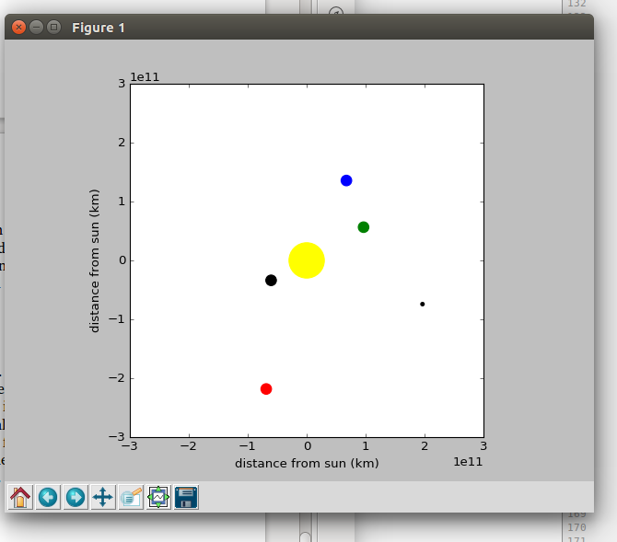 (Figure1)

Discussion

I dont believe the earth is at risk from and an asteroid impact. If something from the asteroid belt were to start a trajectory towards the inner planets it would have such a low velocity that it would just make a direct path to the Sun since it is so massive. If earth were in the way then it would be hit but the likelyhood of this happening is minimal. Although if the asteroid did not hit the Sun and flew past it and came back around then the chance is increased due to having another fly-by. Earth is not massive enough to have a substantial effect on an asteroids flightpath.

Conclusion

The final iteration of my project models the solar system with a moderate degree of accuracy, I have taken some shortcuts (notably when working out gravitational potential energy) but overall it seems to be accurate.

