First Bookdown document

Dr Greig Russell

1 January 2017

# Bookdown trial

This document will be used to build a "book", which will be a single part document in the first instance, leading to a PDF & Word document output (Teece, Pisano, and Shuen 1997).

|  |  |  |  |  |
| --- | --- | --- | --- | --- |
|  | mpg | cyl | disp | hp |
| Mazda RX4 | 21.0 | 6 | 160 | 110 |
| Mazda RX4 Wag | 21.0 | 6 | 160 | 110 |
| Datsun 710 | 22.8 | 4 | 108 | 93 |
| Hornet 4 Drive | 21.4 | 6 | 258 | 110 |
| Hornet Sportabout | 18.7 | 8 | 360 | 175 |
| Valiant | 18.1 | 6 | 225 | 105 |

## Including Plots

You can also embed plots, for example:

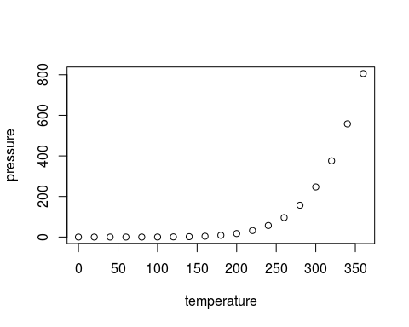

Note that the echo = FALSE parameter was added to the code chunk to prevent printing of the R code that generated the plot.

Teece, David J, Gary Pisano, and Amy Shuen. 1997. “Dynamic Capabilities and Strategic Management.” *Strategic Management Journal*. JSTOR, 509–33.