Greih Murray

Assignment 5.2

Style Guide

# Color Palette

1. #**6E6D00**
2. **#166E00**
3. **#436D00**
4. **#6E5F00**
5. **#006E14**
6. **#526E25**

# Fonts

# Sizing

## Headers

32 pt font

Bold

Color #2

## Sub headers

26 pt font

Bold

Color #1

## Body Text

16 pt font

Black text

## Footers

10 pt font

Black text

## Block Quotes

Indented

Italicized

## General

Links along the top in a line

Centered body element, 80% of screen width

Left aligned text

Objectively Light font family

Interview

* What are some of your hobbies?
  + I love drawing, cooking, and watching the Kansas City Chiefs
* What did you study in school?
  + For my bachelors I majored in architecture at Washington University in St. Louis, and for my masters I dual majored construction management and architecture at the same school.
* Were you involved in campus life at all while in school?
  + I stayed pretty busy with school work but I was also on the football team for four years and was also involved in the Harry Potter Club
* What do you do for work?
  + I work for an architecture firm and am currently taking my licensure exams to become a licensed architect
* Where do you work?
  + I work for Hartshorne Plunkard Architecture in Chicago, IL
* What is your favorite thing about your job?
  + My favorite thing about work is being given responsibility and meaningful work despite being young for the field
* Where is your favorite city in the world?
  + Reykjavik, Iceland
* What is your proudest accomplishment?
  + My proudest accomplishment has yet to physically manifest. I am proud to have realized that my mission and goal in this world is to leave it a better place with my actions and work.
* You are very artistic, what are some of your favorite colors or color schemes?
  + Personally, my favorite color is green, for designs I love using yellow, and for clothes I prefer dark grey.
* I know you are very into and knowledgeable about fonts, what is your favorite font?
  + My favorite font is Objectively Light

Bio

My brother Patrick Murray was born in Knob Noster, Missouri and grew up in Jefferson City, Missouri. During elementary school Patrick attended St. Stanislaus Elementary school before transferring to the Blair Oaks school district for middle and high school. While attending Blair Oaks Patrick was a member of the football, and track and field teams, as well as being a member of the band for three years in high school. After graduating as his class valedictorian, Patrick attended Washington University in St. Louis for his bachelor’s degree where he majored in architecture, and continued his football career by joining the WashU Bears. After graduating with his bachelors, Patrick stayed at WashU to pursue his master’s degree which he dual majored in Architecture and Construction Management. After graduating with his Master’s degree, Patrick moved to Chicago and now works for Hartshorne Plunkard Architecture where he is currently taking his licensure exams to become a licensed architect in the state of Illinois. Patrick has dreamed of being an architect since he was a small child. As a kid, Patrick enjoyed drawing houses and buildings of all sorts, and one day, when discussing a particular house he wanted to draw, his mother mentioned that he should be an architect, and ever since then his goal has been to become an architect, and now he is closer than ever.

In his free time, Patrick enjoys cooking, drawing, and watching his favorite football team, the Kansas City Chiefs, as well as spending time with his family and friends.

Images

# Hobbies

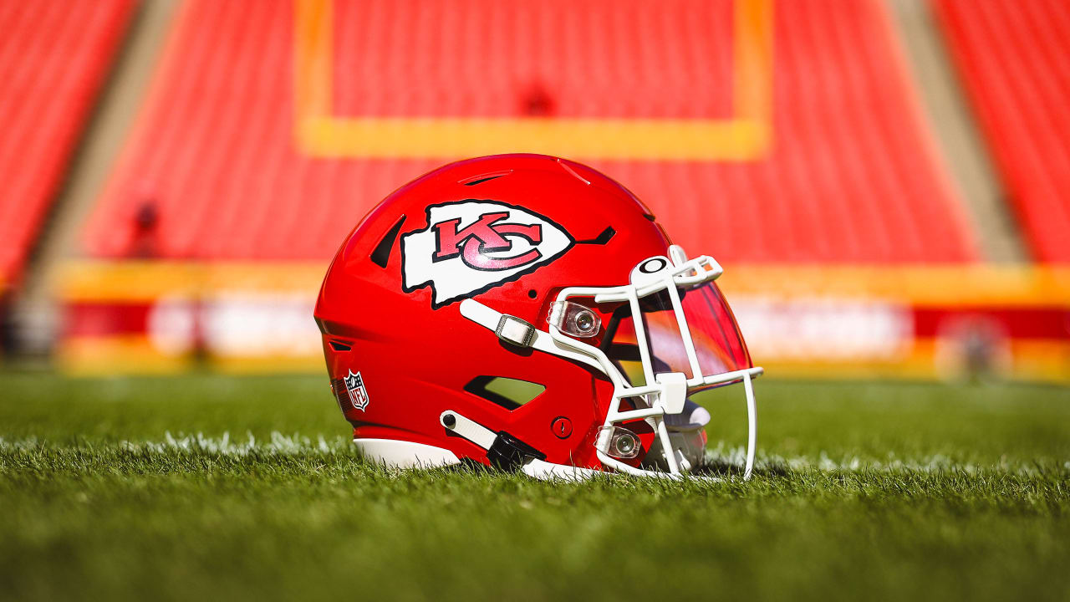

Patrick’s favorite football team is the Kansas City Chiefs and he enjoys watching them in his free time



In his free time Patrick also enjoys cooking and meal prepping for the week ahead

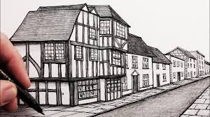

Drawing, especially houses, has always been one of Patrick’s favorite passtimes

# Achievements



Washington University in St. Louis is where Patrick earned his Bachelor’s and Master’s degrees

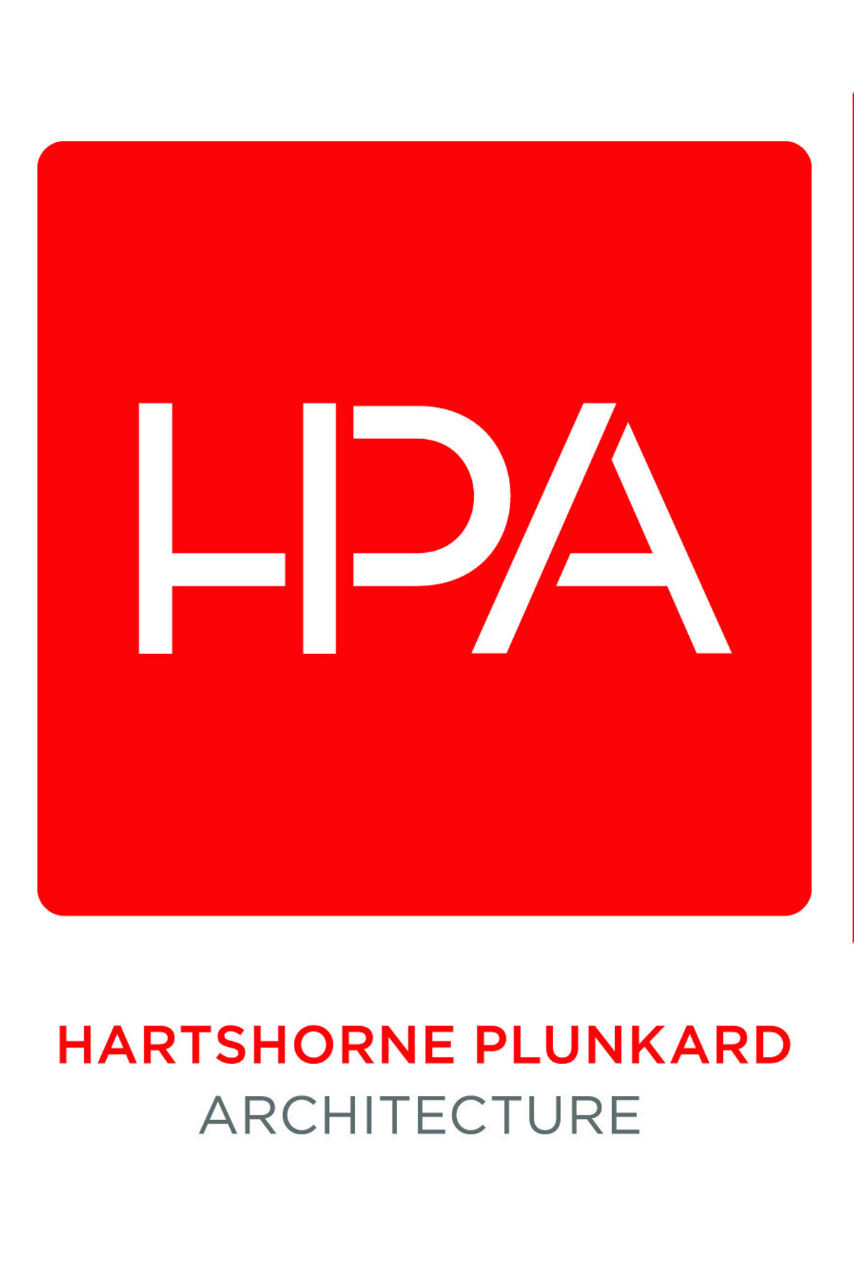

Hartshorne Plunkard is where Patrick currently works and is pursuing his architectural licensure

# Personal

# Wireframe

The below wireframes are sketches obviously, for the actual site things will be centered better and the borders around the text on the about and hobby pages likely will not be there, just wanted to make sure to properly show the space that I plan to use

