Algorithms and Data Patterns
Midterm (50)
- What would be a situation where an ARRAY would be best suited?
- an array is good for when we are working with a collection of items that are similar, and also if we need to access by position. An example of when an array can be use in real life is: a to-do list, can be an array because is a collection of words that we can access by index and easily loop trough it to show what we need to do.

- What would be a situation where a VECTOR would be more suited?
- a vector would be good for a situation when you are not sure how many items of the same category you are going to add or remove. It is good with memory allocation making the program run smooth even if its size is growing by time. An example of a vector in video games, the chat of a video game can be a vector. Since the developers do not know how many messages are going to come trough by the users the most common fix is to use a vector.

- How does a DEQUE function differently than a VECTOR?
The main difference between a dequeue and vector is that the deque allows you to easily remove and add components to the end and the front of the deque. The vector in the other hand is only good for adding and removing stuff from the end, and also vectors tend to be slower than deque due to the shift of components after an addition or subtraction of a component in a vector

- Order the Time Complexity of the different Big0 Notations
(print the letters in order from FASTEST to SLOWEST, print the letters between the scales):
  - 0(n/2)
  - 0(n)
  - 0(1)
  - 0(n!)
  - 0(logn)
  - 0(n^2)
FASTEST SLOWEST
0(1) → 0(logn) → 0(n/2) & 0(n) → 0(n^2) → 0(n!)

0(1): constant time (fastest)
0(logn): logarithmic time
0(n/2) & 0(n): both linear same time speed
0(n^2): quadratic
0(n!): factorial (slowest)

- Which Big0 Complexity would it be (bold/state/circle...answer): X don’t do it
  - 0(1)
  - 0(n)
  - 0(n/2)
  - 0(logn)

- Which Big0 Complexity would it be (bold/state/circle...answer): X don’t do it
  - 0(1)
  - 0(n)
  - 0(n/2)
  - 0(logn)

- Describe what a recursive function is:
recursive function is a function that calls itself to solve a problem by breaking it into simpler and smaller steps. Example in class, when we did all the calculations in our KDTree.h file

- If the value (10, 18, 3) is added to the KDTree, where would it get added:
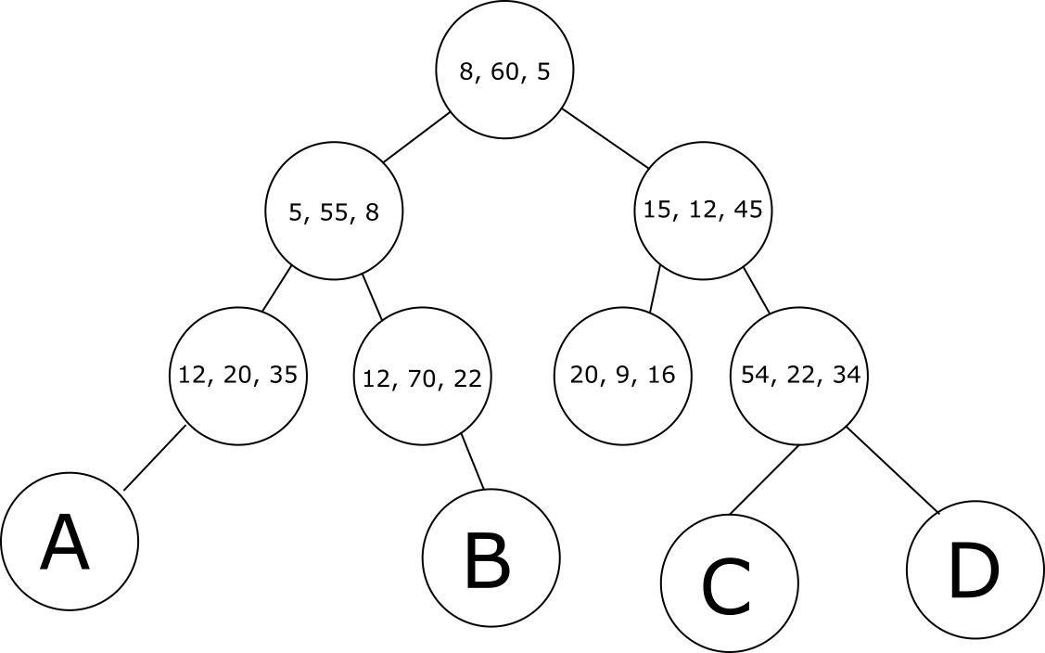
Answer:

C

- What is the practical use of a Depth First Search algorithm in a graph?
A good practical use for DFS in the real world would be maze solving since DFS focuses on one path completely before moving on

- What does the Breadth First Search algorithm provide better than Depth First Search? What does it potentially do worse?

BFS gets to the end point faster, making it a good use for finding what is closest in a graph. However BFS takes more memory than DFS and it will be slower for deeper graphs.

