WL1_Survival_Across_Years
2026-05-06
library(dplyr)
##
## Attaching package: 'dplyr'
## The following objects are masked from 'package:stats':
##
## filter, lag
## The following objects are masked from 'package:base':
##
## intersect, setdiff, setequal, union
library(tidyverse)
## ── Attaching core tidyverse packages ──────────────────────── tidyverse 2.0.0 ──
## ✔ forcats 1.0.0 ✔ readr 2.1.5
## ✔ ggplot2 3.5.2 ✔ stringr 1.5.1
## ✔ lubridate 1.9.4 ✔ tibble 3.2.1
## ✔ purrr 1.0.4 ✔ tidyr 1.3.1
## ── Conflicts ────────────────────────────────────────── tidyverse_conflicts() ──
## ✖ dplyr::filter() masks stats::filter()
## ✖ dplyr::lag() masks stats::lag()
## ℹ Use the conflicted package (<http://conflicted.r-lib.org/>) to force all conflicts to become errors
library(ggplot2)
library(lubridate)
Initial test with WL1 2023-2024
WL1_all <- read_csv("../input/Cleaned/WL1_cleaned.csv") %>%
select(-'...1')
## New names:
## Rows: 1869 Columns: 37
## ── Column specification
## ──────────────────────────────────────────────────────── Delimiter: "," chr
## (11): Site, Phenology, Stem_diam_mm, Longest_leaf_cm, Notes, Entered_by... dbl
## (14): ...1, Transect_plot, Quad, Xcoord, Ycoord, Height_cm, Num_total_b... lgl
## (10): Year_marked, Tag, 2018tag, 2019tag, Band, Canopy_width_cm, Leaf_t... date
## (2): Census_date, Date_entered
## ℹ Use `spec()` to retrieve the full column specification for this data. ℹ
## Specify the column types or set `show_col_types = FALSE` to quiet this message.
## • `` -> `...1`
WL1_24 <- WL1_all %>%
filter(Census_year == 2024) %>%
mutate(plant_id = paste(Site, Band_color, Band_num, sep = "_"),
alive = as.integer(!is.na(Phenology) & Phenology != "X"))
WL1_23 <- WL1_all %>%
filter(Census_year == 2023) %>%
mutate(plant_id = paste(Site, Band_color, Band_num, sep = "_"),
alive = as.integer(!is.na(Phenology) & Phenology != "X"))
WL1_23_24_survival <- WL1_23 %>%
left_join(WL1_24 %>% select(plant_id, alive_2024 = alive, Phenology_2024 = Phenology), by = "plant_id") %>%
mutate(alive_2024 = if_else(is.na(alive_2024), FALSE, alive_2024),
survived_23_24 = alive & alive_2024)
## Warning in left_join(., WL1_24 %>% select(plant_id, alive_2024 = alive, : Detected an unexpected many-to-many relationship between `x` and `y`.
## ℹ Row 269 of `x` matches multiple rows in `y`.
## ℹ Row 31 of `y` matches multiple rows in `x`.
## ℹ If a many-to-many relationship is expected, set `relationship =
## "many-to-many"` to silence this warning.
Try to generalize across all years at WL1 Need to start by only including plants that have the band number and color - not sure if this is the best way to go about it but it is what works for now Will need to think about how this will work for years without band color and number
WL1_survival <- WL1_all %>%
filter(!is.na(Band_color), !is.na(Band_num)) %>% #only include individuals with a band num and color
mutate(plant_id = paste(Site, Transect_plot, Quad, Band_color, Band_num, sep = "_"), #create a unique ID for each individual
alive = as.integer(!is.na(Phenology) & Phenology != "X")) %>% #add a column for binary alive = 1 or dead = 0
arrange(plant_id, Census_year) %>% #arrange individuals by census year
group_by(plant_id) %>%
mutate(age = row_number(), #add an age - so the first row with the unique plant id will be 1 and ever followign row would increase age by 1
next_year = Census_year + 1, #add next year column
alive_next_year = lead(alive), #check alive column from the following year
survived_to_next = as.integer(next_year == Census_year + 1 & alive == 1 & alive_next_year == 1)) %>% #1 if alive = 1 in census year and alive in census year + 1
ungroup()
#This seems to work
#alive_next_year seems to be NA if the plant was not relocated in the following year or if the plant died in the current census year
Test if this works for WL2
WL2_16_23 <- read_csv("../input/Cleaned/WL2_cleaned_16_23.csv")
## Rows: 6512 Columns: 36
## ── Column specification ────────────────────────────────────────────────────────
## Delimiter: ","
## chr (13): Site, Transect_plot, Quad, Stem_diam_mm, Phenology, Num_flowers, ...
## dbl (13): Xcoord, Ycoord, Height_cm, Canopy_width_cm, Num_total_branches, N...
## lgl (8): Band, Tag, 2018tag, 2019tag, Buds, Category_herbivory, Leaf_thick...
## date (2): Census_date, Date_entered
##
## ℹ Use `spec()` to retrieve the full column specification for this data.
## ℹ Specify the column types or set `show_col_types = FALSE` to quiet this message.
WL2_24 <- read_csv("../input/Cleaned/WL2_cleaned_24.csv")
## Rows: 213 Columns: 36
## ── Column specification ────────────────────────────────────────────────────────
## Delimiter: ","
## chr (8): Site, Transect_plot, Stem_diam_mm, Phenology, Notes, Band_color, ...
## dbl (13): Quad, Xcoord, Ycoord, Height_cm, Num_total_branches, Num_flowers,...
## lgl (13): Canopy_width_cm, Band, Pick_color, Sword_color, Tag, 2018tag, 201...
## date (2): Census_date, Date_entered
##
## ℹ Use `spec()` to retrieve the full column specification for this data.
## ℹ Specify the column types or set `show_col_types = FALSE` to quiet this message.
WL2_all <- bind_rows(WL2_16_23, WL2_24 %>% mutate(Quad = as.character(Quad), Num_flowers = as.character(Num_flowers)))
WL2_survival <- WL2_all %>%
filter(!is.na(Band_color), !is.na(Band_num)) %>%
mutate(plant_id = paste(Site, Transect_plot, Quad, Band_color, Band_num, sep = "_"),
alive = as.integer(!is.na(Phenology) & Phenology != "X")) %>%
arrange(plant_id, Census_year) %>%
group_by(plant_id) %>%
mutate(age = row_number(),
next_year = Census_year + 1,
alive_next_year = lead(alive),
survived_to_next = as.integer(next_year == Census_year + 1 & alive == 1 & alive_next_year == 1)) %>%
ungroup()
#Noticed some individuals have a 0 for survived to next year = 0 for 2025, unsure why these are getting assigned a 0 and not NA
Testing for WL3
WL3_all <- read_csv("..//input/Cleaned/WL3_cleaned_all.csv")
## New names:
## Rows: 2864 Columns: 37
## ── Column specification
## ──────────────────────────────────────────────────────── Delimiter: "," chr
## (12): Site, Quad, Phenology, Stem_diam_mm, Longest_leaf_cm, Notes, Ente... dbl
## (14): ...1, Transect_plot, Xcoord, Ycoord, Height_cm, Num_total_branche... lgl
## (9): Tag, 2018tag, 2019tag, Band, Canopy_width_cm, Leaf_thickness_mm, ... date
## (2): Census_date, Date_entered
## ℹ Use `spec()` to retrieve the full column specification for this data. ℹ
## Specify the column types or set `show_col_types = FALSE` to quiet this message.
## • `` -> `...1`
WL3_survival <- WL3_all %>%
filter(!is.na(Band_color), !is.na(Band_num)) %>%
mutate(plant_id = paste(Site, Transect_plot, Quad, Band_color, Band_num, sep = "_"),
alive = as.integer(!is.na(Phenology) & Phenology != "X")) %>%
arrange(plant_id, Census_year) %>%
group_by(plant_id) %>%
mutate(age = row_number(),
next_year = Census_year + 1,
alive_next_year = lead(alive),
survived_to_next = as.integer(next_year == Census_year + 1 & alive == 1 & alive_next_year == 1)) %>%
ungroup()
Testing for BH
BH_all <- read_csv("../input/Cleaned/BH_cleaned_all.csv")
## Rows: 1827 Columns: 36
## ── Column specification ────────────────────────────────────────────────────────
## Delimiter: ","
## chr (12): Site, Transect_plot, Phenology, Stem_diam_mm, Num_flowers, Notes,...
## dbl (13): Quad, Xcoord, Ycoord, Height_cm, Num_total_branches, Longest_leaf...
## lgl (9): Year_marked, Band, Pick_color, Sword_color, Tag, Category_herbivo...
## date (2): Census_date, Date_entered
##
## ℹ Use `spec()` to retrieve the full column specification for this data.
## ℹ Specify the column types or set `show_col_types = FALSE` to quiet this message.
BH_survival <- BH_all %>%
filter(!is.na(Band_color), !is.na(Band_num)) %>%
mutate(plant_id = paste(Site, Transect_plot, Quad, Band_color, Band_num, sep = "_"),
alive = as.integer(!is.na(Phenology) & Phenology != "X")) %>%
arrange(plant_id, Census_year) %>%
group_by(plant_id) %>%
mutate(age = row_number(),
next_year = Census_year + 1,
alive_next_year = lead(alive),
survived_to_next = as.integer(next_year == Census_year + 1 & alive == 1 & alive_next_year == 1)) %>%
ungroup()
Testing for CP2
CP2_all <- read_csv("../input/Cleaned/CP2_cleaned_all.csv")
## Rows: 2035 Columns: 36
## ── Column specification ────────────────────────────────────────────────────────
## Delimiter: ","
## chr (14): Site, Transect_plot, Quad, Phenology, Stem_diam_mm, Height_cm, Lo...
## dbl (13): Xcoord, Ycoord, Num_total_branches, Num_flowers, Num_fruits, Long...
## lgl (7): Tag, 2018tag, 2019tag, Band, Canopy_width_cm, Buds, Category_herb...
## date (2): Census_date, Date_entered
##
## ℹ Use `spec()` to retrieve the full column specification for this data.
## ℹ Specify the column types or set `show_col_types = FALSE` to quiet this message.
CP2_survival <- CP2_all %>%
filter(!is.na(Band_color), !is.na(Band_num)) %>%
mutate(plant_id = paste(Site,Transect_plot, Quad, Band_color, Band_num, sep = "_"),
alive = as.integer(!is.na(Phenology) & Phenology != "X")) %>%
arrange(plant_id, Census_year) %>%
group_by(plant_id) %>%
mutate(age = row_number(),
next_year = Census_year + 1,
alive_next_year = lead(alive),
survived_to_next = as.integer(next_year == Census_year + 1 & alive == 1 & alive_next_year == 1)) %>%
ungroup()
Testing for TM2
TM2_all <- read_csv("../input/Cleaned/TM2_cleaned_all.csv")
## New names:
## Rows: 4366 Columns: 37
## ── Column specification
## ──────────────────────────────────────────────────────── Delimiter: "," chr
## (18): Entered_by, Collected_by, Site, Transect_plot, Quad, Tag, Pick_co... dbl
## (11): ...1, Census_year, Band_num, Xcoord, Ycoord, Canopy_width_cm, Lon... lgl
## (6): 2018tag, 2019tag, Leaf_thickness_mm, Buds, Year_marked, Num_leaves date
## (2): Date_entered, Census_date
## ℹ Use `spec()` to retrieve the full column specification for this data. ℹ
## Specify the column types or set `show_col_types = FALSE` to quiet this message.
## • `` -> `...1`
TM2_survival <- TM2_all %>%
filter(!is.na(Band_color), !is.na(Band_num)) %>%
mutate(plant_id = paste(Site,Transect_plot, Quad, Band_color, Band_num, sep = "_"),
alive = as.integer(!is.na(Phenology) & Phenology != "X")) %>%
arrange(plant_id, Census_year) %>%
group_by(plant_id) %>%
mutate(age = row_number(),
next_year = Census_year + 1,
alive_next_year = lead(alive),
survived_to_next = as.integer(next_year == Census_year + 1 & alive == 1 & alive_next_year == 1)) %>%
ungroup()
Preliminary visualization of survival differences across pops summarize across years and calc sem?
sem <- function(x, na.rm=FALSE) { #for calculating standard error
sd(x,na.rm=na.rm)/sqrt(length(na.omit(x)))
}
WL1_survival <- WL1_survival %>%
group_by(plant_id) %>%
mutate(original_census_year = min(Census_year)) %>% #create a column so we know when the plant was first censused
ungroup()
#The fates of 1st year plants observed in 2024 haven't been uploaded yet so we exclude them for now
max_year_WL1 <- max(WL1_survival$Census_year)
#remove plants that first appeared in 2024 and were not observed beyond age 1
survival_by_year_WL1 <- WL1_survival %>%
group_by(plant_id, original_census_year) %>%
summarise(max_age = max(age),
survived_to_age2 = as.integer(any(age == 2 & alive == 1)),
.groups = "drop") %>%
filter(!(original_census_year == max_year_WL1 & max_age == 1))
#summarize by year
WL1_survival_by_year <- survival_by_year_WL1 %>%
group_by(original_census_year) %>%
summarize(survival = mean(survived_to_age2),
survival_se = sem(survived_to_age2),
n=n(),
.groups = "drop")
#plot survival differences across years at WL1
ggplot(WL1_survival_by_year, aes(x=original_census_year, survival)) +
geom_point(size = 3) +
geom_errorbar(aes(ymin=survival - survival_se,
ymax = survival + survival_se),
width = 0.15) +
scale_y_continuous(limits = c(0, 1)) +
labs(
x = "Original census year",
y = "Proportion surviving to age 2"
) +
theme_classic()
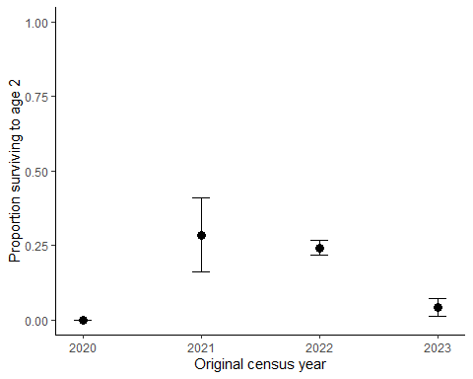 Survival differences across years at WL2
WL2_survival <- WL2_survival %>%
group_by(plant_id) %>%
mutate(original_census_year = min(Census_year)) %>% #create a column so we know when the plant was first censused
ungroup()
#The fates of 1st year plants observed in 2024 haven't been uploaded yet so we exclude them for now
max_year_WL2 <- max(WL2_survival$Census_year)
#remove plants that first appeared in 2024 and were not observed beyond age 1
survival_by_year_WL2 <- WL2_survival %>%
group_by(plant_id, original_census_year) %>%
summarise(max_age = max(age),
survived_to_age2 = as.integer(any(age == 2 & alive == 1)),
.groups = "drop") %>%
filter(!(original_census_year == max_year_WL2 & max_age == 1))
#summarize by year
WL2_survival_by_year <- survival_by_year_WL2 %>%
group_by(original_census_year) %>%
summarize(survival = mean(survived_to_age2),
survival_se = sem(survived_to_age2),
n=n(),
.groups = "drop")
#plot survival differences across years at WL2
ggplot(WL2_survival_by_year, aes(x=original_census_year, survival)) +
geom_point(size = 3) +
geom_errorbar(aes(ymin=survival - survival_se,
ymax = survival + survival_se),
width = 0.15) +
scale_y_continuous(limits = c(0, 1)) +
labs(
x = "Original census year",
y = "Proportion surviving to age 2"
) +
theme_classic()
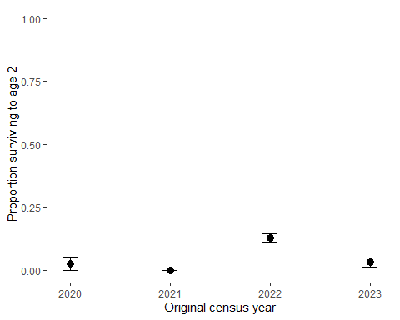 Survival differences across years at WL3
WL3_survival <- WL3_survival %>%
group_by(plant_id) %>%
mutate(original_census_year = min(Census_year)) %>% #create a column so we know when the plant was first censused
ungroup()
#The fates of 1st year plants observed in 2024 haven't been uploaded yet so we exclude them for now
max_year_WL3 <- max(WL3_survival$Census_year)
#remove plants that first appeared in 2024 and were not observed beyond age 1
survival_by_year_WL3 <- WL3_survival %>%
group_by(plant_id, original_census_year) %>%
summarise(max_age = max(age),
survived_to_age2 = as.integer(any(age == 2 & alive == 1)),
.groups = "drop") %>%
filter(!(original_census_year == max_year_WL3 & max_age == 1))
#summarize by year
WL3_survival_by_year <- survival_by_year_WL3 %>%
group_by(original_census_year) %>%
summarize(survival = mean(survived_to_age2),
survival_se = sem(survived_to_age2),
n=n(),
.groups = "drop")
#plot survival differences across years at WL3
ggplot(WL3_survival_by_year, aes(x=original_census_year, survival)) +
geom_point(size = 3) +
geom_errorbar(aes(ymin=survival - survival_se,
ymax = survival + survival_se),
width = 0.15) +
scale_y_continuous(limits = c(0, 1)) +
labs(
x = "Original census year",
y = "Proportion surviving to age 2"
) +
theme_classic()
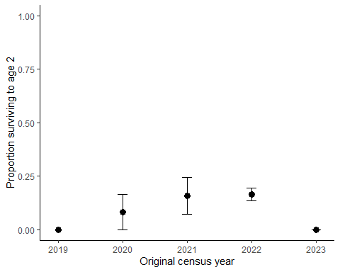 Survival differences across years at BH
BH_survival <- BH_survival %>%
group_by(plant_id) %>%
mutate(original_census_year = min(Census_year)) %>% #create a column so we know when the plant was first censused
ungroup()
#The fates of 1st year plants observed in 2024 haven't been uploaded yet so we exclude them for now
max_year_BH <- max(BH_survival$Census_year)
#remove plants that first appeared in 2024 and were not observed beyond age 1
survival_by_year_BH <- BH_survival %>%
group_by(plant_id, original_census_year) %>%
summarise(max_age = max(age),
survived_to_age2 = as.integer(any(age == 2 & alive == 1)),
.groups = "drop") %>%
filter(!(original_census_year == max_year_BH & max_age == 1))
#summarize by year
BH_survival_by_year <- survival_by_year_BH %>%
group_by(original_census_year) %>%
summarize(survival = mean(survived_to_age2),
survival_se = sem(survived_to_age2),
n=n(),
.groups = "drop")
#plot survival differences across years at WL1
ggplot(BH_survival_by_year, aes(x=original_census_year, survival)) +
geom_point(size = 3) +
geom_errorbar(aes(ymin=survival - survival_se,
ymax = survival + survival_se),
width = 0.15) +
scale_y_continuous(limits = c(0, 1)) +
labs(
x = "Original census year",
y = "Proportion surviving to age 2"
) +
theme_classic()
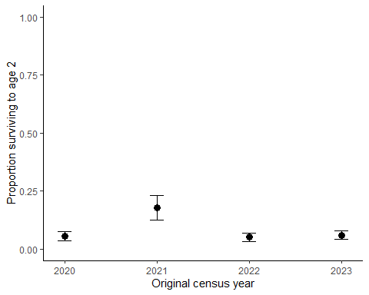 Survival differences across years at CP2
CP2_survival <- CP2_survival %>%
group_by(plant_id) %>%
mutate(original_census_year = min(Census_year)) %>% #create a column so we know when the plant was first censused
ungroup()
#The fates of 1st year plants observed in 2024 haven't been uploaded yet so we exclude them for now
max_year_CP2 <- max(WL2_survival$Census_year)
#remove plants that first appeared in 2024 and were not observed beyond age 1
survival_by_year_CP2 <- CP2_survival %>%
group_by(plant_id, original_census_year) %>%
summarise(max_age = max(age),
survived_to_age2 = as.integer(any(age == 2 & alive == 1)),
.groups = "drop") %>%
filter(!(original_census_year == max_year_CP2 & max_age == 1))
#summarize by year
CP2_survival_by_year <- survival_by_year_CP2 %>%
group_by(original_census_year) %>%
summarize(survival = mean(survived_to_age2),
survival_se = sem(survived_to_age2),
n=n(),
.groups = "drop")
#plot survival differences across years at WL1
ggplot(CP2_survival_by_year, aes(x=original_census_year, survival)) +
geom_point(size = 3) +
geom_errorbar(aes(ymin=survival - survival_se,
ymax = survival + survival_se),
width = 0.15) +
scale_y_continuous(limits = c(0, 1)) +
labs(
x = "Original census year",
y = "Proportion surviving to age 2"
) +
theme_classic()
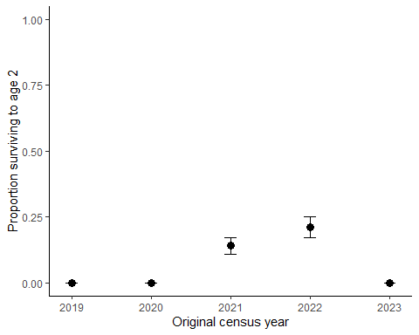
Survival differences across years at TM2
TM2_survival <- TM2_survival %>%
group_by(plant_id) %>%
mutate(original_census_year = min(Census_year)) %>% #create a column so we know when the plant was first censused
ungroup()
#The fates of 1st year plants observed in 2024 haven't been uploaded yet so we exclude them for now
max_year_TM2 <- max(TM2_survival$Census_year)
#remove plants that first appeared in 2024 and were not observed beyond age 1
survival_by_year_TM2 <- TM2_survival %>%
group_by(plant_id, original_census_year) %>%
summarise(max_age = max(age),
survived_to_age2 = as.integer(any(age == 2 & alive == 1)),
.groups = "drop") %>%
filter(!(original_census_year == max_year_TM2 & max_age == 1))
#summarize by year
TM2_survival_by_year <- survival_by_year_TM2 %>%
group_by(original_census_year) %>%
summarize(survival = mean(survived_to_age2),
survival_se = sem(survived_to_age2),
n=n(),
.groups = "drop")
#plot survival differences across years at WL1
ggplot(TM2_survival_by_year, aes(x=original_census_year, survival)) +
geom_point(size = 3) +
geom_errorbar(aes(ymin=survival - survival_se,
ymax = survival + survival_se),
width = 0.15) +
scale_y_continuous(limits = c(0, 1)) +
labs(
x = "Original census year",
y = "Proportion surviving to age 2"
) +
theme_classic()
