COVER SHEET
TITLE: ML1819 Research Assignment 1
TEAM ID: Team-11
TASK ID and TITLE: Task-107 Twitter
STUDENT NAMES and IDs: Geetanjali Singh (18303609), Mark Grennan (18334602), Vishal Rana (18303965)
CONTRIBUTION:
All three students contributed to the initial exploration of the data. Geetanjali and Mark completed the data cleaning and formatting. Vishal analyzed the data using decision tree, Geetanjali using logistic regression and Mark using SVM.
WORD COUNT:
SOURCE CODE URL: https://github.com/GrennanM/ML1819--task-107--team-11
SOURCE CODE REPOSITORY ACTIVITY: https://github.com/GrennanM/ML1819--task-107--team-11/graphs/contributors
SCREENSHOT:
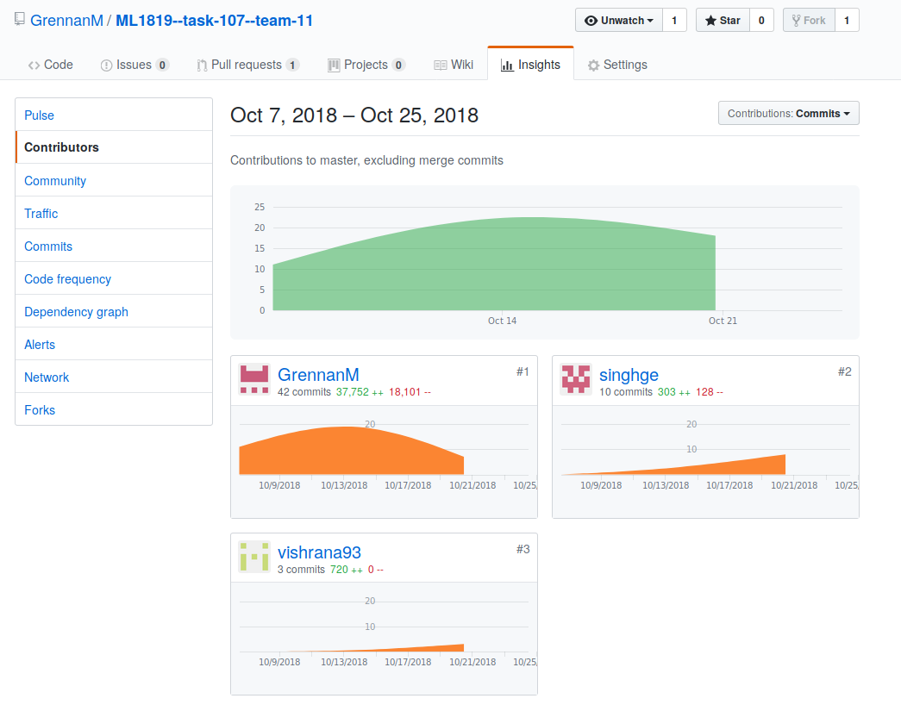

LANGUAGE INDEPENDENT GENDER PREDICTION ON TWITTER

Geetanjali Singh Department of Computer Science & Statistics, Trinity College Dublin  singhge@tcd.ie |  | Mark Grennan  Department of Computer Science & Statistics, Trinity College Dublin  grennama@tcd.ie | Vishal Rana  Department of Computer Science & Statistics, Trinity College Dublin  vrana@tcd.ie

Introduction

Background
When a user signs up to Twitter they do not have to specify their gender. Gender classification has significance for advertising companies, legal investigations and business-intelligence [1]–[3]. The majority of gender classifiers use some form of text analytics or natural language processing [4]–[7]. As highlighted by Alowibdi et al., with only approximately 50% of tweets being in English these language-dependent methods have their limitations [1], [8]. Our aim is to investigate which language independent user features can best predict their gender.

Related Work
Many works on gender classification rely on natural language processing [4]–[7]. Although these approaches can yield high levels of accuracy, Deitrick et al. reported an accuracy of 98%, they rely on using word based n-grams which result in huge feature spaces [2], [7]. Alowibdi et al. explored a language independent gender predictor based solely on five colour features: (1) Background colour (2) Text colour (3) Link colour (4) Sidebar fill colour and (5) Sidebar border colour. Using their entire dataset and probabilistic neural nets they reported an F1 of 77.4 [1].

2 METHODOLOGY
Our dataset was randomly generated from 10,000 tweets containing the word “the” and 10,000 tweets containing the word “and” [9], [10]. In creating this dataset the authors asked people to look at the tweets and state whether they thought the individual was a man, a woman or a brand. A confidence was given for this assessment. The original dataset contained 26 features.
To begin, we removed all entries where the gender confidence score was less than 1. We then removed all entries where the gender was given as ‘brand’ as this did not fit within the scope of our project. This left us 10,020 entries with 53% female and 47% male.
We then removed a number of outliers which can be seen clearly in the plots below.
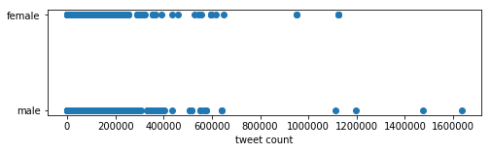
Figure 1: Total Number of Tweets Posted.
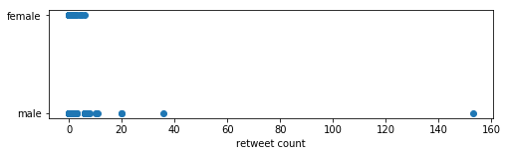
Figure 2: Total number of retweets.
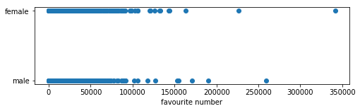
Figure 3: Total number of tweets favourited.
Exploratory plots revealed that males were early adopters of Twitter and females joined in greater numbers after 2011. Other variables did not highlight any clear difference between males and females.
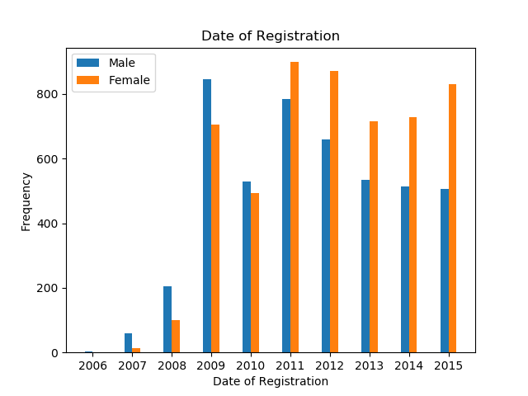
Figure 4: Date of Registration

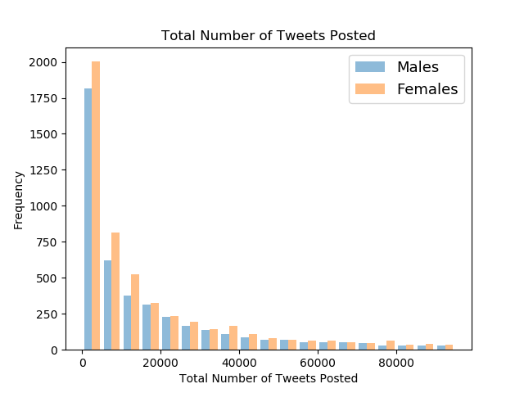
Figure 5: Total Number of Tweets Posted.

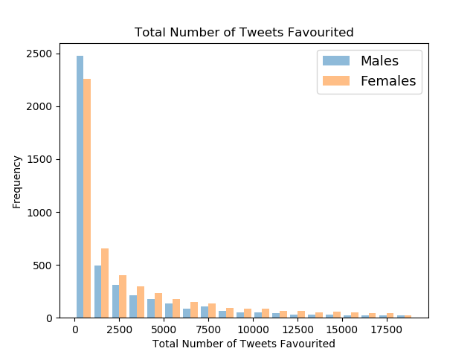
Figure 6: Total Number of Tweets Favourited.

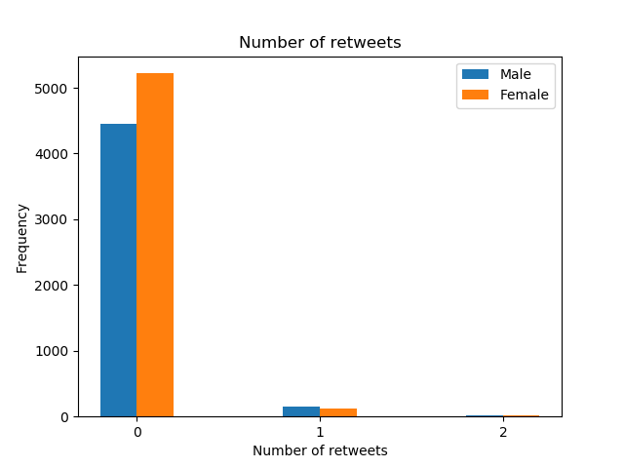
Figure 7: Total Number of retweets
No clear correlation was observed between variables.
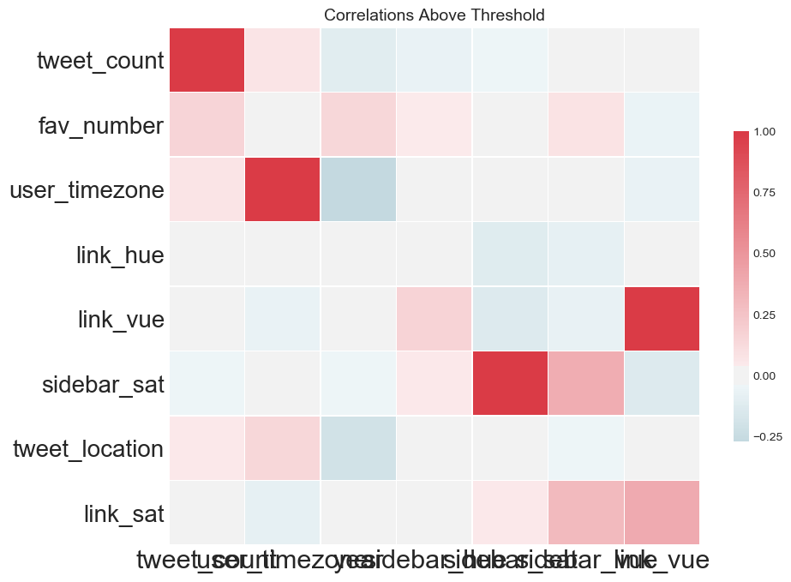
Figure 8: Correlation between features.
We treated tweet location as a binary variable with an entry of 0 if it was filled out and an entry of 1 if it was left empty. We carried out a hypothesis test on the sample proportions and found that the difference between males and females was statistically significant at the 1% level.

 | Female | Male | Z-Score | p-value
Proportion who filled in tweet location | 0.65 | 0.73 | 9.8 | ~0.0
Table 1: Hypothesis Test for whether a user filled out their location.
Alowibdi et al. suggested that more females than males used a custom colour scheme [1], however, in our dataset we found that 9.6% of females and 11.1% of males used custom colour schemes (p=0.02).
 | Female | Male | Z-Score | p-value
Proportion who used custom colour | 0.096 | 0.111 | 2.4 | 0.02
Table 2: Proportion who used custom colour scheme.
We also saw that there was also information to be gained from the specific colour schemes chosen. Of those who chose custom colours more females (1) chose colours with a hue in the range 250 -350 (purple/pink). Rather than create a dummy variable, we converted our colours to hsv format.
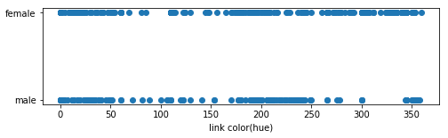
Figure 10: Link hue (colour) for those who chose a custom colour scheme.
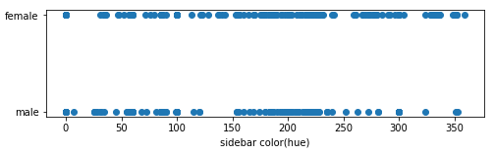
Figure 11: Sidebar Hue for those who chose a custom colour scheme.
We took the length of a person’s username and included this as a feature in our model. Finally, we standardized our variables. A summary of our chosen features is given below:
Feature | Description
gender_catg | 0 if male, 1 if female
fav_number | number of tweets the user has favourited
retweet_count | number of times the user has retweeted
tweet_count | number of tweets that the user has posted
tweet_location | 0 if present, 1 if left empty
year | year of registration
month | month of registration
totalLettersName | Total number of letters in the username
link_hue | the hue of a user’s link colour
link_sat | the saturation of a user’s link colour
link_value | the value (brightness) of a user’s link colour
sidebar_hue | the hue of a user’s sidebar colour
sidebar_sat | the saturation of a user’s sidebar colour
sidebar_value | the value (brightness) of a user’s value colour
Table 3: Features used.
We ran three models on our dataset: 1. decision tree, 2. logistic regression, 3. support vector machines. In each case we split our data into training (90%) and testing (10%) and then ran a 10-fold classification. For Logistic regression we looped through a range of C values (C=1/λ) observing accuracy but conscious that a small C value increases the regularization strength. We arrived at a value of C =1.

For SVM, we tried different kernels: linear, polynomial, gaussian and sigmoid. We also used cross-validation, shown below, to select the parameters (C=1, gamma=0.3) for our model.
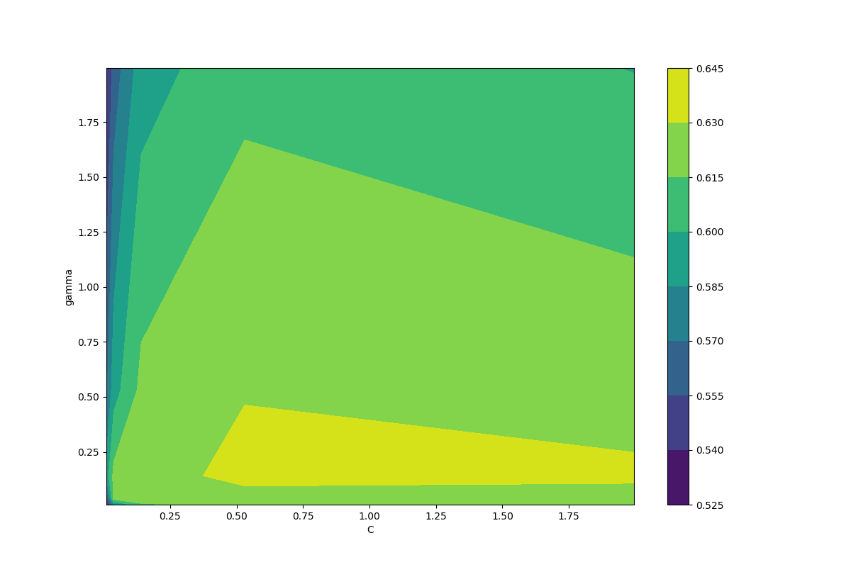
Figure 12: Heat map of cross-validation for Linear SVM Kernel.
We evaluated the strength of each of our models using precision, accuracy and F1. Finally, we used recursive feature selection using cross-validation to select which features were most important.

3 RESULTS

Our research aim was to find out which language independent features, if any, can best predict a users gender on twitter. We ran recursive feature selection using cross-validation on our linear SVM and Logistic model. The graphs below indicates that for SVM with a linear kernel increasing the number of features from 4 to 13 only improves accuracy by 1% and similarly, for logistic regression, increasing the features beyond 4 improves accuracy by at most 2%.

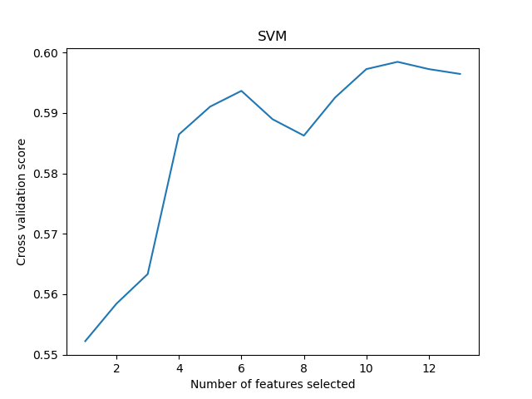
Figure 13: Feature Selection using cross validation for Linear SVM.
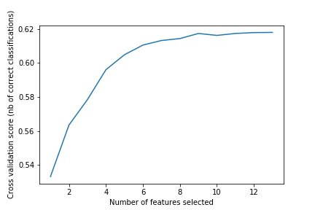
Figure 14: Feature selection using cross validation for Logistic Regression.
With SVM we found that a polynomial kernel of degree 4 performed best regardless of the number of features chosen.

 | Model with 4 features |  |  | Model with 13 features
Kernel | precision | recall | F1 | precision | recall | F1
Sigmoid | 0.52 | 0.52 | 0.52 | 0.48 | 0.48 | 0.48
Linear | 0.58 | 0.58 | 0.56 | 0.60 | 0.60 | 0.60
Gaussian | 0.60 | 0.60 | 0.59 | 0.64 | 0.64 | 0.64
Poly (4) | 0.62 | 0.62 | 0.60 | 0.64 | 0.64 | 0.64
Table 4: Comparison of different kernels SVM.
We ran our three models using every feature and using only the four most predictive features for that model. The results indicate that…

 | Model with 4 features |  |  | Model with 13 features
Model | precision | recall | F1 | precision | recall | F1
DT
Logistic | 0.63 | 0.63 | 0.62 | 0.63 | 0.63 | 0.62
SVM | 0.62 | 0.62 | 0.60 | 0.64 | 0.64 | 0.64
Table 5: Results of different models.
Finally using recursive feature selection, the four most predictive features given, in no particular order, by our three models are listed in the table below.
Model | Features
DT
Logistic | tweet location | year | sidebar hue | sidebar saturation
SVM | retweet count | tweet location | year | sidebar saturation
Table 6: Selected Features.
Compared to a simple baseline of 50%, with four features our model showed a x% increase however, our model was x below the best language independent classifier (F1 0.77) [1]. In summary...
4 LIMITATIONS AND OUTLOOK
The strength of our research depends on the accuracy in which the gender was originally categorized. Given the subjective nature of choosing whether a tweet was written by a male, a female or a brand, this is an unfortunate limitation of our dataset. Further work could be done in ranking the importance of our selected features.
5 REFERENCES
[1] | J. S. Alowibdi, U. A. Buy, and P. Yu, ‘Language independent gender classification on Twitter’, in Proceedings of the 2013 IEEE/ACM International Conference on Advances in Social Networks Analysis and Mining - ASONAM ’13, Niagara, Ontario, Canada, 2013, pp. 739–743.
[2] | J. S. Alowibdi, U. A. Buy, and P. Yu, ‘Empirical Evaluation of Profile Characteristics for Gender Classification on Twitter’, vol. 1, pp. 365–369, Dec. 2013.
[3] | D. Fernandez, D. Moctezuma, and O. S. Siordia, ‘Features combination for gender recognition on Twitter users’, pp. 1–6, Nov. 2016.W. Liu and D. Ruths, ‘What’s in a Name? Using First Names as Features for Gender Inference in Twitter’, in 2013 AAAI Spring Symposium Series, 2013.
[4] | W. Liu and D. Ruths, ‘What’s in a Name? Using First Names as Features for Gender Inference in Twitter’, in 2013 AAAI Spring Symposium Series, 2013.
[5] | Z. Miller, B. Dickinson, and W. Hu, ‘Gender Prediction on Twitter Using Stream Algorithms with N-Gram Character Features’, International Journal of Intelligence Science, vol. 02, no. 04, pp. 143–148, 2012.
[6] | W. Deitrick, Z. Miller, B. Valyou, B. Dickinson, T. Munson, and W. Hu, ‘Gender Identification on Twitter Using the Modified Balanced Winnow’, Communications and Network, vol. 04, no. 03, pp. 189–195, 2012.
[7] | J. D. Burger, J. Henderson, G. Kim, and G. Zarrella, ‘Discriminating gender on Twitter’, In Proceedings of the conference on empirical methods in natural language processing, pp. 1301-1309. Association for Computational Linguistics, 2011.
[8] | Wauters, R. http://techcrunch.com/2010/02/24/twitter-languages/, access in May 2013.
[9] | ‘Twitter User Gender Classification’. [Online]. Available: https://www.kaggle.com/crowdflower/twitter-user-gender-classification.
[10] | ‘Using machine learning to predict gender’. Available: https://www.figure-eight.com/using-machine-learning-to-predict-gender/.

