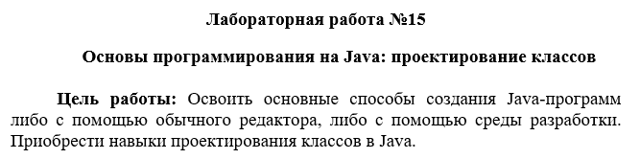

public class Complex {

private double real;

private double imaginary;

// Конструкторы

public Complex(double real, double imaginary) {

this.real = real;

this.imaginary = imaginary;

}

// Методы доступа (getters и setters)

public double getReal() {

return real;

}

public void setReal(double real) {

this.real = real;

}

public double getImaginary() {

return imaginary;

}

public void setImaginary(double imaginary) {

this.imaginary = imaginary;

}

// Метод для сложения комплексных чисел

public Complex add(Complex other) {

return new Complex(this.real + other.real, this.imaginary + other.imaginary);

}

@Override

public String toString() {

return String.format("%s + %si", real, imaginary);

}

}

import java.util.Arrays;

public class Polynomial {

private Complex[] coefficients;

public Polynomial(Complex[] coefficients) {

this.coefficients = coefficients;

}

// Метод доступа к коэффициентам

public Complex[] getCoefficients() {

return coefficients;

}

// Метод для сложения полиномов

public Polynomial add(Polynomial other) {

int length = Math.max(this.coefficients.length, other.coefficients.length);

Complex[] result = new Complex[length];

for (int i = 0; i < length; i++) {

Complex thisCoeff = (i < this.coefficients.length) ? this.coefficients[i] : new Complex(0, 0);

Complex otherCoeff = (i < other.coefficients.length) ? other.coefficients[i] : new Complex(0, 0);

result[i] = thisCoeff.add(otherCoeff);

}

return new Polynomial(result);

}

@Override

public String toString() {

return Arrays.toString(coefficients);

}

}

import java.util.ArrayList;

import java.util.List;

public class Main {

public static void main(String[] args) {

// Пример комплексных чисел

Complex c1 = new Complex(1, 2);

Complex c2 = new Complex(3, 4);

Complex c3 = new Complex(5, 6);

// Пример полиномов

Polynomial p1 = new Polynomial(new Complex[]{c1, c2});

Polynomial p2 = new Polynomial(new Complex[]{c2, c3});

Polynomial p3 = new Polynomial(new Complex[]{c1, c3, c2});

// Список полиномов

List<Polynomial> polynomials = new ArrayList<>();

polynomials.add(p1);

polynomials.add(p2);

polynomials.add(p3);

// Вычисление суммы полиномов

Polynomial sum = sumPolynomials(polynomials);

// Вывод результата

System.out.println("Сумма полиномов: " + sum);

}

public static Polynomial sumPolynomials(List<Polynomial> polynomials) {

if (polynomials == null || polynomials.isEmpty()) {

return new Polynomial(new Complex[0]);

}

Polynomial sum = polynomials.get(0);

for (int i = 1; i < polynomials.size(); i++) {

sum = sum.add(polynomials.get(i));

}

return sum;

}

}

