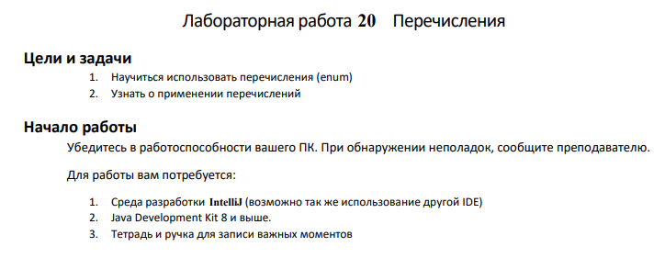

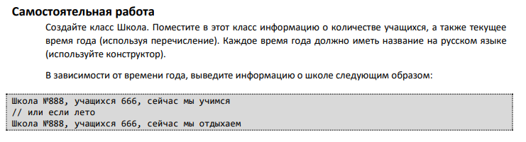

public class Main {

private int numberOfStudents;

private Season currentSeason;

public Main(int numberOfStudents, Season currentSeason) {

this.numberOfStudents = numberOfStudents;

this.currentSeason = currentSeason;

}

public void printInfo() {

String activity;

switch (currentSeason) {

case ЛЕТО:

activity = "сейчас мы отдыхаем";

break;

default:

activity = "сейчас мы учимся";

break;

}

System.out.printf("Школа №888, учащихся %d, %s%n", numberOfStudents, activity);

}

// Перечисление для времени года

public enum Season {

ВЕСНА("Весна"),

ЛЕТО("Лето"),

ОСЕНЬ("Осень"),

ЗИМА("Зима");

private final String name;

Season(String name) {

this.name = name;

}

@Override

public String toString() {

return name;

}

}

public static void main(String[] args) {

Main school = new Main(666, Season.ВЕСНА);

school.printInfo();

Main summerSchool = new Main(666, Season.ЛЕТО);

summerSchool.printInfo();

}

}

