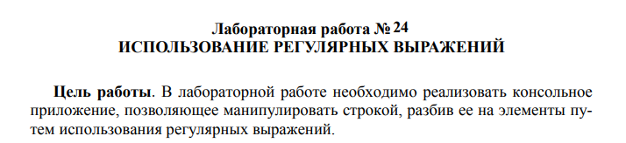

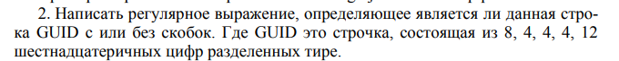

public class Main {

// проверка GUID с или без скобок

private static final String GUID_PATTERN =

"^(\\{)?[0-9a-fA-F]{8}-[0-9a-fA-F]{4}-[0-9a-fA-F]{4}-[0-9a-fA-F]{4}-[0-9a-fA-F]{12}(\\})?$";

public static boolean isValidGuid(String guid) {

Pattern pattern = Pattern.compile(GUID_PATTERN);

Matcher matcher = pattern.matcher(guid);

return matcher.matches();

}

public static void main(String[] args) {

String[] testGuids = {

"e02fd0e4-00fd-090A-ca30-0d00a0038ba0",

"{e02fd0e4-00fd-090A-ca30-0d00a0038ba0}",

"e02fd0e400fd090Aca300d00a0038ba0",

"e02fd0e4-00fd-090A-ca30-0d00a0038ba",

"{e02fd0e4-00fd-090A-ca30-0d00a0038ba0",

"e02fd0e4-00fd-090A-ca30-0d00a0038ba0}"

};

for (String guid : testGuids) {

System.out.printf("GUID: %s is valid: %b%n", guid, isValidGuid(guid));

}

}

}

